DSA0601 • DATA HANDLING AND VISUALIZATION
Course Details | Information
Department | AIML
Course Code / Course Name | DSA0601 / Data Handling and Visualization
Programming / Visualization Tools | R / Tableau
Student Name | K.Akhileswara Reddy
Register Number | 192325068
Date | 03-10-2026

SET 9: ONLINE LEARNING ACTIVITY ANALYSIS
Experiment: Online Learning Activity Analysis

Aim
To analyze online learning activity using R by examining quiz-score distribution, course-wise performance, study-time relationships, and monthly trends, and to develop a Tableau dashboard for interactive exploration.

Dataset: Online_Learning_Activity.csv
Student_ID | Gender | Age | Course | Study_Time (hrs) | Videos_Watched | Quiz_Score | Login_Date
L01 | Male | 20 | R | 3.5 | 12 | 78 | 2025-01-05
L02 | Female | 22 | R | 4.2 | 15 | 85 | 2025-01-05
L03 | Male | 19 | SQL | 2.0 | 8 | 65 | 2025-02-08
L04 | Female | 21 | R | 5.0 | 18 | 92 | 2025-02-08
L05 | Male | 23 | R | 2.5 | 9 | 70 | 2025-03-12
L06 | Female | 20 | SQL | 4.0 | 14 | 88 | 2025-03-12

PROGRAM 1: Quiz Score Histogram and Boxplot by Course
Import the dataset in R. Plot a histogram for Quiz_Score and draw a boxplot of Quiz_Score by Course. Add title and labels. Interpret student performance.
data <- read.csv("Online_Learning_Activity.csv")
hist(data$Quiz_Score,
breaks = 5,
main = "Distribution of Quiz Scores",
xlab = "Quiz Score",
ylab = "Number of Students",
col = "skyblue")
boxplot(Quiz_Score ~ Course,
data = data,
main = "Quiz Score by Course",
xlab = "Course",
ylab = "Quiz Score",
col = "lightgreen")
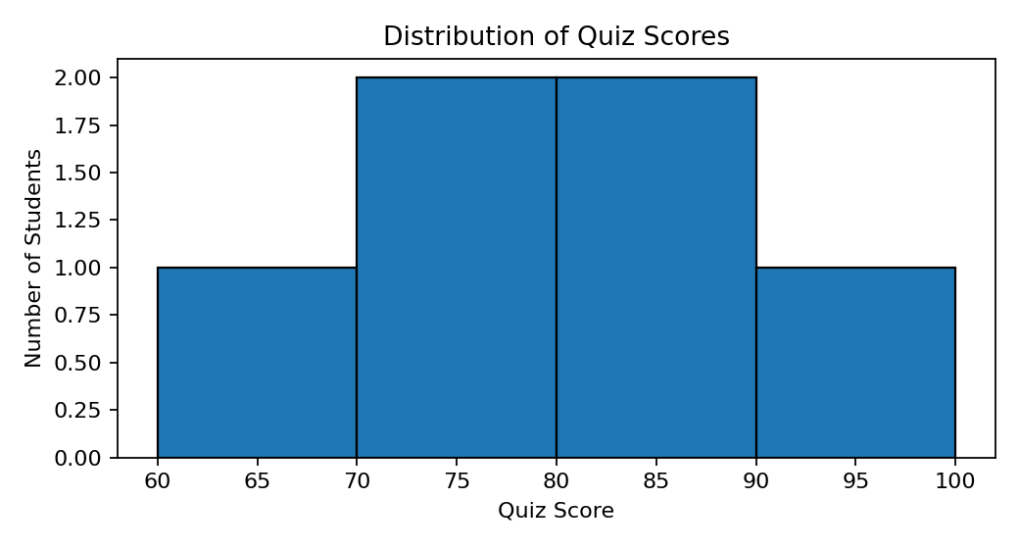
Figure 1: Histogram of quiz scores.
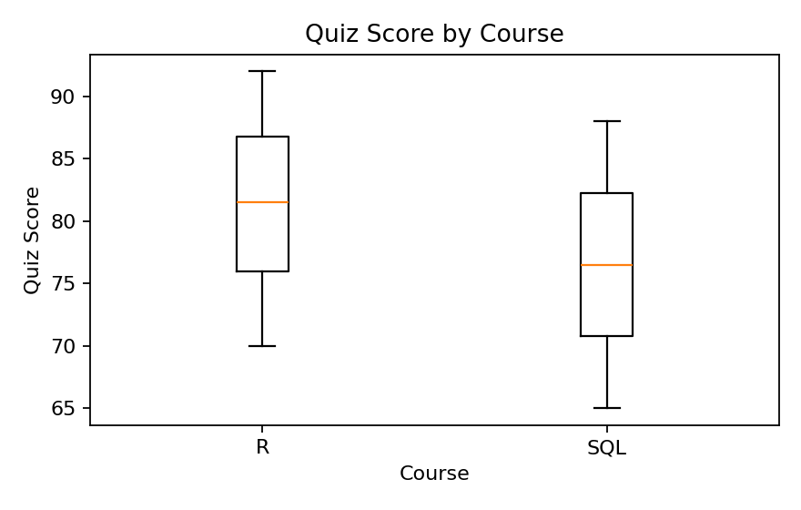
Figure 2: Boxplot comparing quiz scores for R and SQL.
Observation: Quiz scores range from 65 to 92. The R-course scores are 70, 78, 85, and 92, while SQL scores are 65 and 88. With only two SQL observations, the course comparison should be interpreted cautiously.

PROGRAM 2: Study Time vs Quiz Score Bubble Scatter Plot
Create a scatter plot using R programming between Study_Time and Quiz_Score. Represent Videos_Watched using bubble size. Apply transparency. Explain the learning pattern.
data <- read.csv("Online_Learning_Activity.csv")
plot(data$Study_Time, data$Quiz_Score,
pch = 19,
cex = data$Videos_Watched / 5,
col = rgb(0.2, 0.5, 0.8, 0.55),
xlab = "Study Time (hrs)",
ylab = "Quiz Score",
main = "Study Time vs Quiz Score")
text(data$Study_Time, data$Quiz_Score,
labels = data$Student_ID,
pos = 3,
cex = 0.8)
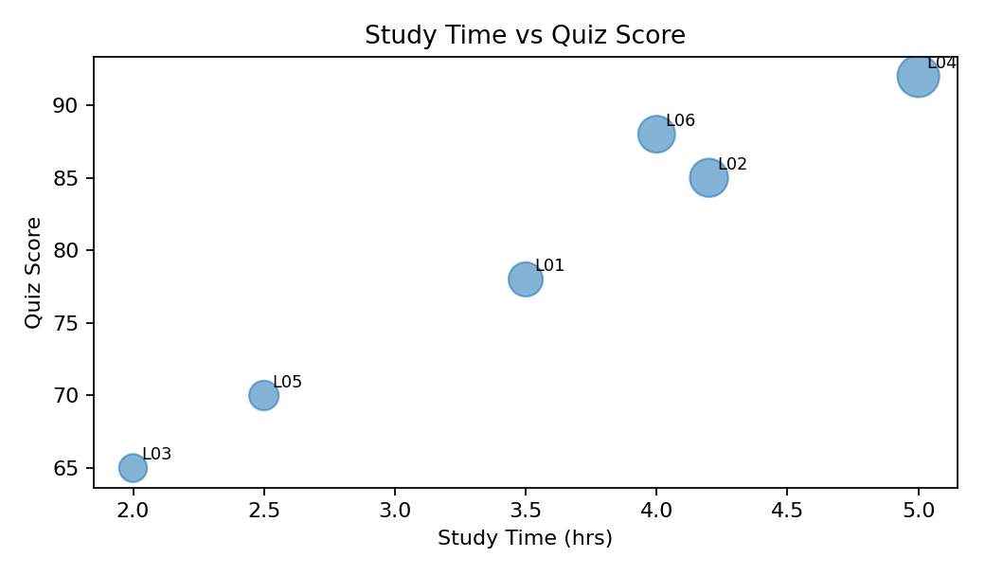
Figure 3: Bubble scatter plot; larger bubbles indicate more videos watched.
Observation: In these six records, higher study time generally coincides with higher quiz scores, but the relationship is not perfectly linear. Video-watching activity also varies across students.

PROGRAM 3: Monthly Average Quiz Score and Moving Average
Convert Login_Date into Date format. Calculate average quiz score per month. Plot a line chart, apply moving-average smoothing, and identify the trend.
data <- read.csv("Online_Learning_Activity.csv")
data$Login_Date <- as.Date(data$Login_Date)
data$Month <- format(data$Login_Date, "%Y-%m")
monthly_avg <- aggregate(Quiz_Score ~ Month,
data = data,
FUN = mean)
monthly_avg$Moving_Average <- stats::filter(
monthly_avg$Quiz_Score,
rep(1/2, 2),
sides = 1
)
plot(as.Date(paste0(monthly_avg$Month, "-01")),
monthly_avg$Quiz_Score,
type = "o",
pch = 19,
xlab = "Month",
ylab = "Average Quiz Score",
main = "Monthly Average Quiz Score")
lines(as.Date(paste0(monthly_avg$Month, "-01")),
monthly_avg$Moving_Average,
type = "o",
lty = 2)
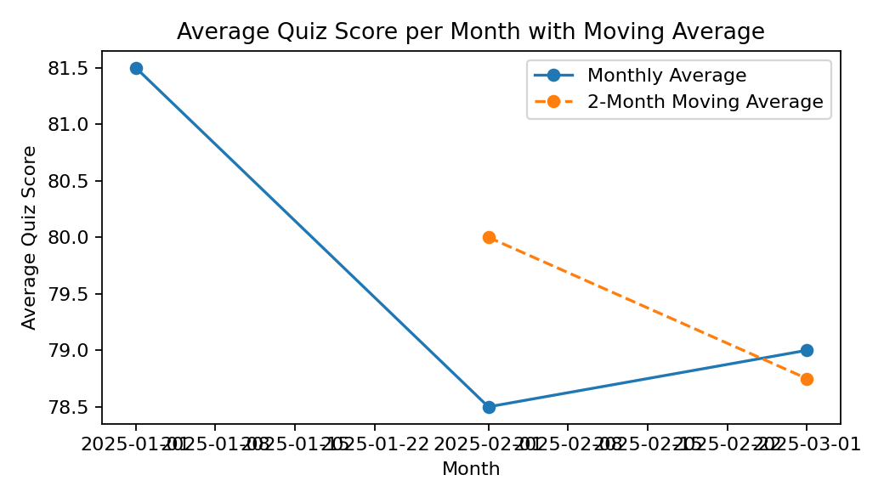
Figure 4: Monthly average quiz score with a 2-month moving average.
Observation: The monthly averages are 81.5 in January, 78.5 in February, and 79.0 in March. The 2-month moving average is available after the first month and smooths the short series. With only three months of data, a long-term trend should not be inferred.

PROGRAM 4: Tableau Mini Interactive Dashboard
Import Online_Learning_Activity.csv into Tableau. Create a bar chart showing average quiz score by Course, create a Study Time vs Quiz Score scatter plot, add Gender and Course filters, and design a mini interactive dashboard.
TABLEAU WORKFLOW
1. Connect Tableau to Online_Learning_Activity.csv.
2. Worksheet 1 – Average Quiz Score by Course:
• Course → Columns
• Quiz_Score → Rows
• Change aggregation to AVG.
• Enable data labels.
3. Worksheet 2 – Study Time vs Quiz Score:
• Study_Time (hrs) → Columns
• Quiz_Score → Rows
• Student_ID → Detail / Label.
• Videos_Watched → Size.
• Gender → Color (optional).
4. Create a new Dashboard and place both worksheets on it.
5. Add Gender and Course filters.
6. Apply the filters to all relevant worksheets.
7. Add dashboard actions for filtering or highlighting.
8. Add a dashboard title and save the Tableau workbook.
Observation: The Tableau dashboard combines course-wise quiz performance and the relationship between study time and quiz score. Gender and Course filters allow users to explore selected student groups interactively.

Procedure
- Import Online_Learning_Activity.csv into R and inspect the variables.
- Plot the Quiz_Score histogram and boxplot by Course.
- Create the Study_Time versus Quiz_Score bubble scatter plot using Videos_Watched for bubble size.
- Convert Login_Date to Date format, calculate monthly average quiz scores, and plot the moving-average trend.
- Import the CSV file into Tableau and create the average quiz score by Course bar chart.
- Create the Study Time versus Quiz Score scatter plot and add Gender and Course filters.
- Combine the Tableau worksheets into a mini interactive dashboard.

Result
The online learning activity dataset was analyzed using a histogram, course-wise boxplot, bubble scatter plot, and monthly line chart with moving-average smoothing. A Tableau mini dashboard was also designed with course and gender filters for interactive exploration.

Key Functions / Tools Used
Function / Tool | Purpose
read.csv() | Imports the Online_Learning_Activity.csv dataset.
hist() | Creates the quiz-score histogram.
boxplot() | Compares quiz-score distributions by course.
plot() / lines() | Creates the scatter and monthly trend visualizations.
as.Date() / format() | Converts Login_Date and extracts month information.
aggregate() / filter() | Calculates monthly averages and moving-average smoothing.
Tableau | Creates interactive worksheets and dashboards.
Filters / Dashboard Actions | Enable interactive exploration by Gender and Course.

