SIMATS ENGINEERING
SAVEETHA INSTITUTE OF MEDICAL AND TECHNICAL SCIENCES
NAME: K.Akhileswara Reddy
DATE:29/09/2026
LAB EXP: 2
Reg Mo: 192325068
Course Code/ Name: DSA0601 / Data Handling and Visualization
Set 2: Customer Feedback Analysis
Dataset: Customer Satisfaction
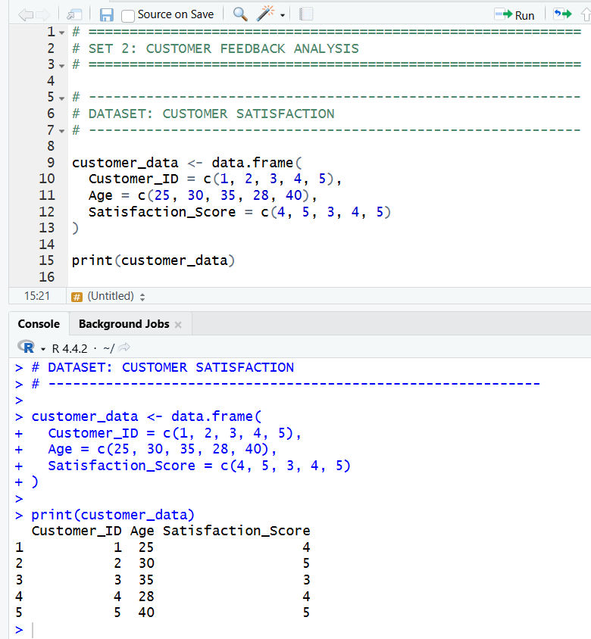
1. Create a histogram to represent the distribution of customer ages. Label the axes and title the chart.
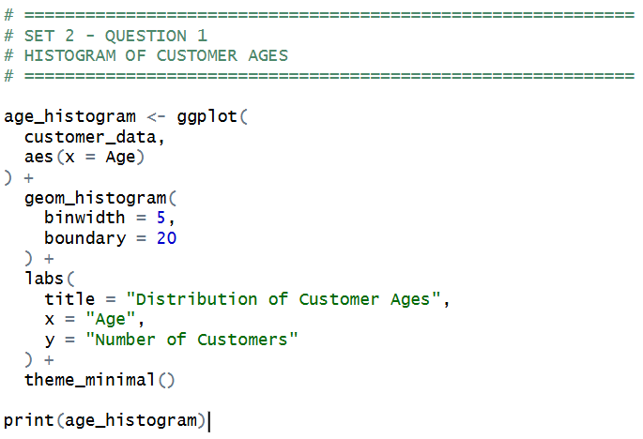
OUTPUT:

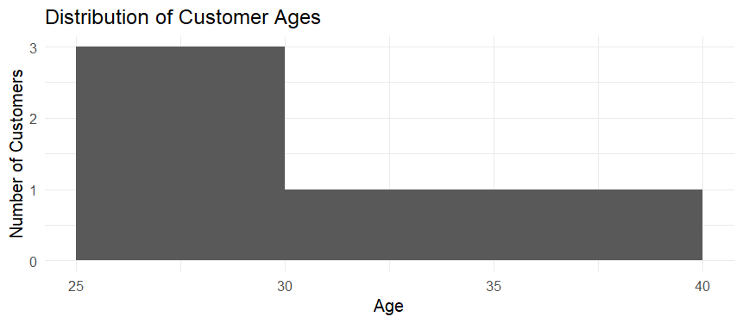

2. Generate a pie chart to display the overall distribution of customer satisfaction scores. Include labels.
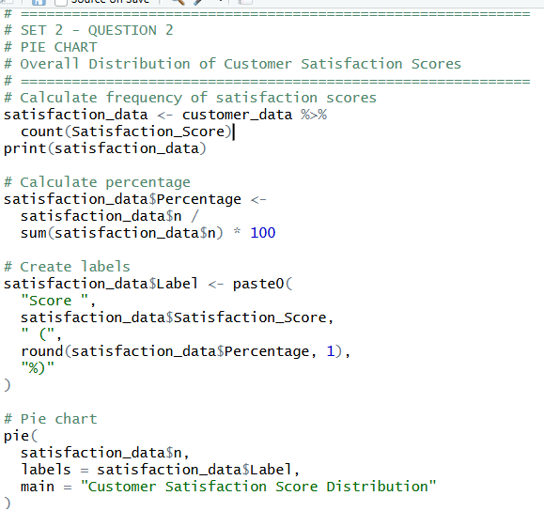
OUTPUT:
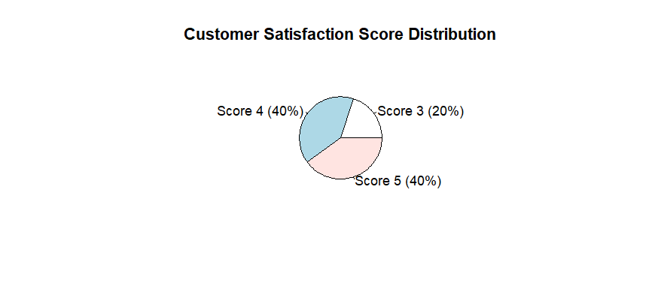
3. Build a stacked bar chart to visualize the distribution of customer satisfaction scores by age group.
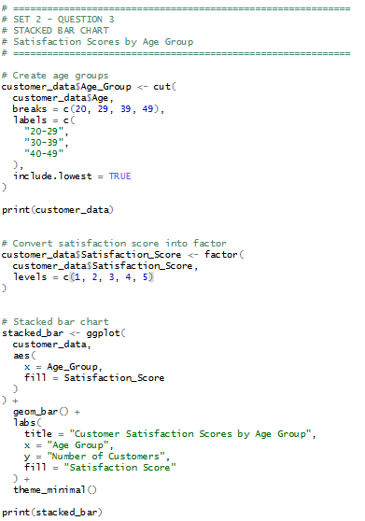
OUTPUT:
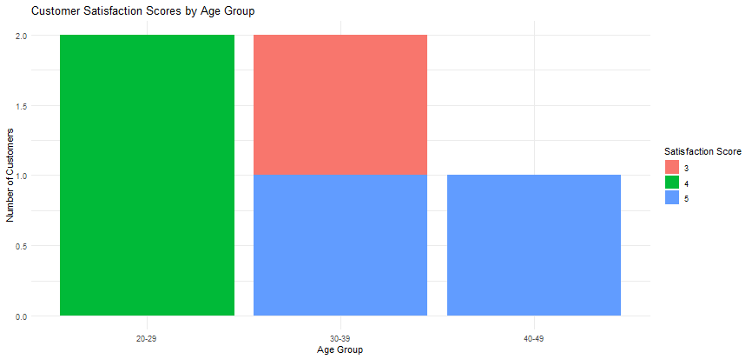
4. Develop a word cloud from open-ended customer feedback to identify prevalent customer sentiments.
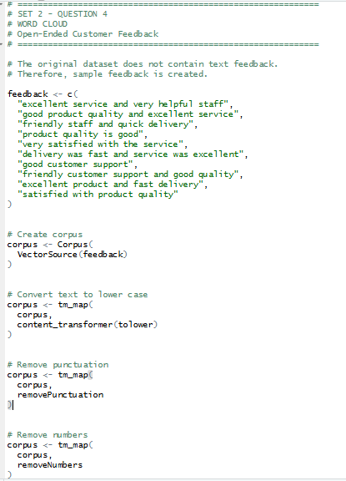
OUTPUT:
