SIMATS ENGINEERING
SAVEETHA INSTITUTE OF MEDICAL AND TECHNICAL SCIENCES
NAME: K.Akhileswara Reddy
DATE:29/09/2026
LAB EXP: 3
Reg Mo: 192325068
Course Code/ Name: DSA0601 / Data Handling and Visualization
Set 3: Employee Performance Evaluation
Dataset: Employee Performance
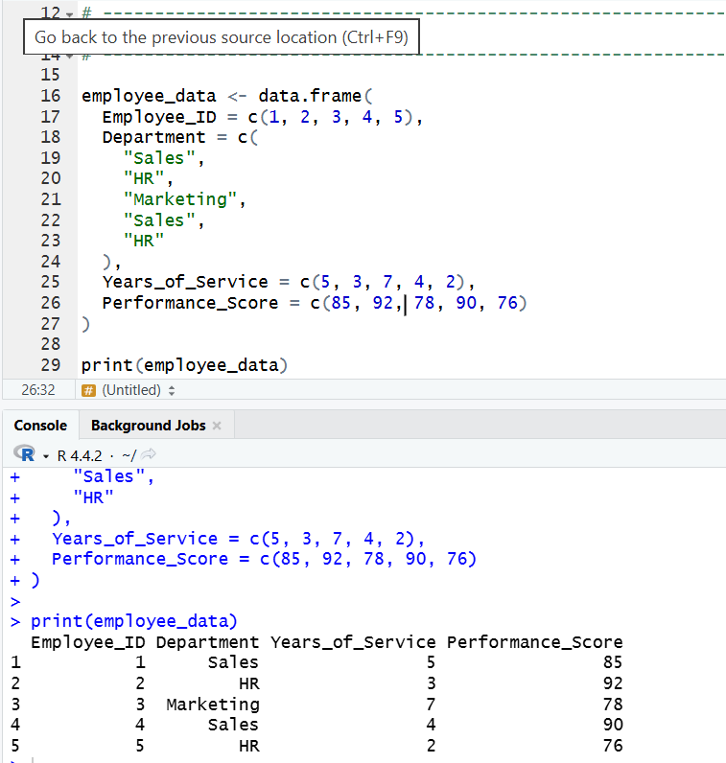
1. Create a line chart to visualize the performance trend of employees over time. Include a legend and labels.
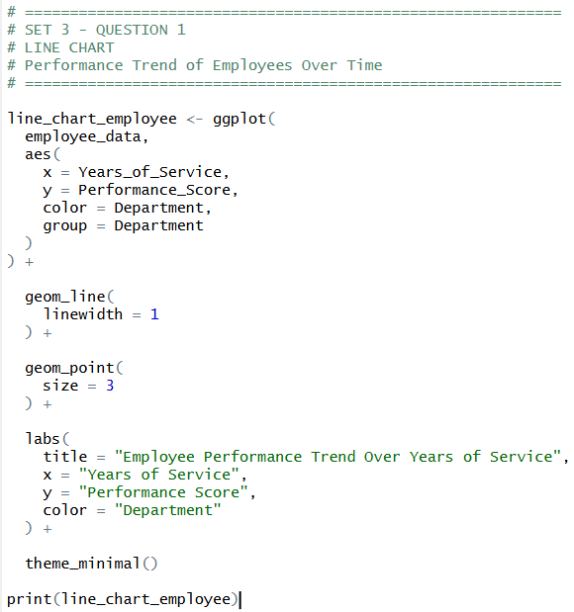
OUTPUT:
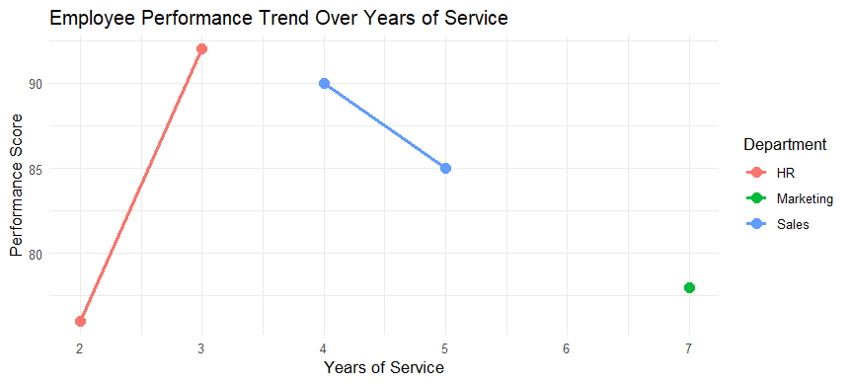
2. Generate a bar chart showing the distribution of employees across different departments. Label the chart elements.
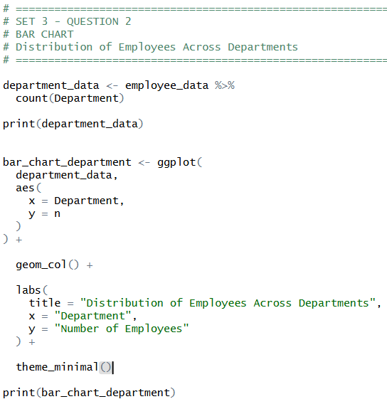
OUTPUT:
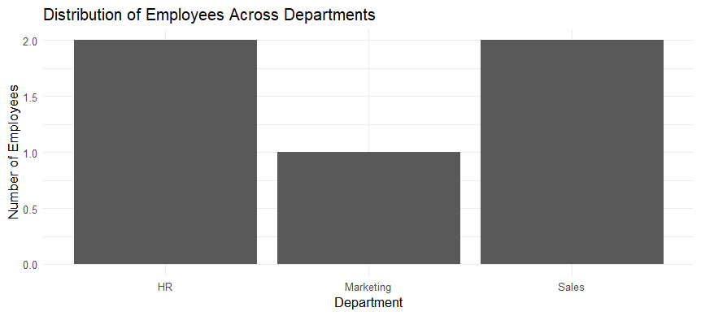

3. Build a scatter plot to analyze the correlation between years of service and performance scores Explain any insights.
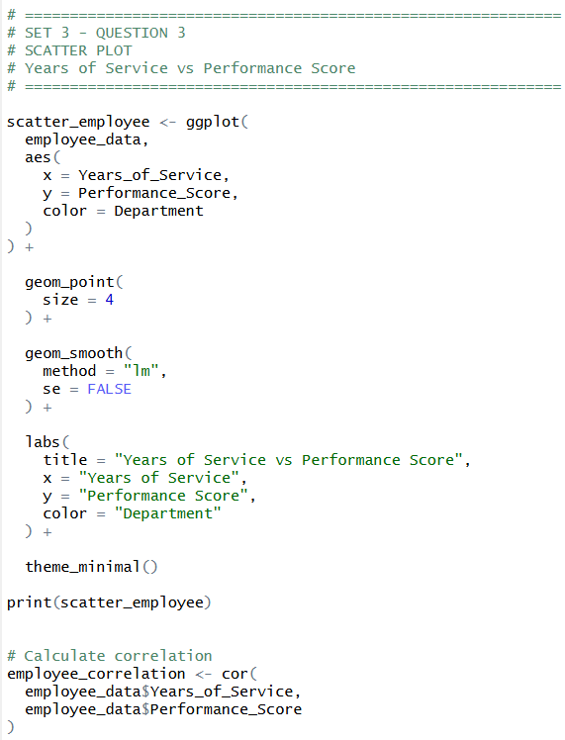
OUTPUT:
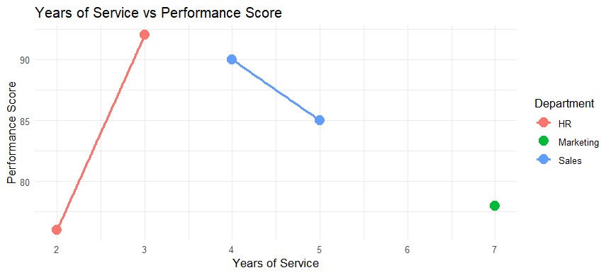
4. Develop a Tableau dashboard with the line chart and bar chart for interactive exploration.
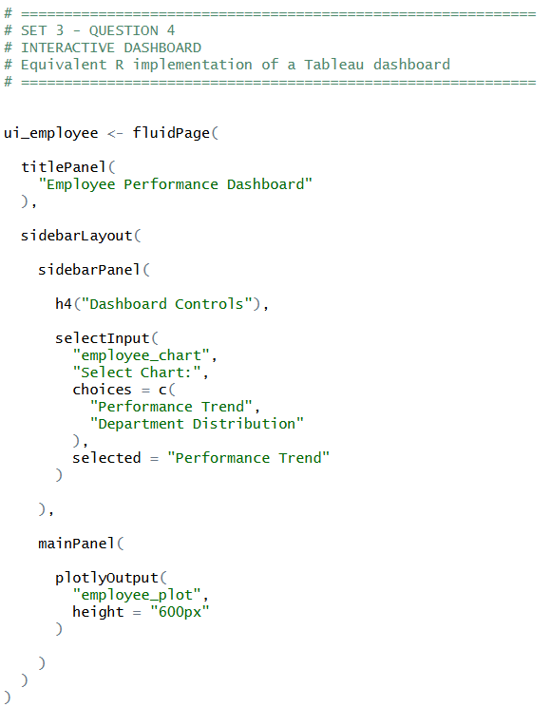
OUTPUT:
