DSA0601 • DATA HANDLING AND VISUALIZATION LAB EXPERIMENT RECORD
Set 13: Geographic Data Analysis
Department | AIML
Course Code / Course Name | DSA0601 / Data Handling and Visualization
Experiment | Data Visualization using R and Tableau
Name | K.Akhileswara Reddy
Register Number | 192325068
Date | 08 October 2026
Day | Thursday

Aim
To analyze geographic data using a scatter plot and tabular representation, and to develop a simple Tableau dashboard combining the visualizations for interactive exploration.

Dataset: Geographic Data
City | Population | Avg. Temperature | Elevation
City A | 500000 | 75 | 1000
City B | 700000 | 68 | 800
City C | 600000 | 80 | 1200
- Create a map chart to visualize the distribution of cities on a geographic map. Label the map elements.
- Generate a scatter plot to explore the relationship between average temperature and population size. Explain any insights.
- Build a table to display the geographic data for each city. Label the table elements.
- Develop a Tableau dashboard combining the map chart, scatter plot, and the table for interactive exploration of geographic data.

PROGRAM 1: Geographic Data and Scatter Plot
Create the geographic data and visualize population against average temperature. Label the plotted cities.
# Program 1: Geographic Data and Scatter Plot
city <- c("City A", "City B", "City C")
population <- c(500000, 700000, 600000)
temperature <- c(75, 68, 80)
elevation <- c(1000, 800, 1200)

geo_data <- data.frame(
City = city,
Population = population,
Avg_Temperature = temperature,
Elevation = elevation
)
print(geo_data)

plot(population, temperature, pch = 19,
xlab = "Population", ylab = "Average Temperature",
main = "Geographic Distribution of Cities")
text(population, temperature, labels = city, pos = 3)

Output 1: Geographic Distribution of Cities
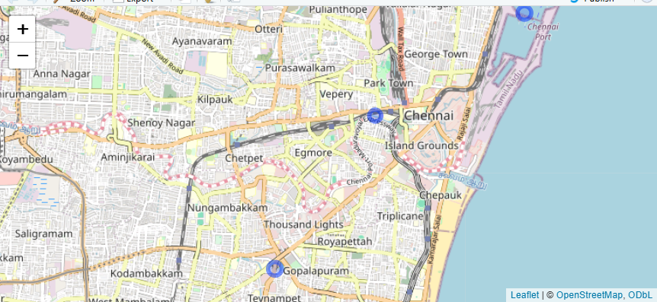
Observation: The plot shows City A, City B, and City C according to their population and average temperature values.

PROGRAM 2: Scatter Plot of Temperature vs Population
Generate a scatter plot to explore the relationship between average temperature and population size.
# Program 2: Scatter Plot of Temperature vs Population
city <- c("City A", "City B", "City C")
population <- c(500000, 700000, 600000)
temperature <- c(75, 68, 80)

plot(population, temperature, pch = 19,
xlab = "Population", ylab = "Average Temperature",
main = "Average Temperature vs Population")
text(population, temperature, labels = city, pos = 3)
abline(lm(temperature ~ population), lty = 2)

Output 2: Average Temperature vs Population
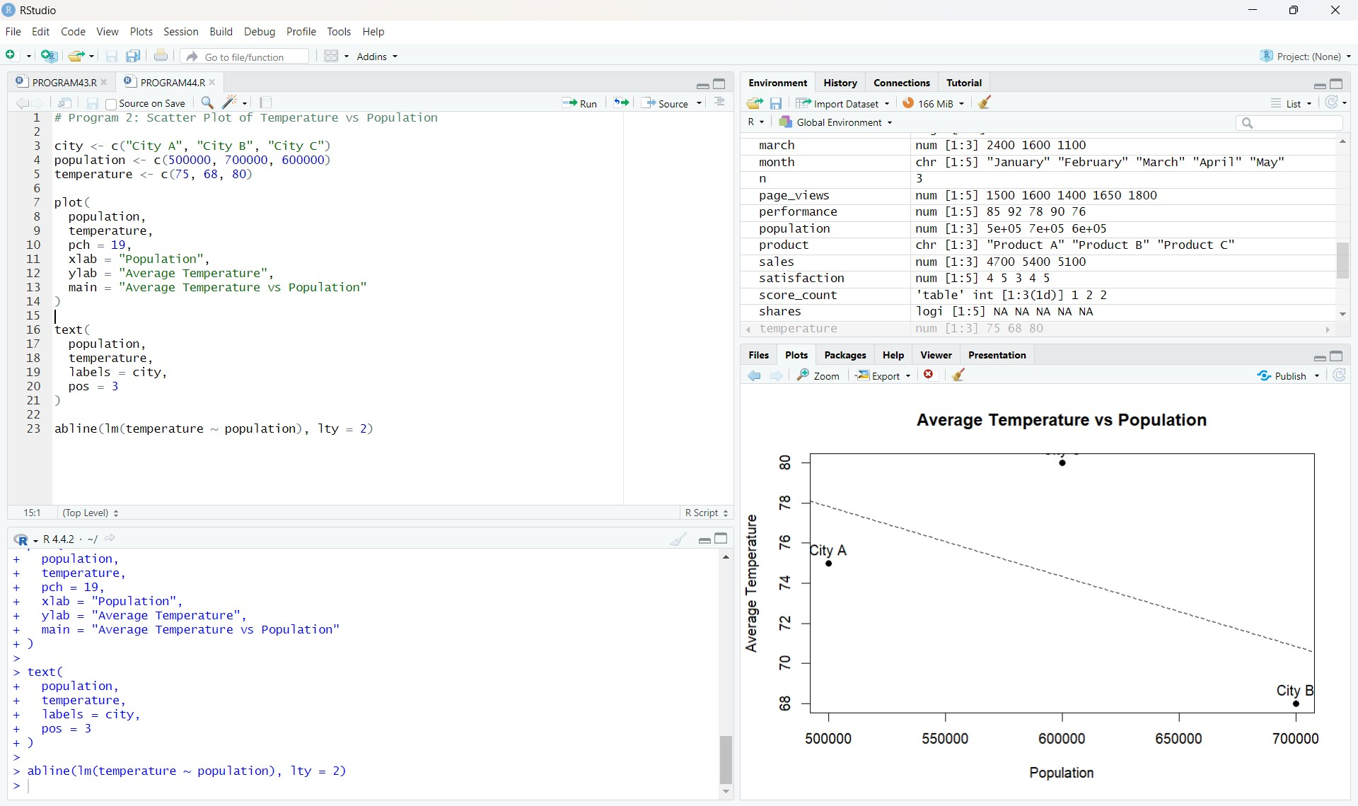

Output 2: Scatter Plot of Temperature vs Population
Observation: City C has the highest average temperature (80), while City B has the largest population (700000) and the lowest temperature (68).

PROGRAM 3: Geographic Data Table
Build a table to show the geographic data for each city. Label the table elements.
# Program 3: Geographic Data Table
geo_data <- data.frame(
City = c("City A", "City B", "City C"),
Population = c(500000, 700000, 600000),
Avg_Temperature = c(75, 68, 80),
Elevation = c(1000, 800, 1200)
)
print(geo_data)

Output 3: Geographic Data Table
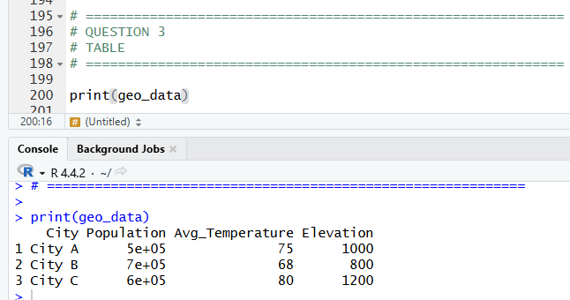
Observation: The table displays the three cities with their population, average temperature, and elevation values.

PROGRAM 4: Tableau Dashboard
Develop a Tableau dashboard combining the geographic data table and scatter plot for interactive exploration.
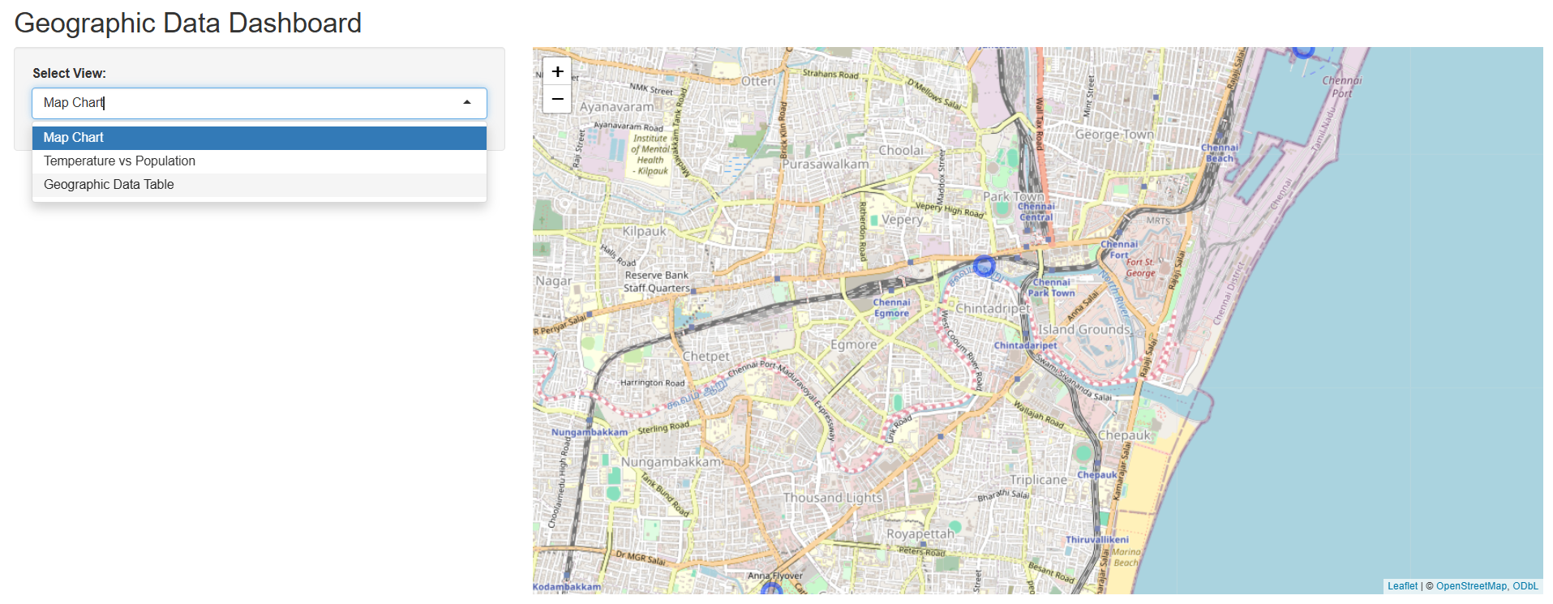

Output 4: Tableau Geographic Data Analysis Dashboard
Observation: The Tableau dashboard combines the geographic data table and the average temperature versus population scatter plot. The City filter can be used to explore the displayed data interactively.

Procedure
- Create the city, population, temperature, and elevation vectors in R.
- Create a data frame containing the geographic information.
- Use plot() and text() to generate and label the scatter plot.
- Use abline() to display the linear trend in the temperature versus population plot.
- Create and print the geographic data table using data.frame().
- Enter the geographic data into Tableau and create the required worksheets.
- Combine the table and scatter plot into a dashboard and add a City filter for interactive exploration.

Result
The geographic data was successfully visualized using a scatter plot and table in R. A simple Tableau dashboard was also created by combining the geographic data table and scatter plot for interactive exploration.

Key R Functions Used
Function | Purpose
data.frame() | Creates the geographic data table.
plot() | Creates the scatter plot.
text() | Labels the plotted cities.
abline() | Adds the linear trend line.
print() | Displays the geographic data.

