SIMATS ENGINEERING
SAVEETHA INSTITUTE OF MEDICAL AND TECHNICAL SCIENCES
Department | AIML
Course Code / Course Name | DSA0601 / Data Handling and Visualization
Experiment | Data Visualization using R and Tableau
Name | K.Akhileswara Reddy
Register Number | 192325068
Date | 08 October 2026
Day | Thursday
Set:14
Dataset: Survey Results
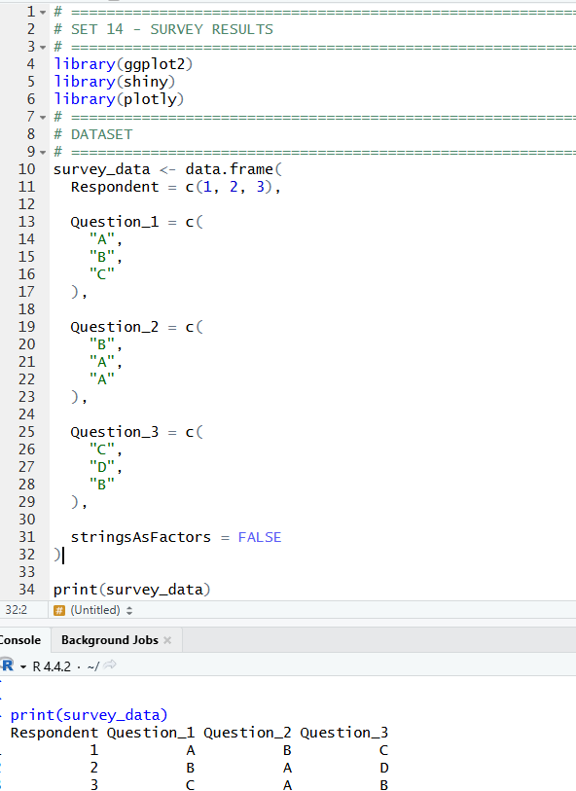
1. Create a stacked bar chart to display the distribution of answers for Question Label the chart elements.
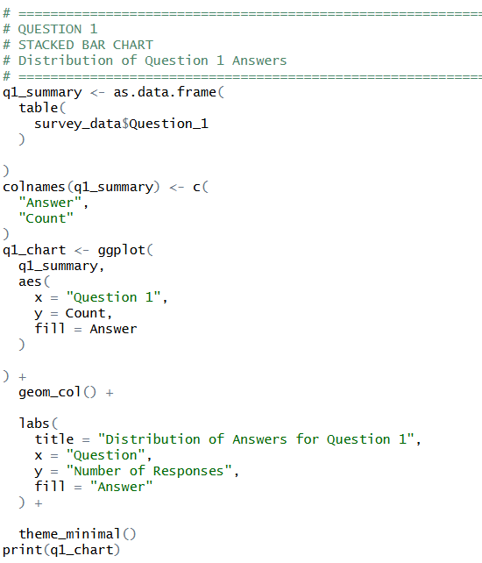
OUTPUT:
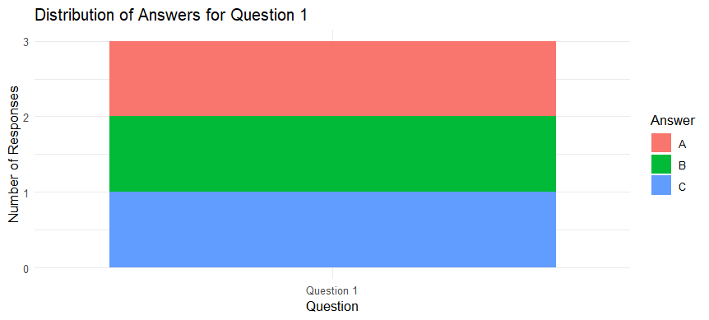

2. Generate a radar chart to visualize the overall pattern of responses across all three questions.
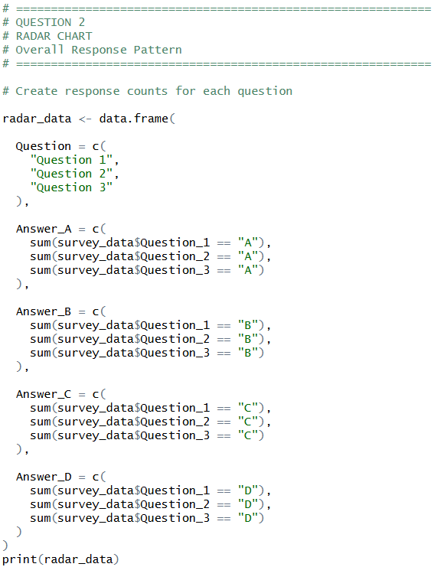
OUTPUT:
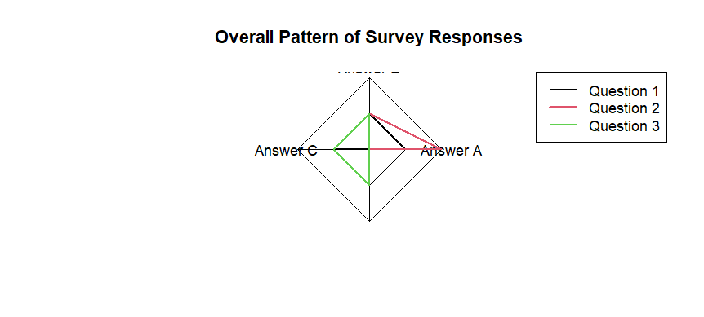

3. Build a table to show the survey response data for each respondent. Label the table elements.
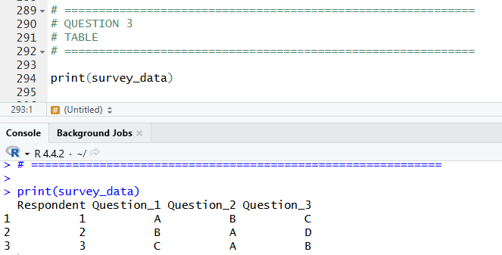

4. Develop a Tableau dashboard combining the stacked bar chart, radar chart, and the table for interactive exploration of survey responses.
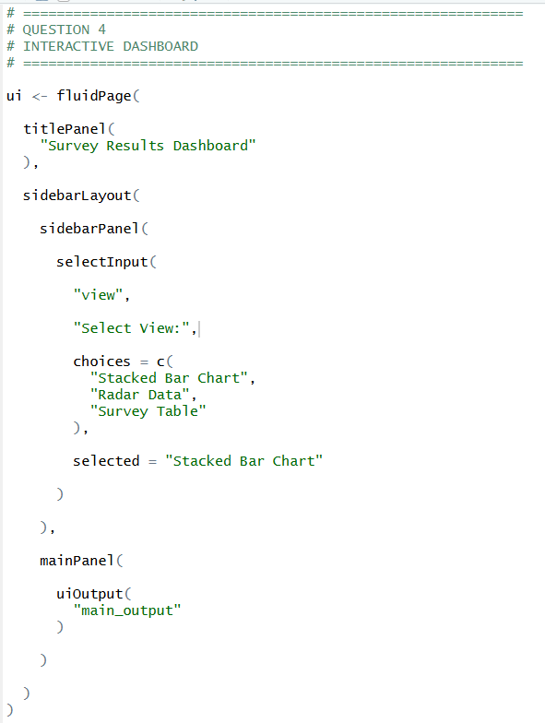
OUTPUT:
