SIMATS ENGINEERING
SAVEETHA INSTITUTE OF MEDICAL AND TECHNICAL SCIENCES
Department | AIML
Course Code / Course Name | DSA0601 / Data Handling and Visualization
Experiment | Data Visualization using R and Tableau
Name | K.Akhileswara Reddy
Register Number | 192325068
Date | 08 October 2026
Day | Thursday
Set 15: Product Sales Analysis
Dataset: Monthly Product Sales
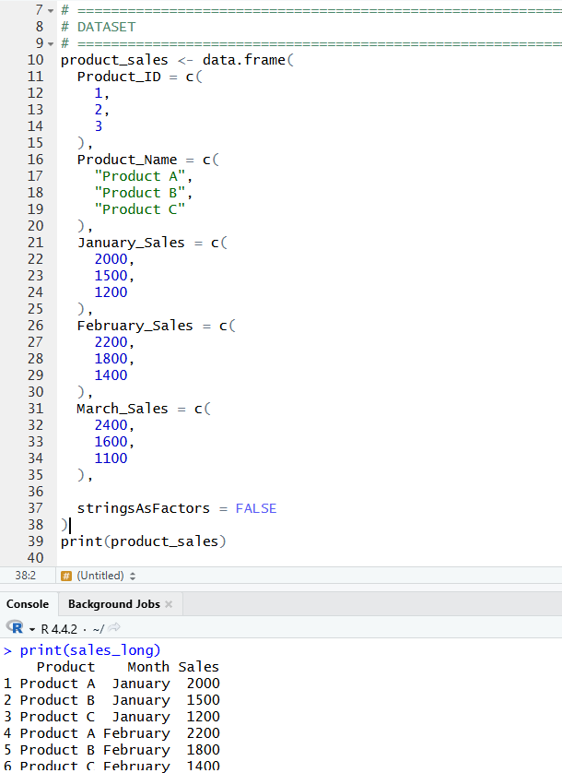
PROGRAM 1. Create a grouped bar chart to visualize the sales of each product for the first quarter. Label the chart elements.
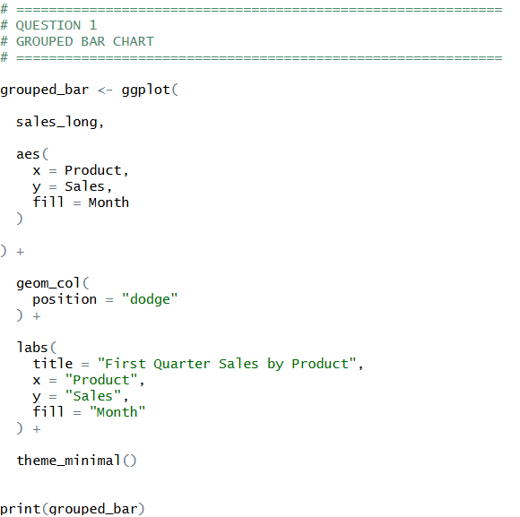
OUTPUT:
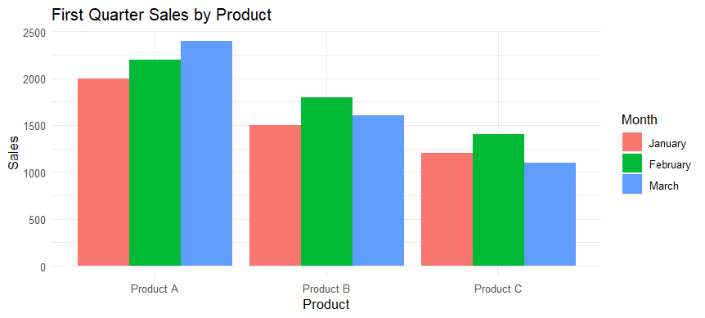

PROGRAM 2. Generate a stacked area chart to represent the overall sales trend for all products over the three months.
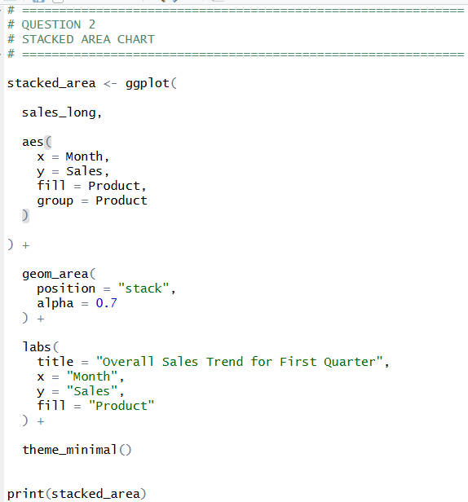
OUTPUT:
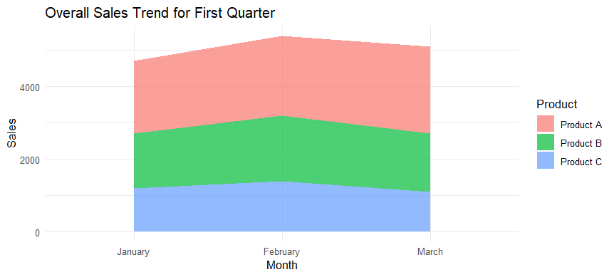

PROGRAM 3. Build a table to show the monthly sales data for each product. Label the table elements.
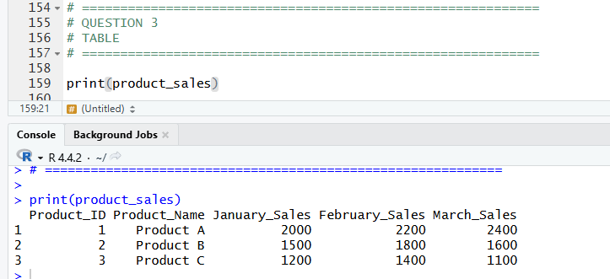

PROGRAM 4. Develop a Tableau dashboard combining the grouped bar chart, stacked area chart, and the table for interactive exploration of sales data.
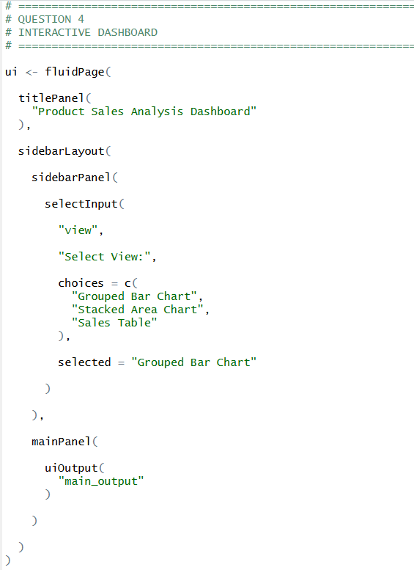
OUTPUT:
