LAB EXPERIMENT RECORD
Set 11: Product Category Analysis
Department | AIML
Course Code / Course Name | DSA0601 / Data Handling and Visualization
Experiment | Data Visualization using R and Tableau
Name | K.Akhileswara Reddy
Register Number | 192325068
Date | 06 October 2026
Day | Tuesday

Aim
To analyze product category sales using a funnel chart, tabular representation, Tableau dashboard, and pie chart, and to visualize the distribution of sales across product categories.
Dataset: Product Categories
Category | Sales (in $)
Electronics | 50000
Clothing | 35000
Appliances | 40000

PROGRAM 1: Funnel Chart for Product Category Sales
Generate a funnel chart to analyze the sales conversion process for each product category. Label the stages and title the chart.
# Program 1: Funnel Chart for Product Category Sales
category <- c("Electronics", "Clothing", "Appliances")
sales <- c(50000, 35000, 40000)
barplot(sales,
names.arg = category,
horiz = TRUE,
xlab = "Sales ($)",
main = "Product Category Sales Funnel",
col = "steelblue")

Output 1: Product Category Sales Funnel
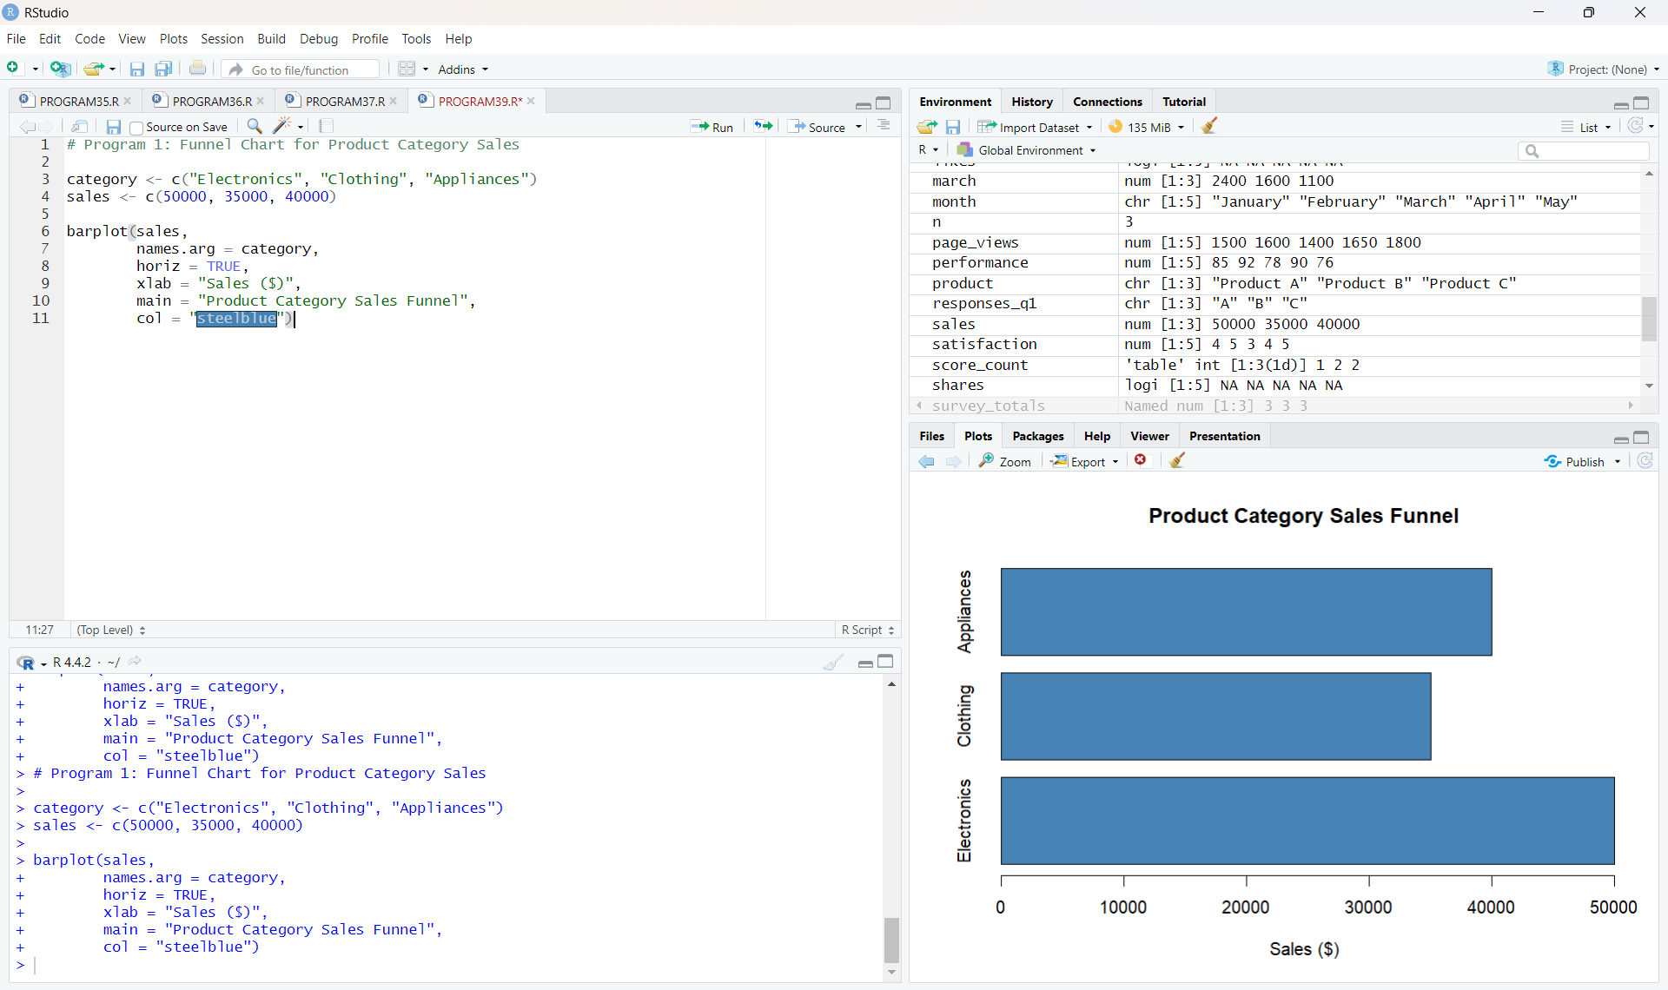
Output 1: Funnel Chart for Product Category Sales
Observation: The funnel-style horizontal bar chart compares sales across the three product categories. Electronics has the highest sales at $50,000, followed by Appliances at $40,000 and Clothing at $35,000.

PROGRAM 2: Product Category Sales Table
Build a table to display the sales data for each product category. Label the table elements.
# Program 2: Product Category Sales Table
product_data <- data.frame(
Category = c("Electronics", "Clothing", "Appliances"),
Sales = c(50000, 35000, 40000)
)
print(product_data)

Output 2: Product Category Sales Table
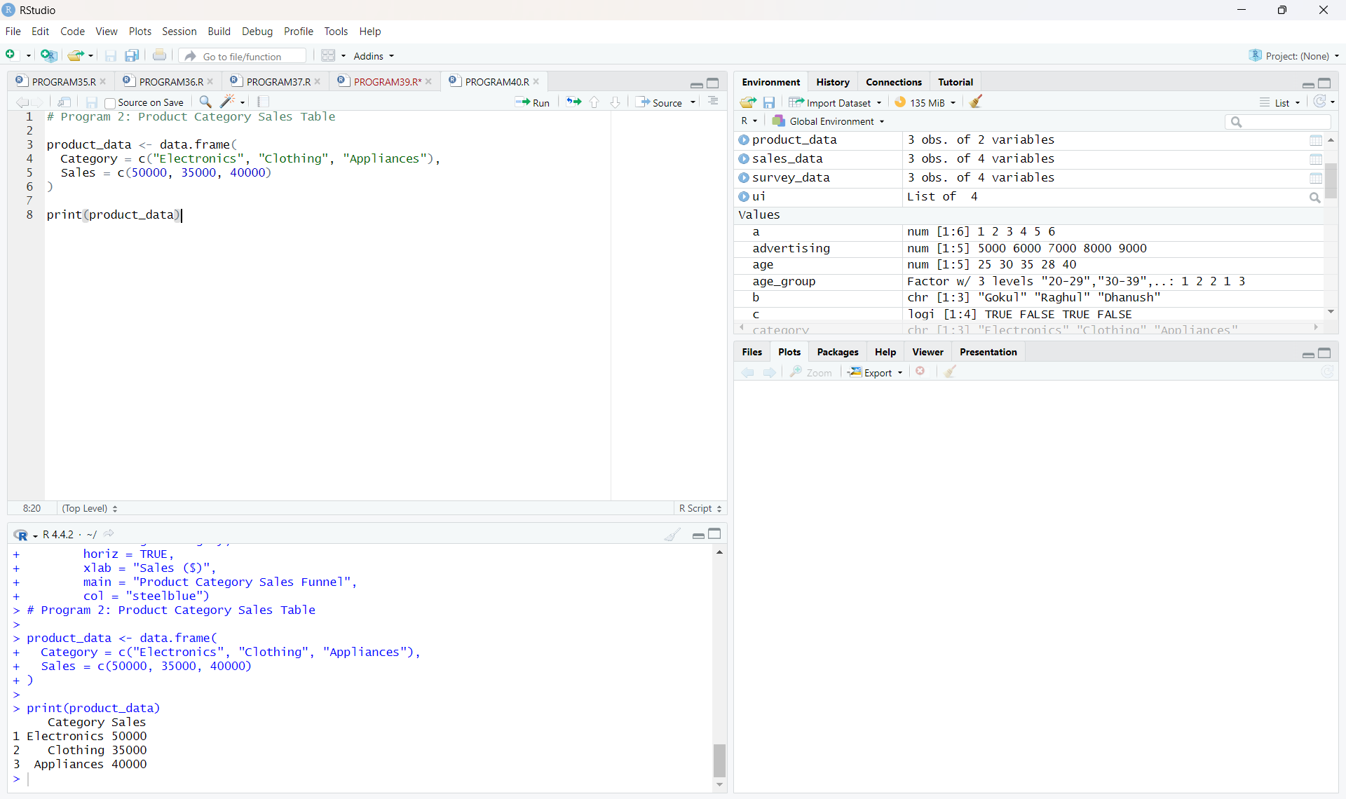
Output 2: Product Category Sales Table
Observation: The table clearly displays each product category and its corresponding sales value.

PROGRAM 3: Tableau Dashboard
Develop a Tableau dashboard combining the pie chart, funnel chart, and table for interactive exploration of product category data.
TABLEAU DASHBOARD STEPS
1. Enter the Product Categories dataset into Tableau Public.
2. Create a Sales Table worksheet using Category and Sales.
3. Create a Pie Chart using Category and Sales.
4. Create a Funnel Chart using Category and Sales as a horizontal bar chart.
5. Create a new dashboard and place the Sales Table, Pie Chart, and Funnel Chart together.
6. Add the Category filter for interactive exploration.
7. Set the dashboard title to "Product Category Analysis".

Output 3: Tableau Product Category Analysis Dashboard
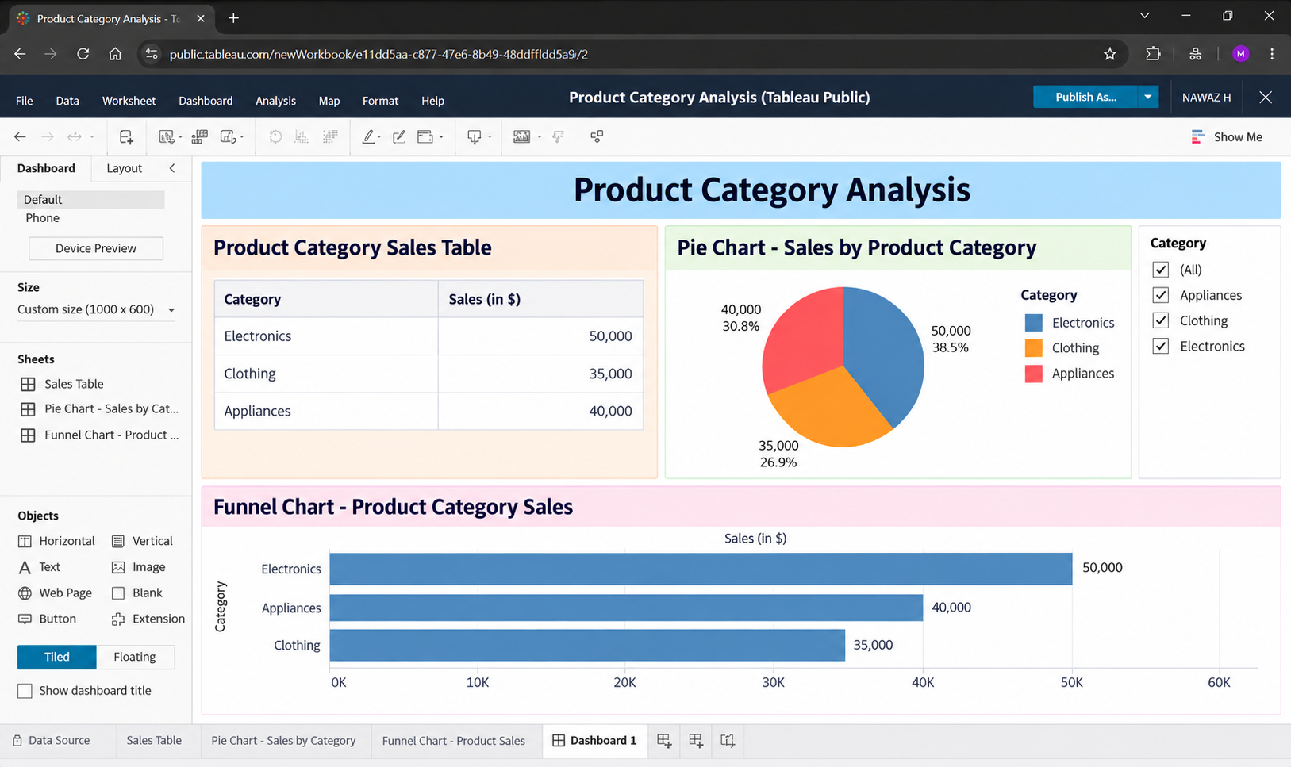
Output 3: Tableau Product Category Analysis Dashboard
Observation: The Tableau dashboard combines the sales table, pie chart, and funnel chart in one interactive view. The Category filter allows individual product categories to be explored.

PROGRAM 4: Pie Chart of Product Category Sales
Create a pie chart to represent the distribution of sales across product categories. Include labels.
# Program 4: Pie Chart of Product Category Sales
category <- c("Electronics", "Clothing", "Appliances")
sales <- c(50000, 35000, 40000)
pie(sales,
labels = category,
main = "Sales Distribution by Product Category",
col = c("skyblue", "orange", "lightgreen"))
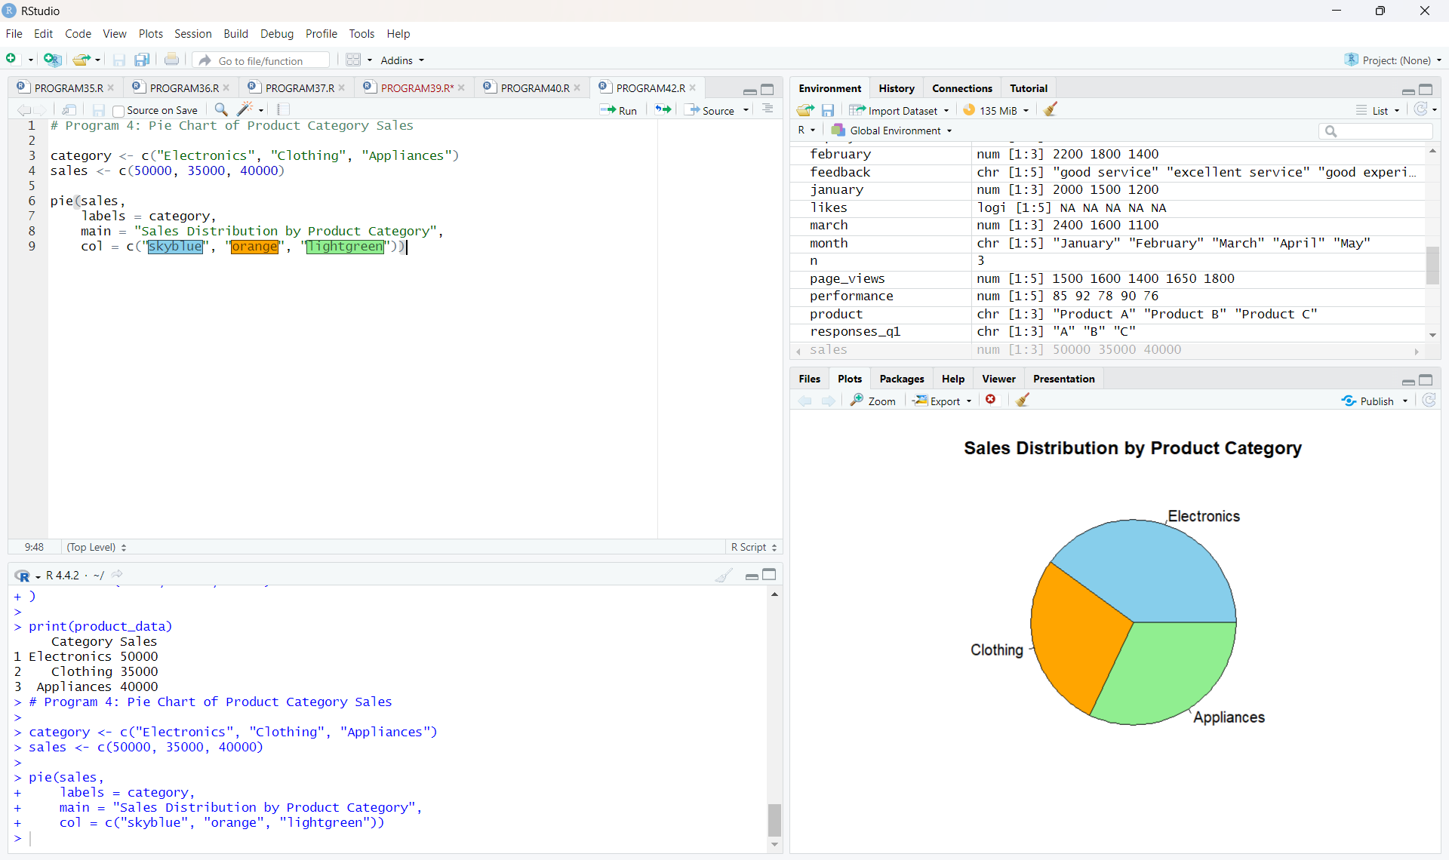
Output 4: Sales Distribution by Product Category
Observation: The pie chart shows the share of total sales contributed by each category. Electronics contributes 40.0%, Appliances 32.0%, and Clothing 28.0%.

Procedure
- Create the product category and sales vectors in R.
- Use barplot() with horizontal orientation to create the funnel-style product category sales chart.
- Create and print the product category sales table using data.frame().
- Enter the product category sales data into Tableau and create the Sales Table, Pie Chart, and Funnel Chart worksheets.
- Combine the Tableau worksheets into a dashboard, add the Category filter, and format the dashboard for interactive exploration.
- Create the pie chart in R using pie() and include category labels.
Result
The Product Category Analysis was successfully completed using R and Tableau. The sales data was represented through a funnel chart, table, interactive Tableau dashboard, and pie chart.
Key R Functions Used
Function | Purpose
barplot() | Creates the horizontal funnel-style sales chart.
data.frame() | Creates the product category sales table.
pie() | Creates the pie chart for sales distribution.
print() | Displays the product category sales data.

