LAB EXPERIMENT RECORD
06-10-2026---Set 12: Website Traffic Analysis
Department | AIML
Course Code / Course Name | DSA0601 / Data Handling and Visualization
Experiment | Data Visualization using R and Tableau
Name |  | K.Akhileswara Reddy
Register Number |  | 192325068
Date |  | 06 OCTOBER 2026
Day | TUESDAY

Aim
To analyze website traffic data using a line chart, bar chart and table, and to build an interactive Tableau dashboard for exploring website traffic.

Dataset: Website Traffic
Date | Page Views | Click-through Rate
2023-01-01 | 1500 | 2.3%
2023-01-02 | 1600 | 2.7%
2023-01-03 | 1400 | 2.0%

Question 1: Line Chart of Daily Page Views
Question: Create a line chart to visualize the trend in daily page views over time. Label the axes and title the chart.
Aim: To visualize the trend in daily page views over time using a line chart with labelled axes and a title.

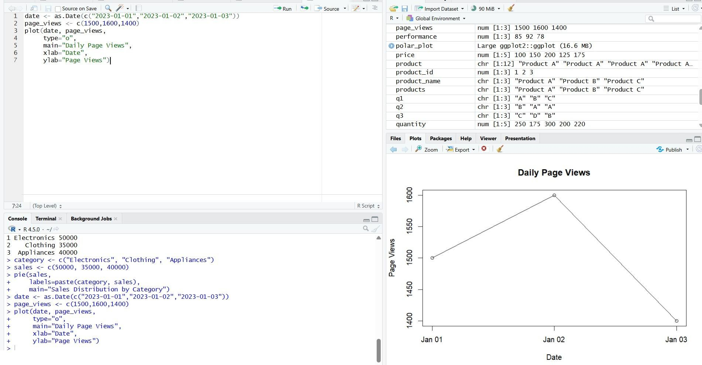
Result: Page views rise from 1500 to a peak of 1600 on 2023-01-02, then fall to the lowest value of 1400 on 2023-01-03.

Question 2: Bar Chart of Top N Days by Click-through Rate
Question: Generate a bar chart showing the top N days with the highest click-through rates. Label the chart elements.
Aim: To identify the top N days with the highest click-through rates using a labelled bar chart.

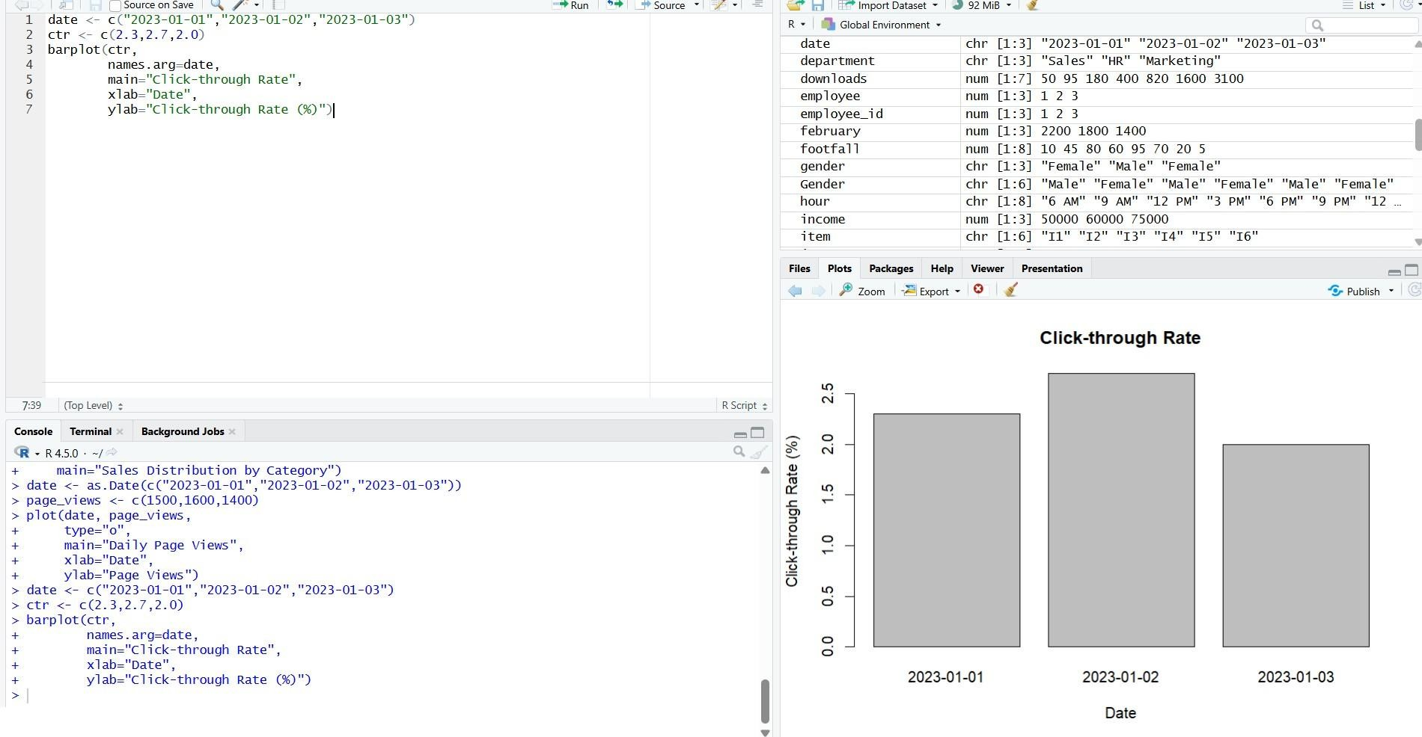
Result: For N = 2, 2023-01-02 ranks first (2.7%) and 2023-01-01 second (2.3%), while 2023-01-03 has the lowest rate (2.0%).

Question 3: Table of Website Traffic
Question: Build a table to show the website traffic data for each day. Label the table elements. Aim: To present the page views and click-through rate of each day in a clearly labelled table.

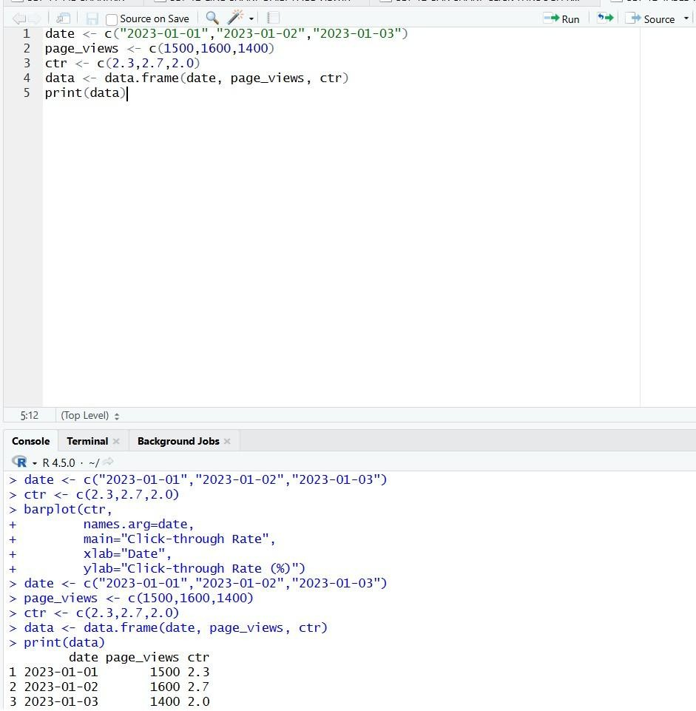

Result: The table lists the three days with their page views and click-through rates; 2023-01-02 is highest in both.

Question 4: Interactive Tableau Dashboard
Question: Develop a Tableau dashboard combining the line chart, bar chart, and the table for interactive exploration of website traffic data.

Aim: To build an interactive Tableau dashboard that combines the line chart, bar chart and table for exploring website traffic data.
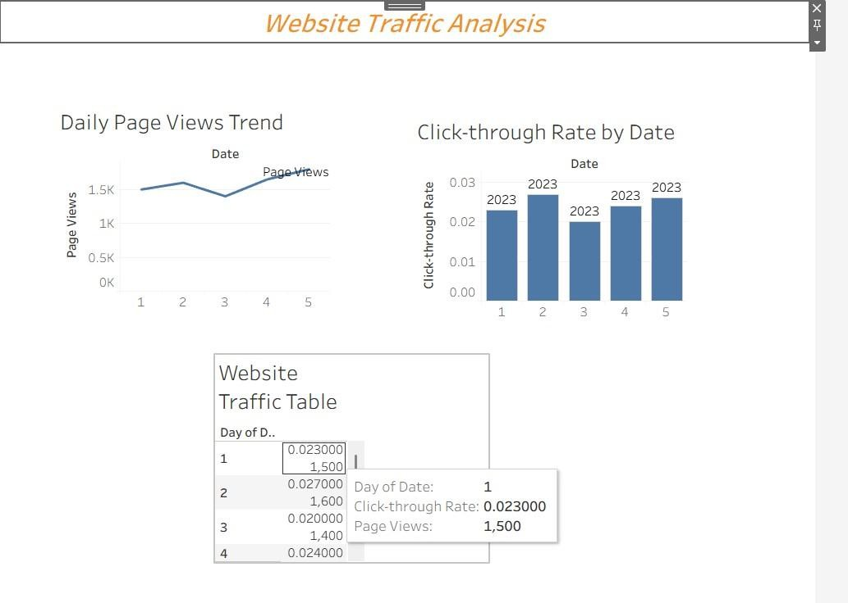
Result: The dashboard places all three views together, and a date filter updates them so users can explore the traffic interactively.

Overall Result
Observation: The average page views are 1500 per day and the average click-through rate is about 2.3%, with 2023-01-02 the best day for both.

