DSA0601 • DATA HANDLING AND VISUALIZATION

Course Details | Information
Department | AIML
Course Code / Course Name | DSA0601 / Data Handling and Visualization
Programming / Visualization Tools | R
Student Name | K.Akhileswara Reddy
Register Number | 192325068
Date | 01-10-2026

SET 4: PRODUCT INVENTORY MANAGEMENT
DSA0601 • DATA HANDLING AND VISUALIZATION
Experiment: Product Inventory Management

Aim
To visualize product inventory quantities using a bar chart and stacked bar chart, explore the relationship between product price and quantity available using a scatter plot, and develop a Tableau dashboard for interactive exploration.

Dataset: Product Inventory
Product ID | Product Name | Quantity Available
1 | Product A | 250
2 | Product B | 175
3 | Product C | 300
4 | Product D | 200
5 | Product E | 220

PROGRAM 1: Bar Chart of Product Inventory
Create a bar chart to visualize the quantity of each product in the inventory. Label the axes and title the chart.
product <- c("Product A", "Product B", "Product C", "Product D", "Product E")
quantity <- c(250, 175, 300, 200, 220)
barplot(quantity,
names.arg = product,
xlab = "Product",
ylab = "Quantity Available",
main = "Product Inventory Quantity",
col = "skyblue")
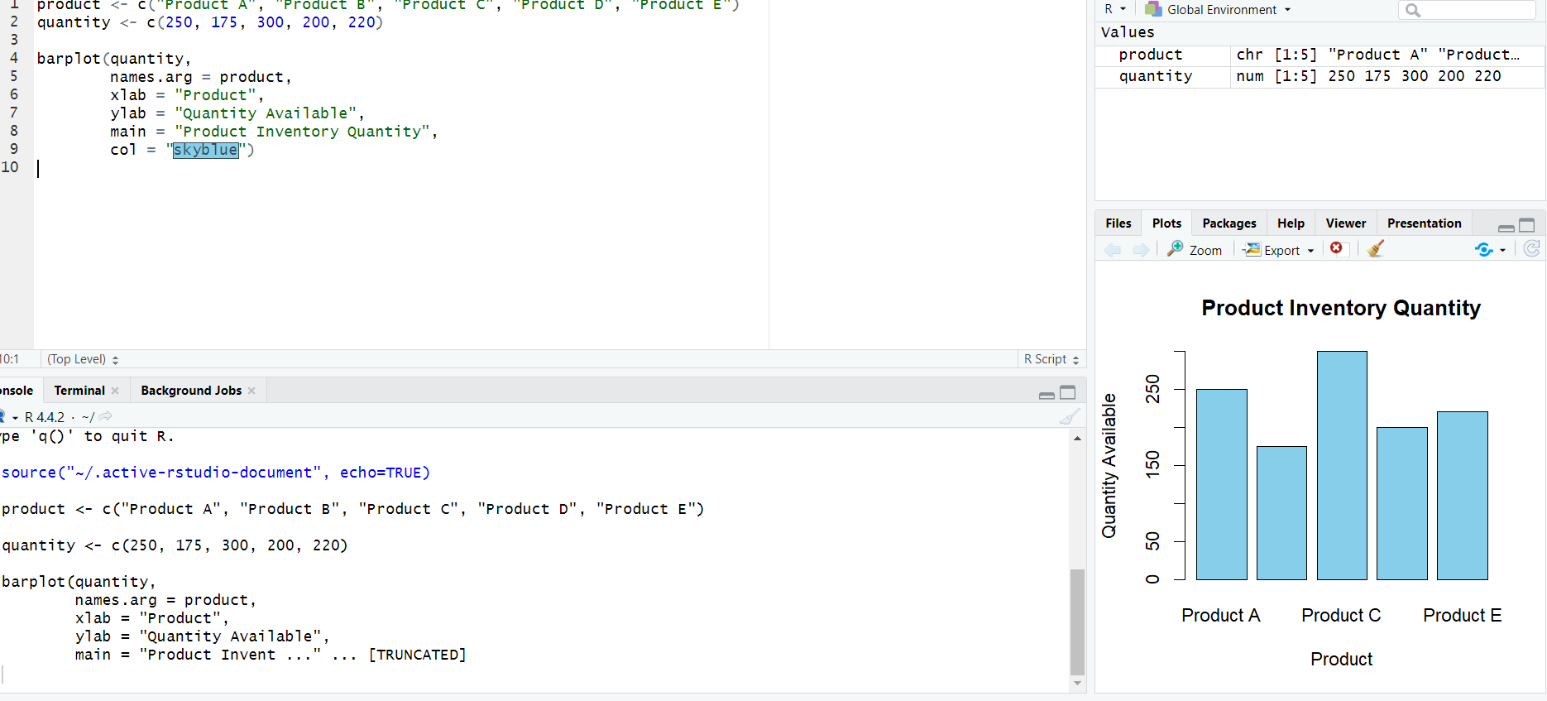Observation: Product C has the highest quantity available (300 units), while Product B has the lowest (175 units).

PROGRAM 2: Stacked Bar Chart by Product Category
Generate a stacked bar chart to show the quantity of each product within different product categories.
product <- c("Product A", "Product B", "Product C", "Product D", "Product E")
quantity <- c(250, 175, 300, 200, 220)
# Illustrative categories because the dataset has no category column
category <- c("Category 1", "Category 1", "Category 2",
"Category 2", "Category 1")
inventory <- xtabs(quantity ~ category + product)
barplot(inventory,
beside = FALSE,
main = "Inventory Quantity by Product Category",
xlab = "Product",
ylab = "Quantity Available",
legend.text = TRUE,
col = c("skyblue", "lightgreen"))
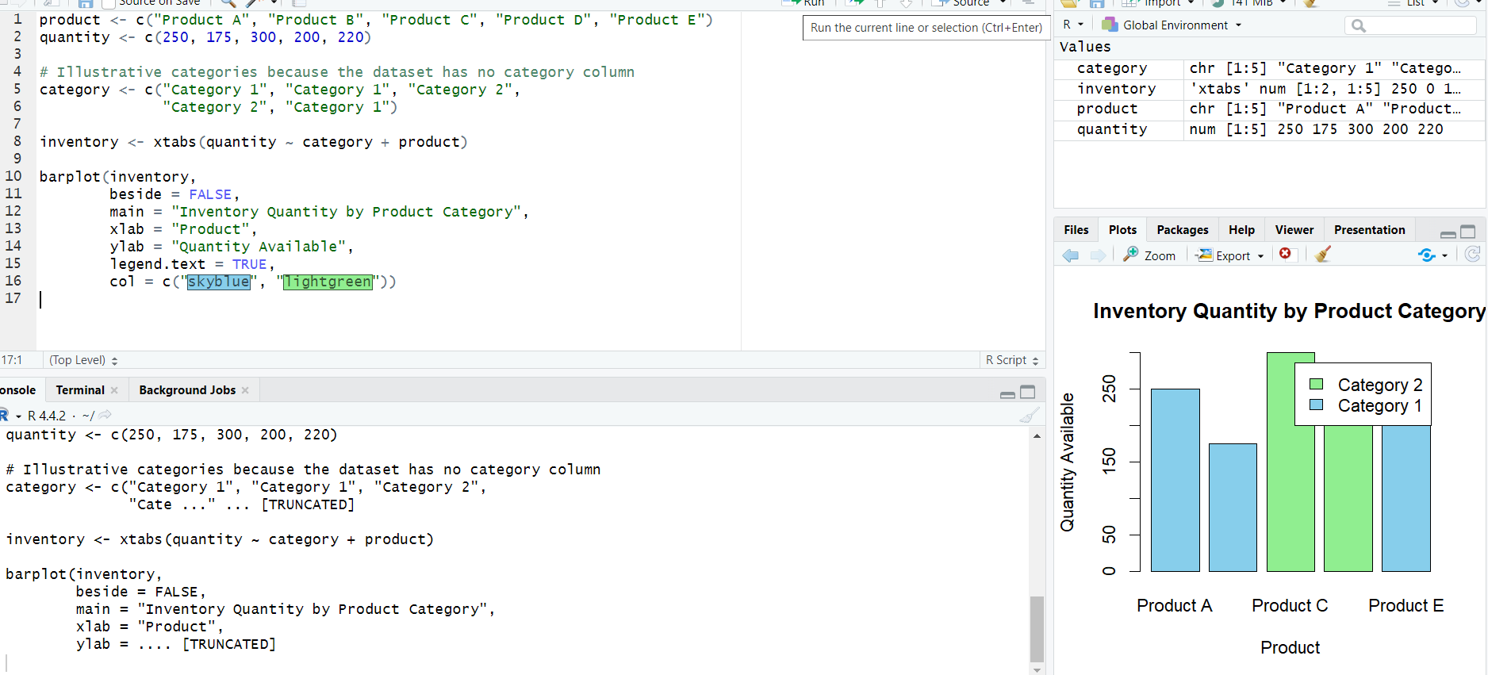Observation: The chart separates inventory quantities by category. The category assignments are illustrative because product categories were not provided.
Data Note: The supplied dataset does not contain a Product Category column. Replace the illustrative categories with actual category data when available.

PROGRAM 3: Scatter Plot of Product Price vs Quantity Available
Build a scatter plot to explore the relationship between product price and quantity available. Explain the findings.
product <- c("Product A", "Product B", "Product C", "Product D", "Product E")
quantity <- c(250, 175, 300, 200, 220)
# Illustrative prices because price is not provided
price <- c(50, 70, 40, 60, 55)
plot(price, quantity,
pch = 19, col = "red",
main = "Product Price vs Quantity Available",
xlab = "Product Price ($)",
ylab = "Quantity Available")
text(price, quantity, labels = product, pos = 3, cex = 0.8)
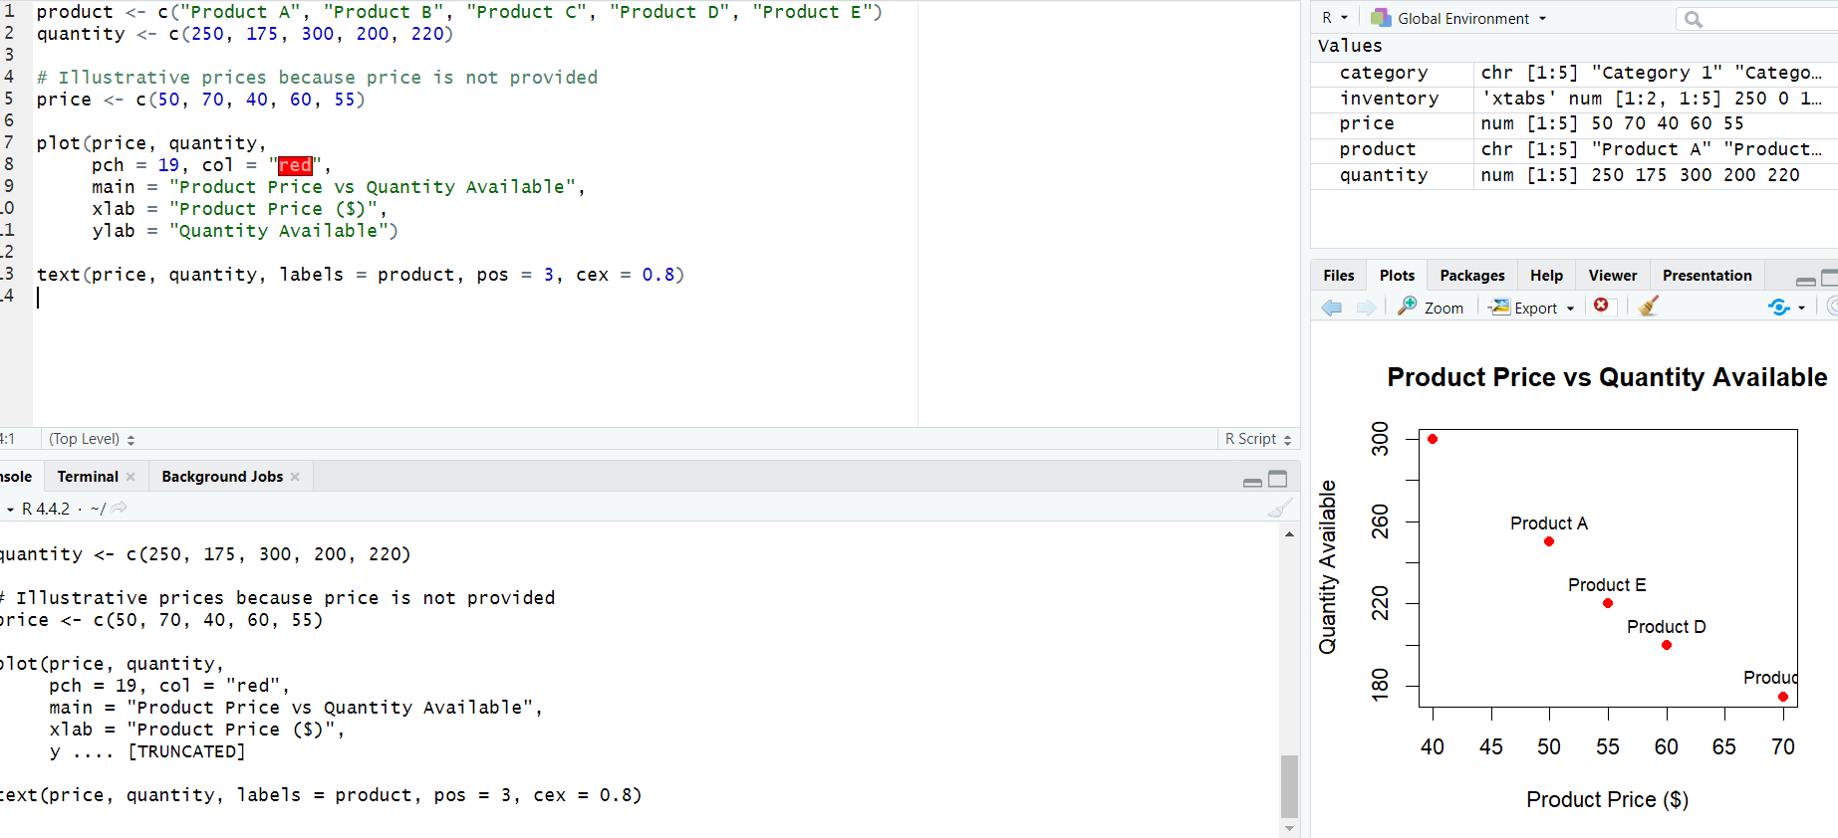Since actual prices were not supplied, the illustrative values should not be used for a real business conclusion.
Data Note: Product Price is not included in the supplied dataset. The prices in the program are illustrative and should be replaced with actual prices.

PROGRAM 4: Tableau Dashboard for Product Inventory
Develop a Tableau dashboard with the bar chart and stacked bar chart to allow users to interact with the data.
TABLEAU WORKFLOW
1. Connect Tableau to the Product Inventory dataset.
2. Worksheet 1 – Inventory Bar Chart:
• Product Name → Columns
• Quantity Available → Rows
• Enable data labels.
3. Worksheet 2 – Stacked Bar Chart:
• Product Name → Columns
• Quantity Available → Rows
• Product Category → Color
• Keep the bars stacked.
• Enable data labels.
4. Create a new Dashboard and place both worksheets on it.
5. Add Product Name and Product Category filters.
6. Add dashboard actions for filtering or highlighting.
7. Add a dashboard title and save the Tableau workbook.
Observation: The dashboard combines product-level inventory and category-wise composition, allowing users to filter and explore the inventory interactively.

Procedure
- Create vectors for product names and quantities from the given dataset.
- Use barplot() to visualize the quantity available for each product.
- Create product-category data and a category-by-product quantity table for the stacked bar chart.
- Use product price and quantity data to create the scatter plot.
- Create the inventory bar chart and stacked bar chart in Tableau.
- Combine both worksheets into a dashboard and add filters or dashboard actions.

Result
The product inventory data was visualized using a bar chart, stacked bar chart, and scatter plot. A Tableau dashboard was developed to combine the inventory charts for interactive exploration.

Key Functions / Tools Used
Function / Tool | Purpose
barplot() | Creates bar and stacked bar charts.
xtabs() | Creates a category-by-product quantity table.
plot() | Creates the scatter plot.
text() | Adds product labels to scatter-plot points.
Tableau | Creates interactive worksheets and dashboards.
Filters / Dashboard Actions | Enable interactive data exploration.

