EXPERIMENT-2
Aim
To develop a simple Flight Reservation System using Zoho Creator SaaS platform for booking and managing flight reservations online.
Software Used
- Zoho Creator
- Web Browser (Chrome/Edge)
- Zoho Cloud Platform
Algorithm
- Open Zoho Creator.
- Create a new application named Flight Reservation System.
- Create a form with fields:
  - Passenger Name
  - Flight Number
  - Source
  - Destination
  - Travel Date
  - Seat Class
  - Email
  - Phone Number
- Enter passenger details.
- Click Submit to book the ticket.
- Store reservation details in the cloud database.
- Display booking confirmation and reservation records.
Output:

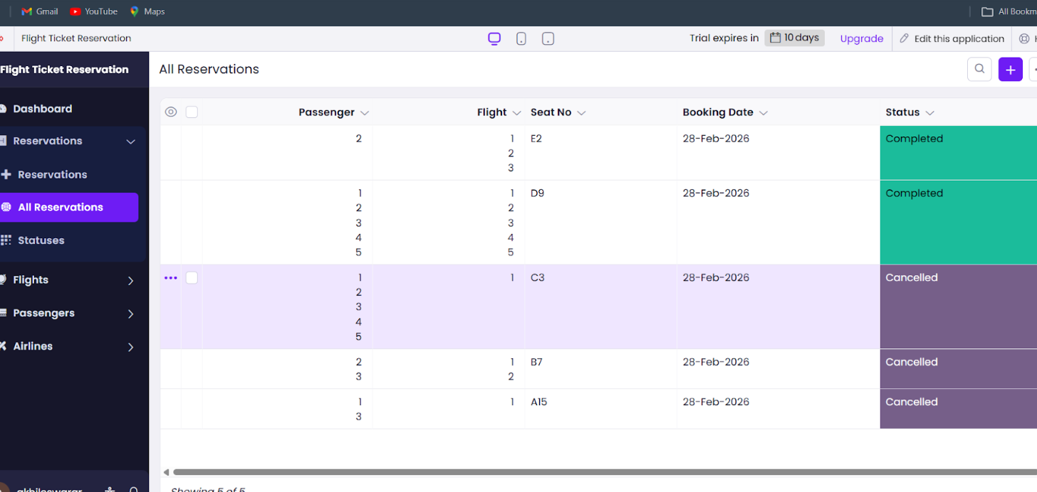

Result
The Flight Reservation System was successfully developed using Zoho Creator SaaS workflow. The system allows users to book flights, store reservation details in the cloud, and view booking confirmations online.

