EXPERIMENT-1
Aim
To create a simple cloud-based Student Management System using Zoho Creator to store and manage student details online.
Software Used
- Zoho Creator
- Web Browser (Chrome/Edge)
- Zoho Cloud Platform
Algorithm
- Open Zoho Creator.
- Create a new application.
- Create a form with fields:
  - Student Name
  - Student ID
  - Department (Dropdown)
  - Year
  - Email
  - Phone
- Enter student details.
- Click Submit.
- Store data in the cloud database.
- Display saved records in a report.
Output:
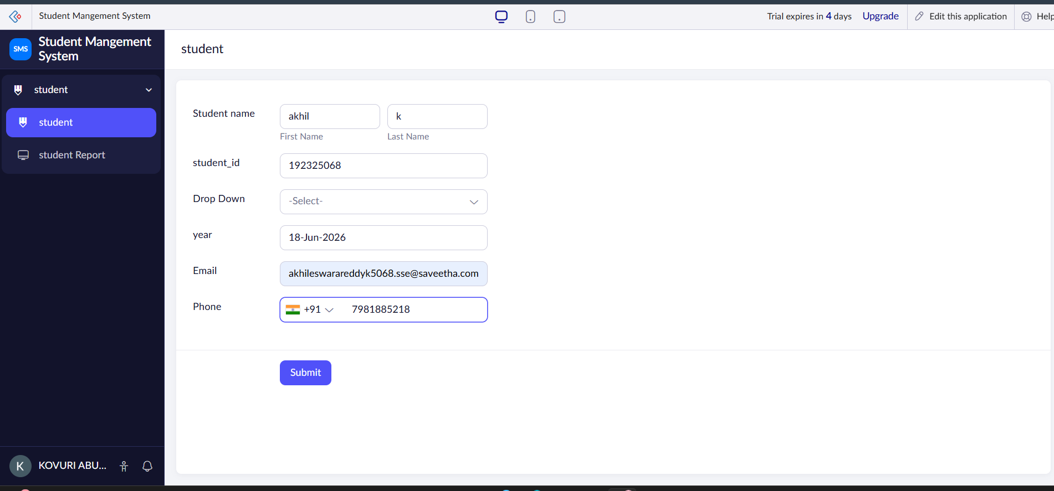

Result
The Student Management System was successfully created and tested in Zoho Creator. Student records can be stored and accessed online through the cloud.

