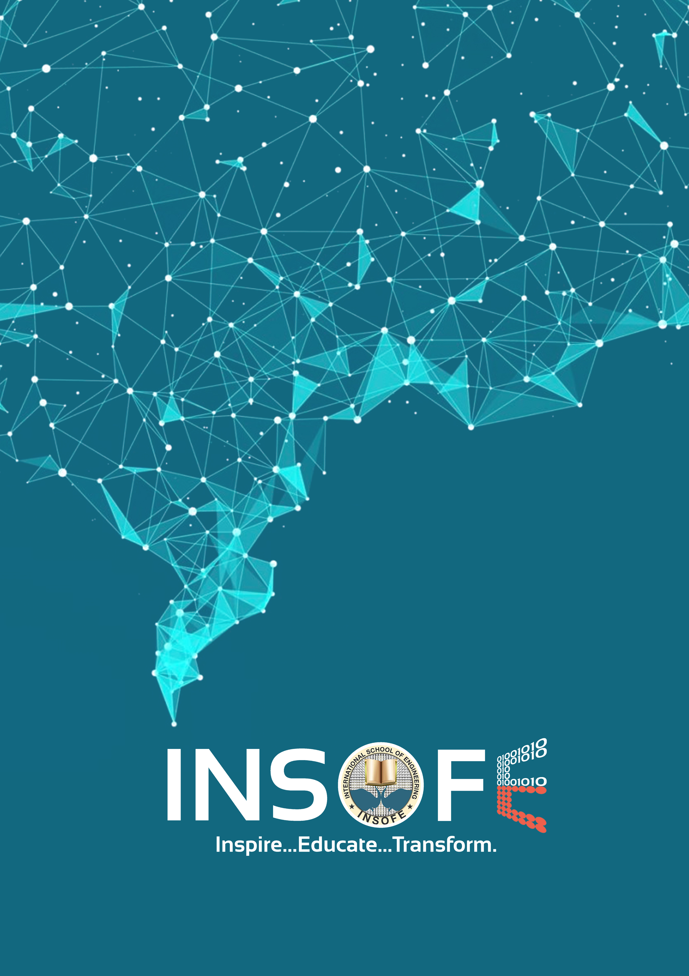**LOGO RELEVANCE**

**LOGO RELEVANCE**

**Abstract**

A logo can be described as the face of a company.  Quite often, it’s the first thing that a potential customer will notice about a business. A logo is much more than just an image; it is a point of recognition for clients and an important foundation for the branding of the company. A well-designed logo is an easy way to convey to potential customers that your business is professional, trustworthy, and provides quality goods or services. A logo should be distinctive enough to be easily recognized and simple enough to work across multiple media. A good logo is memorable and makes a great first impression. It should be effective at any size – whether it’s on a billboard or on a pen.

With logos, details are extremely important. Particular attention must be paid to every element of the logo, including colors, shapes and fonts. All of these elements help to convey a message about your brand. The visuals and imagery should be appropriate for a company to avoid any discrepancies or confusion. All colors, shapes, images and fonts must be consistent with the idea that is to be communicated. It’s very important that the logo delivers the correct message about a company.

Every enterprise tries to bud & shape them into the best form of themselves. In the process of ingraining in a sector, they are represented not only by their professional accomplishments, but also by their ‘Brand Logo’. The course of creating logo for any corporate body requires a lot of effort, as they should not resemble any other famous brand in one or other sense. So, this project helps the

logo-designers to reduce their burden in the process of building an ideal logo for any corporate enterprise.

**Aim**

The project aims in reducing the hardship of a Brand/Logo-Designer, by providing them the ease of composing a Brand/Emblem. So, in the end Logo-designer’s effort for creating a logo with this tool will be as minimal as possible.

**About the Company**

--[Project is for Internal Purpose]--

**Impact We Made**

* It was very useful for the clients [Brand/Logo designers, Marketing Teams] who are new to the industry and trying to create a recognition.
* Helped to cross-check their effort in designing a logo by providing the relevance of the logo they’ve designed versus the logos of prominent and influential players in the business industry.
* Prediction was done based on the test image. Though the process of creating the best logo for a corporate association is not pretty straight forward. They can take the leverage of this application, by iteratively cross-checking the generated idea, and refine it to the sophisticated level.

**Challenges Faced:**

* The first and most prominent challenge we have faced was the gathering the images by performing web scraping, as we aimed to build the model on diverse set of logos/Images.
* After the process of the logo’s collection converged. The set of critical hardships faced were:
  + Corrupted Images: Out of the images we have arranged for every logo, certain portion of them were corrupted images, they were not readable by the model.
  + Irrelevant/Noise Images:
    - There were some insignificant images for every class of the downloaded logo’s.
    - It’s hard to manually check all the noise images in every class and abolish them.
  + Deviation in the Image Size: Every image is of different size, which added an additional step of including a script for re-sizing the images in our work-flow.
  + Old vs New: This is a peculiar type of dis-comfort in this project. As the downloaded images contains the old and current logos of the same company, which made the process a bit tough to generalize well for all sorts of logos.
* Retaining the structure of the ‘images’ and ‘class name’ in the implementation, similar to how they were accommodated in the folder [After downloading].
* A major trouble in the implementation which lured a major portion of the time is getting the data into the appropriate shape for the model to process.
* To train the model on this diverse dataset is another crucial difficulty, as the training took a significant amount of time.

**The Approach:**

* Developed a Dynamic Logo-Relevance Model using Deep-Learning techniques from the Logos data.
* Given a new logo as test, the model predicts how relevant the test image is w.r.t the images in the training dataset.
* Enhanced the algorithm by adding multiple convolutional layers and scaling it to the size of the dataset, i.e size of the dataset could be ‘dynamic’ – any number of classes can be created on the go and run the model on that dataset.

**Results and Analysis:**

* Train data: No result for the Train Data.
* Test Data: The output for the Test Data Image is that the model predicts how relevant, i.e (probability of the test image w.r.t to an class in the train data x 100) – resulting the ‘Percentage of Relevance’ of the test image.

**Our Deliverable**

* Our deliverable is a Tool/Package of following mechanisms:
  + User-Interface: A UI for providing the Input [Test Image] to the Model. We have used the following components for creating the UI:
    - ‘Flask’ framework.
    - HTML
    - Java Script
  + Internal Mechanism: Code for the Plug-ins. Collecting the input from the UI and provide to the Convolutional Neural Model.
* Delivered the application for predicting single Test Image.
* Output:

