**CODEBIN**

**A PROJECT REPORT**

**for**

**Mini Project KCA353**

**Session 2023-24**

**Submitted by**

**Akhil Singh Chauhan**

**2200290140020**

**Submitted in partial fulfillment of the**

**Requirements for the Degree of**

**MASTER OF COMPUTER APPLICATION**

**Under the Supervision of**

### Ms. Divya Singhal

**Associate Professor**



**Submitted to**

**Department Of Computer Applications**

**KIET Group of Institutions, Ghaziabad**

**Uttar Pradesh-201206**

**(2023-2024)**

**CERTIFICATE**

Certified that **Akhil Singh Chauhan 220029014009019** has/ have carried out the project work having “**CODEBIN**” (**Mini Project-KCA353**) for **Master of Computer Application** from Dr. A.P.J. Abdul Kalam Technical University (AKTU**)** (formerly UPTU), Lucknow under my supervision. The project report embodies original work, and studies are carried out by the student himself/herself and the contents of the project report do not form the basis for the award of any other degree to the candidate or to anybody else from this or any other University/Institution.

**Date:**

**Akhil Singh Chauhan 2200290140020**

This is to certify that the above statement made by the candidate is correct to the best of my knowledge.

Date:

**Dr. Sangeeta Arora Dr. Arun Tripathi**

**Associate Professor Head**

**Department of Computer Applications Department of Computer Applications**

**KIET Group of Institutions, Ghaziabad KIET Group of Institutions, Ghaziabad**

**ABSTRACT**

This project aims to replicate the fundamental features of Pastebin.com, a widely used web-based text-sharing platform. The implemented system provides users with the ability to create, share, and manage text snippets with advanced functionalities such as syntax highlighting, privacy settings, and expiration options. Users can register accounts, allowing for secure paste management and editing capabilities. The platform supports various programming languages through syntax highlighting libraries, enhancing the readability of shared code snippets. Privacy settings enable users to choose between public, unlisted, and private paste visibility, while an expiration management system ensures the automatic removal of pastes after specified time intervals. The user interface is designed to be intuitive, offering a seamless experience for paste creation, editing, and viewing. Additional features include search functionality, API integration, notifications, analytics, and legal considerations. The project utilizes modern web technologies, employing a robust backend framework, a reliable database system, and a responsive frontend framework. The replication adheres to security standards, implementing measures such as rate limiting to prevent abuse. This project serves as a comprehensive exploration of web development principles, encompassing user authentication, data management, and feature-rich user interfaces.

**ACKNOWLEDGEMENTS**

Success in life is never attained single-handedly. My deepest gratitude goes to my project supervisor, **Ms. Divya Singhal** for her guidance, help, and encouragement throughout my project work. Their enlightening ideas, comments, and suggestions.

Words are not enough to express my gratitude to **Dr. Arun Kumar Tripathi**, Professor and Head, Department of Computer Applications, for his insightful comments and administrative help on various occasions.

Fortunately, I have many understanding friends, who have helped me a lot on many critical conditions.

Finally, my sincere thanks go to my family members and all those who have directly and indirectly provided me with moral support and other kind of help. Without their support, completion of this work would not have been possible in time. They keep my life filled with enjoyment and happiness.

**Akhil Singh Chauhan**

**TABLE OF CONTENTS**

|  |  |  |  |
| --- | --- | --- | --- |
|  | Certificate | | i |
|  | Abstract | | ii |
|  | Acknowledgements | | iii |
|  | Table of Contents | | iv |
| 1. | Introduction | | 5-11 |
|  | 1.1 | Background and Motivation | 5 |
|  | 1.2 | Objectives and Goals | 6 |
|  | 1.3 | Scope and Limitations | 9 |
| 2 | Literature Overview | | 12-17 |
|  | 2.1 | Review of Existing Text-Sharing Platforms | 13 |
|  | 2.2 | Overview of Technologies and Frameworks | 14 |
|  | 2.3 | Relevant Literature on Web Development and Security | 15 |
| 3 | Requirement Analysis | | 18-21 |
|  | 3.1 | Introduction | 18 |
|  | 3.2 | Functional Requirements | 18 |
|  | 3.3 | Non Functional Requirements | 19 |
|  | 3.4 | Use Case Diagram | 21 |
| 4 | System Design | | 22-26 |
|  | 4.1 | Architecture and System Overview | 22 |
|  | 4.2 | Database Design | 23 |
|  | 4.3 | ER Diagram | 24 |
|  | 4.4 | Data Flow Diagram | 25 |
| 5 | Implementation | | 27-30 |
|  | 5.1 | Tech Stack | 27 |
|  | 5.2 | Challenges | 28 |
|  | 5.3 | Code Snippets | 28 |
| 6 | Testing | | 31-33 |
|  | 6.1 | Testing Methodologies | 31 |
|  | 6.2 | Test Cases | 33 |
| 7 | Conclusion | | 34-35 |
| 8 | References | | 36 |

**CHAPTER 1**

**INTRODUCTION**

In the ever-evolving landscape of digital collaboration and information sharing, the creation of innovative and user-centric platforms has become pivotal. This project takes its roots in the dynamic realm of collaborative text sharing, drawing inspiration from the venerable Pastebin.com. Launched in 2002, Pastebin.com has been a stalwart in the online text-sharing domain, offering a straightforward yet powerful platform for users to create, share, and discuss textual snippets. Its impact has been transformative, providing a space where lines of code, written content, and diverse textual information converge.

The motivation behind this project is deeply rooted in the recognition of the transformative role that platforms like Pastebin.com play in the digital ecosystem. As technology continually redefines the way we communicate, collaborate, and share information, there is an ever-growing need for platforms that facilitate seamless text exchange. This project aims not only to replicate the core functionalities of Pastebin.com but also to innovate and elevate the text-sharing experience.

**1.1 BACKGROUND AND MOTIVATION**

The landscape of online collaboration and information sharing has undergone profound transformations, and at the heart of this evolution lies the venerable Pastebin.com. Established in 2002, Pastebin.com has not merely been a platform; it has been a catalyst for a paradigm shift in how users share, discuss, and collaborate on textual information. Its emergence marked a crucial juncture in the internet's history, providing users with a streamlined mechanism to share succinct textual snippets, ranging from code snippets to general text.

Pastebin.com owes its prominence to its simplicity, accessibility, and the universal utility it provides to a diverse user base. Users can effortlessly create "pastes," condensed units of information that serve as conduits for collaborative efforts, troubleshooting, and the dissemination of knowledge within the expansive global online community. These pastes have become virtual canvases for developers, writers, and enthusiasts alike to share insights, seek assistance, and engage in collaborative problem-solving.

As a repository for code snippets, configuration files, and textual information, Pastebin.com transcends conventional boundaries, enabling a broad spectrum of users to bridge geographical and disciplinary gaps. It has become an integral part of the toolkit for developers looking to share code snippets for debugging, writers seeking feedback on compositions, and collaborative projects that require a centralized repository for textual information. Pastebin.com is more than just a platform; it's a testament to the power of simplicity in facilitating meaningful collaboration in an increasingly interconnected digital world.

The motivation to explore the background of platforms like Pastebin.com is rooted in the recognition of their enduring impact on the digital landscape. Pastebin.com has not only withstood the test of time but has continued to evolve, adapting to the changing needs of its user base. Its success story serves as a beacon, illuminating the possibilities and potentials of platforms that transcend conventional expectations, providing a valuable lesson for aspiring developers and innovators looking to contribute meaningfully to the digital realm.

In this project, we delve into the intricacies of Pastebin.com, unraveling its design principles, user interactions, and the core functionalities that have contributed to its enduring legacy. As we draw inspiration from this venerable platform, our aim is not just to replicate but to enhance and innovate, contributing to the ever-expanding narrative of online collaboration and text sharing. The background of platforms like Pastebin.com serves as the rich soil from which our project sprouts, growing into a testament to the resilience and adaptability of digital tools that connect individuals, ideas, and innovations across the vast expanse of the virtual landscape.

**1.2 OBJECTIVES AND GOALS**

The multifaceted objectives of this project are intricately woven to create a comprehensive and user-centric text-sharing platform that transcends the conventional boundaries of its predecessors. At the core of these objectives is the unwavering commitment to simplicity, efficiency, and innovation, all guided by the overarching goal of enriching the user experience in collaborative text sharing.

**1.2.1 User-Centric Platform Development**

**Objective**: To design and develop a platform that caters to the unique needs of individual users and collaborative groups.

**Goal**: Create an intuitive and user-friendly environment for effortless creation, editing, and sharing of text snippets. Prioritize user experience in every aspect of the platform's functionality.

**1.2.2 Integration of Advanced Features**

**Objective**: To enhance the utility and versatility of the platform through the integration of advanced features.

**Goal**: Implement features such as syntax highlighting, which significantly improves the readability of code snippets, ensuring the platform accommodates a diverse range of programming languages.

**1.2.3 Privacy and Customization**

**Objective**: To empower users with control over their shared content.

**Goal**: Provide robust privacy settings, allowing users to choose between public, unlisted, and private visibility options for their pastes. Introduce customizable expiration options for enhanced content control.

**1.2.4 Best Practices in Web Development**

**Objective**: To apply and experiment with industry best practices in web development.

**Goal**: Ensure the platform adheres to standards of efficiency, security, and scalability. Employ secure authentication mechanisms, optimize performance, and implement scalable architecture for seamless user experiences.

**1.2.5. Exceeding Industry Standards**

**Objective**: To surpass industry benchmarks in terms of efficiency, security, and scalability.

**Goal**: Strive for excellence by employing cutting-edge technologies and methodologies. Conduct rigorous testing to identify and eliminate vulnerabilities, ensuring a robust and secure platform that can scale with increasing user demands.

**1.2.6 Continuous Improvement**

**Objective**: To foster an environment of continuous improvement and adaptation.

**Goal**: Establish mechanisms for user feedback, iterate on features based on user suggestions, and remain agile in responding to evolving technological trends. Implement a development roadmap that anticipates future enhancements.

**1.2.7 Exploration of Emerging Technologies**

**Objective**: To explore and experiment with emerging technologies relevant to web development.

**Goal**: Integrate emerging technologies that enhance the platform's capabilities, whether through improved user interfaces, real-time collaboration features, or innovative approaches to data storage and retrieval.

**1.2.8. Community Engagement**

**Objective**: To foster a sense of community and collaboration among platform users.

**Goal**: Implement features such as commenting and feedback mechanisms to encourage user interaction. Establish channels for community-driven initiatives and contributions to the platform's growth.

As these objectives and goals intertwine, they weave a narrative of innovation, user empowerment, and commitment to excellence. The project envisions not only replicating the functionalities of established platforms but setting new benchmarks and contributing meaningfully to the evolving landscape of collaborative text sharing. Through these objectives and goals, we aim to create a platform that not only meets but exceeds the expectations of a discerning user base, contributing to the digital tapestry of user-centric, innovative web development.

**1.3 SCOPE AND LIMITATIONS**

The scope and limitations of this project delineate the parameters within which our ambitious endeavor to replicate and innovate upon the core functionalities of platforms like Pastebin.com will unfold. These factors are crucial in setting realistic expectations, guiding the development process, and ensuring a focused and achievable outcome.

**1.3.1 Scope**:

**1.3.1.2 Text Sharing Foundation**

**Scope**: The primary focus is on providing a robust foundation for text sharing, allowing users to effortlessly create, edit, and share textual snippets.

**Rationale**: This foundational aspect ensures that the platform caters to a broad spectrum of users, from developers sharing code snippets to writers exchanging text excerpts.

**1.3.1.2 Programming Language Diversity**

**Scope**: The platform will cater to various programming languages, facilitating syntax highlighting and readability for users with diverse coding preferences.

**Rationale**: By supporting a wide array of programming languages, the platform becomes an inclusive space for developers working in different technological stacks.

**1.3.1.3 Privacy Settings and Expiration Options**

**Scope**: Implement privacy settings, including public, unlisted, and private visibility options, as well as customizable expiration options for shared content.

**Rationale**: These features empower users with granular control over the visibility and lifespan of their shared content, enhancing the platform's adaptability to individual preferences.

**1.3.1.4 User Authentication**

**Scope**: Implement secure user authentication mechanisms to safeguard user data and ensure platform security.

**Rationale**: Secure user authentication is paramount in creating a trustworthy environment, protecting user accounts, and maintaining the integrity of shared content.

**1.3.2 Limitations**

**1.3.2.1 Real-time Collaborative Editing**

**Limitation**: Real-time collaborative editing features are not within the immediate scope of this project.

**Rationale**: While real-time collaboration is a valuable feature, its complexity necessitates a more focused development approach. It remains a potential avenue for future enhancements.

**1.3.2.2 Resource Constraints**

**Limitation**: The project operates within resource constraints, including time and available development resources.

**Rationale**: Realistic project timelines and resource allocations are essential to balance the ambition of features with the need for a timely and functional deliverable.

**1.3.2.3 Advanced Machine Learning Integration**

**Limitation**: Advanced machine learning integration for code analysis is beyond the current scope.

**Rationale**: While the concept is intriguing, the complexity and resource requirements for robust machine learning integration require careful consideration and may be explored in subsequent phases.

**1.3.2.4 Complex Collaborative Workflows**

**Limitation**: Elaborate collaborative workflows with features like version control are not included in the initial scope.

**Rationale**: The project prioritizes foundational features, and while collaboration is essential, more complex workflows require in-depth planning and development.

**1.3.2.5 Syntax Highlighting**:

**Limitations**: Syntax highlighting for code snippets to enhance readability and facilitate collaboration among developers is not in the immediate scope of this application

**Rationale**: Syntax highlighting contributes to a more effective and visually appealing presentation of code, supporting collaborative coding efforts.

Navigating these carefully defined scopes and limitations ensures a pragmatic and focused development approach. By acknowledging the boundaries and setting realistic expectations, we aim to deliver a functional and impactful text-sharing platform, laying the groundwork for potential future enhancements and expansions.

**CHAPTER 2**

**LITERATURE REVIEW**

The literature review serves as the cornerstone of our project, offering a panoramic exploration of text-sharing platforms, the technological underpinnings shaping their development, and the critical dimensions of web development and security. This comprehensive overview encapsulates a rich tapestry of knowledge that informs and guides the trajectory of our endeavors.

In examining existing text-sharing platforms, we draw upon the experiences and insights garnered from venerable platforms such as Pastebin.com and GitHub's Gist. Pastebin.com, established in 2002, stands as a testament to the enduring success of a platform founded on simplicity and user-centric design. Exploring Gist allows us to dive into collaborative coding practices and version control integration, extracting valuable lessons in fostering collaborative development environments. Additionally, platforms like Hastebin and Ghostbin contribute nuanced perspectives, shedding light on feature sets and user experiences that have resonated with their respective user bases. Peer-reviewed studies and user feedback provide qualitative depth, offering perspectives on usability, feature prioritization, and collaborative functionalities.

The technological landscape is ever-evolving, and our overview encompasses both frontend and backend technologies shaping the development of text-sharing platforms. Frontend frameworks such as React, Angular, and Vue.js influence the creation of responsive and interactive user interfaces, each offering unique advantages. On the backend, frameworks such as Flask, Django, and Node.js dictate the architecture and scalability of these platforms. The choice of database technologies, such as PostgreSQL and MongoDB, further influences the efficiency of data storage and retrieval. Delving into RESTful APIs and GraphQL usage informs our approach to data communication and integration. Exploring emerging technologies like serverless computing and microservices equips us to adopt an innovative and future-ready technology stack.

Security considerations are paramount in the development of any web-based project. By immersing ourselves in the literature on web development methodologies, such as Agile and DevOps, we gain insights into collaborative and iterative development processes. Security best practices, including authentication and authorization protocols, secure coding practices, and encryption methodologies, become integral in fortifying our platform against potential threats. Adhering to security standards, such as those advocated by OWASP, ensures the implementation of robust measures against common vulnerabilities.

The literature review is more than a repository of knowledge; it is a dynamic and strategic roadmap. By synthesizing insights from existing platforms and understanding the technological and security landscape, our project is not only informed but poised to push the boundaries of user-centric innovation and secure web development. This synthesis of knowledge becomes the compass guiding our journey towards a text-sharing platform that is not only technically robust but also resonant with the needs and expectations of its users.

**2.1 REVIEW OF EXISTING TEXT-SHARING PLATFORM**

A thorough exploration of existing text-sharing platforms offers a nuanced understanding of the ever-evolving landscape within which our project is situated. These platforms, each with its unique features and user experiences, serve as invaluable sources of inspiration, guiding principles, and cautionary tales in the development of our text-sharing endeavor.

**Pastebin.com**, an eminent figure in the history of online collaboration, provides a foundation for understanding the enduring appeal of simplicity. Since its inception in 2002, Pastebin.com has proven that a straightforward user interface and ease of use can be powerful catalysts for widespread adoption. Its success lies not only in its minimalist design but also in the universality of its application, accommodating everything from code snippets to prose.

GitHub's Gist, another luminary in the text-sharing domain, introduces us to the realm of collaborative coding. Gist seamlessly integrates version control functionalities into text-sharing, facilitating collaborative workflows among developers. This intersection of text sharing and version control stands as a testament to the evolving needs of a community engaged in collective coding efforts.

Diversifying our exploration, platforms like Hastebin and Ghostbin bring forth unique feature sets and user experiences. Hastebin, with its emphasis on speed and simplicity, highlights the importance of responsive platforms for users seeking quick and efficient text sharing. Ghostbin, on the other hand, emphasizes privacy with its encrypted pastes, catering to users who prioritize secure and confidential information sharing.

Peer-reviewed studies and user feedback provide qualitative insights into the strengths and shortcomings of these platforms. They unveil the user preferences, pain points, and feature expectations that have contributed to the success or challenges faced by these platforms. By dissecting the user experience, we gain invaluable perspectives on factors such as interface intuitiveness, collaborative functionalities, and the balance between simplicity and feature richness.

The review of existing text-sharing platforms, therefore, serves not merely as a survey of current offerings but as a deep dive into the diverse ecosystems, use cases, and user expectations that characterize this niche. This exploration becomes a crucible from which we distill the essential elements that will shape our own text-sharing platform—a platform that strives to not only replicate but to innovate and cater to the evolving needs of a dynamic user base.

**2.2 OVERVIEW OF TECHNOLOGIES AND FRAMEWORKS**

`Navigating the contemporary landscape of web development requires a comprehensive understanding of the technologies and frameworks that shape the architecture, functionality, and performance of digital platforms. Our project, aiming to create an innovative text-sharing environment, draws inspiration from and strategically incorporates the diverse tools available in this expansive technological toolkit.

In the realm of frontend development, the choice of frameworks profoundly influences the user interface and interactivity of our text-sharing platform. React, known for its declarative and component-based approach, empowers the creation of dynamic and responsive user interfaces. Angular, with its extensive set of features and robust architecture, provides a comprehensive framework for building complex single-page applications. Vue.js, known for its simplicity and flexibility, presents an enticing option for crafting intuitive and user-friendly interfaces. Each of these frameworks offers unique advantages, and the selection hinges on factors such as project requirements, scalability, and the development team's familiarity and preferences.

On the backend, the choice of frameworks shapes the server-side logic, routing, and data interactions of our text-sharing platform. Flask, recognized for its simplicity and modularity, provides a lightweight and flexible foundation for web applications. Django, with its batteries-included philosophy, streamlines the development of robust and scalable applications. Node.js, leveraging JavaScript for both frontend and backend development, facilitates the creation of efficient, event-driven servers. The selection of a backend framework depends on factors such as project complexity, development speed, and the need for specific features like real-time capabilities.

Database technologies play a pivotal role in storing and retrieving data, shaping the platform's efficiency and scalability. PostgreSQL, known for its extensibility and adherence to SQL standards, provides a robust relational database solution. MongoDB, a NoSQL database, excels in handling unstructured data and offers scalability for large datasets. The choice between these technologies involves considerations of data structure, relationships, and the nature of the information being stored.

RESTful APIs and GraphQL serve as critical tools for data communication and integration in modern web development. RESTful APIs follow a standard architecture, offering simplicity and widespread adoption. GraphQL, on the other hand, provides a flexible and efficient alternative, enabling clients to request precisely the data they need. The selection between these approaches depends on factors such as data complexity, bandwidth requirements, and the need for granular control over data retrieval.

Exploring emerging technologies, such as serverless computing and microservices architecture, opens avenues for optimizing performance, scalability, and resource utilization. Serverless computing allows for the execution of functions without managing the underlying infrastructure, promoting cost-effectiveness and scalability. Microservices, with their modular and independently deployable architecture, facilitate the development of scalable and maintainable applications.

In summary, the overview of technologies and frameworks becomes a compass for our project, guiding the selection of tools that align with our goals of creating an efficient, scalable, and user-centric text-sharing platform. This exploration goes beyond a mere survey; it becomes a strategic decision-making process, ensuring that our technological choices harmonize with the overarching vision of innovation and user satisfaction.

**2.3 RELEANT LITERATURE ON WEB DEVLOPMENT**

The realm of web development is intricately entwined with considerations of security, making a thorough exploration of relevant literature imperative for the success and integrity of our text-sharing platform. This literature review encompasses foundational principles, methodologies, and best practices that guide the development process while ensuring robust security measures are integrated seamlessly.

**2.1 Web Development Methodologies**

Agile Development: Literature on Agile methodologies provides a roadmap for an Iterative and flexible development approach. Agile principles, emphasizing collaboration, adaptability, and customer feedback, inform our project's development cycles. By embracing Agile practices, we aim to iteratively refine our text-sharing platform, responding adeptly to evolving user needs and industry trends.

DevOps Practices: Understanding literature on DevOps practices becomes instrumental in streamlining collaboration between development and operations teams. DevOps principles, focusing on automation, continuous integration, and continuous delivery, guide the implementation of efficient deployment processes. By adopting DevOps practices, we aim to enhance the speed, reliability, and collaboration in the development lifecycle.

**2.2 Security Best Practices**

**Authentication and Authorization**: In-depth exploration of secure authentication and authorization protocols is crucial for safeguarding user data. Understanding the nuances of protocols like OAuth and OpenID Connect guides the implementation of robust access controls. By adhering to best practices in authentication and authorization, our platform ensures that user interactions are secure and data privacy is prioritized.

**Secure Coding Guidelines**: The literature on secure coding practices serves as a beacon in minimizing vulnerabilities at the code level. Understanding and implementing secure coding principles, such as input validation, parameterized queries, and secure session management, mitigate the risks of common web application vulnerabilities like cross-site scripting (XSS) and SQL injection. By engraining secure coding guidelines into our development practices, we fortify the platform against potential exploits.

**Encryption Methodologies**: Literature on encryption methodologies becomes pivotal in ensuring the confidentiality of user data during transmission and storage. Exploring the principles of HTTPS, TLS, and end-to-end encryption informs the implementation of robust encryption mechanisms. By adopting encryption best practices, our platform aims to create a secure communication channel, protecting sensitive information from unauthorized access.

Security Standards (OWASP): Adhering to established security standards, such as those outlined by OWASP, provides a comprehensive framework for identifying and addressing security vulnerabilities. Understanding the OWASP Top Ten, a list of common web application security risks, guides the implementation of countermeasures. By aligning with OWASP recommendations, our platform aims to stay ahead of emerging threats and vulnerabilities.

The exploration of relevant literature on web development and security is not merely a theoretical exercise; it serves as a foundational blueprint for the development of our text-sharing platform. By integrating the insights and best practices gleaned from this literature, we fortify our commitment to creating a secure, resilient, and user-centric environment for text sharing in the ever-evolving landscape of the World Wide Web.

**CHAPTER 3**

**REQUIREMENT ANALYSIS**

**3.1. INTRODUCTION**

The requirement analysis phase is a critical precursor to the development of our text-sharing platform. Through a meticulous examination of functional and non-functional aspects, this analysis aims to define the project's scope, functionalities, and performance characteristics. The requirements outlined here serve as the foundation upon which the development team will build a robust and user-centric platform.

**3.2 FUNCTIONAL REQUIREMENTS**

**3.2.1 User Authentication**

**Objective**: Implement a secure and user-friendly authentication system.

**Features**:

* + User registration and login.
  + Secure login with JWT Authentication.

**3.2.2 Paste Creation and Editing**

**Objective**: Enable users to create, edit, and manage text snippets.

**Features**:

* + Syntax highlighting for various programming languages.
  + Rich-text editing capabilities for general text snippets.
  + Version history and revision tracking for collaborative editing.
  + Organizational features such as folders or categories.

**3.2.3 Privacy Settings**

**Objective**: Provide users with control over the visibility of their pastes.

**Features**:

* + Public, private visibility options for pastes.
  + Customizable expiration options for time-limited sharing.

**3.2.4 Search and Discovery**

**Objective**: Enhance user experience through efficient content discovery.

**Features**:

* + Search functionality based on paste id
  + Shows Users paste as well as most recent public pastes

**3.2.5 Sharing**:

**Objective**: Allow users to share pastes among their friends.

**Features**:

* Share code with links or with paste id
* Can also share the snippet with copy button for easy sharing.

**3.3 NON-FUNCTIONAL REQUIREMENTS**

**3.3.1 Performance**

**Objective**: Ensure responsive and efficient platform performance.

**Requirements**:

* Page load times within a specified threshold.
* Support for a scalable number of concurrent users.

**3.3.2 Security**

**Objective**: Prioritize the security of user data and interactions.

**Requirements**:

* + Encryption of data in transit using HTTPS.
  + Implementation of secure coding practices to mitigate common vulnerabilities.

**3.3.3 Scalability**

**Objective**: Design the platform to scale with increasing user demands.

**Requirements**:

* Architecture supporting horizontal scalability.
* Efficient database indexing and query optimization.

**3.3.4 Usability**

**Objective**: Ensure an intuitive and user-friendly interface.

**Requirements**:

* + Accessibility features for diverse user needs.
  + Consistent and cohesive design elements.

**3.3.5 Availability**

**Objective**: Minimize downtime and ensure platform availability

**Requirements**

* + Implementing redundant servers and failover mechanisms.
  + Regular maintenance windows communicated in advance.

This requirement analysis provides a comprehensive overview of both functional and non-functional aspects, ensuring a clear and detailed understanding of the platform's scope and performance expectations. These requirements will guide the development team in creating a robust, secure, and user-centric text-sharing platform.

**3.4 USE CASE DIAGRAM**

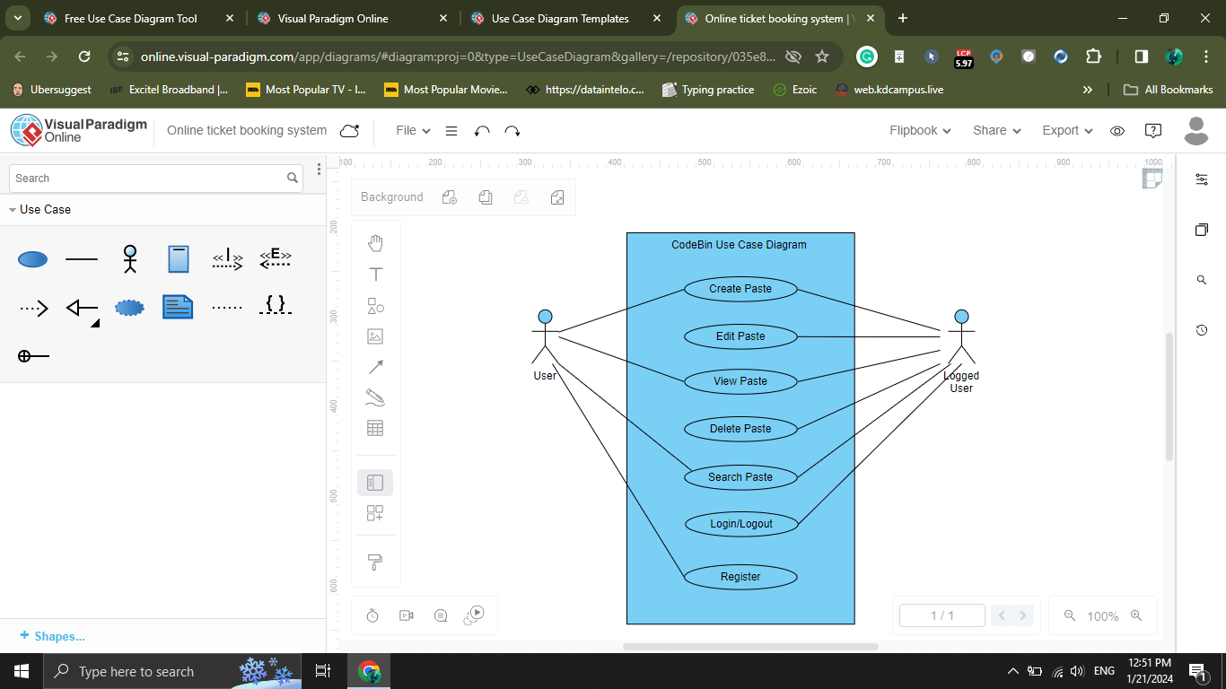

**CHAPTER 4**

**SYSTEM DESIGN**

In the system design phase, we delve into the architectural blueprint and detailed schematics of our text-sharing platform built on the MERN (MongoDB, Express.js, React, Node.js) stack. This phase is pivotal for ensuring a scalable, efficient, and cohesive system that aligns with the project's objectives.

**4.1 ARCHITECUTRE AND SYSTEM OVERVIEW**:

**4.1.1 Architecture**

The platform adopts a client-server architecture. Clients interact with the server through a RESTful API for data exchange. The server-side application, built with Node.js and Express.js, serves as the backend logic handler.

**4.1.2 System Overview**

Client is built using React, constitute the frontend of the application. Node.js, along with Express.js, manages server-side logic and API endpoints. MongoDB, a NoSQL database, stores and retrieves data efficiently.

**4.1.3 Key Components**

**Client-Side (React)**

Components for paste creation, editing, and viewing. User authentication and profile management interfaces. Search and discovery components for efficient content exploration.

**Server-Side (Node.js and Express.js)**

RESTful API handling for CRUD operations on pastes and user-related functionalities. Middleware for authentication, error handling, and data validation. Integration with the MongoDB database for data storage.

**Database (MongoDB)**

Collections for users, pastes. Indexing for efficient querying and data retrieval. Adherence to MongoDB best practices for scalability.

**4.2 DATABASE DESIGN AND SCHEMA**

**4.2.1 MongoDB Collections**

**Users Collection**:User details such as username, email, hashed password, and authentication tokens. User preferences and profile information.

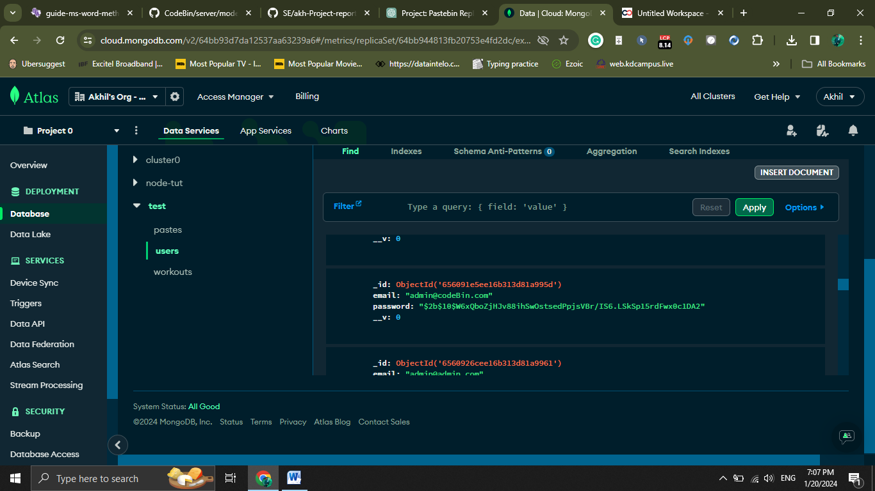

**Pastes Collection:** Paste content, metadata, and visibility settings. Version history and revision information for collaborative editing.

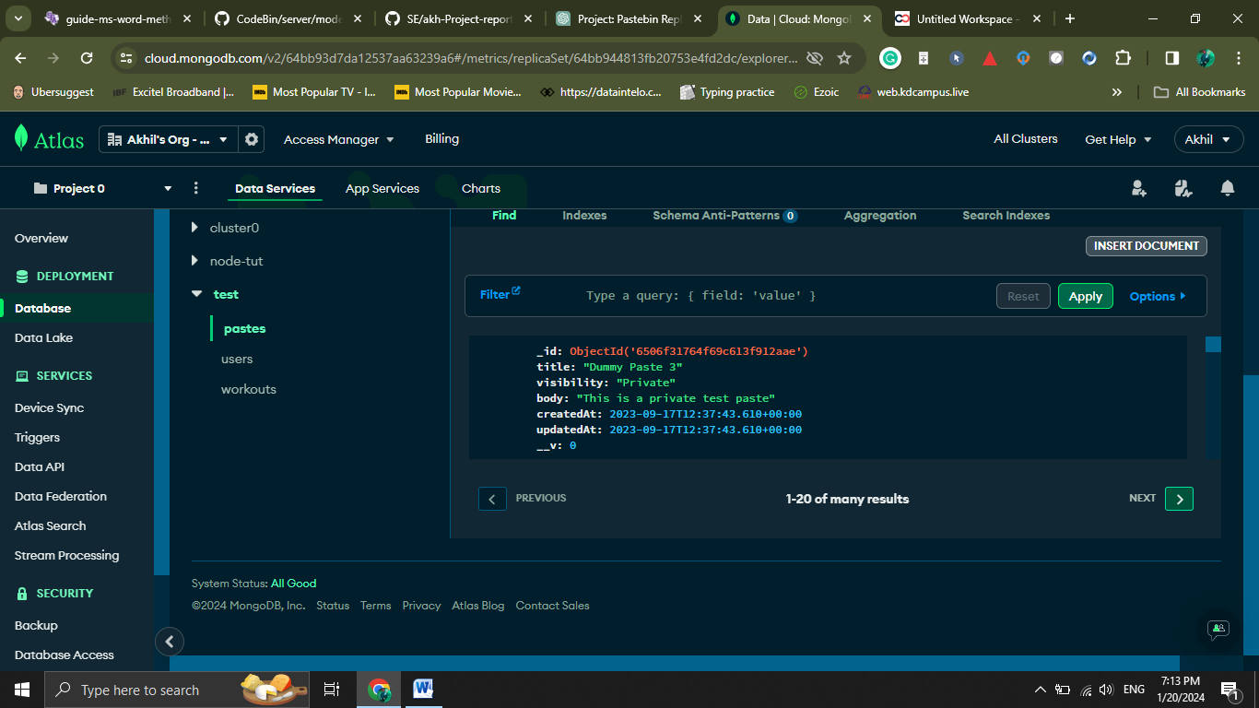

**4.3 ER DIAGRAM**

ER diagram to show the relation between a registered user and the pastes he creates.

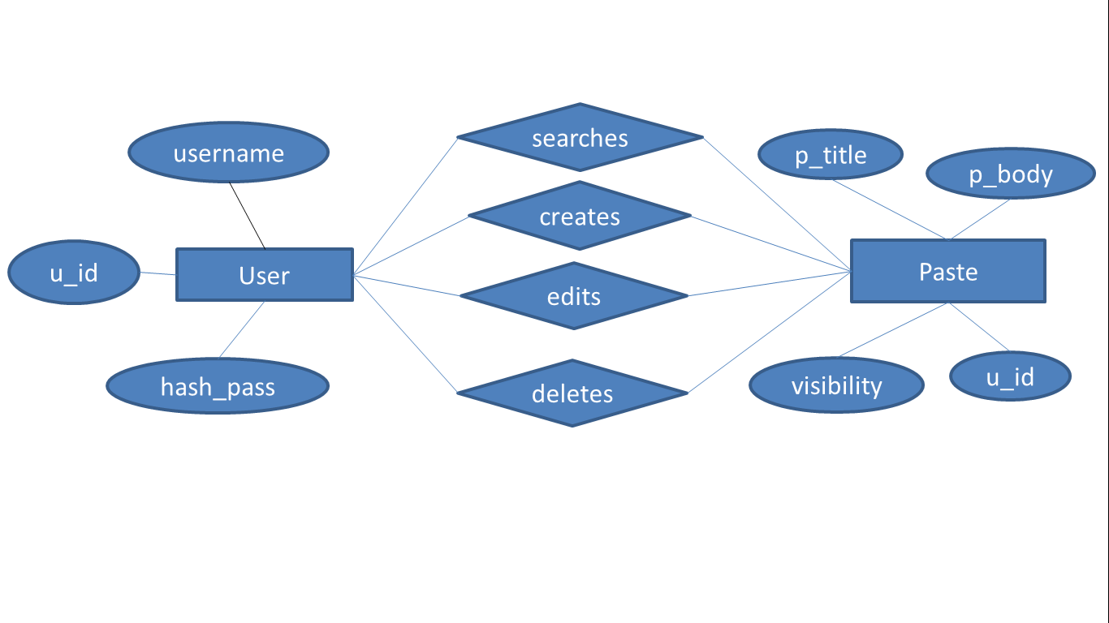

**4.4 DATA FLOW DIAGRAM**

**4.4.1 User Authentication Flow**

User initiates authentication by providing credentials. Client sends a request to the server for authentication. Server validates credentials, generates a JWT, and sends it back to the client. Subsequent requests from the client include the JWT for authentication.

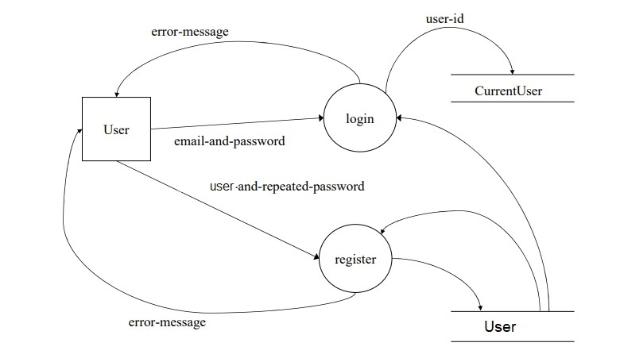

**4.4.2 Paste Creation and Editing Flow**

User creates or edits a paste through the frontend interface. Client sends a request to the server's API endpoint for paste creation or update. Server processes the request, updates the database, and returns the result to the client.

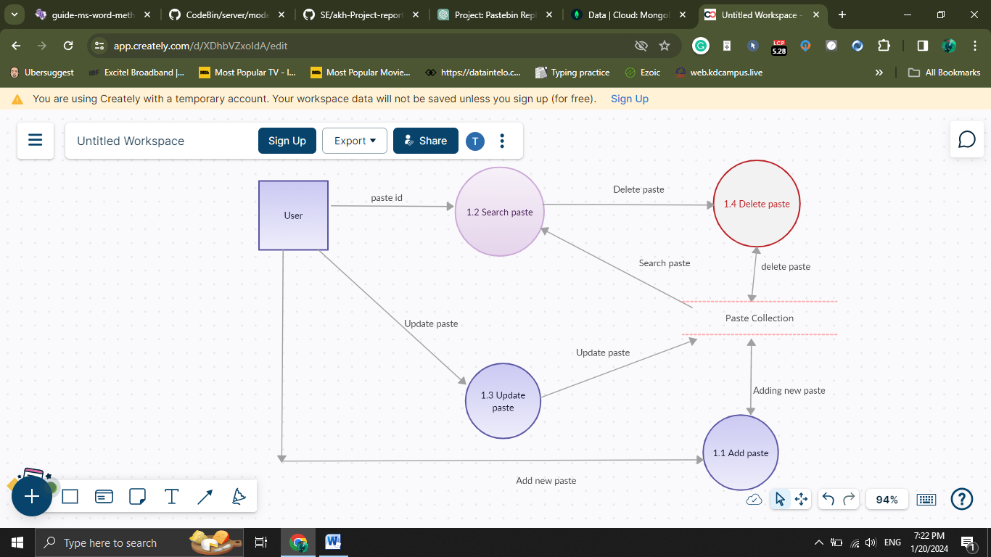

**CHAPTER 5**

**IMPLEMENTATION**

In the implementation phase, we bring our system design to life, utilizing the chosen technologies, addressing challenges, and providing key code snippets. This phase is crucial for turning conceptual ideas into a functional and tangible text-sharing platform.

**5.1 TECH STACK**

**5.1.1 Frontend (React)**

**React.js**: A JavaScript library for building user interfaces.

**React Router**: For declarative routing in React applications.

**5.1.2** **Backend** (Node.js and Express.js)

**Node.js**: A JavaScript runtime for server-side development.

**Express.js**: A web application framework for Node.js.

**JSON Web Tokens (JWT):** For secure and stateless authentication.

**5.1.3 Database (MongoDB)**

**MongoDB**: A NoSQL database for efficient and scalable data storage.

**5.1.4 Additional Tools and Libraries**

**Mongoose**: An ODM (Object Data Modeling) library for MongoDB and Node.js.

**bcrypt**: A library for hashing passwords securely.

**5.2 CHALLENGES**

**5.2.1 Security**

Ensuring robust security measures, including secure authentication, authorization, and data encryption, is crucial to protect user data.

**5.2.2 Scalability**

Designing the platform to scale efficiently with an increasing number of users and data entries poses challenges in database optimization and server-side performance.

**5.2.3 Error Handling**

Implementing effective error handling mechanisms to gracefully manage unexpected scenarios and provide meaningful feedback to users.

**5.3 CODE SNIPPETS**

**5.3.1 User Authentication (Backend - Express.js)**

Middleware for verifying whether the user is authenticated.

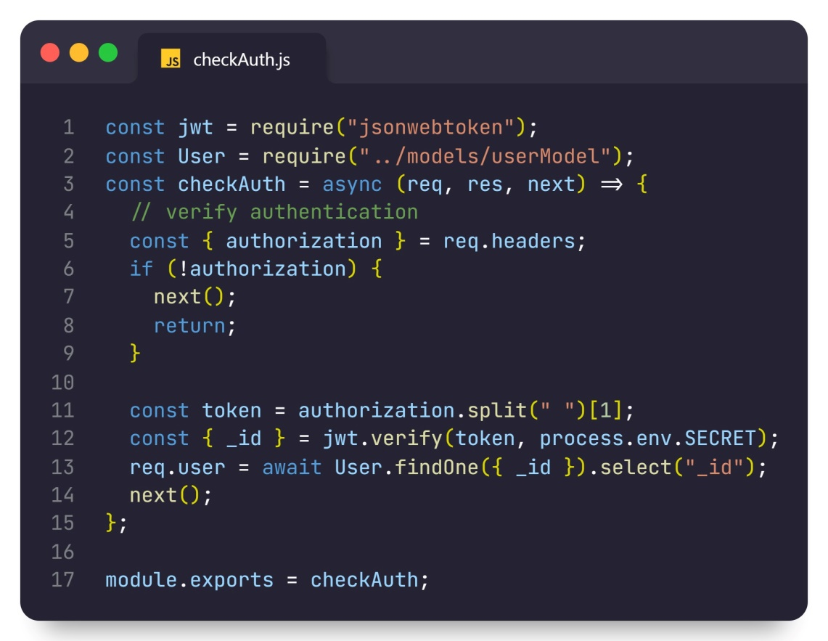

**5.3.2 Paste Creation (Backend - Express.js and MongoDB)**

Code Snippet for creating a paste

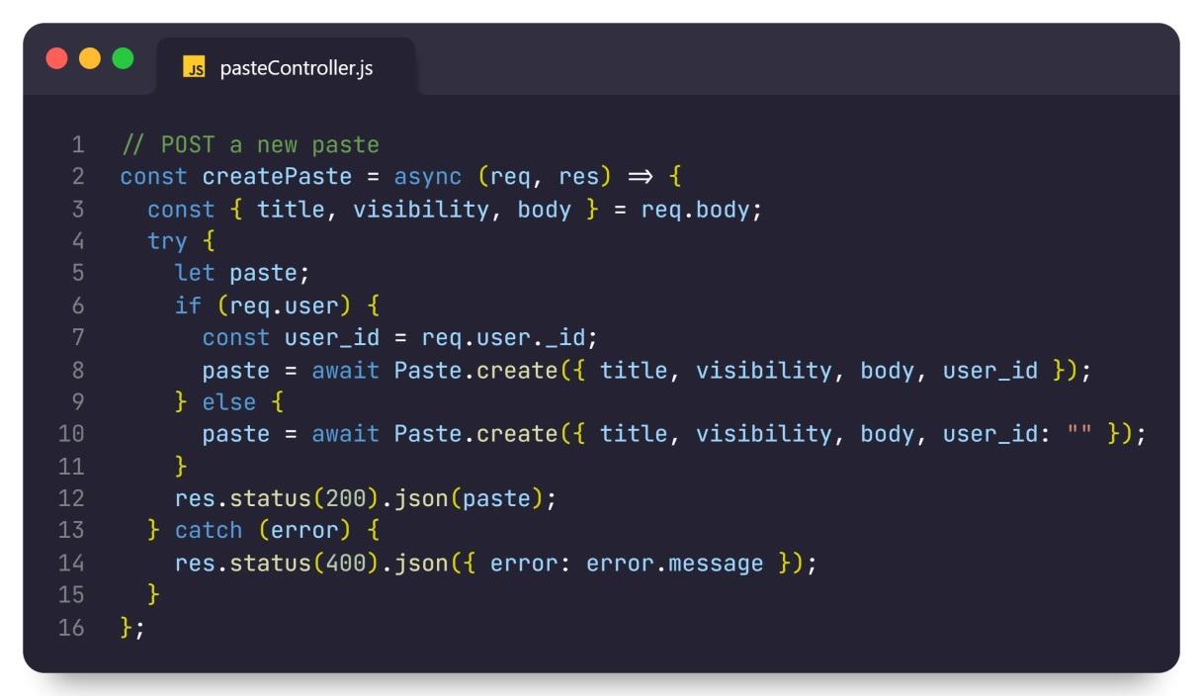

**5.3.3 Frontend Component (React - Paste.js)**

Here is how the Paste in fetched in the frontend with React hitting the API endpoint.

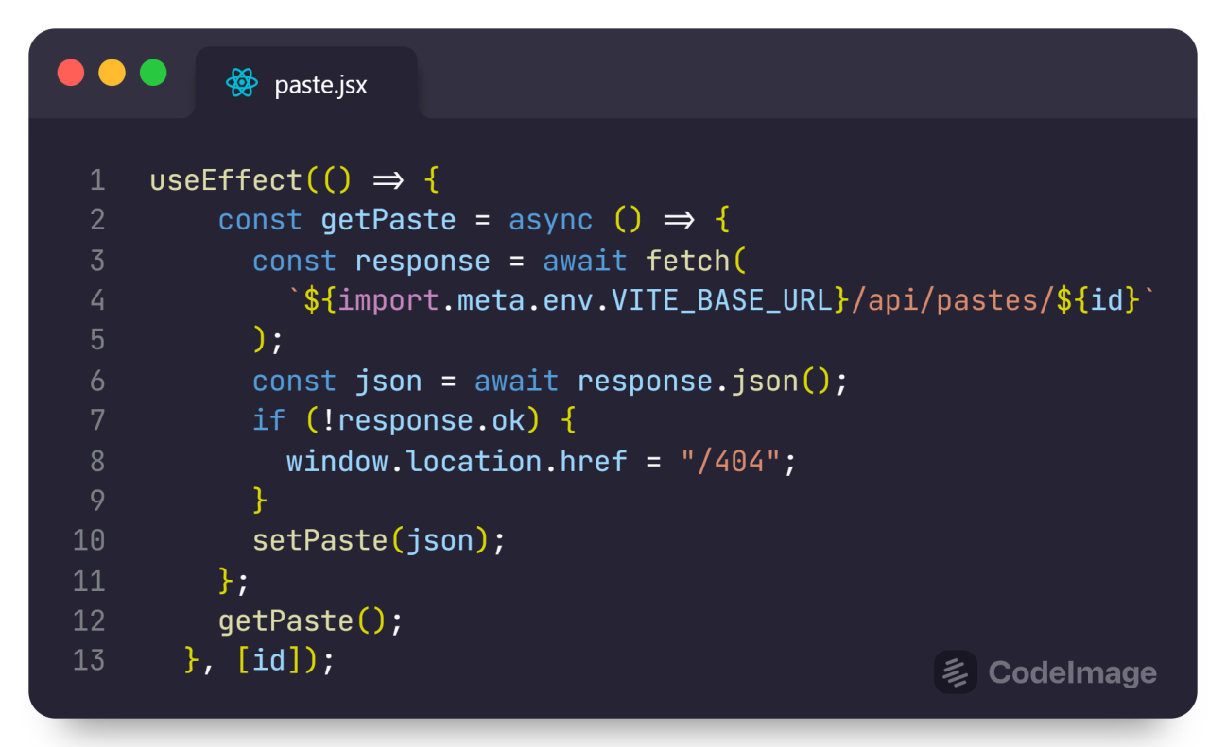

**CHAPTER 6**

**TESTING**

For a college project, the testing phase plays a crucial role in ensuring the robustness and functionality of the text-sharing platform. While the scale may be smaller than a production-level application, employing testing methodologies is essential to deliver a high-quality and reliable project.

**6.1 Testing Methodologies**

**6.1.1 Unit Testing**

**Objective**: Verify individual components and functions.

**Approach**: Utilize testing frameworks like Jest for React components and Mocha/Chai for backend functions. Test cases should cover different scenarios and edge cases.

**6.1.2 Integration Testing**

**Objective**: Evaluate interactions between components.

**Approach**: Use tools like Postman for backend API testing. Ensure smooth communication between the frontend and backend.

**6.1.3 End-to-End (E2E) Testing**

**Objective**: Validate entire application flows.

**Approach**: Test critical user journeys, including authentication, paste creation, and commenting.

**6.1.4 Performance Testing**

**Objective**: Assess system responsiveness and scalability.

**Approach**: Use tools like Apache JMeter or Artillery to simulate user loads. Evaluate and optimize database query performance.

**6.1.5 Security Testing**

**Objective**: Identify and address security vulnerabilities.

**Approach**: Conduct security audits and penetration testing. Focus on common issues like SQL injection and secure data transmission.

**6.1.6 Usability Testing**

**Objective**: Evaluate user interface and experience.

**Approach**: Conduct usability tests with real users for feedback on design and navigation. Aim to enhance user-friendliness.

**6.1.7 Regression Testing**

**Objective**: Ensure new changes don't impact existing functionalities.

**Approach**: Automate regression tests using tools like Selenium. Run tests with each deployment to catch potential regressions.

**6.1.8 Exploratory Testing:**

**Objective**: Identify unexpected issues.

**Approach**: Allow testers to explore the platform freely. Document any issues or areas for improvement found during exploratory testing.

**6.2 TEST CASES**

|  |  |  |  |  |
| --- | --- | --- | --- | --- |
| **Test Case ID** | **Test Case Description** | **Test Steps** | **Expected Result** | **Pass/Fail** |
| TC_001 | User Registration | 1. Navigate to the Registration Page | Registration form is displayed | Pass |
|  |  | 2. Enter valid user details | User is Registered Successfully. | Pass |
|  |  | 3. Submit the Registration form. |  | Pass |
| TC_002 | User Login | 1. Navigate to the login page. | Login form is displayed | Pass |
|  |  | 2. Enter Valid login credentials. | User is logged in and redirected to the dashboard | Pass |
|  |  | 3. Submit the login form. | User can now see his own pastes | Pass |
| TC_003 | Paste Creation | 1. Navigate to create Paste. | Paste creation form is displayed. | Pass |
|  |  | 2. Enter Paste content and set the visibility. | Paste is successfully created. | Pass |
| TC_004 | Editing a Paste | 1. Navigate to edit Page form by clicking edit button. | Paste edit form is displayed with current content | Pass |
|  |  | 2. Modify the content and submit the form | Paste is successfully updated | Pass |
| TC_005 | Search Functionality | 1. Enter the Paste Id | Search result is displayed | Pass |
|  |  | 2. If incorrect Paste Id | 404 page is displayed | Pass |

**CHAPTER 7**

**CONCLUSION**

The development and testing phases of our text-sharing platform project have provided valuable insights into the creation of a robust and user-friendly application. This endeavor aimed to replicate the core functionalities of popular platforms like Pastebin.com, focusing on user registration, paste creation, collaboration features, and effective search functionality.

**7.1 ACHIEVEMENTS AND HIGHLIGHTS**

**User Registration and Authentication**: The user registration and authentication processes have been successfully implemented, ensuring secure access to the platform.

**Paste Creation / Editing / Deleting**: Users can seamlessly create, edit, and manage their pastes, fostering a collaborative environment for content sharing.

**Search Functionality**: The search functionality enables efficient content discovery, enhancing the overall user experience.

**7.2 CHALLENGES OVERCOME**

**Security Measures:** Robust security measures, including secure authentication and data encryption, were implemented to safeguard user information.

**7.3 TESTING AND QUALITY ASSURANCE**

Rigorous testing methodologies, including unit testing, integration testing, and end-to-end testing, were employed to ensure the reliability and functionality of the platform. Performance testing identified potential areas for optimization, contributing to a smoother user experience.

**7.4 FUTURE ENHANCEMENTS**

Consideration for real-time collaboration features, such as live editing and instant commenting, could be explored in future iterations.

Further optimization for scalability, particularly in managing large datasets and concurrent user loads, will be a focus for ongoing improvements.

**7.5 LESSONS LEARNED**

The project emphasized the importance of iterative development and continuous testing, allowing for early detection and resolution of potential issues.

Collaboration and effective communication among team members played a pivotal role in overcoming challenges and ensuring project success.

In conclusion, the text-sharing platform project has laid a strong foundation for a functional and user-centric application. The journey from conceptualization to implementation has been both challenging and rewarding, providing valuable insights for future software development endeavors. As we move forward, the commitment to user satisfaction, security, and continuous improvement will remain at the forefront of our development philosophy.

**CHAPTER 8**

**REFERENCES**

**1. MongoDB - NoSQL Database**

**Website**: <https://www.mongodb.com/>

**2. Mongoose** - MongoDB Object Data Modeling (ODM) Library for Node.js

**Website**: <https://mongoosejs.com/>

**3**. **React.js** - JavaScript Library for Building User Interfaces

**Website**: <https://reactjs.org/>

**4. Node.js - JavaScript Runtime for Server-Side Development**

**Website**: <https://nodejs.org/>

**5. Express.js** - Web Application Framework for Node.js

**Website**: <https://expressjs.com/>

**6. CORS (Cross-Origin Resource Sharing)** - Middleware for Express.js

**GitHub Repository**: <https://github.com/expressjs/cors>

**7. JSON Web Tokens (JWT)** - Secure Authentication Mechanism

**Website**: <https://jwt.io/>

**8.** **Bcrypt** - Password Hashing Library

**GitHub Repository:** <https://github.com/kelektiv/node.bcrypt.js>