Annexure3b- Complete filing

INVENTION DISCLOSURE FORM

Details of Invention for better understanding:

1. TITLE: Smart health report generator and monitoring device using IOT

2. INTERNAL INVENTOR(S)/ STUDENT(S):
Our Mentor :
Full Name | Manish Singh
Mobile Number | 6397349331
Email | Myswayam21@gmail.com
UID/Registration Number | 32920
Address of Internal Inventors | Lovely Professional University, Punjab-144411, India
Signature

Patent Holder 1:
Full name | M Rahul Chowdary
Mobile Number | 8688016399
Email (personal) | mutthulururahulchowdary@gmail.com
UID/Registration number | 12315383
Address of Internal Inventors | Lovely Professional University, Punjab-144411, India
Signature (Mandatory) | 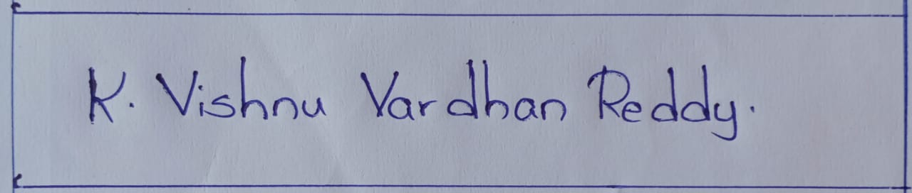

Patent Holder 2:
Full name | Akhil Kumar
Mobile Number | 8106467102
Email (personal) | Banothakhil417@gmail.com
UID/Registration number | 12318876
Address of Internal Inventors | Lovely Professional University, Punjab-144411, India
Signature (Mandatory) | 

Patent Holder 3:
Full name | Ishika Sharma
Mobile Number | 6205705988
Email (personal) | sharmaishika1109@gmail.com
UID/Registration number | 12321397
Address of Internal Inventors | Lovely Professional University, Punjab-144411, India
Signature (Mandatory) | 

3. DESCRIPTION OF THE INVENTION: In the present scenario where the IO of devices, AI, and a lot of technical advancement are taking place, there is an emerging need for such a smart automated real-time health monitoring system that does not require regular hospital visits but used to monitoring only the important health parameters continuously and efficiently. Existing health devices are good for tracking but do not have AI predictive analysis or automated report generation which is crucial for preventive health care. Smart technology is disrupting sectors across the board, and now healthcare systems need to keep pace by delivering proactive, real-time solutions. Smart health report generator and monitoring device overcome these challenges by introducing intelligent AI powered and IoT integrated health monitoring solutions and continuous and remote health monitoring which are more accurate, convenient and consumer friendly, thus making the healthcare process more accessible and efficient.
Novelty : Generating the instant report and sending it to the nearby hospitals and emergency contacts.
Moreover the Machine Learning model which we are creating uses variety of datasets to predict the other health constraints like BP, cholesterol etc with a reasonable accuracy.

- PROBLEM ADDRESSED BY THE INVENTION:
The basic problem being addressed by the invention is the lack of a device capable of:
Real-time monitoring and reporting of heart health using pulse rate and waveform data.
Generating instant health reports that can predict additional health constraints (like BP and cholesterol) using Machine Learning (ML).
Sending immediate alerts to emergency contacts and hospitals during unusual heart rate detection, improving response times in critical situations.

- OBJECTIVES OF THE INVENTION
It will allow us to monitor real-time patient data using the AI, manage, and generate reports automatically using the Smart Health Report Generator and the Smart Health Monitoring Device. The main aim is to make an equipment that will help in monitoring heart rate, blood pressure, SpO2, ECG and glucose levels of any person at any time, thus providing the users an overview of their health status. Advanced machine learning models are integrated into this technology to analyze pulse waveforms and provide early detection of potential health conditions. This device eliminates the limitations of traditional health monitoring systems by introducing automated, data-driven diagnosis, leading to a significant reduction in hospital visits, as well as the realization of preventive treatment.
A separate goal is building a speedy response mechanism which improves emergency preparedness. In life-threatening health emergencies, the device can instantly identify the irregularities and communicate real-time alerts to the emergency contacts, medical helpers, hospitals around the vicinity along with minute-by-minute health summaries. In case of emergencies, this feature greatly improves response time, allowing timely medical intervention if necessary, potentially saving lives. This IoT-based device offers seamless communication between the wearable sensor and cloud servers via mobile applications, enabling remote monitoring and secure data storage.

C. STATE OF THE ART/ RESEARCH GAP/NOVELTY:

Serial Number | Patent ID | Year of Publishing | Abstract | Research Gap | Novelty
1 | US20050075577A1 | 2005 | Wireless Heart Rate Monitor with Infrared Detecting Module  This invention relates to a heartbeat sensing device that uses an infrared detecting module to monitor heart rate wirelessly. | The device may lack integration with modern mobile applications and advanced data analytics. | Proposes a wireless heart rate monitor utilizing infrared technology for non-invasive measurement.
2 | US20100016741A1 | 2010 | Waterproof Heart Rate Monitor  A device designed to measure heart rate using infrared sensors, suitable for swimmers and underwater activities. | Limited to heart rate measurement; lacks integration with predictive analytics or emergency alert features. | Introduces a waterproof design with infrared sensors for heart rate measurement, providing audio feedback via bone conduction.
3 | WO2015139930A1 | 2015 | Heart Rate Monitor System  A system designed to monitor a user's heart rate and provide feedback. | Primarily focuses on heart rate monitoring without predictive diagnostics or emergency alert capabilities. | Details a system that monitors heart rate and offers user feedback, potentially integrating with other health monitoring systems.

D. DETAILED DESCRIPTION:
The Smart Health Report Generator and Monitoring Device is a unique innovation which can generate health report instantly and monitor health in real-time using IoT technology. The system mainly aspires to be capable of pulse measurement by means of Arduino microcontroller in combination with a few sensors to ascertain the pulse rate and emit a live pulse graph. The approved metrics are wirelessly transferred to an Android application on a unique device using Bluetooth or Wi-Fi.
Machine learning is one of the highlights of this system. The application also contains a trained ML model which analyses the pulse data collected through the application to predict parameters like blood pressure and cholesterol levels. This predictive ability gives the system a more significant responsibility to deliver all-encompassing
[3/20, 10:14 PM] Vishnu PE Lpu: The device also has a built-in emergency response system to keep the user safe. Once potential irregular heart rate is identified, the application sends an alert and/or sends an SMS to pre-defined contacts and nearby hospitals. The notification also contains a PDF report with health metrics, enabling timely medical intervention.
Moreover, system gives the advantage to create reports in a few seconds, where user can get a formatted health report which contains pulse waveform and predictive health parameters. Enable people to monitor their health trends over time and share that information with their health care providers to help diagnose and treat. With real-time monitoring, predictive analysis and an emergency alert system, this smart health device is a positive step towards active health management, making health monitoring easier and integration-friendly.
E. RESULTS AND ADVANTAGES:
- Real-time monitoring and reporting of heart health.
- Accurate prediction of additional health parameters using Machine Learning.
- Effective emergency response through automated alerts.
- Integration of predictive health analytics using Machine Learning.
- Automated and instant report generation and transmission during emergencies.
- Improves response time and potentially saves lives in critical health scenarios.
- Simple and intuitive mobile application interface.
- Easy device setup with minimal technical knowledge required.

F.EXISTING DATA:
Clinical and comparative data are employed to enhance the precision, reliability, and effectiveness of real-time health monitoring through the Smart Health Report Generator and Monitoring Device. Interpretable ML algorithms are trained on clinical data obtained from public repositories like the UCI Machine Learning Repository, the WHO, and Open Healthcare Data, which provide a comprehensive and diverse set of medical records that include readings like ECG, blood pressure, glucose levels, etc.] These datasets will later train the Machine Learning model to predict your possible health risks & personalized insights. With the ongoing collection of real-world patient data, the accuracy of AI-driven predictive analytics also improves, ensuring reliable health assessments.
Pointing out the shortcomings of current wearable fitness devices while offering diagnostics, predictive analytics, and emergency alerting capabilities, a comparison of existing devices was performed. You know, fitness trackers mostly track just basic and traditional health metrics like heart rate or oxygen levels; AI-based insights or emergency response don't exist. Existing solutions do not offer solutions that integrate health that comprises continuous health monitoring, predictive health analytics, instant report generation and automated emergency notification. These gaps in healthcare technology hinder the early diagnosis process of critical conditions like hypertension, heart disease, or any kind of abnormal ECG patterns.
The IoT-based, AI-enabled Smart Health Report Generator and Monitoring Device has the potential to bridge this gap by providing proactive healthcare, early disease detection, and timely action in case of an emergency, thus contributing to holistic and well-informed healthcare for users.
- FlowCharts and Images of the components:

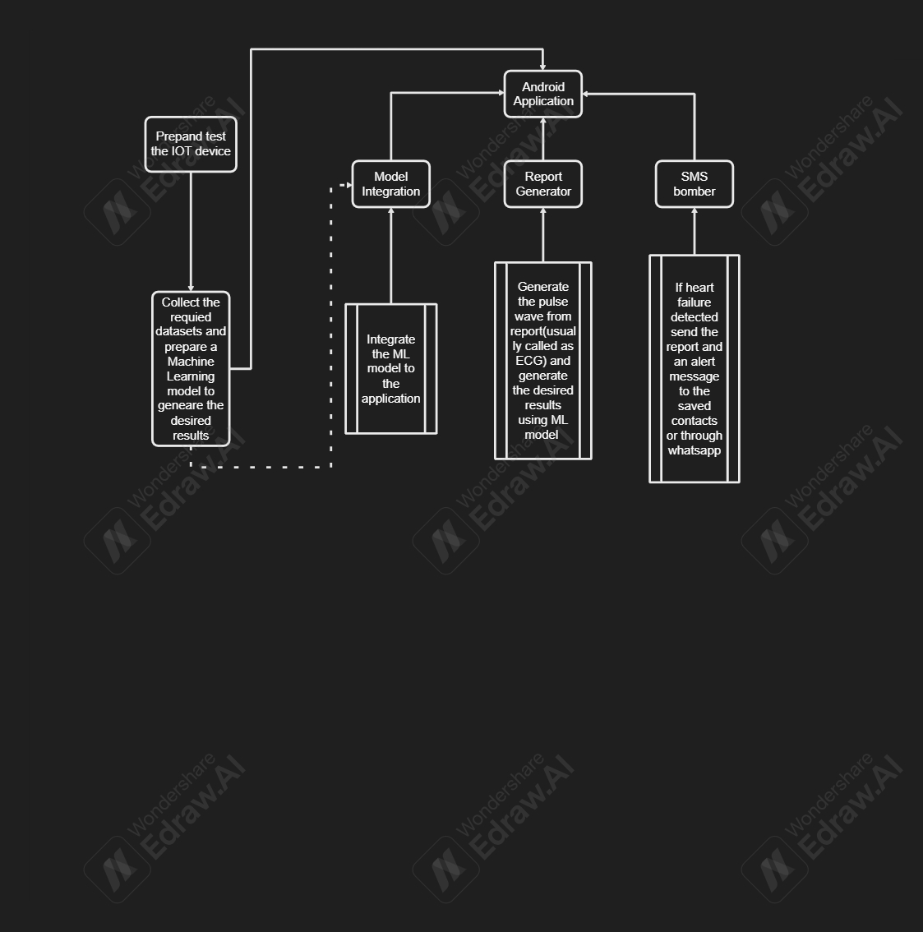

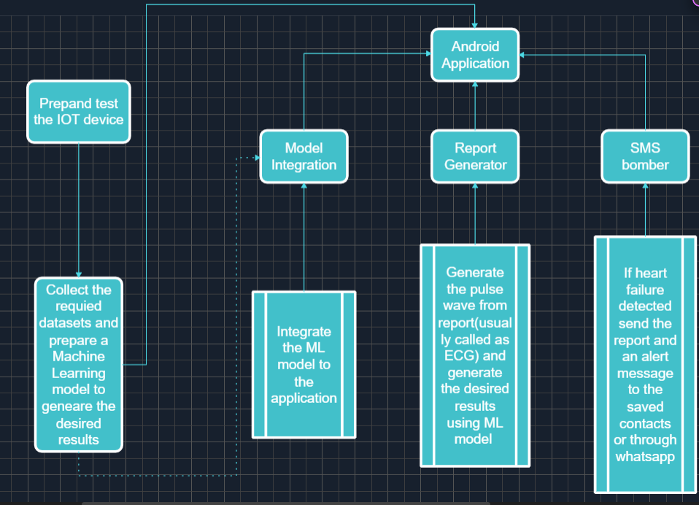

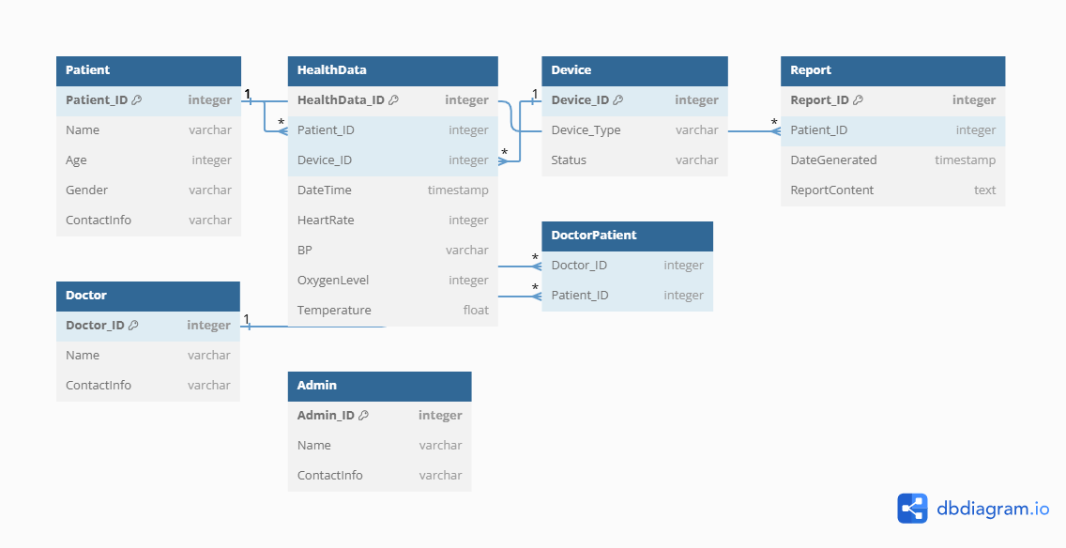

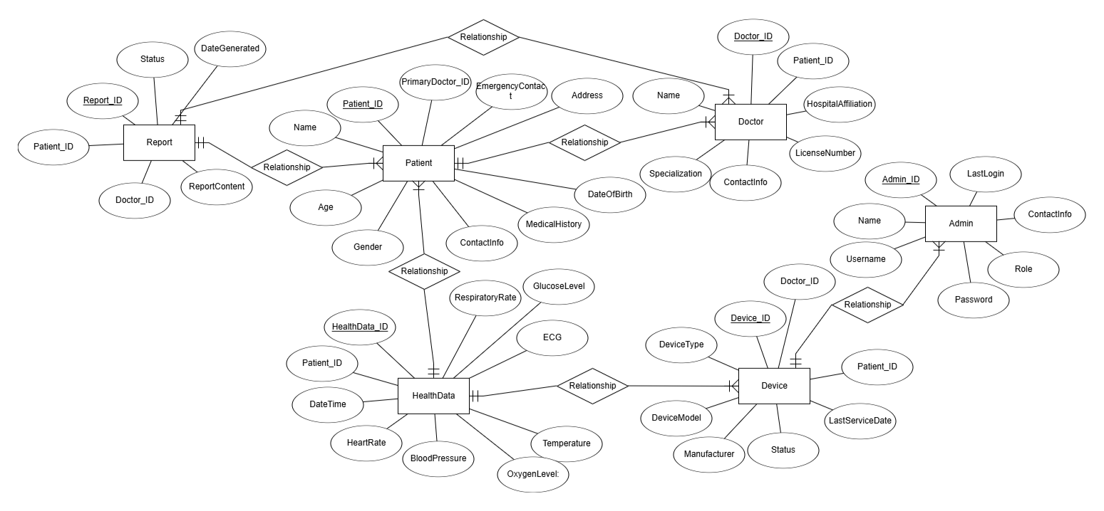

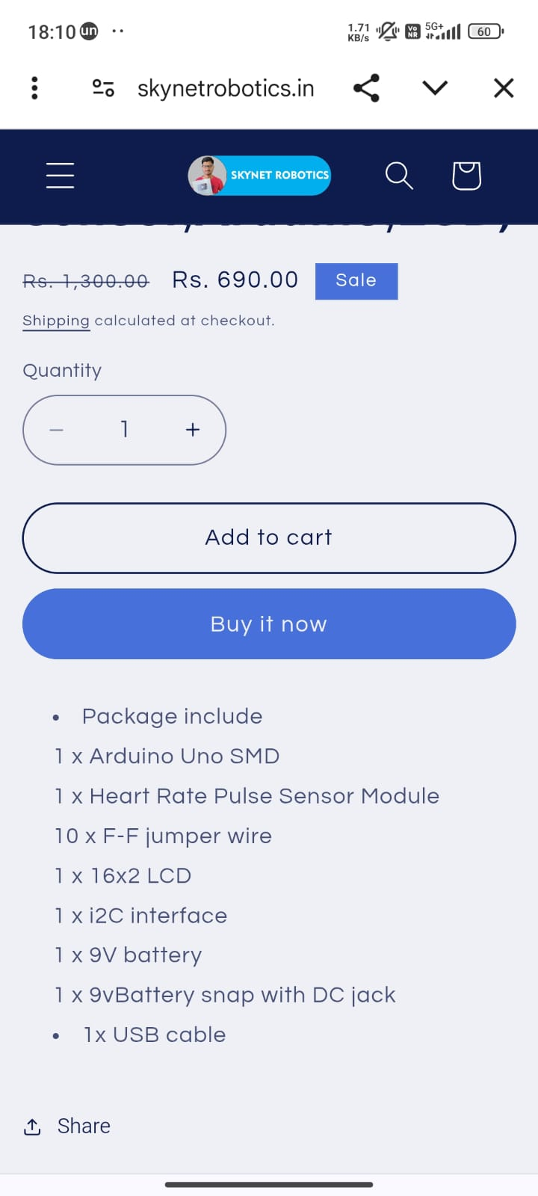

ESP8266 WIFI Sensor module:

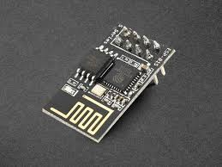

4. USE AND DISCLOSURE (IMPORTANT): Please answer the following questions:

- Have you described or shown your invention/ design to anyone or in any conference? | YES ( ) | NO (✔)
- Have you made any attempts to commercialize your invention (for example, have you approached any companies about purchasing or manufacturing your invention)? | YES ( ) | NO (✔)
- Has your invention been described in any printed publication, or any other form of media, such as the Internet? | YES ( ) | NO (✔)
- Do you have any collaboration with any other institute or organization on the same? Provide name and other details. | YES ( ) | NO (✔)
- Name of Regulatory body or any other approvals if required. | YES ( ) | NO (✔ )

5. Provide links and dates for such actions if the information has been made public (Google, research papers, YouTube videos, etc.).
Google Patents: https://patents.google.com/
Research Papers: IEEE Xplore, PubMed, ScienceDirect
YouTube Videos: A search for "pulse rate monitoring device" and "predictive health analytics" on YouTube
Company Blogs: Fitbit, Apple, Garmin, and other wearable tech companies
6. Provide the terms and conditions of the MOU also if the work is done in collaboration within or outside university (Any Industry, other Universities, or any other entity).
N/A

7. Potential Chances of Commercialization
YES

List of Companies for Commercialization

Company | Website
Fitbit (Google) | https://www.fitbit.com
Apple (Apple Watch) | https://www.apple.com/watch
Garmin | https://www.garmin.com
Xiaomi (Mi Bands) | https://www.mi.com
Philips Healthcare | https://www.usa.philips.com/healthcare
Medtronic | https://www.medtronic.com
These companies already have heart rate monitoring solutions, and they could be potential licensing partners for the technology.
9. Filing Options:
Provisional
10. Keywords for Searching and Classification
- Heart Rate Monitoring
- Wearable Pulse Sensor
- Predictive Healthcare Analytics
- Machine Learning for ECG/Pulse Data
- Smartwatch Heart Rate Detection
- IoT in Medical Devices

