**README**

Folder structure

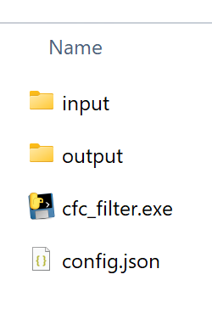

1. Folder “input” – This is the folder to contain the input csv files to process.
2. Folder “output” – This is the folder that contains the processed output files that are processed.
3. File “cfc_filter.exe” – Windows executable file. This is the program to process and filter csv file from “input” and save processed files in “output” folder.
4. File “config.json” – This is the configuration file required for “cfc_filter.exe” to process csv files.

Note: Please do not delete any folder or file that are listed above.

**Filter program usage**

1. Copy csv file that are to be processed in “input” folder.

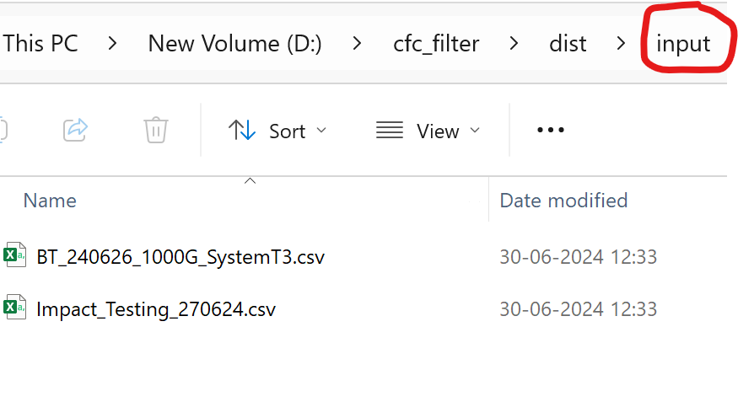

1. Open windows command prompt

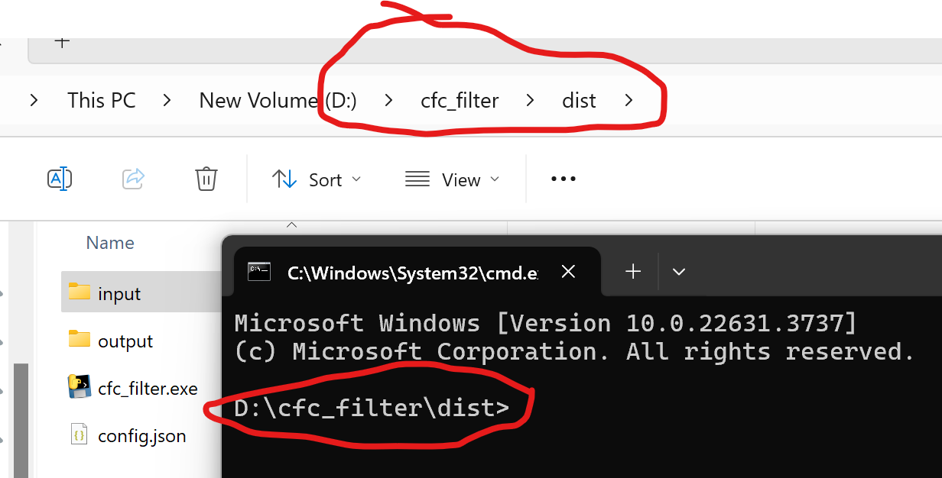

1. Type executable file name and the name of the file that is to be processed and press “ENTER” key. Make sure the file is present in “input” folder.

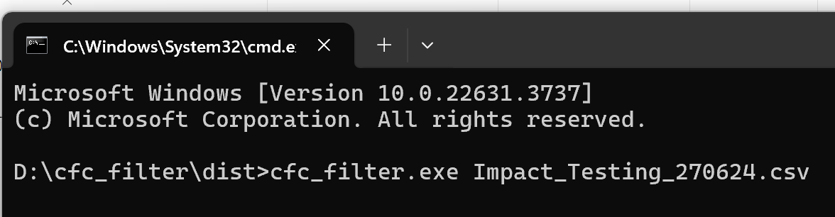

1. Filter program will process the input file and save results in “output” folder.

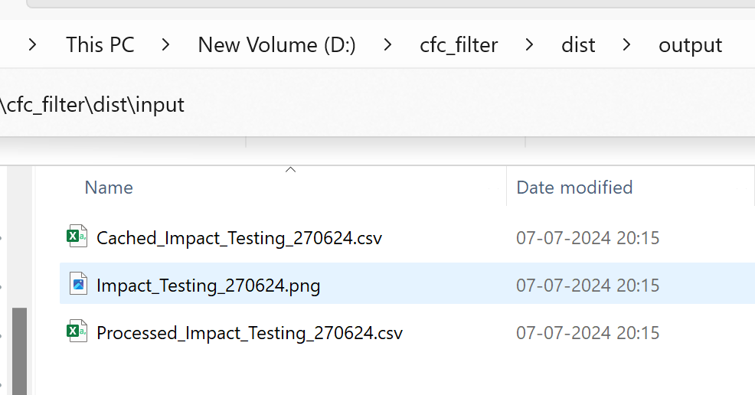

1. List of files in “output” folder.
   1. Cached_<Input_File_Name>.csv – Subset of data points before and after maximum value data point. Use this file to further analyse the data in case if required.
   2. <Input_File_Name>.png – Graph of processed data. This data is available in “Cached_xxx.csv” file to analyse further.
   3. “Processed_<Input_File_Name>.csv – Input data appended with filtered data. This is full set of data.

**Config file**

1. File “config.json” is configuration file that contains configuration parameters as in below image.

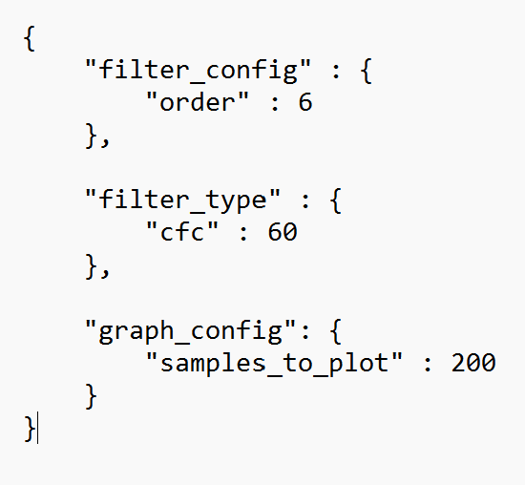

1. List of configuration parameters is as below
   1. “filter_config”->”order” – This is the filter order. By default filter is configured for 6th order.
   2. “filter_type”->”cfc” – This is filter type e.g. CFC60. By default filter is configured for CFC60. Supported values for this configuration are 60, 180, 600 and 1000.
   3. “graph_config”->”samples_to_plot” – This configuration is the total data points that are to be plotted and cached in csv file for further analysis. The peak will be in the middle and the data points before and after maximum will be captured.

For example: if “samples_to_plot” is 200 then 100 data points before and 99 data points after will be captured. Peak will be in the middle of the data points making it total 200 points.

Note: Please do not delete any configuration parameter from “config.json” file. Editing of the configuration parameters is allowed.

Note: “filter_type”->”cfc” supported values are 60, 180, 600 and 1000. Results will be wrong in case if the value is other than supported value.

Note: Please do not alter csv file present in “input” folder.

Note: Close or save files present in “output” folder after processed for further analysis if required.