Energy Projection Forecasting Using Time Series and Deep Learning Models: A Comparative Study of SARIMA and LSTM Approaches

Acknowledgements
I would like to express my sincere gratitude to my project supervisor for their guidance, feedback and support during the development of this project. Their suggestions did prove to be most valuable as far as defining the way the research was going and how the methodology was developed.
Another thing I would like to express my gratitude to the University for the academic resources and learning environment it provided helped me complete this work successfully. Lastly, I owe my peers and family the support and encouragement they provided when doing this project.

Abstract
The energy sector requires adequate demand forecasting to be conducted accurately to facilitate adequate planning and decision making. The study in this project examines the efficiency of statistical and deep learning to predict monthly energy production based on past time series support. The main aim is to check the performance of SARIMA models and LSTM models in terms of identifying the trend of time variation and making accurate short-term predictions. The analysis employs an open-source dataset on monthly energy production that is retrieved on Kaggle. The two models were equally executed with respect to equal preprocessing, forecasting horizons as also in terms of evaluation metrics. Findings indicate that SARIMA is better at delivering predictable and interpretable forecasts, but the LSTM model is better at predictive performance especially when dealing with nonlinear trends. All in all, the results indicate that deep learning strategies are more effective in short term energy demand prediction, but statistical models are also useful as a clear baseline tool.

Table of Contents
Acknowledgements 2
Abstract 3
1. Introduction 6
1.1 Project Overview 6
1.2 Research Problem and Motivation 6
1.3 Research Question 6
1.4 Aims and Objectives 7
2. Background and Literature Review 7
2.1 Introduction to the Literature 7
2.2 Technical Background 7
2.3 Critical Review of Key Studies 8
2.4 Literature Comparison and Research Gap 9
3. Dataset and Exploratory Data Analysis 9
3.1 Dataset Description 9
3.2 Dataset Selection Justification 10
3.3 Exploratory Data Analysis 10
3.4 Data Preprocessing 13
4. Ethical Issues 14
4.1 Ethical Review of Dataset 14
4.2 Ethical Approval Considerations 14
4.3 Data Usage and Consent 14
5. Methodology 14
5.1 Problem Formulation 14
5.2 Model Selection Rationale 15
5.3 LSTM Model Implementation 15
5.4 SARIMA Model Implementation 15
5.5 Model Optimisation 16
5.6 Evaluation Metrics 16
6. Results 16
6.1 LSTM Results 16
6.2 SARIMA Results 18
6.3 Model Comparison 20
7. Analysis and Discussion 21
7.1 Interpretation of Results 21
7.2 Model Performance Comparison 22
7.3 Comparison with Literature 22
7.4 Practical Implications 22
7.5 Limitations 22
7.6 Research Question Evaluation 23
8. Conclusion and Future Work 23
References 25
Appendices 29
Appendix A: Additional Images 29
Appendix B: Python Code 29

1. Introduction

1.1 Project Overview
This project aims at creating and testing data driven models to predict the demand of energy production based on historical time series data. Good planning, operational efficiency, and reliable energy supply require proper energy projection forecasting. In this project, the data is monthly energy production and uses the methods of statistical and deep learning to forecast upcoming levels of production after a specified forecast horizon.
The project is applied to the energy sector, specifically large-scale energy production and demand forecasting. Reliable forecasts are important to the energy providers and regulatory bodies to maintain stability on the grids, to allocate resources optimally and long long-term infrastructure planning (Aluko-Olokun, 2024). The growing variability in demand and integration of renewable energy has made modern-day energy even complex.
This is because traditional statistical models are very prevalent in modern industry since they are easier to interpret. Nonetheless, increased information and computing power have promoted the use of long short-term memory networks or deep learning models, which can encode complex time series patterns in time series data.

1.2 Research Problem and Motivation
The significance of energy projection forecasting is that the wrong predictions would translate to inefficient energy generation, high costs of operation, and even shortage or excess in its supply. Both over and underestimation can lead to wastage of resources and insecurity of energy and reliability of the system, respectively. Thus, enhancing the accuracy of forecasts directly leads to efficiency in the economy and neutral management of energy resources.
The current methods of forecasting are limited in a number of ways. The standard statistical models have several assumptions of linearity and stationarity, which do not seem to fully reflect the intricate and changing dynamics found in energy time series data fully (Dixit and Jain, 2023). In contrast, deep learning models need a specific design, adequate data, and evaluation to guarantee trustworthy performance. This brings about the necessity to compare techniques used in classical statistics with recent deep learning methods systematically on actual world energy data.

1.3 Research Question
- To what extent can statistical and deep learning models predict the demand of the monthly energy production based on the historic time series data?
- How much better does the LSTM model do in terms of predicting the temporal trend and accuracy of forecasting compared to the SARIMA model?
- What is the more appropriate forecasting method that is applicable to conduct practical energy projection forecasting in terms of predictive performance and stability?

1.4 Aims and Objectives
Aim
This project will be pursued in order to predict the demand of monthly energy production using time series models as well as to compare the performance of the traditional statistical model and its counterpart which is a deep learning based model.
Objectives
- To take analysis of past monthly energy production records to find out the most significant trends and seasonal variation used as predictors.
- To make sufficient short term predictions of the future production of energy with the help of predictive modelling.
- To identify the performance differences between statistical and the deep learning based forecasting models.
- To assess the merciful value of the forecasting findings to energy planning and decision-making.

2. Background and Literature Review

2.1 Introduction to Literature
The need to have a reliable energy supply, efficient cost, and proper planning of energy systems have made energy demand forecasting an old research field. To make operations and infrastructure decisions and policy, which are increasingly driven by demand variability and renewable interventions, reliable forecasting is vital. New studies have been devoted to enhancing forecasting quality through the traditional and modern methods of using machine learning.
The sources used in this review are peer-reviewed journal articles and conference papers written between 2020-2025 that cover energy demand or production forecasting based on time series data. The selection criteria gave preference to the works that use statistical forecasting models, deep learning techniques, or both to real-world energy data. These papers were selected since they contain pertinent methodological information, similar evaluation measures, and applications, which are consistent with the objectives of the present project.

2.2 Technical Background
Time series forecasting is used to predict future values by taking into consideration past values that were observed across time. The important attributes of time series data are trend, seasonality and irregular components (Dudek, 2023). Knowledge of these properties is critical to the choice of the right forecasting model as well as the preprocessing methodology. Energy time series have a huge seasonality and long-term trends, which are highly appropriate to the specialised forecasting models.
Energy demand forecasting has long relied on statistical forecasting techniques. Autoregressive integrated moving average and its seasonal extension models are based on historical trends and presuppose the line relationships in the data. These techniques are prized by their interpretability and relative simplicity of computation. Research work, like Nammalam et al., (2020), emphasises the significance of indicators of energy efficiency and statistical analysis on the interpretation of demand patterns proving the topicality of classical methods.
Over the last few years, time series forecasting tasks have received considerable attention based on deep learning methods. Long short-term memory neural networks happen to be especially useful in long-range temporal dependencies and nonlinear associations among sequential data. Malakar et al., (2021) study proves that LSTM models can be applied to short-term energy-related forecasting task, performing better than conventional tools. Such developments have led to the further study of deep learning models in energy forecasting research.

2.3 Critical Review of Key Studies
Malakar et al., (2021) have developed a long, short term memory network used to forecast short term global horizontal irradiance. The experiment utilized the historical data of irradiance and LSTM architecture to learn temporal variations. The findings indicated that the model proposed had high predictive accuracy and was better than the traditional methods. This article can be applied to the present project because it proves the efficiency of LSTM models in forecasting energy-related time series. One of the strengths of the study is that it has an elaborate model design and evaluation. Nevertheless, the prior employment of a given variable of energy limits its generalisation towards larger scale energy production demands forecasting.
Aguilar Madrid and Antonio, (2021) examined short term electricity load forecasting in machine learning methods. The authors used real world data of electricity consumption and evaluated several machine learning models. The findings were that forecasting accuracy can be highly achieved with data driven approaches. The paper is topical since it describes the benefits of machine learning, as opposed to conventional statistical procedures. One of the strengths of the work is its comparative analysis. One of the drawbacks is that there is no profound research on future forecasts against the backdrop of the long term.
The model suggested by Ullah et al., (2023) is a hybrid one, integrating LSTM and modified split convolution when rigidly splitting the load forecasting into multiple horizons. The analysis based on residential load data and examined the forecasting results over various time scales. The findings have shown that hybrid deep learning systems can perform better on isolated LSTM systems. This article can be relevant since it demonstrates that model improvements can enhance predictive accuracy. The study strength lies in the fact that it is a multi horizon assessment. One of the disadvantages is that the level of model complexity is likely to go up, making it less interpretable and more expensive to calculate.
Husnoo et al., (2023) identify a secure federated learning framework that is used to forecast residential short-term load. The experiment involved the use of residential energy data and federated learning methods were adopted to maintain privacy of data. Their findings demonstrated an accuracy of competitive forecasting, in addition to the security of data. The paper is pertinent because it demonstrates practical considerations of deployment of energy forecasting models. It is strong in enhancing privacy issues. Nevertheless, the concentrations on federated learning add complexity to the system that might not apply to each application.

2.4 Literature Comparison and Research Gap
The literature review has shown that statistical and deep learning-based methodologies have been successfully implemented to solve problems to do energy forecasting. Statistical models are simple and easy to interpret but fail to address nonlinear trends and complicated temporal effects. Deep learning models, especially LSTM-based architectures, are always more predictive and accurate but they need careful tuning and sufficient data (Zaheer et al., 2023).
One of the weaknesses found in the literature is the absence of comparisons between custom statistical models and deep learning frameworks using identical datasets and evaluation procedures. Most studies either concentrate more on a single modelling method, or they use disparate datasets, and hence, objective comparison becomes hard.
This gap is filled in this project by applying and comparing SARIMA and LSTM models to the same dataset of monthly energy production (Dubey et al., 2021). Through the regular preprocessing, forecasting horizons and evaluation metrics, the project offers a comprehensive comparison between the predictive performance and practical appropriateness. This leads to enhanced realisation of the trade-off between the statistical and deep learning models in a real-world energy demand forecasting setting.

3. Dataset and Exploratory Data Analysis

3.1 Dataset Description
The data set employed in this work was sourced on Kaggle, 2025 and includes comprehensive information on oil and gas production and disposition in the US. Government energy agencies had initially gathered the data to monitor and report. It extends over a decade, 2015-2025 and encompasses monthly volumes of production, the type of commodity, classification of land, and geographic identifiers, which are state and county.

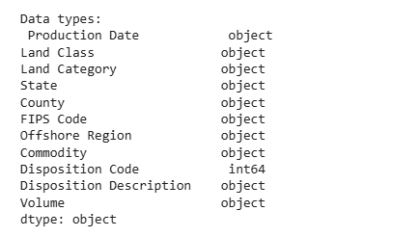
Figure 3.1: Data Types in the Dataset
This figure illustrates the type of data present in each of the variables in the data. All the properties are categorical with location, land classification, and commodity type among others and production volume as an object and then converted. The correct choice of preprocessing stages and modelling methods depends on the knowledge of the type of data.

3.2 Dataset Selection Justification
The dataset is appropriate on the project, as it offers a long time run of monthly time series of the volume of energy production that is necessary to achieve the reliable forecast analysis. The data has evident temporal trends, trends, and seasonal behaviour which sustain time series modelling (Parpoula, 2024). It is the one that is relevant to the research question because it allows a direct comparison of the statistical and deep learning models in predicting the monthly demand of energy production with the help of the history.

3.3 Exploratory Data Analysis
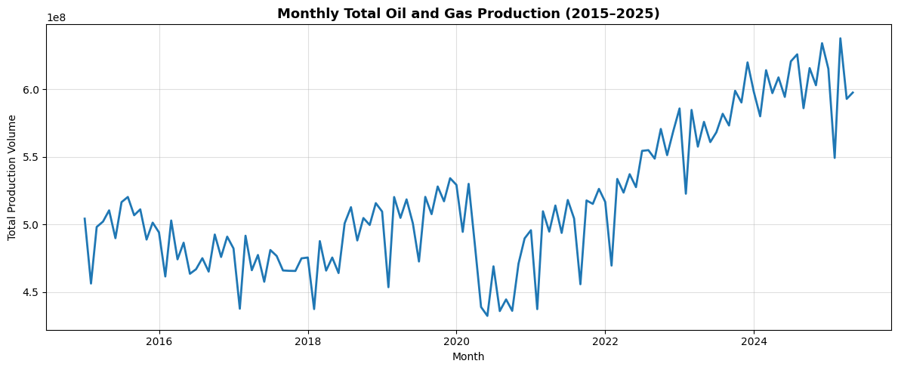
Figure 3.2 Monthly Total Oil and Gas Production 2015 to 2025
This value is used to show monthly aggregated oil and gas production of the period under study. It points out seasonal variations, long term variations and significant production declines and recoveries. The apparent time series pattern justifies the application of time series forecasting models that are able to help to capture seasonality and trend behaviour.
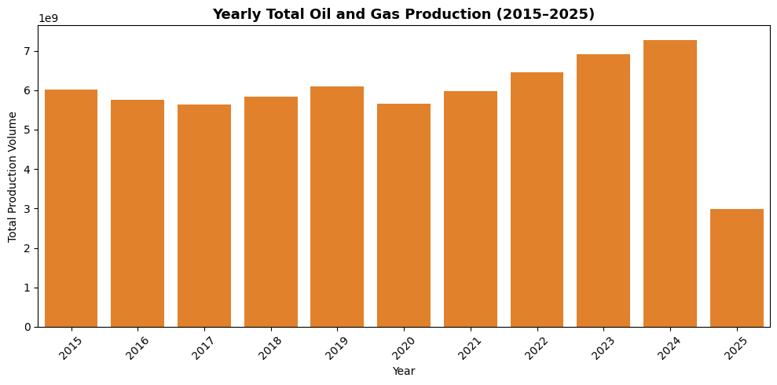
Figure 3.3 Yearly Total Oil and Gas Production 2015 to 2025
This number displays annual cumulative production quantities throughout the dataset period. It shows a general upward trend albeit with a noticeable drop towards 2020 after which there is an improvement in the next few years. Such an annual compilation assists in contextualising the long term changes in productions as well as confirming the occurrence of structural changes in the data.
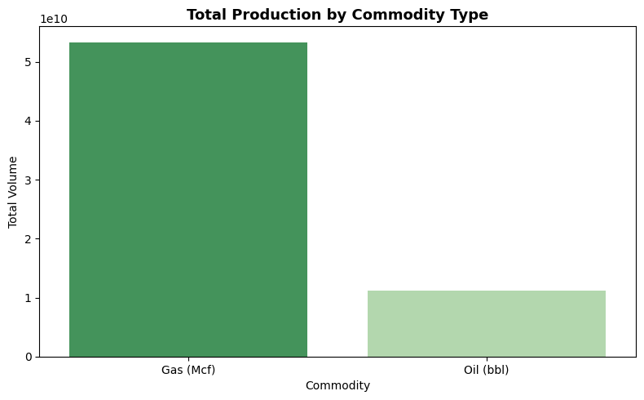
Figure 3.4 Total Production by Commodity Type
This figure is a comparison of volumes of production of different commodities in totality. The production of gas is significantly more than that of oil in the sense that it is making the bigger share of total energy production. Such imbalance is significant in terms of interpreting the results of the forecasting because the aggregate series of production is dominated by the patterns of gas production.
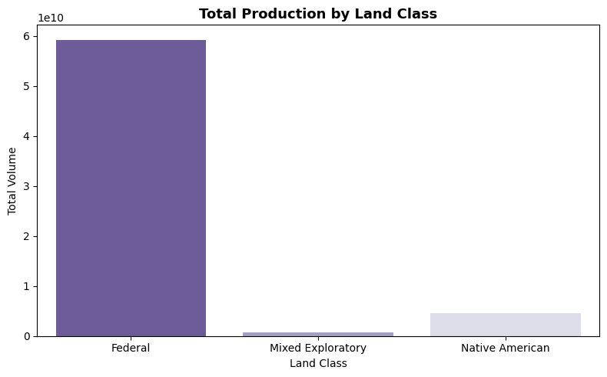
Figure 3.5 Total Production by Land Class
This table shows aggregate production rates by the land class. Most of the production in Federal land and mixed and Native American-oriented exploratory lands have less significant portion. The distribution emphasizes geographical and regulatory effects of production and assists in aggregation choices of preprocessing.

3.4 Data Preprocessing
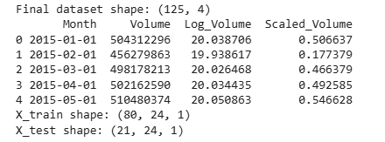
Figure 3.6: Final Dataset Shape with Train and Test Shape
This value is just the sum of the ready data set that is used to model. It displays the amount of observations that were observed, the features that were selected and the training and test shapes. The form of the dataset validates the appropriateness of the sequence-based models with a fixed lookback window and supervised learning format.

4. Ethical Issues

4.1 Ethical Review of Dataset
The data employed in this project is aggregated information on monthly energy production and does not include individual or identifiable data. There is no information on individuals, households and particular organisations. Consequently, the problems of anonymisation are nonexistent, as the data is being provided at an aggregated stage (Gadotti et al., 2024). The data that is collected only concerns the amount of production and the factors in terms of time, making sure that individual privacy is not compromised.
Regarding the rules on data protection, the dataset is not subject to the General Data Protection Regulation. The GDPR concerns mostly personal data, as the term is information pertaining to a specific identified or identifiable natural person (Irti, 2021). As the dataset does not provide such information, the GDPR requirements of compliance do not apply in the given case.

4.2 Ethical Approval Considerations
The university ethics committee did not need to give this project formal approval regarding ethical issues. No new data collection, surveys, interviews, or experiments were used on human participants. The entire creativity of the analysis was carried out through the secondary data retrieved from a publicly available source. Thus, the project is exempt from the necessity to receive ethical approval, and it does not pose risks to individuals or groups.

4.3 Data Usage and Consent
Kaggle is an open-source data sharing site where datasets are available and can be accessed via the platform for this project. Kaggle has provided licensing and use data that allow non-commercial academic analysis of the data. The information is not confidential and is available without payment or authorisation. This data is first of all compiled by a reputable organisation to keep track of the activity of energy production and the fact that it is transparent in its derivation is an indicator of ethical data collection methods.

5. Methodology

5.1 Problem Formulation
The aim of this project is to predict the future volumes of monthly energy production through the use of five monthly time series data. This is a problem of univariate time series forecasting, where previous observations are used to make future predictions.
Short-term forecasting, which refers to a forecast between one to three months ahead, is the prediction horizon. This horizon is suitable for operational planning, and it is in accordance with the usual practice in energy demand management in the industry.
Several assumptions are involved. Natural cycles like trends and seasonality are assumed to continue into the near future. Exogenous events like policy modifications or extreme events do not explicitly feature in the model. Preprocessing and aggregation of the data (monthly level), to an assumption of reliability, is made.

5.2 Model Selection Rationale
Two contrasting modelling approaches were chosen. The deep learning-based model and statistical time series model were applied to offer a powerful comparison.
LMST was selected because it possesses features to learn long-term dependencies on sequential data. Recurrent neural networks are suitable for complex nonlinear patterns that might not be sufficiently represented with a traditional statistical model (Mao and Sejdić, 2022). The vanishing gradient problem is solved by LSTM cells, and it enables the model to remember long sequences.
The choice of SARIMA was due to its strength as a baseline statistical model (Szostek et al., 2024). It is a clear model of trend, seasonality and autoregressive relationships. SARIMA is still commonly applied in industry because of its interpretation and applicability to organised time series data (Majka, 2024).
Other alternatives, like simple exponential smoothing of alternatives, were also entertained. These were not chosen as they either did not provide as much flexibility to represent complex temporal relationships, or they were conceptually redundant to SARIMA or did not provide much new information.

5.3 LSTM Model Implementation
The sequential neural network architecture was used to implement the LSTM model. The model comprises an LSTM layer and a dropout layer with a dense output layer at the end. This is a model capacity and overfitting control structure.
The sliding window was used to create input sequences. The look-back window of 24 months was adopted to ensure that the model learnt the seasonal patterns every year. All the input sequences hold log-transformed values of past production, which are scaled.
The process of training was to divide the data into training and testing sets by way of time cut. The learning rate reduction callback, as well as early stopping, were used to prevent overfitting and to enhance convergence (Anam et al., 2024). Adam optimiser was employed because it is effective when dealing with noisy gradients (Makinde, 2024). Important hyperparameters were the number of units of the LSTM, the batch size, the learning rate, and the number of epochs. These values were chosen by means of empirical practice.

5.4 SARIMA Model Implementation
The SARIMA model was applied to long-monthly values of production. The model order selection was in regular notation, with non-seasonal and seasonal terms being represented by autoregressive, differencing, and moving averaging.
Explicit seasonality was managed with a 12-month period being used to capture annual energy production cycles. This was done to create stationarity by differencing.
The training was done with the model fitted on the training part of the data by maximum likelihood estimation. SARIMA does not perform iterative epoch-based training as the neural networks do (Zheng et al., 2021). Residual diagnostics and forecast performance were used to test the model adequacy.

5.5 Model Optimisation
Model optimisation was aimed at enhancing generalisation and predicting ability. In the LSTM model, the length of lookback windows was varied so that the effect of these variables could be evaluated. The number of neurons, the dropout rate, and the hyperparameters increased and decreased.
A hold-out temporal split was used to validate instead of random sampling, to keep time dependent (Bami et al., 2025). In the case of SARIMA, the optimisation process entailed trial on the various orders of the model and estimation on the residual behaviour to determine whether assumptions were met.

5.6 Evaluation Metrics
The performance of models was evaluated using a number of evaluation metrics. Absolute prediction error was measured using RMSE and MAE. To have a scale-independent measure of relative error, MAPE was added.
Aggregation reports of the values of production were mainly assessed on a log scale due to its huge scale (Chaturvedi et al., 2022). This makes the variance constant and more interpretable error measures. The original scale was used to report MAPE and accuracy in order to ensure that the established metrics remained practical.

6. Results

6.1 LSTM Results
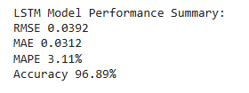
Figure 6.1: LSTM Model Performance Summary
This value is a summation of the total performance of the LSTM model based on several evaluation measures. The minimum values of RMSE and MAE on the log are good predictors. The low MAPE and high accuracy indicate that the model is reliable when it is used to give short-term forecasts, even when the values of production are huge.
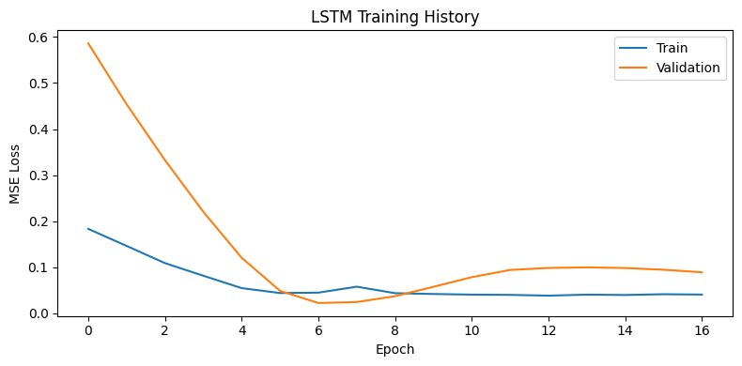
Figure 6.2: LSTM Training History
The figure indicates the training and validation loss of the LSTM model at consecutive epochs. Both the losses diminish in early periods and level off later, pointing to good learning. The fact that there is no divergence between the training and validation curve indicates that there are minimal overfitting and excellent generalisation.
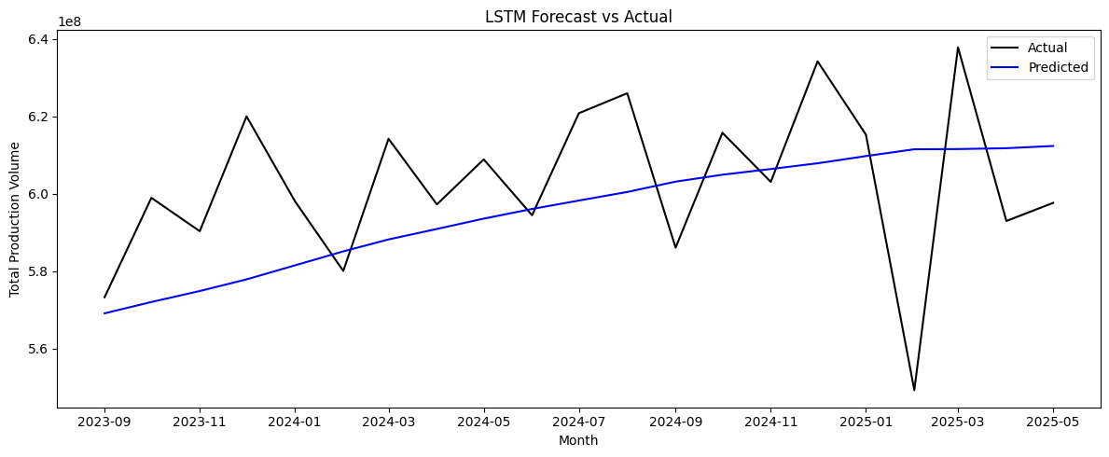
Figure 6.3: LSTM Forecast vs Actual
This figure is a comparison between the iso-production values and LSTM predictions during the test period. The forecast is used to capture the general trend and smooth short-run fluctuations. Although extreme fluctuations are not quite matched, the model still conforms closely to the underlying pattern, which happens to justify that it can be used in short-term energy projection forecasting.
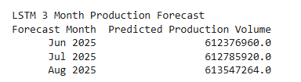
Figure 6.4: LSTM 3-Month Production Forecast
The figure illustrates the LSTM model prediction of the following three months out of the observed data. According to the forecasts, smooth further development of the current trend can be expected. These predictions are indicative of the model's capacity to project extrapolated future values of production and give recommendations to apply soon planning.

6.2 SARIMA Results
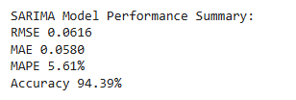
Figure 6.5: SARIMA Model Performance Summary
The figure is an overview of the SARIMA model’s performance in the same terms as the LSTM model. The increment in the RMSE and MAE implies that the predictive accuracy of higher RMSE and MAE is lower than that of LSTM. Nevertheless, the outcomes are also quite rational, which proves the effectiveness of SARIMA as a quality statistical foundation of monthly energy predictions.
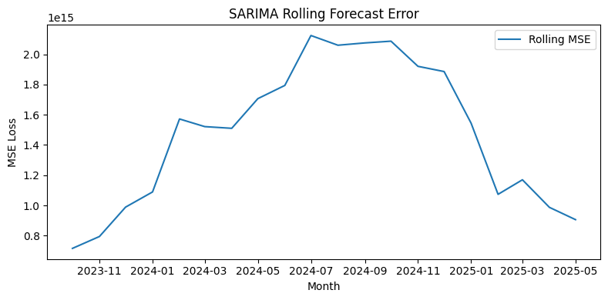
Figure 6.6: SARIMA Rolling Forecast Error
Through this figure, the time series of rolling mean squared error of SARIMA forecasts has been illustrated in the test period. The changes in error draw significant time differences when the model failed to cope with new changes. In general, the plot offers some understanding of forecast stability and can be seen as a similar performance diagnostic to the history of neural network training.
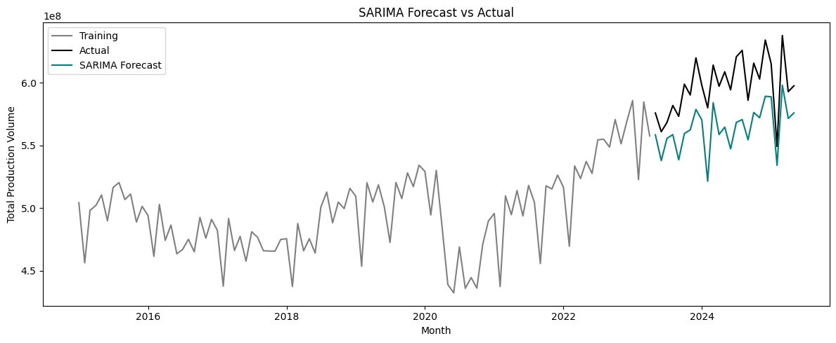
Figure 6.7: SARIMA Forecast vs Actual
This figure is the comparison between SARIMA forecasting and real production values for the whole dataset. The model represents the long-term trend and seasonality and undervalues sudden changes. This behaviour is the manifestation of the linearity of SARIMA and the reasons why it has relatively poorer performance relative to the nonlinear LSTM method.
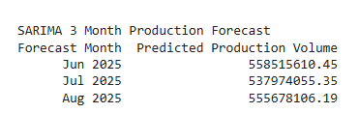
Figure 6.8: SARIMA 3-Month Production Forecast
This figure demonstrates the SARIMA prediction of the next three months. The values that are predicted are a slight decline in comparison with the current observations. These outcomes, indicative of the model's dependence on historical seasonality and trend, are a conservative short-term forecast that is applicable in the case of baseline planning.

6.3 Model Comparison
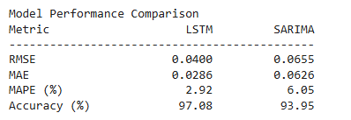
Figure 6.9: Model Performance Comparison
This figure involves a quantitative comparison of LSTM and SARIMA models. The error values and the accuracy obtained by LSTM are lower and higher, respectively. The comparison affirms that deep learning offers better predictive performance to the dataset, whilst SARIMA is a practical, interpretable benchmark.
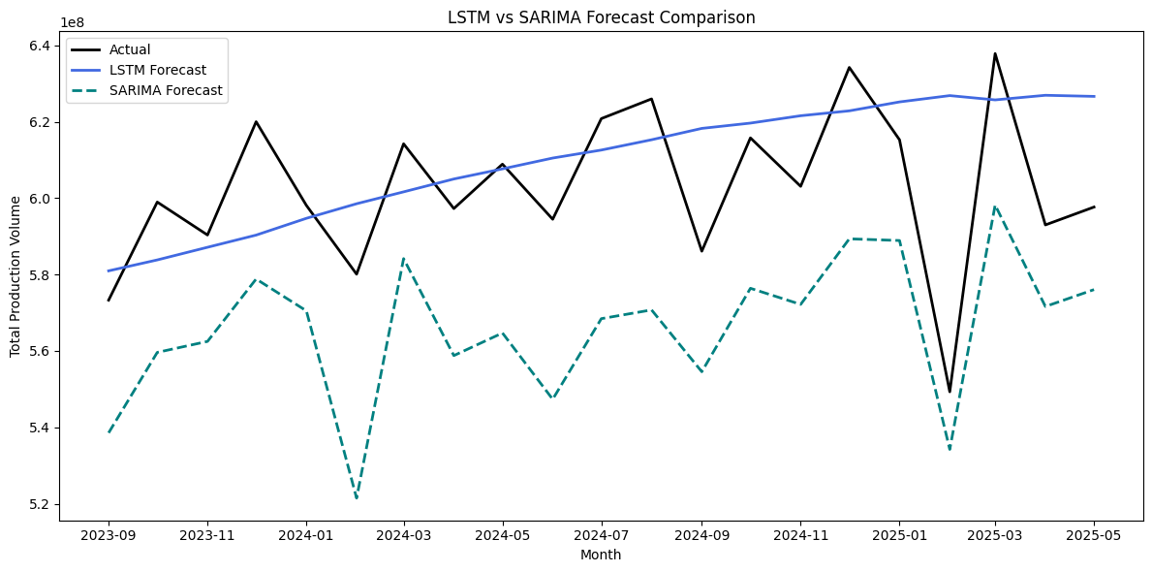
Figure 6.10: LSTM vs SARIMA Forecast Comparison
The visual representation of this figure is the comparison of LSTM and SARIMA forecasts with the true production values. The forecasts for LSTM are close to the observed trend, whereas SARIMA lags during turbulent times. The comparison demonstrates the benefit of LSTM to learn nonlinear time dynamics that are found in energy production data.

7. Analysis and Discussion
This part of the study will discuss the output of the LSTM and SARIMA models, explain their performance, compare it with the available literature, and assess the practical implications and constraints of the study. The discussion is organized in a manner that directly answers the research question and objectives of the project.

7.1 Interpretation of Results
The assessment measures give awareness of various performance forecasts. The log scale relative error indices, RMSE, and MAE minimize the impacts of high production values associated with the actual error. A decrease in values of these measures shows the closer the value of the prediction and actual. Relative error measure provided by MAPE is scale independent and hence it is specifically useful in determining the strength of forecasts in high magnitude data. Accuracy is the MAPE-based measure that gives easy-to-understand information about the quality of the model.
The forecasting behaviour obtained indicates that both the models are effective in including the overall trend as well as the seasonal pattern of the monthly energy production. The LSTM model will be more flowing and adaptive to make predictions particularly when there is a slow change. SARIMA forecasts have consistent behaviour with slower responses to changes, especially in volatile periods. These disparities show the modelling methods that these models have and how they can learn more intricate temporal variations.

7.2 Model Performance Comparison
In sum, the LSTM model showed better results compared to the SARIMA model in all the assessment measures. It had less error, and a high level of accuracy, and this means it has a better level of predictive ability. This is a quantitative and visual performance advantage that has been observed in the forecast comparison plots.
The major cause of this variation is that LSTM networks have the capacity of modeling nonlinear relationships and long term relations in the time series data. Gated memory cells implemented enable the LSTM to memorise the appropriate historical data and adjust to the emerging trends. Conversely, SARIMA is dependent on linear variations and structural seasonal models but is therefore less proximate to the sudden variation and subcomplicated dynamics. Although the SARIMA is able to withstand steady and highly seasonal time series, it is not as adaptable as the deep learning methods in this regard.

7.3 Comparison with Literature
According to the findings of the presented study, the existing research on the statistical and deep learning models in the field of energy forecasting are similar. It has been stated in previous works that LSTM based models have a high tendency of doing better as compared to SARIMA when it is known to contain nonlinear temporal dependencies (Chaturvedi et al., 2022). These are evidenced by the fact that LSTM is performing better in this project. Nevertheless, other works do competitive or similar performance of SARIMA versus neural networks when data sets are smaller, or the datasets have strong regular seasonality. The variability in the results may be explained by the nature of data, prediction horizon, and the method used in preprocessing. In this undertaking, log transformation and adequate historical data could have played a role in better performance of the LSTM as compared to SARIMA.

7.4 Practical Implications
The findings provide that the LSTM models can give reliable and accurate predictions of short-term energy production, which makes them applicable in the real world. Such forecasts can be utilized by energy providers when planning their operations, managing resources, and balancing demand. Better forecasting can be used to overcome operational inefficiencies and increase decision making in the face of uncertainty. The SARIMA models are also useful because they are easier to interpret and less computationally intensive (Kumari and Muthulakshmi, 2024). They may be used as standard prediction instruments or be utilised under conditions that focus on transparency and simplicity are of interest. The models have complementary information that can be used to support various energy planning levels and analyses.

7.5 Limitations
There are some shortcomings that should be mentioned. This analysis relied on the univariate time series data and it failed to include any external explanatory factors, like weather, economic activity or policy changes. This omission of the factors can restrain the accuracy of forecasting at a time of influence by the external events.
These are also model related limitations. The LSTM model requires delicate calibration and adequately large amounts of data to prevent the possibility of overfitting and SARIMA is limited by its linear nature and its assumption of stationarity (Sirisha et al., 2022). Also, the study concentrated on short-term forecasting which reduces information on the long-term energy planning.

7.6 Research Question Evaluation
The project goals were largely fulfilled. The past trends in energy production were effectively examined, prediction models were created, and overall comparison was made. The findings form a clear indication that LSTM outperforms SARIMA in the ability to identify the time-related occurrences and make precise forecasts in relation to this dataset. Overall, the suggested method can help answer the research question and prove the usefulness of the integration of statistical and deep learning techniques in energy demand prediction.

8. Conclusion and Future Work
The current project explored the possibility of using statistical and deep learning-based methods to predict monthly energy production using a historical time series. An end-of-the-end methodology has been used which consists of preprocessing of data, exploratory data analysis, model implementation, optimisation and evaluation. Two forecasting models were created, SARIMA and LSTM, and evaluated with the same metrics so that they could be fairly compared.
The findings indicate that the two models could both be used to model the overall trends and seasonality that exist in the data of energy production. Nevertheless, the LSTM model had high forecasting levels. It yielded smaller error values on the log scale and greater accuracy with the evaluation of MAPE. The LSTM model was better at getting complex temporal dependencies and fitting nonlinear qualities of the data. SARIMA, in contrast, gave consistent and understandable forecasts but was weak in reacting to extreme fluctuations and variations in response.
Practically, the conclusions indicate that deep learning models like LSTM are better applied in short-term energy demand forecasting in case enough historical data is available. Proper forecasts will help the energy providers in operational planning, management capacity, and balancing of the demand (Adekunle et al., 2021). The more transparent basis tools, nonetheless, such as SARIMA, are also useful in a context where interpretability and reduced computational demands are of concern.
Nevertheless, several limitations were found even in view of these strengths. This analysis was based on univariate time series data, and it failed to consider other external variables like weather conditions, economic indicators or changes in policies. Also, these are short-term predictions and give no insights into the long-term planning scenarios.
Further research on these shortcomings may take place in the future, where the models are expanded into a multivariate approach that considers important exogenous variables. The performance can also be improved by exploring other deep learning models like GRU or attention-based models (Yin et al., 2023). Lastly, testing of model robustness under alternative ( Energy ) datasets and forecasting horizons would further increase the generalisability and applicability of the proposed approach in the real world.

References
Malakar, S., Goswami, S., Ganguli, B., Chakrabarti, A., Roy, S.S., Boopathi, K. and Rangaraj, A.G., (2021), ‘Designing a long short-term network for short-term forecasting of global horizontal irradiance’, SN Applied Sciences, 3(4), p. 477. (Available at: https://link.springer.com/content/pdf/10.1007/s42452-021-04421-x.pdf)
Muhammad, A.A.M., (2024), Energy consumption in COVID-19 impact: data analysis and deep learning modeling, Master’s thesis, Ural Federal University. (Available at: https://elar.urfu.ru/bitstream/10995/140560/1/m_th_a.a.m.muhammad_2024.pdf)
Oliveira, N., Sousa, N. and Praça, I., (2022), ‘Deep learning for short-term instant energy consumption forecasting in the manufacturing sector’, Proceedings of the International Symposium on Distributed Computing and Artificial Intelligence, pp. 165–175. (Available at: https://arxiv.org/pdf/2207.01595)
Aguilar Madrid, E. and Antonio, N., (2021), ‘Short-term electricity load forecasting with machine learning’, Information, 12(2), p. 50. (Available at: https://www.mdpi.com/2078-2489/12/2/50)
Ullah, I., Hasanat, S.M., Aurangzeb, K., Alhussein, M., Rizwan, M. and Anwar, M.S., (2023), ‘Multi-horizon short-term load forecasting using hybrid of LSTM and modified split convolution’, PeerJ Computer Science, 9, p. e1487. (Available at: https://peerj.com/articles/cs-1487/)
Husnoo, M.A., Anwar, A., Hosseinzadeh, N., Islam, S.N., Mahmood, A.N. and Doss, R., (2023), ‘A secure federated learning framework for residential short-term load forecasting’, IEEE Transactions on Smart Grid, 15(2), pp. 2044–2055. (Available at: https://arxiv.org/pdf/2209.14547)
Wang, K., Zhang, J., Li, X. and Zhang, Y., (2023), ‘Long-term power load forecasting using LSTM-informer with ensemble learning’, Electronics, 12(10), p. 2175. (Available at: https://www.mdpi.com/2079-9292/12/10/2175)
Nammalam, L.N.R., Arif, M.T., Gargoom, A. and Oo, A.M., (2020), ‘Energy efficiency as a key indicator for energy demand forecasting and management’, Proceedings of the Australasian Universities Power Engineering Conference, pp. 1–6. (Available at: https://ieeexplore.ieee.org/abstract/document/9344477)
Aluko-Olokun, P., (2024), ‘Leveraging deep learning for predictive maintenance and grid stability in renewable energy integrated power systems’, International Journal of Research Publication and Reviews, 5, pp. 7984–8000. (Available at: https://www.researchgate.net/profile/Pelumi-Aluko-Olokun/publication/387065285_Leveraging_Deep_Learning_for_Predictive_Maintenance_and_Grid_Stability_in_Renewable_Energy-Integrated_Power_Systems/links/68c52aeb508ac7086f59abff/Leveraging-Deep-Learning-for-Predictive-Maintenance-and-Grid-Stability-in-Renewable-Energy-Integrated-Power-Systems.pdf)
Dixit, A. and Jain, S., (2023), ‘Contemporary approaches to analyze non-stationary time series: some solutions and challenges’, Recent Advances in Computer Science and Communications, 16(2), pp. 61–80. (Available at: https://www.benthamdirect.com/content/journals/rascs/10.2174/2666255815666220523125447)
Dudek, G., (2023), ‘STD: a seasonal trend dispersion decomposition of time series’, IEEE Transactions on Knowledge and Data Engineering, 35(10), pp. 10339–10350. (Available at: https://ieeexplore.ieee.org/stamp/stamp.jsp?arnumber=10105521)
Zaheer, S., Anjum, N., Hussain, S., Algarni, A.D., Iqbal, J., Bourouis, S. and Ullah, S.S., (2023), ‘A multi parameter forecasting for stock time series data using LSTM and deep learning model’, Mathematics, 11(3), p. 590. (Available at: https://www.mdpi.com/2227-7390/11/3/590)
Dubey, A.K., Kumar, A., García-Díaz, V., Sharma, A.K. and Kanhaiya, K., (2021), ‘Study and analysis of SARIMA and LSTM in forecasting time series data’, Sustainable Energy Technologies and Assessments, 47, p. 101474. (Available at: https://www.sciencedirect.com/science/article/abs/pii/S2213138821004847)
Parpoula, C., (2024), ‘An analytical approach for identifying trend seasonal components and detecting unexpected behaviour in psychological time series’, International Journal of Psychology, 59(6), pp. 1307–1316. (Available at: https://onlinelibrary.wiley.com/doi/pdf/10.1002/ijop.13244)
Irti, C., (2021), ‘Personal data, non personal data, anonymised data, pseudonymised data, de identified data’, in Privacy and Data Protection in Software Services, Singapore: Springer Singapore, pp. 49–57. (Available at: https://link.springer.com/chapter/10.1007/978-981-16-3049-1_5)
Gadotti, A., Rocher, L., Houssiau, F., Creţu, A.M. and De Montjoye, Y.A., (2024), ‘Anonymization: The imperfect science of using data while preserving privacy’, Science Advances, 10(29), eadn7053. (Available at: https://www.science.org/doi/abs/10.1126/sciadv.adn7053)
Mao, S. and Sejdić, E., (2022), ‘A review of recurrent neural network based methods in computational physiology’, IEEE Transactions on Neural Networks and Learning Systems, 34(10), pp. 6983–7003. (Available at: https://ieeexplore.ieee.org/abstract/document/9705533)
Majka, M., (2024), ‘Seasonal time series analysis: Why SARIMA outshines ARIMA’, ResearchGate, September 2024. (Available at: https://www.researchgate.net/profile/Marcin-Majka-2/publication/384196885)
Szostek, K., Mazur, D., Drałus, G. and Kusznier, J., (2024), ‘Analysis of the effectiveness of ARIMA, SARIMA, and SVR models in time series forecasting: A case study of wind farm energy production’, Energies, 17(19). (Available at: https://search.ebscohost.com)
Anam, M.K., Defit, S., Haviluddin, H., Efrizoni, L. and Firdaus, M.B., (2024), ‘Early stopping on CNN LSTM development to improve classification performance’, Journal of Applied Data Sciences, 5(3), pp. 1175–1188. (Available at: http://www.bright-journal.org/Journal/index.php/JADS/article/view/312)
Makinde, A., (2024), ‘Optimizing time series forecasting: A comparative study of Adam and Nesterov accelerated gradient on LSTM and GRU networks using stock market data’, arXiv preprint, arXiv:2410.01843. (Available at: https://arxiv.org/abs/2410.01843)
Zheng, J., Wang, J., Li, J., Chen, S., Shu, L. and Peng, Y., (2021), ‘Deep neural networks for detection of abnormal trend in electricity data’, Proceedings of the Romanian Academy, Series A, 22(3), pp. 291–298. (Available at: https://academiaromana.ro/sectii2002/proceedings/doc2021-3/11-Zheng.pdf)
Bami, Z., Behnampour, A. and Doosti, H., (2025), ‘A new flexible train test split algorithm: An approach for choosing among the hold out, k fold cross validation, and hold out iteration’, arXiv preprint, arXiv:2501.06492. (Available at: https://arxiv.org/abs/2501.06492)
Chaturvedi, S., Rajasekar, E., Natarajan, S. and McCullen, N., (2022), ‘A comparative assessment of SARIMA, LSTM RNN and FB Prophet models to forecast total and peak monthly energy demand for India’, Energy Policy, 168, p. 113097. (Available at: https://www.sciencedirect.com/science/article/pii/S0301421522003226)
Yin, C., Tang, D., Zhang, F., Tang, Q., Feng, Y. and He, Z., (2023). ‘Students learning performance prediction based on feature extraction algorithm and attention-based bidirectional gated recurrent unit network’. Plos one, 18(10), p.e0286156. (Available at: https://journals.plos.org/plosone/article?id=10.1371/journal.pone.0286156)
Adekunle, B.I., Chukwuma-Eke, E.C., Balogun, E.D. and Ogunsola, K.O., (2021). Predictive analytics for demand forecasting: Enhancing business resource allocation through time series models. Journal of Frontiers in Multidisciplinary Research, 2(01), pp.32-42. (Available at: https://www.researchgate.net/profile/Anfo-Pub-2/publication/390459807_Predictive_Analytics_for_Demand_Forecasting_Enhancing_Business_Resource_Allocation_Through_Time_Series_Models/links/67ee8c3376d4923a1af2a74e/Predictive-Analytics-for-Demand-Forecasting-Enhancing-Business-Resource-Allocation-Through-Time-Series-Models.pdf)

Chaturvedi, S., Rajasekar, E., Natarajan, S. and McCullen, N., (2022). A comparative assessment of SARIMA, LSTM RNN and Fb Prophet models to forecast total and peak monthly energy demand for India. Energy Policy, 168, p.113097. (Available at: https://www.sciencedirect.com/science/article/pii/S0301421522003226)
Kumari, S. and Muthulakshmi, P., (2024). SARIMA model: an efficient machine learning technique for weather forecasting. Procedia Computer Science, 235, pp.656-670. (Available at: https://www.sciencedirect.com/science/article/pii/S1877050924007403)
Sirisha, U.M., Belavagi, M.C. and Attigeri, G., (2022). Profit prediction using ARIMA, SARIMA and LSTM models in time series forecasting: A comparison. Ieee Access, 10, pp.124715-124727. (Available at: https://ieeexplore.ieee.org/abstract/document/9964190/)

Appendices

Appendix A: Additional Images
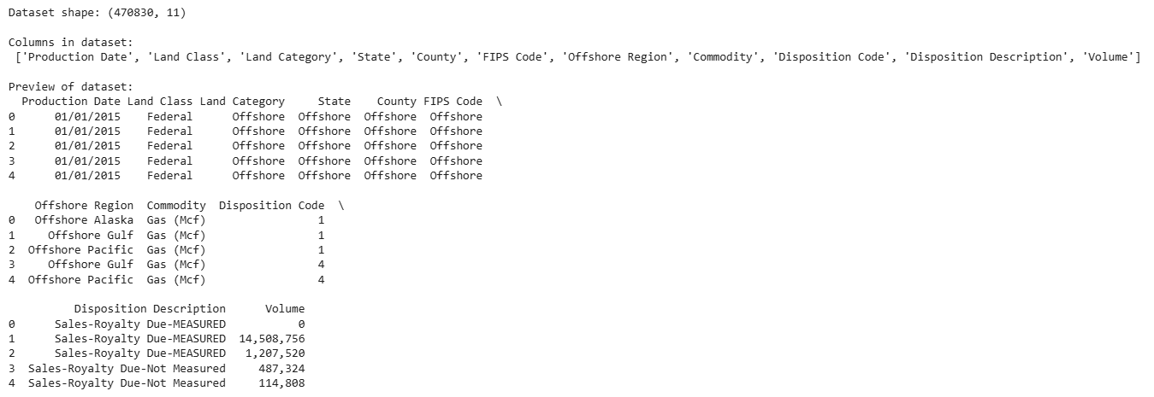
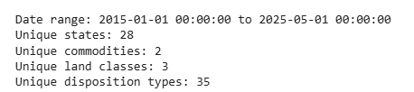
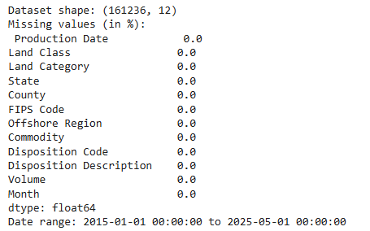

Appendix B: Python Code
# Data Loading

# Step 1: Load and inspect the dataset
# Import required libraries
import pandas as pd
import numpy as np

# Load dataset
file_path = "OGORBcsv_cleaned.csv"
df = pd.read_csv(file_path)

# Display basic information
print("Dataset shape:", df.shape)
print("\nColumns in dataset:\n", df.columns.tolist())

# Display first few rows
print("\nPreview of dataset:")
print(df.head())

# Step 2: Check data types and missing values
print("\nData types:\n", df.dtypes)
print("\nMissing values (in %):\n", (df.isna().mean() * 100).round(2))

# Step 3: Convert date and volume columns
# Convert 'Production Date' to datetime format
df['Production Date'] = pd.to_datetime(df['Production Date'], errors='coerce')

# Convert 'Volume' to numeric (remove commas if needed)
df['Volume'] = df['Volume'].replace(',', '', regex=True)
df['Volume'] = pd.to_numeric(df['Volume'], errors='coerce')

# Step 4: Quick summary after cleaning
print("\nDate range:", df['Production Date'].min(), "to", df['Production Date'].max())
print("Unique states:", df['State'].nunique())
print("Unique commodities:", df['Commodity'].nunique())
print("Unique land classes:", df['Land Class'].nunique())
print("Unique disposition types:", df['Disposition Description'].nunique())

"""# Data Preparation"""

import pandas as pd
import numpy as np
from sklearn.preprocessing import MinMaxScaler

# Convert data types
df['Production Date'] = pd.to_datetime(df['Production Date'], errors='coerce')
df['Volume'] = pd.to_numeric(df['Volume'], errors='coerce')

# Drop invalid rows
df = df.dropna(subset=['Production Date', 'Volume'])
df = df[df['Volume'] > 0]

# Create Month column
df['Month'] = df['Production Date'].values.astype('datetime64[M]')

# Aggregate monthly total production
monthly_df = df.groupby('Month')['Volume'].sum().reset_index()

# Create full monthly range
full_range = pd.date_range(
start=monthly_df['Month'].min(),
end=monthly_df['Month'].max(),
freq='MS'
)

# Reindex to include missing months
monthly_df = (
monthly_df
.set_index('Month')
.reindex(full_range)
.fillna(0.0)
.rename_axis('Month')
.reset_index()
)

# Log transform AFTER reindexing
monthly_df['Log_Volume'] = np.log1p(monthly_df['Volume'])

# Train test split index
train_size = int(len(monthly_df) * 0.8)

# Scale using training data only
scaler = MinMaxScaler(feature_range=(0, 1))

monthly_df.loc[:train_size, 'Scaled_Volume'] = scaler.fit_transform(
monthly_df.loc[:train_size, ['Log_Volume']]
)

monthly_df.loc[train_size:, 'Scaled_Volume'] = scaler.transform(
monthly_df.loc[train_size:, ['Log_Volume']]
)

# Verify
print("Final dataset shape:", monthly_df.shape)
print(monthly_df.head())

# Sequence creation function
def create_sequences(data, lookback=24):
X, y = [], []
for i in range(lookback, len(data)):
X.append(data[i - lookback:i])
y.append(data[i])
return np.array(X), np.array(y)

# Create LSTM sequences
lookback = 24
values = monthly_df['Scaled_Volume'].values
X, y = create_sequences(values, lookback)

# Train test split
split_index = int(len(X) * 0.8)
X_train, X_test = X[:split_index], X[split_index:]
y_train, y_test = y[:split_index], y[split_index:]

# Reshape for LSTM
X_train = X_train.reshape((X_train.shape[0], X_train.shape[1], 1))
X_test = X_test.reshape((X_test.shape[0], X_test.shape[1], 1))

print("X_train shape:", X_train.shape)
print("X_test shape:", X_test.shape)

"""# Exploratory Data Analysis (EDA)"""

import pandas as pd
import numpy as np
import matplotlib.pyplot as plt
import seaborn as sns
import warnings
warnings.filterwarnings("ignore")

# Convert necessary columns
df['Production Date'] = pd.to_datetime(df['Production Date'], errors='coerce')
df['Volume'] = df['Volume'].replace(',', '', regex=True)
df['Volume'] = pd.to_numeric(df['Volume'], errors='coerce')

# Basic information
print("Dataset shape:", df.shape)
print("Missing values (in %):\n", (df.isna().mean() * 100).round(2))
print("Date range:", df['Production Date'].min(), "to", df['Production Date'].max())

# Create monthly and yearly aggregations
df['Month'] = df['Production Date'].values.astype('datetime64[M]')
df['Year'] = df['Production Date'].dt.year
monthly_df = df.groupby('Month')['Volume'].sum().reset_index()
yearly_df = df.groupby('Year')['Volume'].sum().reset_index()

# 1. Monthly total production trend (Blue theme)
plt.figure(figsize=(12, 5))
plt.plot(monthly_df['Month'], monthly_df['Volume'], color='#1f77b4', linewidth=2)
plt.title("Monthly Total Oil and Gas Production (2015–2025)", fontsize=13, fontweight='bold')
plt.xlabel("Month")
plt.ylabel("Total Production Volume")
plt.grid(True, alpha=0.4)
plt.tight_layout()
plt.show()

# 2. Yearly total production trend (Orange theme)
plt.figure(figsize=(10, 5))
sns.barplot(x='Year', y='Volume', data=yearly_df, color='#ff7f0e')
plt.title("Yearly Total Oil and Gas Production (2015–2025)", fontsize=13, fontweight='bold')
plt.xlabel("Year")
plt.ylabel("Total Production Volume")
plt.xticks(rotation=45)
plt.tight_layout()
plt.show()

# 3. Total production by commodity type (Green theme)
plt.figure(figsize=(8, 5))
commodity_df = df.groupby('Commodity')['Volume'].sum().reset_index()
sns.barplot(x='Commodity', y='Volume', data=commodity_df, palette='Greens_r')
plt.title("Total Production by Commodity Type", fontsize=13, fontweight='bold')
plt.xlabel("Commodity")
plt.ylabel("Total Volume")
plt.tight_layout()
plt.show()

# 4. Total production by land class (Purple theme)
plt.figure(figsize=(8, 5))
land_df = df.groupby('Land Class')['Volume'].sum().reset_index()
sns.barplot(x='Land Class', y='Volume', data=land_df, palette='Purples_r')
plt.title("Total Production by Land Class", fontsize=13, fontweight='bold')
plt.xlabel("Land Class")
plt.ylabel("Total Volume")
plt.tight_layout()
plt.show()

"""# Model Training

## Long Short-Term Memory (LSTM)
"""

import tensorflow as tf
from tensorflow import keras
from tensorflow.keras import layers
from sklearn.preprocessing import MinMaxScaler
from sklearn.metrics import mean_squared_error, mean_absolute_error
import matplotlib.pyplot as plt

# Reproducibility
seed = 42
np.random.seed(seed)
tf.random.set_seed(seed)

# Convert data types
df['Production Date'] = pd.to_datetime(df['Production Date'], errors='coerce')
df['Volume'] = df['Volume'].replace(',', '', regex=True)
df['Volume'] = pd.to_numeric(df['Volume'], errors='coerce')

# Remove invalid rows
df = df.dropna(subset=['Production Date', 'Volume'])
df = df[df['Volume'] > 0]

# Create Month column
df['Month'] = df['Production Date'].values.astype('datetime64[M]')

# Aggregate monthly totals
monthly_df = df.groupby('Month')['Volume'].sum().reset_index()

# Create full monthly range
full_range = pd.date_range(
start=monthly_df['Month'].min(),
end=monthly_df['Month'].max(),
freq='MS'
)

# Reindex missing months
monthly_df = (
monthly_df
.set_index('Month')
.reindex(full_range)
.fillna(0.0)
.rename_axis('Month')
.reset_index()
)

# Log transformation
monthly_df['Log_Volume'] = np.log1p(monthly_df['Volume'])

# Train test split index
train_size = int(len(monthly_df) * 0.8)

# Scaling using training data only
scaler = MinMaxScaler(feature_range=(0, 1))

monthly_df.loc[:train_size, 'Scaled_Volume'] = scaler.fit_transform(
monthly_df.loc[:train_size, ['Log_Volume']]
)

monthly_df.loc[train_size:, 'Scaled_Volume'] = scaler.transform(
monthly_df.loc[train_size:, ['Log_Volume']]
)

# Sequence creation
def create_sequences(data, lookback=24):
X, y = [], []
for i in range(lookback, len(data)):
X.append(data[i - lookback:i])
y.append(data[i])
return np.array(X), np.array(y)

lookback = 24
values = monthly_df['Scaled_Volume'].values
X, y = create_sequences(values, lookback)

# Train test split
split_index = int(len(X) * 0.8)
X_train, X_test = X[:split_index], X[split_index:]
y_train, y_test = y[:split_index], y[split_index:]

# Reshape for LSTM
X_train = X_train.reshape((X_train.shape[0], X_train.shape[1], 1))
X_test = X_test.reshape((X_test.shape[0], X_test.shape[1], 1))

print("X_train shape", X_train.shape)
print("X_test shape", X_test.shape)

# Build LSTM model
model = keras.Sequential([
layers.Input(shape=(X_train.shape[1], 1)),
layers.LSTM(64, activation='tanh'),
layers.Dropout(0.2),
layers.Dense(1)
])

model.compile(
optimizer=keras.optimizers.Adam(learning_rate=0.001),
loss='mse'
)

model.summary()

# Callbacks
early_stop = keras.callbacks.EarlyStopping(
monitor='val_loss',
patience=10,
restore_best_weights=True
)

reduce_lr = keras.callbacks.ReduceLROnPlateau(
monitor='val_loss',
factor=0.5,
patience=5,
min_lr=1e-5
)

# Train model
history = model.fit(
X_train,
y_train,
epochs=30,
batch_size=32,
validation_split=0.2,
callbacks=[early_stop, reduce_lr],
verbose=1
)

# Predict on test set
y_pred_scaled = model.predict(X_test).ravel()

# Inverse scaling and log transform
y_test_log = scaler.inverse_transform(y_test.reshape(-1, 1))
y_pred_log = scaler.inverse_transform(y_pred_scaled.reshape(-1, 1))

y_test_inv = np.expm1(y_test_log).ravel()
y_pred_inv = np.expm1(y_pred_log).ravel()

# Evaluation metrics in log scale
rmse_log = np.sqrt(mean_squared_error(y_test_log, y_pred_log))
mae_log = mean_absolute_error(y_test_log, y_pred_log)
mape = np.mean(np.abs((y_test_inv - y_pred_inv) / np.clip(np.abs(y_test_inv), 1e-8, None))) * 100
accuracy = 100 - mape

print("\nLSTM Model Performance Summary:")
print(f"RMSE {rmse_log:.4f}")
print(f"MAE {mae_log:.4f}")
print(f"MAPE {mape:.2f}%")
print(f"Accuracy {accuracy:.2f}%")

# Plot training history
plt.figure(figsize=(8, 4))
plt.plot(history.history['loss'], label='Train')
plt.plot(history.history['val_loss'], label='Validation')
plt.xlabel('Epoch')
plt.ylabel('MSE Loss')
plt.title('LSTM Training History')
plt.legend()
plt.tight_layout()
plt.show()

# Plot actual vs predicted
test_months = monthly_df['Month'].iloc[-len(y_test_inv):].reset_index(drop=True)

plt.figure(figsize=(12, 5))
plt.plot(test_months, y_test_inv, label='Actual', color='black')
plt.plot(test_months, y_pred_inv, label='Predicted', color='blue')
plt.xlabel('Month')
plt.ylabel('Total Production Volume')
plt.title('LSTM Forecast vs Actual')
plt.legend()
plt.tight_layout()
plt.show()

# Recursive forecasting
def recursive_forecast(model, scaler, last_sequence, steps, last_date):
seq = last_sequence.copy()
preds = []

for _ in range(steps):
pred_scaled = model.predict(seq[np.newaxis, :, :], verbose=0)[0, 0]
preds.append(pred_scaled)
seq = np.vstack([seq[1:], [[pred_scaled]]])

preds_log = scaler.inverse_transform(np.array(preds).reshape(-1, 1))
preds_inv = np.expm1(preds_log).ravel()

future_dates = pd.date_range(
start=last_date + pd.offsets.MonthBegin(1),
periods=steps,
freq='MS'
)

return pd.DataFrame({
'Forecast Month': future_dates.strftime('%b %Y'),
'Predicted Production Volume': np.round(preds_inv, 2)
})

# Generate 3 month forecast
last_date = monthly_df['Month'].max()
forecast_df = recursive_forecast(
model,
scaler,
last_sequence=X_test[-1],
steps=3,
last_date=last_date
)

print("LSTM 3 Month Production Forecast")
print(forecast_df.to_string(index=False))

"""## Seasonal Autoregressive Integrated Moving Average (SARIMA)"""

from statsmodels.tsa.statespace.sarimax import SARIMAX
from sklearn.metrics import mean_squared_error, mean_absolute_error

# Convert data types
df['Production Date'] = pd.to_datetime(df['Production Date'], errors='coerce')
df['Volume'] = df['Volume'].replace(',', '', regex=True)
df['Volume'] = pd.to_numeric(df['Volume'], errors='coerce')

# Remove invalid rows
df = df.dropna(subset=['Production Date', 'Volume'])
df = df[df['Volume'] > 0]

# Create Month column
df['Month'] = df['Production Date'].values.astype('datetime64[M]')

# Aggregate monthly totals
monthly_df = df.groupby('Month')['Volume'].sum().reset_index()

# Create full monthly range
full_range = pd.date_range(
start=monthly_df['Month'].min(),
end=monthly_df['Month'].max(),
freq='MS'
)

# Reindex missing months
monthly_df = (
monthly_df
.set_index('Month')
.reindex(full_range)
.fillna(0.0)
.rename_axis('Month')
.reset_index()
)

# Log transformation
monthly_df['Log_Volume'] = np.log1p(monthly_df['Volume'])

# Train test split
split_index = int(len(monthly_df) * 0.8)
train = monthly_df.iloc[:split_index]
test = monthly_df.iloc[split_index:]

print("Training range", train['Month'].min(), "to", train['Month'].max())
print("Testing range", test['Month'].min(), "to", test['Month'].max())

# Build SARIMA model on log scale
model = SARIMAX(
train['Log_Volume'],
order=(1, 1, 1),
seasonal_order=(1, 1, 1, 12),
enforce_stationarity=False,
enforce_invertibility=False
)

sarima_result = model.fit(disp=False)

# Forecast on test period
forecast = sarima_result.get_forecast(steps=len(test))
pred_log = forecast.predicted_mean
conf_int_log = forecast.conf_int()

# Inverse log transform
pred_volume = np.expm1(pred_log)
actual_volume = test['Volume'].values

# Evaluation metrics
rmse_log = np.sqrt(mean_squared_error(test['Log_Volume'], pred_log))
mae_log = mean_absolute_error(test['Log_Volume'], pred_log)
mape = np.mean(np.abs((actual_volume - pred_volume) / np.clip(np.abs(actual_volume), 1e-8, None))) * 100
accuracy = 100 - mape

print("\nSARIMA Model Performance Summary:")
print(f"RMSE {rmse_log:.4f}")
print(f"MAE {mae_log:.4f}")
print(f"MAPE {mape:.2f}%")
print(f"Accuracy {accuracy:.2f}%")

# Compute forecast errors
errors = actual_volume - pred_volume

# Rolling window MSE
window = 6 # 6 month rolling window
rolling_mse = (
pd.Series(errors ** 2)
.rolling(window=window)
.mean()
)

# Plot rolling MSE
plt.figure(figsize=(8, 4))
plt.plot(test['Month'], rolling_mse, label='Rolling MSE')
plt.xlabel('Month')
plt.ylabel('MSE Loss')
plt.title('SARIMA Rolling Forecast Error')
plt.legend()
plt.tight_layout()
plt.show()

# Plot actual vs predicted
plt.figure(figsize=(12, 5))
plt.plot(train['Month'], train['Volume'], label='Training', color='gray')
plt.plot(test['Month'], actual_volume, label='Actual', color='black')
plt.plot(test['Month'], pred_volume, label='SARIMA Forecast', color='teal')
plt.title('SARIMA Forecast vs Actual')
plt.xlabel('Month')
plt.ylabel('Total Production Volume')
plt.legend()
plt.tight_layout()
plt.show()

# Forecast next 3 months
future_steps = 3
future_forecast = sarima_result.get_forecast(steps=future_steps)
future_log = future_forecast.predicted_mean
future_volume = np.expm1(future_log)

future_dates = pd.date_range(
start=monthly_df['Month'].max() + pd.offsets.MonthBegin(1),
periods=future_steps,
freq='MS'
)

future_df = pd.DataFrame({
'Forecast Month': future_dates.strftime('%b %Y'),
'Predicted Production Volume': np.round(future_volume.values, 2)
})

print("\nSARIMA 3 Month Production Forecast")
print(future_df.to_string(index=False))

"""# Model Comparison"""

from sklearn.metrics import mean_squared_error, mean_absolute_error

# Ensure SARIMA predictions are on log scale
sarima_pred_log = pred_log.values

# LSTM predictions already available
lstm_pred_log = y_pred_log.ravel()
actual_log = y_test_log.ravel()

# Align lengths
min_length = min(len(actual_log), len(lstm_pred_log), len(sarima_pred_log))

actual_log = actual_log[-min_length:]
lstm_pred_log = lstm_pred_log[-min_length:]
sarima_pred_log = sarima_pred_log[-min_length:]

dates = test['Month'].reset_index(drop=True)[-min_length:]

# Convert to original scale for MAPE only
actual_volume = np.expm1(actual_log)
lstm_volume = np.expm1(lstm_pred_log)
sarima_volume = np.expm1(sarima_pred_log)

# Create comparison dataframe
comparison_df = pd.DataFrame({
'Month': dates,
'Actual': actual_volume,
'LSTM_Predicted': lstm_volume,
'SARIMA_Predicted': sarima_volume
})

# Log scale metrics
lstm_rmse_log = np.sqrt(mean_squared_error(actual_log, lstm_pred_log))
lstm_mae_log = mean_absolute_error(actual_log, lstm_pred_log)

sarima_rmse_log = np.sqrt(mean_squared_error(actual_log, sarima_pred_log))
sarima_mae_log = mean_absolute_error(actual_log, sarima_pred_log)

# MAPE and Accuracy
lstm_mape = np.mean(np.abs((actual_volume - lstm_volume) /
np.clip(np.abs(actual_volume), 1e-8, None))) * 100
sarima_mape = np.mean(np.abs((actual_volume - sarima_volume) /
np.clip(np.abs(actual_volume), 1e-8, None))) * 100

lstm_accuracy = 100 - lstm_mape
sarima_accuracy = 100 - sarima_mape

# Print comparison
print("\nModel Performance Comparison")
print(f"{'Metric':<15}{'LSTM':>15}{'SARIMA':>15}")
print("-" * 45)
print(f"{'RMSE':<15}{lstm_rmse_log:>15.4f}{sarima_rmse_log:>15.4f}")
print(f"{'MAE':<15}{lstm_mae_log:>15.4f}{sarima_mae_log:>15.4f}")
print(f"{'MAPE (%)':<15}{lstm_mape:>15.2f}{sarima_mape:>15.2f}")
print(f"{'Accuracy (%)':<15}{lstm_accuracy:>15.2f}{sarima_accuracy:>15.2f}")

# Plot comparison
plt.figure(figsize=(12, 6))
plt.plot(comparison_df['Month'], comparison_df['Actual'], label='Actual', color='black', linewidth=2)
plt.plot(comparison_df['Month'], comparison_df['LSTM_Predicted'], label='LSTM Forecast', color='royalblue', linewidth=2)
plt.plot(comparison_df['Month'], comparison_df['SARIMA_Predicted'], label='SARIMA Forecast', color='teal', linestyle='--', linewidth=2)
plt.xlabel('Month')
plt.ylabel('Total Production Volume')
plt.title('LSTM vs SARIMA Forecast Comparison')
plt.legend()
plt.tight_layout()
plt.show()

