

Hypertext Summarization for Hotel Review

Minh Tien, François Portet, Cyril Labbé

To cite this version:

Minh Tien, François Portet, Cyril Labbé. Hypertext Summarization for Hotel Review. 1. Introduction
2. SuRe system 3. Result and Evaluation 4. Discussion. 2015. <hal-01153598>

HAL Id: hal-01153598 https://hal.archives-ouvertes.fr/hal-01153598
Submitted on 20 May 2015

HAL is a multi-disciplinary open access archive for the deposit and dissemination of sci- entific research documents, whether they are pub- lished or not. The documents may come from teaching and research institutions in France or abroad, or from public or private research centers.
L’archive ouverte pluridisciplinaire HAL, est destinée au dépôt et à la diffusion de documents scientifiques de niveau recherche, publiés ou non, émanant des établissements d’enseignement et de recherche français ou étrangers, des laboratoires publics ou privés.
Hypertext Summarization for Hotel Review

First Author Nguyen Minh Tien Laboratoire d’Informatique
de Grenoble - e´quipe SIGMA
minh-tien.nguyen@imag.fr
Second Author Franc¸ois Portet Laboratoire d’Informatique
de Grenoble - e´quipe GETALP
francois.portet@imag.fr
Third Author
Cyril Labbe´
Laboratoire d’Informatique de Grenoble - e´quipe SIGMA cyril.labbe@imag.fr

Abstract

Nowadays, there is a huge amount of online reviews for almost every product and service. These reviews have largely contributed to the growth of e-commerce; however in place of a human, extracting related information from this mass of re- views in order to create an easy to under- stand summarization is not a trivial matter. In this study, we present the SuRe system to produce a textual summarization from hotel free-text reviews as well as a prelim- inary evaluation.

1 Introduction

Nowadays, there is a huge amount of customer re- views available online for almost every product and service. Commonly they are in the form of a short free-text, which contains not only general comments but also highly personal opinions or cir- cumstances. It would be a very valuable source of information for both the customers and the pro- ducers if we could be able to extract related in- formation from this large amount of review and present them in an efficient manner.
There have been different approaches in this field of research such as those purely based on fre- quency (Rotem, retrieved may 2014) or discover the overall polarity of a document (Sebastiani et al., 2006). Some tried to tackle with abstrac- tion/natural language generation (Portet et al.,
2007); however the abstractive summarize field of research is still quite weak and very open for re- search. Therefore we propose our SuRe system based on a pilot research by (Labbe´ and Portet,
2012). It not only extracts data from a set of text but also abstractively reforms those data to a tex- tual output i.e. SuRe decides by itself ”What to say?” and ”How to say it?”.
2 SuRe System

2.1 Architecture
A simple architecture for SuRe system can be vi- sualized as several steps as seen in Figure 1 .

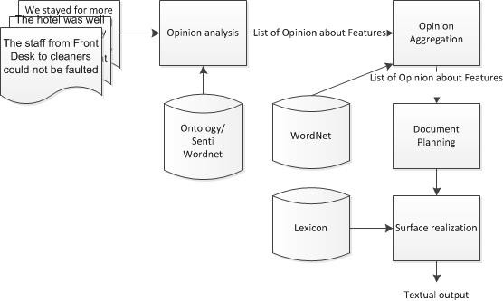

Figure 1: Overall Architecture of the SuRe system

2.2 Opinion Analysis
We consider a product to be composed of different features and these features are described by var- ious opinions mentioned in the free-text reviews. Thus this step intents to extract as much relevant opinions as possible from the source. First the system extract words referencing features thanks to a pre-defined dictionary/ontology; then opin- ion tokens about these features are extracted using two different methods with slightly different archi- tectures namely Sliding window and Dependency tree.
To account for the many synonyms; these opin- ions were then aggregated using WordNet rela- tions between adjective synsets.
At the end of this step, the flowing data structure is obtained: F eature-N ame =< Aggregated- Op1, Aggregated-Op2, ..., Aggregated-Opn >
Where in turn each Aggregated-Op has a gen-
eral number of times that opinion has been men- tioned along with a detail list of information for
each time it was mentioned (from which review, which sentence and what is the polarity).

2.3 Document Planning / Micro Planning

In this research we chose to separate features into positive or negative based on the most frequent opinion that linked to it. SuRe also tries to make a decision if the feature should be described us- ing more than one opinion and in that case what should the conjunction be. Next step was to de- cide which would be the reference expression of the sentence (e.g that feature was mentioned by how many people) and how should they be refer- enced to.

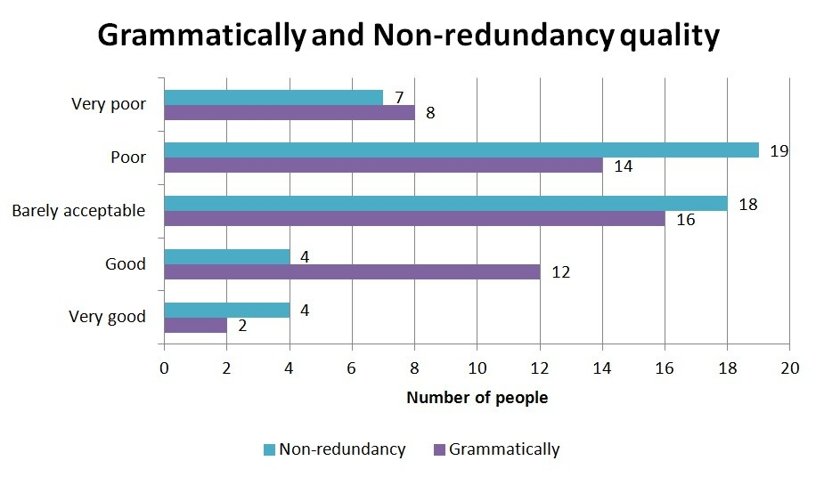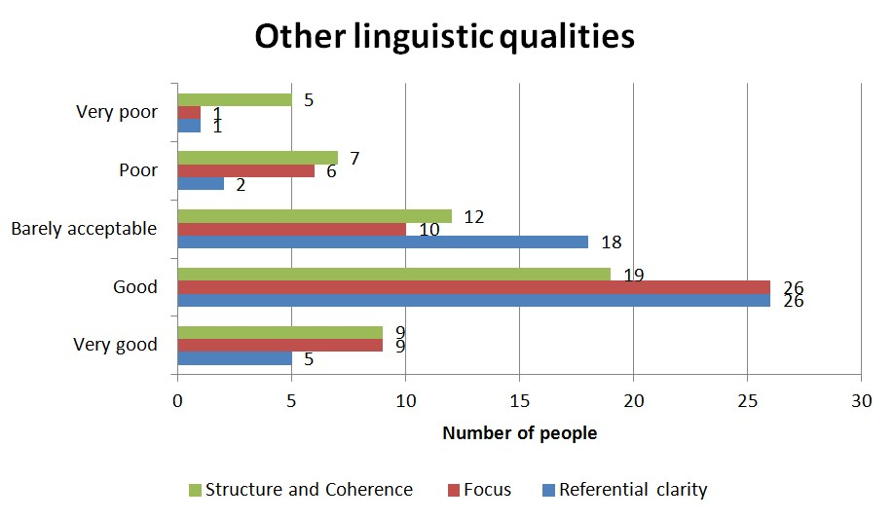2.4 Surface Realization

From the planning that has been made in the pre- vious step; a tree structure for each feature is ob- tained. they are used to create a phrase for the feature by employ Simple NLG (Gatt and Reiter,
2009); then these phrases are grouped up using reference expressions to create sentences.
We chose to make the output as a small hyper- text body code in order to be able to represent it better(with bold text, extra information in form of a pop-up box) as seen in Figure 2.

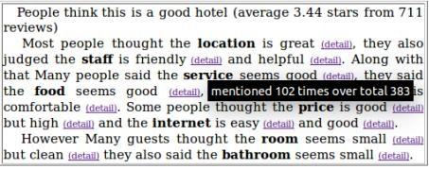

Figure 2: SuRe output example

3 Result and Evaluation

SuRe project has been implemented in Java and the output has been evaluated in order to give a complete assessment for the project. We closely assessed different aspects of two opinion analysis approaches(reliability, run-time, output). Later on we carried out a survey to collect people prefer- ences between different type of presentations and linguistic quality of SuRe system base on the us- ing a set of characteristic that were defined for the Document understanding conference (Baten and Dang, 2007) at NIST and presented in Figure 3.

Figure 3: linguistic qualities the output

4 Discussion

SuRe system has been proven to be able to handle a large set of reviews to create a short, informative and easy to understand summary in an abstractive manner that is close to the way human process. However there are still problems with SuRe sys- tem that need to be taken in to consideration for future development such as:

• Aggregation can be filtered even more by dif- ferent criteria to create even more concen- trated summary; e.g. based on temporal in- formation or by age, place, sex, etc.

• A clear word sense disambiguation before aggregation instead of blindly select similar words from WordNet.

• Referencing resolution would also enhance the opinion analysis step since in written re- view, people often use reference as ”they” or
”it” instead of remark again the feature, as well as double negation or even sarcasm.

References

Nicole Baten and Hoa Dang. 2007. Document under- standing conferences.
Albert Gatt and Ehud Reiter. 2009. Simplenlg: A re- alisation engine for practical applications. In Pro- ceedings of the 12th European Workshop on Natu- ral Language Generation, ENLG ’09, pages 90–93, Stroudsburg, PA, USA. Association for Computa- tional Linguistics.

Cyril Labbe´ and Franc¸ois Portet. 2012. Towards an Abstractive Opinion Summarisation of Multiple Re- views in the Tourism Domain. In The First Inter- national Workshop on Sentiment Discovery from Af- fective Data (SDAD 2012), pages 87–94, Bristol, Royaume-Uni.

Franc¸ois Portet, Ehud Reiter, Jim Hunter, and Somaya- julu Sripada. 2007. Automatic generation of tex- tual summaries from neonatal intensive care data. In In Proccedings of the 11th Conference on Artificial Intelligence in Medicine (AIME 07). LNCS, pages
227–236.

Nadav Rotem. retrieved may 2014. Open text summa- rizer (ots) - http://libots.sourceforge.net.

Fabrizio Sebastiani, Andrea Esuli, and Fabrizio Se- bastiani. 2006. Determining term subjectivity and term orientation for opinion mining. In In Proceed- ings of the 11th Conference of the European Chap- ter of the Association for Computational Linguistics (EACL06, pages 193–200.

