**First OfficialDeadpool 2 PosterGives Thanks**

You might recall that *[Deadpool](https://www.empireonline.com/movies/deadpool/)* included a funny montage featuring the hero ([Ryan Reynolds](https://www.empireonline.com/people/ryan-reynolds/)) and girlfriend Vanessa ([Morena Baccarin](https://www.empireonline.com/people/morena-baccarin/)) "celebrating" the holidays. With the US staple Thanksgiving coming up, the first official poster for *[Deadpool 2](https://www.empireonline.com/movies/deadpool-2-2/)* has arrived, celebrating families getting together, as shared via Reynolds' twitter feed.

[View image on Twitter](https://twitter.com/VancityReynolds/status/928704382610395136/photo/1)

[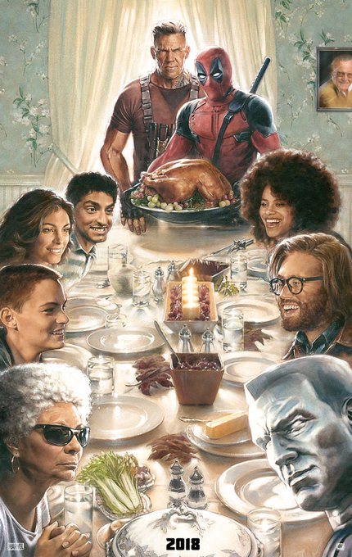](https://twitter.com/VancityReynolds/status/928704382610395136/photo/1)

[https://pbs.twimg.com/profile_images/741703039355064320/ClVbjlG-_normal.jpg](https://twitter.com/VancityReynolds)**[Ryan Reynolds](https://twitter.com/VancityReynolds)**

[✔@VancityReynolds](https://twitter.com/VancityReynolds)

Thanksgiving in our house is a glorious, non-stop car accident set to the music of cocaine.

[12:52 AM - Nov 10, 2017](https://twitter.com/VancityReynolds/status/928704382610395136)

[874874 Replies](https://twitter.com/intent/tweet?in_reply_to=928704382610395136)

[33,67533,675 Retweets](https://twitter.com/intent/retweet?tweet_id=928704382610395136)

[131,116131,116 likes](https://twitter.com/intent/like?tweet_id=928704382610395136)

[Twitter Ads info and privacy](https://support.twitter.com/articles/20175256)

While we haven't had many details about the movie's story – beyond the addition of [Josh Brolin](https://www.empireonline.com/people/josh-brolin/)'s Cable and [Zazie Beetz](https://www.empireonline.com/people/zazie-beetz/)' Domino – the poster confirms the return of [TJ Miller](https://www.empireonline.com/people/tj-miller/) as Weasel along with some of the other *Deadpool* cast. We're honestly not sure what a Deadpool thanksgiving would actually look like, but probably a bit bloodier than this.

In related Wade Wilson news, the latest clever promotional twist for the character and his sequel is having him show up in the pages (and cover) of *Good Housekeeping*. Not the most natural combination you might imagine, but it certainly seems to be bringing the mirth, with actual recipes (albeit with silly Deadpool names such as D's Spiced Nuts) and even a letter from Wade himself.

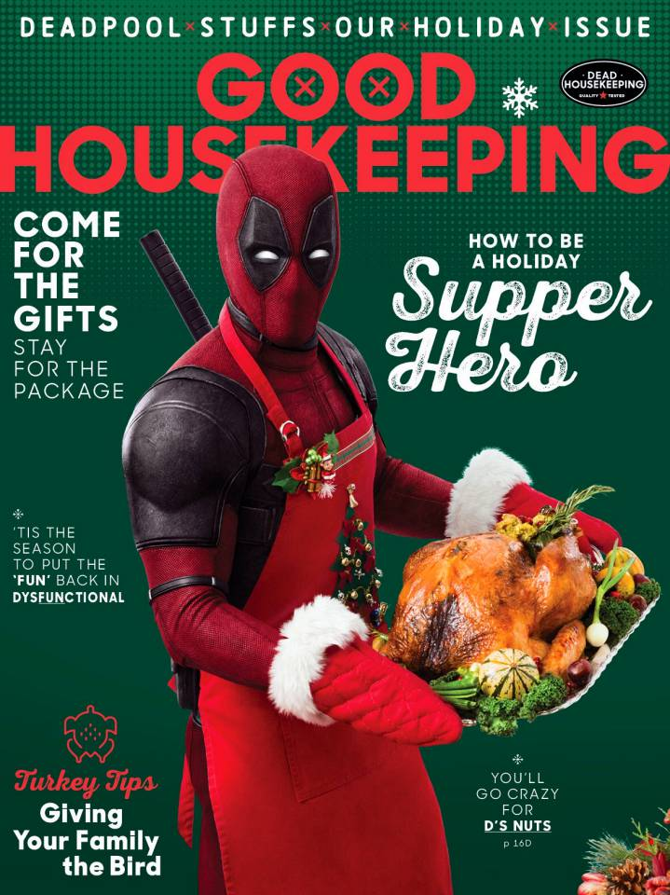

"Deadpool’s persistence to be in *Good Housekeeping* was impressive – initially we had no idea who he was, let alone that he was a fan of the magazine," says Jane Francisco, Editor in Chief, *Good Housekeeping*. "But after repeated attempts to ignore his… passion… we came to a compromise. He could appear in one issue, if he promised to stop leaving care packages at our editors’ homes and agreed to maintain a 50-foot distance from the *Good Housekeeping*offices and our staff."

"After years of weekly emails and countless carrier pigeons, *Good Housekeeping* finally returned my calls," says Deadpool. "And while it’s a dream come true, apparently we have vastly different opinions on the definition of a 'holiday spread'…"

As for the movie itself, the madness lands on 1 June next year.