

Data Science Program

Capstone Report - Spring 2024

Mapping Deprived Areas in Low and Middle Income Countries (LMIC)

Daqian
Akhil

supervised by
Amir Jafari

Abstract

A strong abstract sums up your work in very few sentences: (i) state the problem you are addressing; (ii) say why it's an interesting problem, and which issues are hard to tackle; (iii) give your approach towards solving the problem; (iv) say Why and how well your approach solves the problem.

Contents
1 Introduction 3
2 Problem Statement 3
3 Related Work 3
4 Solution and Methodology 3
5 Results and Discussion 4
5.1 Experimentation protocol 5
5.2 Data tables 5
5.3 Graphs 5
6 Discussion 6
7 Conclusion 7
8 Bibliography 7

Introduction

Your introduction briefly explains the problem you address, and what you've achieved towards
solving the problem. It's an edited and updated version of your context and objectives from your
topic outline document.

Problem Statement

Add problem statement here and challenges of the project.

Related Work

Your related work section positions your problem and your approach with respect to other, maybe
similar, projects you've found in the literature. It "should not only explain what research others
have done, but in each case should compare and contrast that to your work and also to other
related work. After reading this section, a reader should understand the key idea and contribution
of each significant piece of related work, how they _t together, and how your work di_ers." [1]1
It's an edited and updated version of your literature review. Here are a few examples of how
to insert citations like, [2] [1]and also [3], or even .

Solution and Methodology

The solution section covers all of your contributions (architecture, algorithms, formulas, findings).
It explains in detail each contribution, if possible, with figures/schematics.
Don't forget that a figure goes a long way towards helping your reader understand your work.
For instance, Figure 1 outlines the layers involved in a distributed certification service, and how
they articulate together. Nevertheless, a figure must always come with at least one paragraph of
explanation. The rule is that anyone should be able to understand your solution from reading
the text in this section, even if they skip the figures.
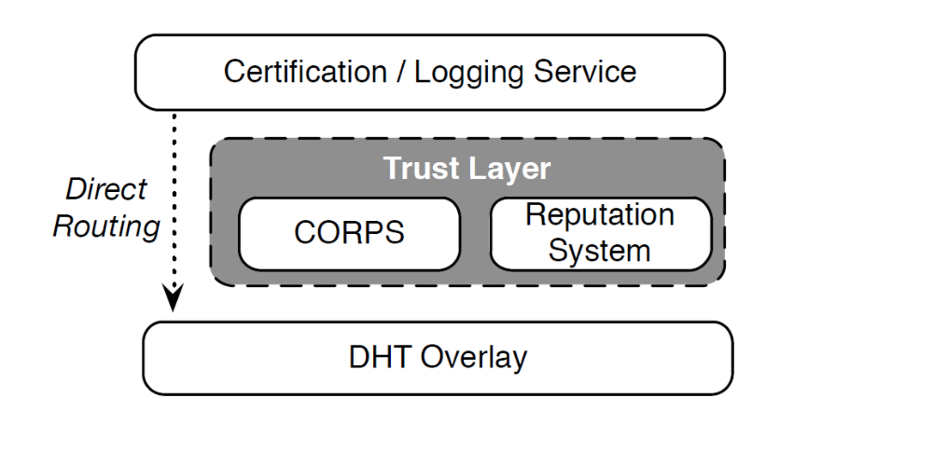
Figure 1: Architecture of our distributed certifcation service
Figure 2 is a pretty good example of a figure that is completely useless unless it is not accompanied by a textual explanation.

Results and Discussion

The results section details your metrics and experiments for the assessment of your solution. It
then provides experimental validation for your approach with visual aids such as data tables and

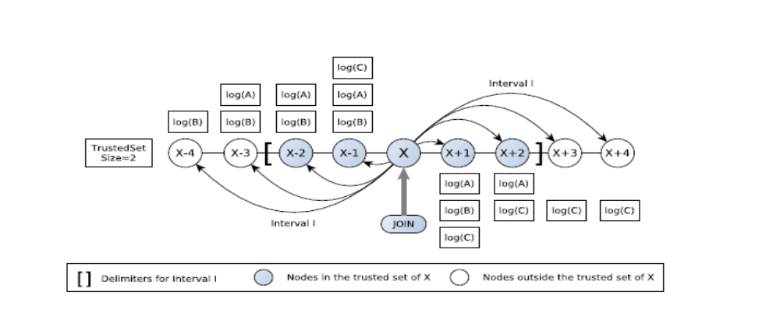
Figure 2: Try to guess what this gure illustrates; I double-dare you.

graphs. In particular, it allows you to compare your idea with other approaches you've tested,
for example solutions you've mentioned in your related work section.

Experimentation protocol

It is of the utmost importance to describe how you came up with the measurements and results
that support your evaluation.

Data tables

Every data table should be numbered, have a brief description as its title, and specify the units
used.
As an example, Table 1 compares the average latencies of native application calls to networked
services. The experiments were conducted on an Apple MacBook Air 2010 with a CPU speed of
1.4GHz and a bus speed of 800MHz. Each data point is a mean over 20 instances of each call,
after discarding both the lowest and the highest measurement.

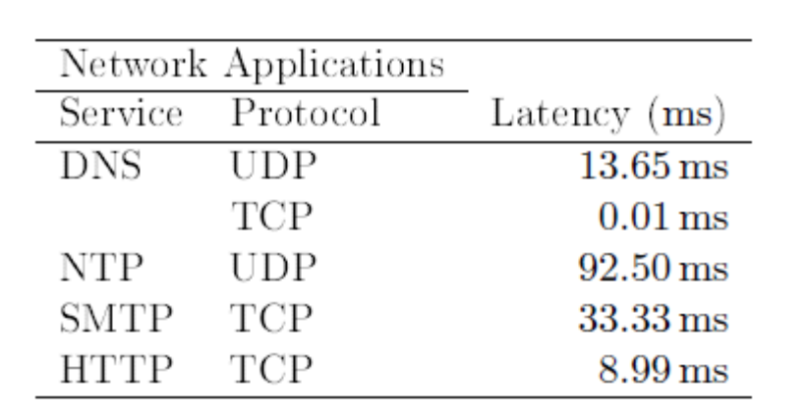

Graphs

Graphs are often the most important information in your report; you should design and plot
them with great care. A graph contains a lot of information in a short space. Graphs should be
numbered and have a title. Their axes should be labelled, with the quantities and units specified.
Make sure that individual data points (your measurements) stand out clearly. And of course,
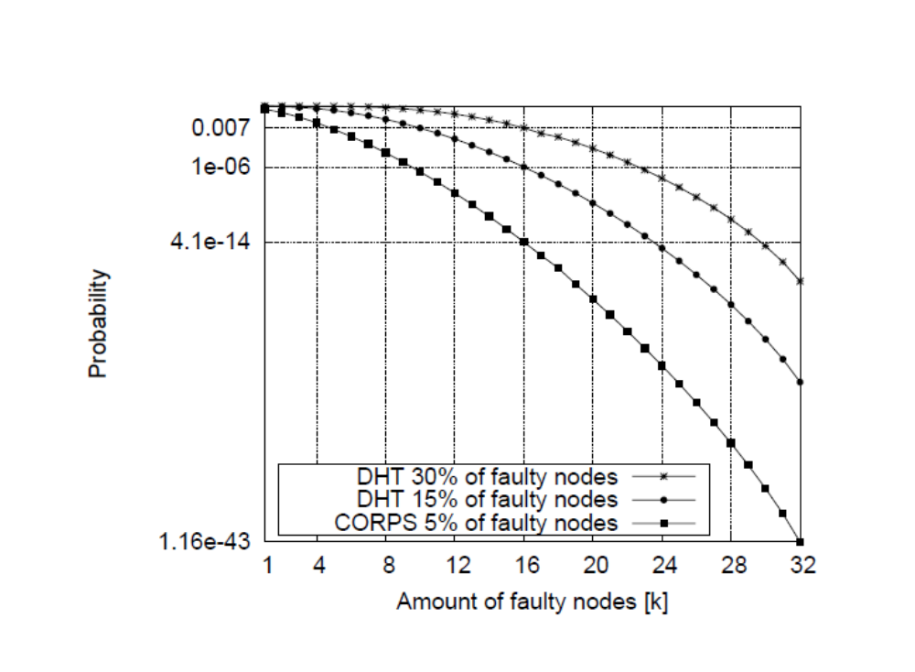
Figure 3: Probability of including [k] faulty/malicious nodes in the service

always associate your graph with text that explains your results, and outlines the conclusions you
draw from these results.
For example, Figure 3 compares the efficiency of three different service architectures in eliminating adversarial behaviors. Every data point gives the probability that k faulty/malicious nodes managed to participate in a computation that involves 32 nodes. In the absence of at least one reliable node (k = 32), the failure will go undetected; but the results show that this case is extremely unlikely, regardless of the architecture. The most significant result pertains to k = 16: the reliable nodes detect the failure, but cannot reach a majority to recover. The graph shows that the CORPS 5% architecture is much more resilient than the DHT 30% architecture, by a magnitude of 1011.

Discussion

The discussion section focuses on the main challenges/issues you had to overcome during the project. Outline what your approach does better than the ones you mentioned in your related work, and explain why. Do the same with issues where other solutions outperform your own. Are there limitations to your approach? If so, what would you recommend towards removing/mitigating them? Given the experience you've gathered working on this project, are there other approaches that you feel are worth exploring?

Conclusion

Give a clear, short, and informative summary of all your important results. Answer the initial
question(s) or respond to what you wanted to do, as stated in your introduction. It can be a
short table or a list, and possibly one or two short comments or explanations.
Target a reader who may not have time to read t [2]he whole report yet, but needs the results or
the conclusions immediately. This is a typical situation in real life. Some readers will read your
introduction and skip to your conclusion first, and read the whole report only later (if at all).
You may also draw perspectives. What's missing? In what directions could your work be
extended?

Bibliography

[1] | R. Guerraoui, "Genuine atomic multicast in asynchronous distributed systems," Theoretical, 2001.
[2] | V. P. a. L. Iftode, "Byzantine fault tolerant public key authentication in peer-to-peer," Computer Networks,, 2006..
[3] | J. R. Douceur, IPTPS '01., 2001.

