A Mini Project Report
On
POWER GENERATING SYSTEM USING FOOT-STEPS
Submitted to
Jawaharlal Nehru Technological University, Hyderabad
In partial fulfillment of requirement for the award of degree of
BACHELOR OF TECHNOLOGY
in
ELECTRONICS AND COMMUNICATION ENGINEERING
By
Malaraj Chandana 236Y1A0427
Panjala Sanjana Laxmi 236Y1A0438
Nalla Mercy 236Y1A0433
Kammagoni Akhila 246Y5A0407

Under the esteemed supervision of
K. THIRUPATHI REDDY
Assistant Professor

DEPARTMENT OF ELECTRONICS AND COMMUNICATION ENGINEERING
SUMATHI REDDY INSTITUTE OF TECHNOLOGY FOR WOMEN
(Approved by AICTE, New Delhi; Accredited by NBA; Affiliated to JNTU,
Hyderabad) Ananthasagar (Vill), Hasanparthy (M), Warangal-506371
2025-2026


DEPARTMENT OF ELECTRONICS AND COMMUNICATION ENGINEERING

CERTIFICATE

This is to certify that the Mini project entitled “POWER GENERATING SYSTEM USING FOOT-STEPS” submitted to JNTUH is carried out by the following students of III B. Tech in the partial fulfillment of the requirement for the award of the degree of Bachelor of Technology in Electronics and Communication Engineering during academic year 2025-2026.
Malaraj Chandana 236Y1A0427
Panjala Sanjana Laxmi 236Y1A0438
Nalla Mercy 236Y1A0433
Kammagoni Akhila 246Y5A0407

Mr. K. THIRUPATHI |  | Dr. E. KUMARASWAMY
Assistant Professor  Supervisor |  | Associate Professor Head of the Department

ACKNOWLEDGEMENT
The success accomplished in this Mini project report would not have been possible without the timely help and guidance by many people. We wish to express gratitude to all those who have helped and guided us for the completion of the Real time project.
It is our great pleasure to thank our project supervisor Mr. K. Thirupathi Reddy, Assistant Professor, Department of ECE for his valuable guidance through provoking discussions, vital suggestions and sharing his valuable expertise throughout the Mini project.
We convey our profound debts to the project coordinator Mrs. D. Raghava Kumari, Assistant Professor, Department of ECE for her valuable suggestions in completion of Mini project.
We express our sincere gratitude to Dr. E. Kumaraswamy, Associate Professor and Head of Department, ECE for his wholehearted support.
We express our sincere gratitude to Dr. I. Rajasri Reddy, Principal, Sumathi Reddy Institute of Technology for Women, Ananthasagar for her encouragement and providing facilities to accomplish our real time project successfully.
Our special thanks to all the Teaching and Non-Teaching staff of Department of ECE for their suggestions and support.
Malaraj Chandana 236Y1A0427
Panjala Sanjana Laxmi 236Y1A0438
Nalla Mercy 236Y1A0433
Kammagoni Akhila 246Y5A0407

CONTENTS

CHAPTER No. |  |  | DESCRIPTION |  |  |  | Page No.
1 |  |  | INTRODUCTION TO EMBEDDED SYSTEMS |  |  |  | 1-7
 |  |  | 1.1 | Applications of Embedded System
 |  |  | 1.2 | Characteristics of Embedded System
 |  |  | 1.3 | Processors in Embedded Systems
 |  |  | 1.4 | Debugging in Embedded Systems
 |  |  | 1.5 | Reliability
 |  |  | 1.6 | Tracing
2 |  |  | INTRODUCTION TO PROJECT |  |  |  | 8-10
 |  |  | 2.1 | Objectives
 |  |  | 2.2 | Problem specification
 |  |  | 2.3 | Methodologies
3 |  |  | SOFTWARE REQUIREMENTS |  |  |  | 11-19
 |  |  | 3.1 | Introduction to Arduino ide
 |  |  | 3.2 | Introduction to Arduino Libraries
 |  |  | 3.3 | How to Install a Library
 |  |  | 3.4 | How to Connect Arduino Board
 |  |  | 3.5 | How to Upload a Program
4 |  |  | HARDWARE REQUIREMENTS |  |  |  | 20-34
 |  |  | 4.1 | Introduction to Arduino Uno
 |  |  | 4.2 | Introduction to Piezo Electric sensor
 |  |  | 4.3 | 16×2 LCD Display
 |  |  | 4.3. | Strip LED
 |  |  | 4.4 | BC 547
 |  |  | 4.5 | Resistors
 |  |  | 4.6 | Diodes
 |  |  | 4.7 | Capacitors
5 |  |  | 4.8 Bread board |  |  |  | 35-37
 |  |  | 4.9 Jumper wires
 |  |  | PROGRAM CODE
 | 6 |  | RESULT OF THE PROJECT  REFERENCE |  |  |  | 38
 | 7 |  |  |  |  |  | 39
LIST OF FIGURES
Figure No. | Figure Name |  | Page No.
3.1 | Arduino |  | 10
3.2 | Arduino Ide |  | 12
3.3 | Digital Read Serial |  | 13
3.4 | Library Manager Installation |  | 16
3.5 | Library Manager |  | 17
4.1 | Arduino UNO |  | 21
4.2 | Piezoelectric sensor |  | 26
4.3 | LCD Display |  | 27
4.3.3 | Strip LED |  | 28
4.4 | BC 547 |  | 29
4.5 | Resistors |  | 30
4.6 | Diodes |  | 31
4.7 | Capacitors |  | 32
4.8 | Bread Board |  | 33
4.9 | Jumper wires |  | 34

ABSTRACT
This project presents a vibration detection system using a Piezoelectric Sensor to detect mechanical pressure and vibrations and convert them into electrical signals. The system operates based on the Piezoelectric Effect, where certain materials generate voltage when mechanical stress is applied. In this project, multiple piezoelectric sensors are placed to detect vibrations such as footsteps, surface movements, or mechanical impacts. When vibration is applied, the sensors generate electrical signals that are processed using a Arduino Uno microcontroller. The processed data is displayed on an LCD Display with the help of an I2C module, allowing real-time monitoring of vibration levels. An LED strip is also used as a visual indicator to show when vibration is detected. This project demonstrates the practical implementation of piezoelectric sensors in vibration monitoring systems and highlights their importance in embedded electronics. Such systems can be useful in applications like security systems, smart flooring, motion detection, and structural vibration monitoring. The project also helps in improving practical knowledge of sensor interfacing, signal processing, and microcontroller-based system design..

CHAPTER 1
INTRODUCTION TO EMBEDDED SYSTEMS
Embedded Technology is now in its prime and the wealth of knowledge available is mind blowing. However, most embedded systems engineers have a common complaint. There are no comprehensive resources available over the internet which deal with the various design and implementation issues of this technology. Intellectual property regulations of many corporations are partly to blame for this and also the tendency to keep technical know-how within a restricted group of researchers.
An embedded computer is frequently a computer that is implemented for a particular purpose. In contrast, an average PC computer usually serves a number of purposes: checking email, surfing the internet, listening to music, word processing, etc... However, embedded systems usually only have a single task, or a very small number of related tasks that they are programmed to perform.
Every home has several examples of embedded computers. Any appliance that has a digital clock, for instance, has a small embedded micro-controller that performs no other task than to display the clock. Modern cars have embedded computers onboard that control such things as ignition timing and anti-lock brakes using input from a number of different sensors.
Embedded computers rarely have a generic interface, however. Even if embedded systems have a keypad and an LCD display, they are rarely capable of using many different types of input or output. An example of an embedded system with I/O capability is a security alarm with an LCD status display, and a keypad for entering a password.
An embedded system can be defined as a control system or computer system designed to perform a specific task. Common examples of embedded systems include MP3 players, navigation systems on aircraft and intruder alarm systems.An embedded system can also be defined as a single purpose computer.
Most embedded systems are time critical applications meaning that the embedded system is working in an environment where timing is very important: the results of an operation are only relevant if they take place in a specific time frame. An autopilot in an aircraft is a time critical embedded system. If the autopilot detects that the plane for some reason is going into a stall then it should take steps to correct this within milliseconds or there would be catastrophic results.

1.1 Applications of Embedded System
Embedded systems are commonly found in consumer, cooking, industrial, automotive, medical, commercial and military applications.
Telecommunications systems employ numerous embedded systems from telephone switches for the network to cell phones at the end user. Computer networking uses dedicated routers and network bridges.
Advanced HVAC systems use networked thermostats to more accurately and efficiently control temperature that can change by time of day and season. Home automation uses wired- and wireless-networking that can be used to control lights, climate, security, audio/visual, surveillance, etc., all of which use embedded devices for sensing and controlling. Transportation systems from flight to automobiles increasingly use embedded systems. New airplanes contain advanced avionics such as inertial guidance systems and GPS receivers that also have considerable safety requirements. Automobiles, electric vehicles, and hybrid vehicles increasingly use embedded systems to maximize efficiency and reduce pollution.
Other automotive safety systems include anti-lock braking system (ABS), Electronic Stability (ESC/ESP), traction control (TCS) and automatic four-wheel drive. Medical equipment uses embedded systems for vital signs monitoring, electronic stethoscopes for amplifying sounds, and various medical imaging (PET, SPECT, CT, and MRI) for non-invasive internal inspections. Embedded systems within medical equipment are often powered by industrial computers. Embedded systems are used in transportation, fire safety, safety and security, medical applications and life critical systems, as these systems can be isolated from hacking and thus, be more reliable. For fire safety, the systems can be designed to have greater ability to handle higher temperatures and continue to operate. In dealing with security, the embedded systems can be self-sufficient and be able to deal with cut electrical and communication systems.
1.2 Characteristics of Embedded System
Embedded systems are designed to do some specific tasks, rather than be a general-purpose computer for multiple tasks. Some also have real-time performance constraints that must be met, for reasons such as safety and usability; others may have low or no performance requirements, allowing the system hardware to be simplified to reduce costs. 10Embedded systems are not always standalone devices. Many embedded systems consist of small parts within a larger device that serves a more general purpose. For example, the Gibson Robot Guitar features an embedded system for tuning the strings, but the overall purpose of the Robot Guitar is, of course, to play music. Similarly, an embedded system in an automobile provides a specific function as a subsystem of the car itself. Embedded systems range from no user interface at all, in systems dedicated only to one task, to complex graphical user interfaces that resemble modern computer desktop operating systems. Simple embedded devices use buttons, LEDs, graphic or character LCDs (HD44780LCD for example) with a simple menu system.
More sophisticated devices which use a graphical screen with touch sensing or screen-edge buttons provide flexibility while minimizing space used: the meaning of the buttons can change with the screen, and selection involves the natural behaviour of pointing at what is desired. Handheld systems often have a screen with a "joystick button" for a pointing device.
Some systems provide user interface remotely with the help of a serial (e.g. RS- 232, USB, I²C, etc.) or network (e.g. Ethernet) connection. This approach gives several advantages: extends the capabilities of embedded system, avoids the cost of a display, simplifies BSP and allows one to build a rich user interface on the PC. A good example of this is the combination of an embedded web server running on an embedded device (such as an IP camera) or a network router. The user interface is displayed in a web browser on a PC connected to the device, therefore needing no software to be installed.
1.3 Processors in Embedded System
Embedded processors can be broken into two broad categories. Ordinary microprocessors Embedded processors can be broken into two broad categories. Ordinary microprocessors (μP) use separate integrated circuits for memory and peripherals. Microcontrollers (μC) have on chip peripherals, thus reducing power consumption, size and cost. In contrast to the personal computer market, many different basic CPU architectures are used, since software is custom developed for an application and is not a commodity product installed by the end user. Both Von Neumann as well as various degrees of Harvard architectures are used. RISC as well as non-RISC processors are found. Word lengths vary from 4-bit to 64-bits and beyond, although the most typical remain 8/16-bit. Most architectures come in a large number of different variants and shapes, many of which are also manufactured by several different companies. Numerous microcontrollers have been developed for embedded systems use. General-purpose microprocessors are also used in embedded systems, but generally require more support circuitry than microcontrollers. (μP) use separate integrated circuits for memory and peripherals. Microcontrollers (μC) have on-chip peripherals, thus reducing power consumption, size and cost. In contrast to the personal computer market, many different basic CPU architectures are used, since software is custom-developed for an application and is not a commodity product installed by the end user.
Both Von Neumann as well as various degrees of Harvard architectures are used. RISC as well as non-RISC processors are found. Word lengths vary from 4-bit to 64-bits and beyond, although the most typical remain 8/16-bit. Most architectures come in a large number of different variants and shapes, many of which are also manufactured by several different companies.
Numerous microcontrollers have been developed for embedded systems use. General-purpose microprocessors are also used in embedded systems, but generally require more support circuitry than microcontrollers.
1.4 Debugging in Embedded Systems
Embedded debugging may be performed at different levels, depending on the facilities available. The different metrics that characterize the different forms of embedded debugging are: does it slow down the main application, how close is the debugged system or application to the actual system or application, how expressive are the triggers that I can set for debugging (e.g., I want to inspect the memory when a particular program counter value is reached), and what can I inspect in the debugging process (such as, only memory, or memory and registers, etc.).
From simplest to most sophisticated they can be roughly grouped into the following areas: Interactive resident debugging, using the simple shell provided by the embedded operating system (e.g., Forth and Basic).
External debugging using logging or serial port output to trace operation using either a monitor in flash or using a debug server like the Remedy Debugger which even works for heterogeneous multicore systems. An in-circuit debugger (ICD), a hardware device that connects to the microprocessor via a JTAG or Nexus interface. This allows the operation of the microprocessor to be controlled externally, but is typically restricted to specific debugging capabilities in the processor.
An in-circuit emulator (ICE) replaces the microprocessor with a simulated equivalent, providing full control over all aspects of the microprocessor. A complete emulator provides a simulation of all aspects of the hardware, allowing all of it to be controlled and modified, and allowing debugging on a normal PC. The downsides are expense and slow operation, in some cases up to 100 times slower than the final system. For SoC designs, the typical approach is to verify and debug the design on an FPGA prototype board. Tools such as Certus are used to insert probes in the FPGA RTL that make signals available for observation. This is used to debug hardware, firmware and software interactions across multiple FPGA with capabilities similar to a logic analyser. Unless restricted to external debugging, the programmer can typically load and run software through the tools, view the code running in the processor, and start or stop its operation. The view of the code may be as HLL source-code, assembly code or mixture of both. Because an embedded system is often composed of a wide variety of elements, the debugging strategy may vary. For instance, debugging a software- (and microprocessor-) centric embedded system is different from debugging an embedded system where most of the processing is performed by peripherals (DSP, FPGA, and co-processor).
Increasing number of embedded systems today use more than one single processor core. A common problem with multi-core development is the proper synchronization of software execution. In such a case, the embedded system design may wish to check the data traffic on the buses between the processor cores, which requires very low-level debugging, at signal/bus level, with a logic analyser, for instance.
1.5 Reliability
Embedded systems often reside in machines that are expected to run continuously for years without errors, and in some cases recover by themselves if an error occurs. Therefore, the software is usually developed and tested more carefully than that for personal computers, and unreliable mechanical moving parts such as disk drives, switches or buttons are avoided. Specific reliability issues may include:
- The system cannot safely be shut down for repair, or it is too inaccessible to repair.
- Examples include space systems, undersea cables, navigational beacons, bore-hole systems, and automobiles.
- The system must be kept running for safety reasons. "Limp modes" are less tolerable. Often backups are selected by an operator. Examples include aircraft navigation, reactor control systems, safety-critical chemical factory controls, train signals.
- The system will lose large amounts of money when shut down: Telephone switches, factory controls, bridge and elevator controls, funds transfer and market making, automated sales and service.
A variety of techniques are used, sometimes in combination, to recover from errors both software bugs such as memory leaks, and also soft errors in the hardware:
- Watchdog timer that resets the computer unless the software periodically notifies the watchdog subsystems with redundant spares that can be switched over to software "limp modes" that provide partial function.
- Designing with a Trusted Computing Base (TCB) architecture ensures a highly secure & reliable system environment.
- A hypervisor designed for embedded systems, is able to provide secure encapsulation for any subsystem component, so that a compromised software component cannot interfere with other subsystems, or privileged-level system software. This encapsulation keeps faults from propagating from one subsystem to another, improving reliability. This may also allow a subsystem to be automatically shut down and restarted on fault detection.
- Immunity Aware Programming.

1.6 Tracing
Real-time operating systems (RTOS) often supports tracing of operating system events. A graphical view is presented by a host PC tool, based on a recording of the system behaviour.
The trace recording can be performed in software, by the RTOS, or by special tracing hardware.
14RTOS tracing allows developers to understand timing and performance issues of the software system and gives a good understanding of the high-level system behaviours. Commercial tools like RTXC Quadro’s or IAR Systems exists.

CHAPTER 2
INTRODUCTION
This project focuses on developing a vibration detection and monitoring system using Piezoelectric Sensor technology. The system consists of electronic components and embedded hardware integrated with a microcontroller to detect vibrations or mechanical pressure. The piezoelectric sensors convert mechanical stress such as footsteps, impacts, or surface vibrations into electrical signals. These signals are processed using a Arduino Uno microcontroller and the results are displayed on an LCD Display using an I2C module. The system also uses an LED strip as a visual indicator to show when vibrations are detected.
2.1 Objectives
To develop a vibration detection system using embedded technology:
This project applies embedded system concepts to integrate sensors, signal conditioning components, and a microcontroller to detect and monitor vibrations in real time.
To detect vibrations using piezoelectric sensors:
The main objective is to detect mechanical vibrations or pressure using multiple piezoelectric sensors and convert them into electrical signals that can be measured and analysed.
To display vibration values on an LCD:
The vibration signals processed by the microcontroller are displayed on an LCD screen so that users can easily monitor the detected vibration levels.
To provide visual indication using LED strip:
An LED strip is used to provide a clear visual indication when vibration or pressure is detected by the sensors.
2.2 Problem Specification
In many environments, vibrations or mechanical movements occur due to footsteps, machinery operation, or structural movements. Detecting these vibrations is important in applications such as security systems, structural monitoring, and motion detection. Traditional systems may not effectively detect small vibrations or movements. This project addresses this issue by using piezoelectric sensors that are highly sensitive to pressure and vibration, enabling accurate detection and monitoring.
2.3 Methodologies
Use of Arduino Uno as the control unit:
The Arduino Uno microcontroller board acts as the central processing unit of the system. It reads the signals generated by the piezoelectric sensors and processes them to determine vibration levels.
Integration of piezoelectric sensors:
Multiple Piezoelectric Sensor devices are integrated into the system to detect vibrations or mechanical pressure applied to the surface. These sensors work based on the Piezoelectric Effect, where mechanical stress generates an electrical voltage.
When force, vibration, or impact occurs, the sensors produce electrical signals proportional to the intensity of the vibration. These signals are then transmitted to the Arduino Uno microcontroller for further processing and analysis.
Use of signal conditioning components:
The electrical signals generated by piezoelectric sensors are usually very small and may contain noise. Therefore, signal conditioning components such as resistors, diodes, capacitors, and transistors (for example BC547) are used in the circuit.
Resistors help in limiting current, diodes protect the circuit from reverse voltage, capacitors filter unwanted noise and stabilize the signal, and transistors amplify weak signals. These components ensure that the signals reaching the microcontroller are stable and suitable for accurate processing.
Display of vibration values on LCD:
An LCD Display with an I2C interface is used to display the vibration values detected by the sensors. The microcontroller continuously reads the sensor signals and converts them into readable values, which are then shown on the LCD screen. This allows users to observe and monitor the vibration levels in real time, making the system more interactive and user-friendly.

LED strip indication:
An LED strip is connected to the system to provide a clear visual indication when vibration is detected. When the sensor detects mechanical movement or pressure above a certain level, the LED Strip lights up. This visual feedback helps users quickly identify vibration activity without constantly checking the LCD display, making the system more effective for monitoring and alert purposes.

CHAPTER 3
SOFTWARE REQUIREMENTS
Software used in this project for uploading code onto Arduino is Arduino IDE.

3.1 Introduction to Arduino IDE
IDE stands for Integrated Development Environment. Pretty fancy sounding, and should make you feel smart any time you use it. The IDE is a text editor-like program that allows you to write Arduino code. When you open the Arduino program, you are opening the IDE. It is intentionally streamlined to keep things as simple and straightforward as possible. When you save a file in Arduino, the file is called a sketch – a sketch is where you save the computer code you have written. The coding language that Arduino uses is very much like C++ (“see plus plus”), which is a common language in the world of computing. The code you learn to write for Arduino will be very similar to the code you write in any other computer language – all the basic concepts remain the same – it is just a matter of learning a new dialect you should pursue other programming languages.



Fig.3.1: Arduino
The code you write is “human readable”, that is, it will make sense to you (sometimes), and will be organized for a human to follow. Part of the job of the IDE is to take the human readable code and translate it into machine-readable code to be executed by the Arduino. This process is called compiling. The process of compiling is seamless to the user. All you have to do is press a button. If you have errors in your computer code, the compiler will display an error message at the bottom of the IDE and highlight the line of code that seems to be the issue. The error message is meant to help you identify what you might have done wrong – sometimes the message is very explicit, like saying, “Hey – you forget a semicolon”, sometimes the error message is vague. Why be concerned with a semicolon you ask? A semicolon is part of the Arduino language syntax, the rules that govern how the code is written. It is like grammar in writing. Say for example we didn’t use periods when we wrote – everyone would have a heck of a time trying to figure out when sentence didn’t employ the comma, we convey a dramatic pause to the reader?

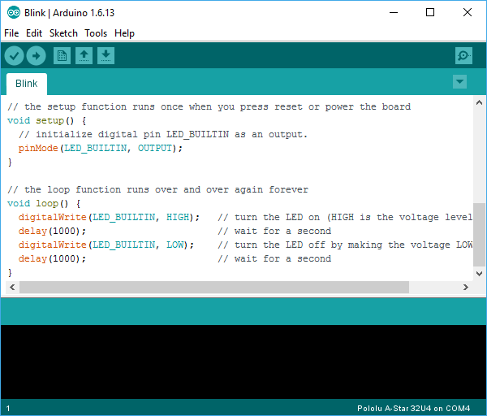

Fig.3.2. Arduino Ide

And let me tell you, if you ever had an English teacher with an overactive red pen, the compiler is ten times worse. In fact – your programs WILL NOT compile without perfect syntax. This might drive you crazy at first because it is very natural to forget syntax. As you gain experience programming you will learn to be assiduous about coding grammar.

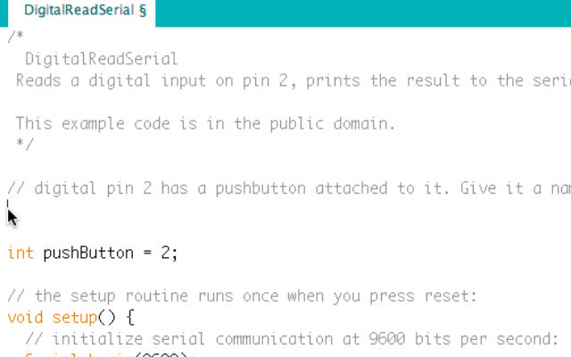

Fig.3.3: Digital Read Serial

3.1.1 The Semicolon
A semicolon needs to follow every statement written in the Arduino programming language. For example, …
Int Led Pin=9;
In this statement, I am assigning a value to an integer variable (we will cover this later), notice the semicolon at the end. This tells the compiler that you have finished a chunk of code and are moving on to the next piece. A semicolon is to Arduino code, as a period is to a sentence. It signifies a complete statement.

3.1.2 The Double Backslash for Single Line Comments //
Comments are what you use to annotate code. Good code is commented well.
Comments are meant to inform you and anyone else who might stumble across your code, what the heck you were thinking when you wrote it. A good comment would be something like this…
Now, in 3 months when I review this program, I know where to stick my LED. Comments will be ignored by the compiler – so you can write whatever you like in them. If you have a lot you need to explain, you can use a multi-line comment, shown below…
//This is an example
Comments are like the footnotes of code, except far more prevalent and not at the bottom of the page.

3.1.3 The Curly Braces
Curly braces are used to enclose further instructions carried out by a function (we discuss functions next). There is always an opening curly bracket and a closing curly bracket.
If you forget to close a curly bracket, the compiler will not like it and throw an error code.
Void loop () {
}
Remember – no curly brace may go

3.1.4 Function ()
Functions are pieces of code that are used so often that they are encapsulated in certain keywords so that you can use them more easily. For example, a function could be the following set of instructions…
This set of simple instructions could be encapsulated in a function that we call Wash Dog. Every time we want to carry out all those instructions, we just type Wash Dog and voila – all the instructions are carried out. In Arduino, there are certain functions that are used so often they have been built into the IDE. When you type them, the name of the function will appear orange. The function pin Mode (), for example, is a common function used to designate the mode of an Arduino pin. Pin Mode (13, OUTPUT);
The argument 13 refers to pin 13, and OUTPUT is the mode in which you want the pin to operate. When you enter these arguments, the terminology is called passing. You pass the necessary information to the functions. Not all functions require arguments, but opening and closing parentheses will stay regardless though empty.
Notice that the word OUTPUT is blue. There are certain keywords in Arduino that are used frequently and the colour blue helps identify them. The IDE turns them blue automatically. Now we won’t get into it here, but you can easily make your own functions in Arduino, and you can even get the IDE to colour them for you. We will, however, talk about the two functions used in nearly EVERY Arduino program .
3.1.5 Void Setup ()
The function, setup (), as the name implies, is used to set up the Arduino board. The Arduino executes all the code that is contained between the curly braces of setup () only once. Typical things that happen in setup () are setting the modes of pins, starting You might be wondering what void means before the function setup (). Void means that the function does not return information. Some functions do return values – our Dog Wash function might return the number of buckets it required to clean the dog. The function analogues Read () returns an integer value between 0-1023. If this seems a bit odd now, don’t worry as we will cover everycommon Arduino function in depth as we continue the course.
Let us review a couple things you should know about setup () …
- Setup () only runs once.
- Setup () needs to be the first function in your Arduino sketch.
3. Setup () must have opened and closing curly braces.
3.1.6 Void Loop ()
You have to love the Arduino developers because the function names are so telling. As the name implies, all the code between the curly braces in loop () is repeated over and over again – in a loop. The loop () function is where the body of your program will reside. As with setup (), the function loop () does not return any values, therefore the word void precedes it.
Does it seem odd to you that the code runs in one big loop? This apparent lack of variation is an illusion. Most of your code will have specific conditions lying in wait which will trigger new actions. If you have a temperature sensor connected to your Arduino for example, then when the temperature gets to a predefined threshold you might have a fan kick on. The looping code is constantly checking the temperature waiting to trigger the fan. So even though the code loops over and over, not every piece of the code will be executed every iteration of the loop.

3.2 Introduction Arduino Libraries
Libraries are a collection of code that makes it easy for you to connect to a sensor, display, module, etc. For example, the built-in Liquid Crystal library makes it easy to talk to character LCD displays. There are hundreds of additional libraries available on the Internet for download. The built-in libraries and some of these additional libraries are listed in the reference. To use the additional libraries, you will need to install them.
Arduino libraries are managed in three different places: inside the IDE installation folder, inside the core folder and in the libraries folder inside your sketchbook. The way libraries are chosen during compilation is designed to allow the update of libraries present in the distribution. This means that placing a library in the “libraries” folder in your sketchbook overrides the other libraries versions. The same happens for the libraries present in additional cores installations. It is also important to note that the version of the library you put in your sketchbook may be lower than the one in the distribution or core folders, nevertheless it will be the one used during compilation. When you select a specific core for your board, the libraries present in the core’s folder are used instead of the same libraries present in the IDE distribution folder.
Last, but not least important is the way the Arduino Software (IDE) upgrades itself: all the files in Programs/Arduino (or the folder where you installed the IDE) are deleted and a new folder is created with fresh content. This is why we recommend that you only install libraries to the sketchbook folder so they are not deleted during the Arduino IDE update process.
3.2.1 How to Install a Library
To install a new library into your Arduino IDE you can use the Library Manager
(available from IDE version 1.6.2). Open the IDE and click to the “Sketch” menu and then
include Library > Manage Libraries.
Then the Library Manager will open and you will find a list of libraries that are already installed or ready for installation. In this example we will install the Bridge library. Scroll the list to find it, click on it, then select the version of thelibrary you want to install. Sometimes only one version of the library is available. If the version selection menu does not appear, don't worry: it is normal.

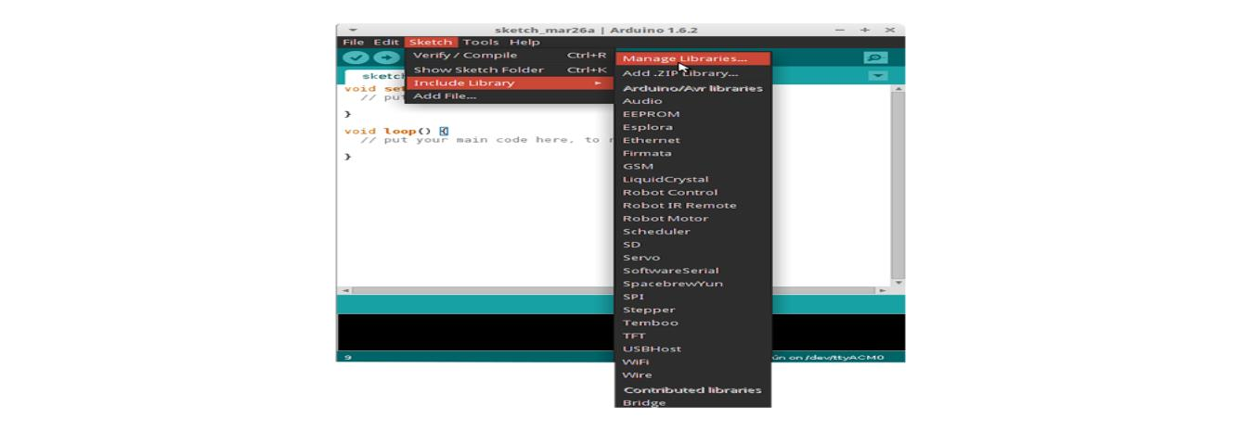
Fig.3.4: Library Manager Installation

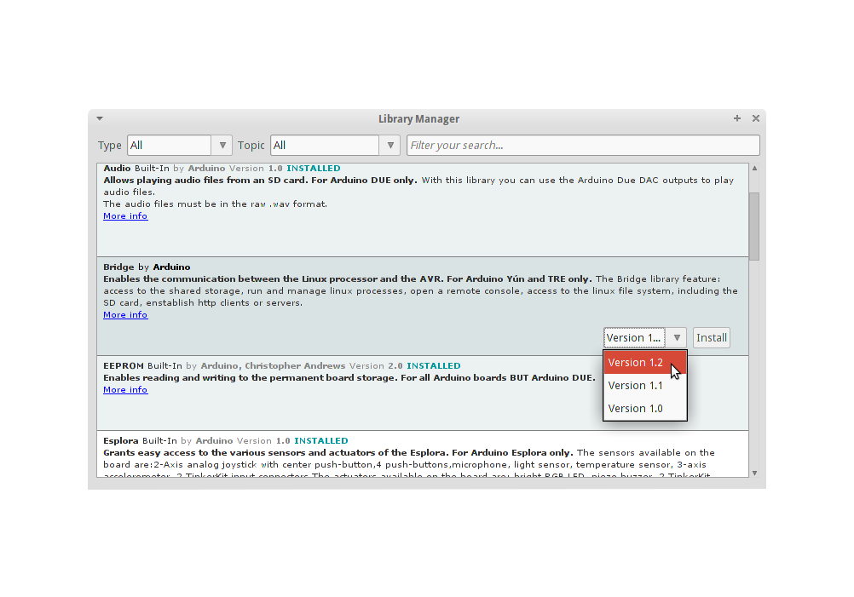
Fig.3.5: Library Manager

Finally click on install and wait for the IDE to install the new library. Downloading may take time depending on your connection speed. Once it has finished, an Installed tag should appear next to the Bridge library. You can close the library manager. You can now find the new library available in the Sketch > Include Library menu. If you want to add your own library to Library Manager, follow these instructions.

3.3 How to Connect Arduino Board
If you're using a serial board, power the board with an external power supply (6 to 25 volts DC, with the core of the connector positive). Connect the board to a serial port on your computer. On the USB boards, the power source is selected by the jumper between the USB and power plugs. To power the board from the USB port (good for controlling low power devices like LEDs), place the jumper on the two pins closest to the USB plug. To power the board from an external power supply (needed for motors and other high current devices), place the jumper on the two pins closest to the power plug. Either way, connect the board to a USB port on your computer. On Windows, the Add New Hardware wizard will open; tell it you want to specify the location to search for drivers and point to the folder containing the USB drivers you unzipped in the previous step.
3.4 How to Upload a Program
The content of circuits and Arduino sketches can vary greatly. Before you get started, there is one simple process for uploading a sketch to an Arduino board that you can refer back to.
Follow these steps to upload your sketch:
1. Connect your Arduino using the USB cable.
The square end of the USB cable connects to your Arduino and the flat end connects to a USB
port on your computer.
2. Choose Tools→Board→Arduino Uno to find your board in the Arduino menu.
You can also find all boards through this menu, such as the Arduino MEGA 2560 and Arduino Leonardo.
3. Choose the correct serial port for your board.
You find a list of all the available serial ports by choosing Tools Serial Port→ comX or X marks a sequentially or randomly assigned number. In Windows, if you have just connected your Arduino, the COM port will normally be the highest number, such as com 3 or com 15.
Many devices can be listed on the COM port list, and if you plug in multiple Arduinos, each one will be assigned a new number. Unless you have another Arduino connected, it should be the only one visible.
4. Click the Upload button. This is the button that points to the right in the Arduino environment. You can also use the keyboard shortcut Ctrl+ U for Windows or Cmd+ U for Mac OS X.

CHAPTER 4
HARDWARE REQUIREMENTS
Hardware Components of this project are

Arduino UNO Board

Piezo Electric Sensor

16×2 LCD display

BC 547

Resistors

Capacitor

Diodes

Strip LED

Breadboard

Jumper Wires

4.1 Introduction to Arduino Uno
Arduino is an open-source electronics platform based on easy-to-use hardware and software. Arduino boards are able to read inputs - light on a sensor, a finger on a button, or a Twitter message - and turn it into an output - activating a motor, turning on an LED, publishing something online. You can tell your board what to do by sending a set of instructions to the microcontroller on the board. To do so you use the Arduino programming language (based on Wiring), and the Arduino Software (IDE), based on Processing.
Over the years Arduino has been the brain of thousands of projects, from everyday objects to complex scientific instruments. A worldwide community of makers - students, hobbyists, artists, programmers, and professionals - has gathered around this open-source platform, their contributions have added up to an incredible amount of accessible knowledge that can be of great help to novices and experts alike.
Arduino was born at the Ivrea Interaction Design Institute as an easy tool for fast prototyping, aimed at students without a background in electronics and programming. As soon as it reached a wider community, the Arduino board started changing to adapt to new needs and challenges, differentiating its offer from simple 8-bit boards to products for IoT applications, wearable, 3D printing, and embedded environments. All Arduino boards are completely open-source, empowering users to build them independently and eventually adapt them to their particular needs. The software, too, is open-source, and it is growing through the contributions of users worldwide.

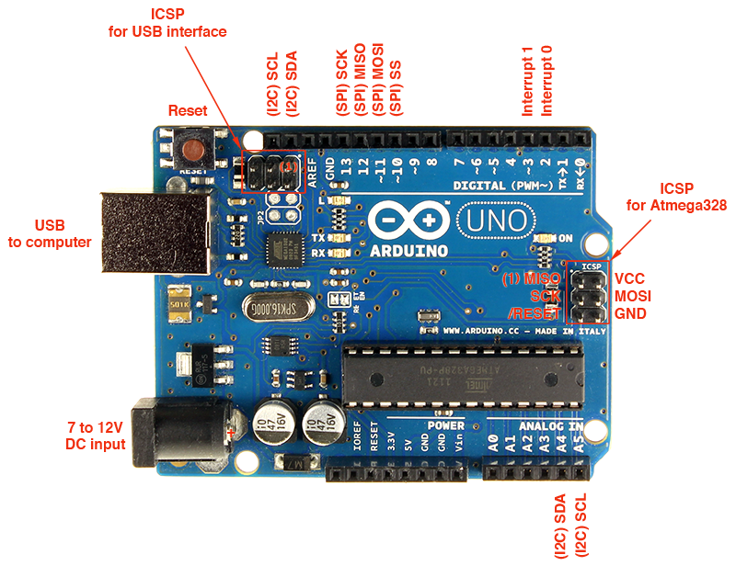

Fig.4.1: Arduino Uno
4.1.1 Why Arduino
Thanks to its simple and accessible user experience, Arduino has been used in thousands of different projects and applications. The Arduino software is easy-to-use for beginners, yet flexible enough for advanced users. It runs on Mac, Windows, and Linux.
Teachers and students use it to build low-cost scientific instruments, to prove chemistry and physics principles, or to get started with programming and robotics. Designers and architects build interactive prototypes, musicians and artists use it for installations and to experiment with new musical instruments. Makers, of course, use it to build many of the projects exhibited at the Maker Faire, for example. Arduino is a key tool to learn new things.
Anyone - children, hobbyists, artists, programmers - can start tinkering just following the step-by-step instructions of a kit, or sharing ideas online with other members of the Arduino community.
4.1.2 Advantages of Arduino:
- Inexpensive - Arduino boards are relatively inexpensive compared to other microcontroller platforms. The least expensive version of the Arduino module can be assembled by hand, and even the pre-assembled Arduino modules cost less than $50
- Cross-platform - The Arduino Software (IDE) runs on Windows, Macintosh OSX, and Linux operating systems. Most microcontroller systems are limited to Windows.
- Simple, clear programming environment - The Arduino Software (IDE) is easy-to use for beginners, yet flexible enough for advanced users to take advantage of as well. For teachers, it's conveniently based on the Processing programming environment, so students learning to program in that environment will be familiar with how the Arduino IDE works.
- Open source and extensible software - The Arduino software is published as opensource tools, available for extension by experienced programmers.
- The language can be expanded through C++ libraries, and people wanting to understand the technical details can make the leap from Arduino to the AVR C programming language on which it's based. Similarly, you can add AVR-C code directly into your Arduino programs if you want to.
- Open source and extensible hardware - The plans of the Arduino boards are published under a Creative Commons license, so experienced circuit designers can make their own version of the module, extending it and improving it. Even relatively inexperienced users can build the breadboard version of the module in order to understand how it works and save money.
4.1.3 Features of Arduino Uno
The Arduino Uno is a microcontroller board based on the ATmega328. Arduino is an opensource, prototyping platform and its simplicity makes it ideal for hobbyists to use as well as professionals. The Arduino Uno has 14 digital input/output pins (of which 6 can be used as PWM outputs), 6 analogue inputs, a 16 MHz crystal oscillator, a USB connection, a power jack, an ICSP header, and a reset button. It contains everything needed to support the microcontroller; simply connect it to a computer with a USB cable or power it with a AC-to
DC adapter or battery to get started.

Features of the Arduino UNO
∙ Microcontroller: ATmega328
∙ Operating Voltage: 5V
∙ Input Voltage (recommended): 7-12V
∙ Input Voltage (limits): 6-20V
∙ Digital I/O Pins: 14 (of which 6 provide PWM output)
∙ Analog Input Pins: 6
∙ DC Current per I/O Pin: 40 mA
∙ DC Current for 3.3V Pin: 50 mA
∙ Flash Memory: 32 KB of which 0.5 KB used by bootloader
∙ SRAM: 2 KB (ATmega328)
∙ EEPROM: 1 KB (ATmega328)
∙ Clock Speed: 16 MHz
4.2.1: Introduction to Piezo Electric Sensor
A Piezoelectric Sensor is an electronic device used to convert mechanical energy such as pressure, vibration, or force into electrical energy. It operates on the principle of the Piezoelectric Effect, which states that certain materials like quartz, ceramic, or crystals can generate an electrical charge when mechanical stress is applied to them. When pressure, bending, or vibration occurs on the surface of the sensor, the internal structure of the material changes slightly and produces a small electrical voltage. This voltage can then be measured and used for detecting different physical events such as movement, vibration, or sound.
A typical piezoelectric sensor generally has two pins, namely a positive (+) pin and a negative (–) pin. The positive pin is usually connected to the input of a circuit or to a microcontroller, while the negative pin is connected to the ground of the system. The operating voltage of a piezoelectric sensor is not fixed because it depends on the amount of mechanical stress applied to the sensor.
Normally, it can generate an output voltage ranging from a few millivolts to several volts depending on the pressure or vibration applied. Because the output signal may fluctuate, additional electronic components such as resistors, capacitors, and diodes are often used in the circuit to regulate and stabilize the signal.
Piezoelectric sensors are widely used in many applications such as vibration monitoring, pressure sensing, sound detection, and motion detection systems. In embedded system projects, these sensors can be easily interfaced with microcontrollers like the Arduino Uno to detect physical activities such as footsteps or surface vibrations and convert them into electrical signals that can be processed, displayed, or used to trigger other devices in the system. Due to their high sensitivity, fast response, compact size, and reliability, piezoelectric sensors are commonly used in modern electronic systems and industrial monitoring applications.
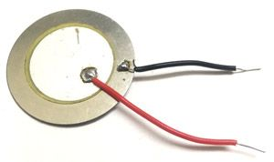
Fig.4.2: Piezo Electric Sensor
Description:
A Piezoelectric Sensor is a device that converts mechanical pressure or vibration into an electrical signal using the Piezoelectric Effect. It typically has two terminals (positive and negative) and produces voltage when mechanical force is applied. It is commonly used in vibration detection and embedded systems with microcontrollers like the Arduino Uno.
4.2.2 Working Principle
The Piezoelectric Sensor works based on the principle of the Piezoelectric Effect. According to this principle, certain materials such as quartz, ceramic, and other crystalline substances generate an electrical charge when mechanical stress such as pressure, vibration, or force is applied to them. This unique property allows the sensor to convert mechanical energy into electrical energy, making it very useful for sensing and measurement applications.
When a mechanical force or vibration is applied to the surface of the piezoelectric sensor, the internal crystal structure of the piezoelectric material undergoes slight deformation. Due to this deformation, positive and negative charges inside the material become separated, which results in the generation of an electrical voltage across the terminals of the sensor. The magnitude of the generated voltage is directly proportional to the amount of pressure or vibration applied to the sensor.
The sensor usually has two terminals, namely a positive terminal and a negative terminal, through which the generated electrical signal is obtained. This electrical signal can be very small, so it is often connected to electronic circuits containing components such as resistors, capacitors, or diodes to stabilize and process the signal before sending it to a microcontroller or measuring device.
The generated electrical signal can then be detected, measured, and processed by electronic systems. In embedded systems and electronics projects, the output signal from the piezoelectric sensor is often given to a microcontroller such as the Arduino Uno, which analyzes the signal and performs specific actions based on the detected vibration or pressure. Because of their high sensitivity, fast response, and small size, piezoelectric sensors are widely used in applications such as vibration detection, pressure sensing, sound detection, impact monitoring, and security systems.
Overall, the piezoelectric sensor provides an efficient method for detecting mechanical changes and converting them into electrical signals that can be easily measured, displayed, and used for controlling different electronic systems.
4.2.3: Pin Diagram of Piezoelectric Sensor:
A piezoelectric sensor usually has two terminals used to obtain the electrical signal generated when pressure or vibration is applied.
Positive (+) Terminal:
This pin provides the output voltage signal generated when mechanical pressure or vibration is applied to the sensor. It is typically connected to the input pin of a microcontroller such as Arduino Uno.
Negative (–) Terminal:
This pin is connected to the ground (GND) of the circuit to complete the electrical path and allow proper signal measurement.This pin provides the output voltage signal generated when mechanical pressure or vibration is applied to the sensor. It is typically connected to the input pin of a microcontroller such as Arduino Uno.

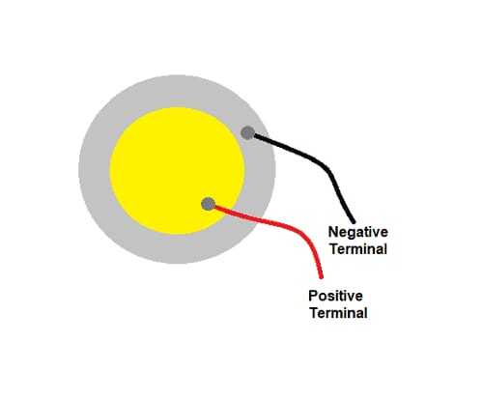
Fig. 4.2.3 pin diagram of piezo sensor

4.2.4: Technical Specifications of Piezoelectric Sensor
- It does not require an external power supply; it generates voltage when mechanical pressure or vibration is applied.
- It works based on the Piezoelectric Effect.
- The sensor generally has two terminals (positive and negative).
- Output voltage ranges from a few millivolts to several volts depending on the applied force.
- It has high sensitivity to vibration, pressure, and mechanical stress.
- The sensor provides a very fast response to mechanical changes.
- Typical operating temperature range is −20°C to 70°C (varies by sensor type).
- The sensor is commonly used for vibration detection, pressure sensing, and impact detection.
- The output signal can be interfaced with microcontrollers such as Arduino Uno.
- The sensor has low power consumption since it only generates signal when force is applied.
- It is compact in size and lightweight, making it suitable for embedded system applications.
- The sensor is capable of detecting small vibrations and mechanical movements with high accuracy.
4.2.5: Piezoelectric Sensor Features
- Works based on the Piezoelectric Effect to convert mechanical pressure into electrical voltage
- Does not require an external power supply to generate output signal
- Highly sensitive to vibration, pressure, and mechanical stress
- Generates voltage output ranging from a few millivolts to several volts depending on applied force
- Fast response time to detect sudden vibrations or impacts
- Small size and lightweight design suitable for embedded applications
- Can be easily interfaced with microcontrollers such as Arduino Uno
- Suitable for applications like vibration detection, motion sensing, and impact monitoring
- Durable and reliable for long-term use in electronic systems
- Simple structure with two terminals for easy circuit integration

4.2.6 Applications
- Vibration Monitoring Systems: Piezoelectric sensors are widely used in vibration monitoring systems to detect and measure mechanical vibrations in machines, buildings, and other structures. When vibrations occur, the sensor converts the mechanical energy into electrical signals, which can be analyzed to determine the vibration level. This helps in monitoring the condition of machines and structures and in identifying potential problems before they become serious.
- Security and Intrusion Detection Systems: These sensors are also used in security systems to detect movements such as footsteps or surface vibrations caused by intruders. When someone walks or applies pressure on the monitored surface, the sensor detects the vibration and generates a signal. This signal can be processed by a microcontroller to trigger alarms or other security mechanisms.
- Pressure and Impact Detection: Piezoelectric sensors are used to detect pressure or sudden impacts on surfaces. When a force or impact is applied, the sensor produces a voltage signal proportional to the applied force. This feature makes them useful in applications where monitoring mechanical pressure or impacts is important.
- Industrial Equipment Monitoring: In industrial environments, piezoelectric sensors are used to monitor machinery and equipment. They help detect abnormal vibrations that may indicate mechanical faults or wear in the equipment. Early detection of such vibrations allows maintenance teams to take preventive measures and avoid equipment failure.
- Sound and Acoustic Detection: Piezoelectric sensors are capable of detecting sound vibrations and converting them into electrical signals. Because of this property, they are used in devices such as microphones, buzzers, and acoustic sensors where sound detection is required.
- Embedded System and Electronics Projects: Piezoelectric sensors are commonly used in embedded system applications with microcontrollers such as Arduino Uno. They are used to detect vibrations, footsteps, or mechanical movements and provide real-time data that can be displayed or used to trigger other electronic devices in the system.

4.3: 16×2 LCD Display with I2C module Introduction
An LCD Display with an I2C Module is a commonly used display device in embedded systems for showing text and sensor data. The I2C module is attached to the back of the LCD and allows qcommunication with microcontrollers using only two wires. This reduces the number of pins required compared to the normal LCD interface, making the circuit simpler and easier to design.
The LCD with I2C module operates using the I2C Protocol, which uses two communication lines called Serial Data (SDA) and Serial Clock (SCL). These lines allow the microcontroller to send data to the display efficiently. In many electronic projects, the LCD with I2C module is connected to microcontrollers such as the Arduino Uno to display sensor values, system status, and messages in real time. Because it requires fewer connections and provides clear output, it is widely used in embedded system and IoT applications.
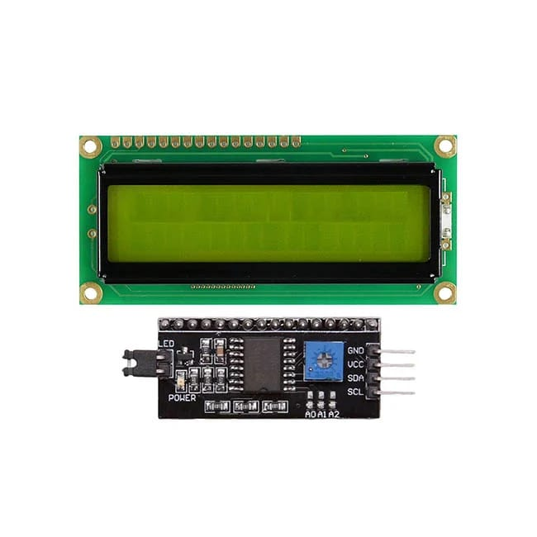
Fig.4.3: LCD with I2C Module

4.3.1: What is an LCD Display?
An LCD Display (Liquid Crystal Display) is an electronic display device used to show text, numbers, and simple graphics in electronic systems. It works using liquid crystals that control light to form visible characters on the screen.
LCDs are widely used in electronic and embedded systems because they consume very little power and provide clear output. They are commonly connected to microcontrollers such as the Arduino Uno to display sensor values, system status, and messages in real time.
4.3.2: What is an I2C Module?
An I2C Module is a small interface device used to connect an LCD Display to a microcontroller using the I2C Protocol. It is usually attached to the back of the LCD and reduces the number of connection pins required to operate the display.
Normally, an LCD requires many pins to communicate with a microcontroller, but the I2C module allows communication using only two lines: SDA (Serial Data) and SCL (Serial Clock). This makes the circuit simpler and easier to design. The module is commonly used with microcontrollers such as the Arduino Uno to display sensor data, messages, and system information in embedded system projects.

4.3.3 Strip LED
In this project, a strip LED is employed as a visual output indicator controlled by the measured power level. The generated power is continuously monitored, and a threshold of 0.5 mW is set within the system. When the power exceeds this threshold, the control circuit activates the LED strip, causing it to glow. Conversely, when the power falls below 0.5 mW, the LED remains deactivated. This implementation enables efficient real-time indication of sufficient power generation.

Fig.4.3.3:Strip LED
4.4: BC 547:
The BC547 is a widely used NPN bipolar junction transistor designed for general-purpose switching and amplification applications. It is made of silicon and comes in a compact TO-92 package, making it suitable for small electronic circuits. The transistor has three terminals namely collector, base, and emitter, where a small current applied at the base controls a larger current flowing between the collector and emitter.
It can operate in two modes: as a switch to turn electronic components ON and OFF, and as an amplifier to increase signal strength. The BC547 can handle a maximum collector-emitter voltage of about 45V and a collector current of up to 100mA, with a gain range between 110 and 800. Due to its low cost, reliability, and ease of use, it is commonly used in applications such as audio amplifiers, LED circuits, relay drivers, and various sensor-based electronic projects. However, it is not suitable for high-power applications due to its limited current and power handling capacity.
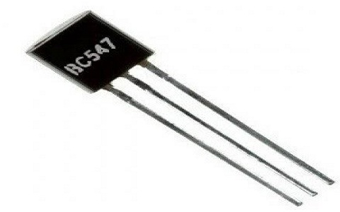

Fig.4.4: BC547 Transistor

4.5:Resistors:

Resistors are fundamental electronic components used in circuits to control, limit, and regulate the flow of electric current. They work on the principle of resistance, which opposes the movement of electrons in a conductor. The value of resistance is measured in ohms (Ω), and it determines how much current will flow for a given voltage. Resistors are commonly made from materials such as carbon, metal film, or wire wound, and they come in different shapes and sizes depending on their application.
In a circuit, resistors are mainly used to protect components from excessive current, divide voltage, and set operating conditions for devices like transistors and LEDs. For example, in an LED circuit, a resistor is connected in series to prevent too much current from damaging the LED. Resistors can be fixed, where the resistance value remains constant, or variable, where the value can be adjusted using components like potentiometers.
They are widely used in almost all electronic devices, including televisions, mobile phones, computers, and power systems. Resistors are simple, inexpensive, and reliable, but they dissipate electrical energy in the form of heat, which can be a disadvantage in high-power applications.
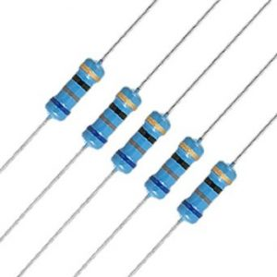

Fig.4.5: Resistors
4.6 Diodes:
Diodes are essential electronic components that allow electric current to flow in only one direction while blocking it in the opposite direction. They are made from semiconductor materials such as silicon and consist of two terminals called the anode and cathode. The operation of a diode is based on the formation of a p-n junction, where current flows easily when the diode is forward biased (anode connected to positive and cathode to negative) and is restricted when reverse biased.
Diodes are widely used in electronic circuits for various purposes such as rectification, signal modulation, voltage regulation, and protection. For example, in power supply circuits, diodes convert alternating current (AC) into direct current (DC). There are different types of diodes including rectifier diodes, Zener diodes, light-emitting diodes (LEDs), and photodiodes, each designed for specific applications.
They are simple, reliable, and inexpensive components used in almost all electronic devices like televisions, mobile phones, and computers. However, diodes have limitations such as voltage drop and limited power handling capacity depending on their type.
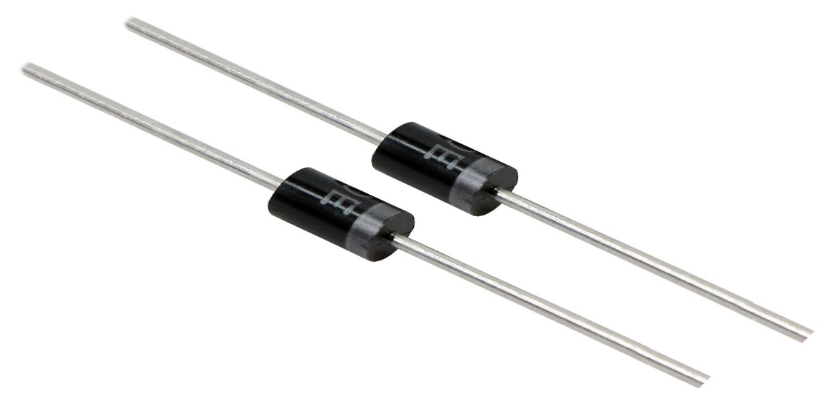
Fig.4.6: Diodes
4.7: Capacitors
A capacitor is a basic electronic component used to store electrical energy temporarily in the form of an electric field. It consists of two conductive plates separated by an insulating material called a dielectric. When voltage is applied across the plates, electric charge accumulates, allowing the capacitor to store energy and release it when needed.
Capacitors are widely used in electronic circuits for various purposes such as filtering, smoothing, coupling, and timing applications. For example, in power supply circuits, they help reduce voltage fluctuations (ripple), while in signal processing, they block direct current (DC) and allow alternating current (AC) to pass. The ability of a capacitor to store charge is called capacitance, and it is measured in farads (F).
There are different types of capacitors, including ceramic, electrolytic, and film capacitors, each suited for specific applications based on their size, voltage rating, and performance. Capacitors play a crucial role in almost all electronic devices like radios, televisions, computers, and mobile phones.
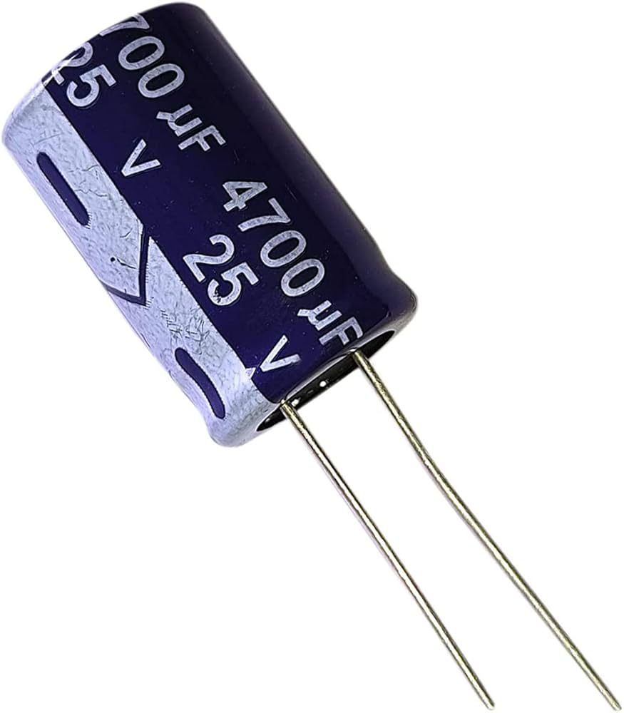
Fig.4.7:Capacitor
4.8: Breadboard
With all the powerful and fun to use development boards out there, there’s a lot you can do without a breadboard. However, if you’re setting up small circuits for learning the basics of electronics or need a place for peripheral components, breadboard is a great tool to have.

4.8.1: What is a Breadboard?
A Breadboard is simply a board for prototyping or building circuits on. It allows you to place components and connections on the board to make circuits without soldering. The holes in the breadboard take care of your connections by physically holding onto parts or wires where you put them and electrically connecting them inside the board. The ease of use and speed are great for learning and quick prototyping of simple circuits. More complex circuits and high frequency circuits are less suited to bread boarding. Breadboard circuits are also not ideal for long term use like circuits built on perfboard (protoboard) or PCB (printed circuit board), but they also don’t have the soldering (protoboard), or design and manufacturing costs (PCBs).
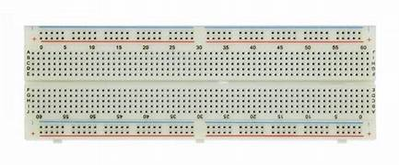
Fig.4.8: Breadboard

4.8.1: Why do you use a Breadboard?
A breadboard is used in electronic projects to build and test circuits without the need for soldering. It allows components to be easily inserted, removed, and rearranged, making it very convenient for experimenting and correcting mistakes. Using a breadboard saves time and makes the circuit reusable, as the same board can be used for multiple projects. It is especially useful during the development stage, where connections may need to be changed frequently. Once the circuit works properly on the breadboard, it can then be made permanent using a soldered PCB.
4.9:Jumper wires:
Jumper wires, also known as jumper cables or DuPont wires, are electrical wires used to conn.etc components, sensors, or modules to a microcontroller or a printed circuit board (PCB). They are commonly used in electronics prototyping, DIY projects, and robotics.

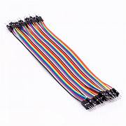
Fig.4.9: Jumper wires
4.9.1 Characteristics of jumper wires:
- Flexible insulated wires with a conductor (copper or aluminium) inside
- Typically, 20-24 AWG (American Wire Gauge) in size
- Have a male or female connector (pin) on each end
- Used for signal, power, or data transmission
- Often color-coded to indicate different signals or functions
4.9.2 Types of jumper wires:
- Male-male (M-M)
- Male-female (M-F)
- Female-female (F-F)

CHAPTER 5
PROGRAM CODE

#include <Wire.h>
#include <LiquidCrystal_I2C.h>
LiquidCrystal_I2C lcd(0x27,16,2);
int sensorPin = A0;
int ledPin = 7;

float voltage = 0.0;
float power = 0.0;
const float R = 1000.0; // assume 1kΩ load resistor
int baseline = 0;

void setup() {
pinMode(sensorPin, INPUT);
pinMode(ledPin, OUTPUT);
lcd.init();
lcd.backlight();
lcd.setCursor(0,0);
lcd.print("Smart Floor");
delay(2000);
lcd.clear();

// 🔧 Baseline calibration
long sum = 0;
for(int i=0; i<50; i++) {
sum += analogRead(sensorPin);
delay(10);
}
baseline = sum / 50; // average idle value
}

void loop() {
int rawValue = analogRead(sensorPin);

// Adjust with baseline
int adjusted = rawValue - baseline;
if(adjusted < 0) adjusted = 0;

// Convert to voltage (assuming 5V reference)
voltage = (adjusted / 1023.0) * 5.0;

// Calculate power (P = V^2 / R)
power = (voltage * voltage) / R;

// Display values
lcd.setCursor(0,0);
lcd.print("V: ");
lcd.print(voltage,2); // 2 decimal places
lcd.print(" ");

lcd.setCursor(0,1);
lcd.print("P: ");
lcd.print(power,4); // 4 decimal places
lcd.print("W ");

// Vibration detection: if voltage > 0.5V
if(voltage > 0.5) {
digitalWrite(ledPin, HIGH); // LED strip ON
} else {
digitalWrite(ledPin, LOW); // LED strip OFF
}

delay(200);
}

CHAPTER 6
RESULT OF THE PROJECT

The footsteps power generation system successfully generated electrical energy using human motion. The output voltage varied between 3V and 12V depending on the applied pressure. The generated energy was stored in a capacitor and used to power an LED strip. With continuous footsteps, the stored energy increased, providing a stable output. The system proved to be effective for low-power applications and can be implemented in high-footfall areas for energy harvesting.

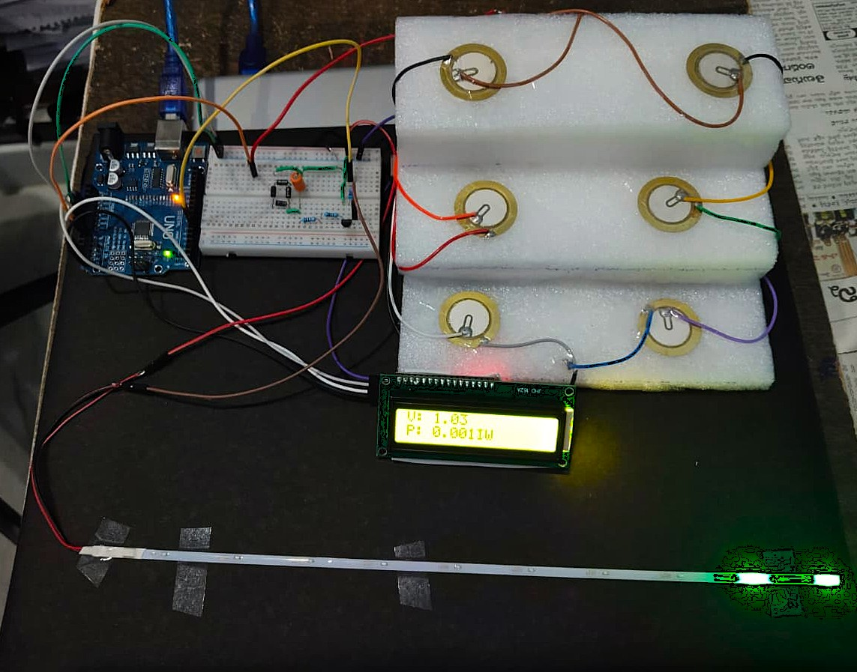
Fig.: FINAL OUTPUT

REFERENCES

- Power electronics: Circuits, Devices and Applications, 3rd Edition, Pearson Education.
- Electronic Devices and Circuit Theory, 11th Edition, Pearson.
- IEEE, “Research papers on Energy Harvesting Systems,” Available: IEEE Xplore Digital Library.
- Electronics Hub, “Footstep Power Generation System,” [Online]. Available: https://www.electronicshub.org/
- All About Circuits, “Basic Electronic Circuits and Components,” [Online]. Available: https://www.allaboutcircuits.com/
- Wikipedia, “Piezoelectric Effect and Energy Harvesting,” [Online].

