Ensuring the Security of Logistics Information & Data Searching using Ant Colony Optimization & Blockchain
In this paper as per your requirements we have splitted file data into multiple chunks and each chunk will get encrypted using symmetric AES algorithm and then encrypted trapdoor will be generated from each chunk. Different chunks will be stored in cloud server (here we don’t have any cloud server so we are storing all file blocks into IPFS (inter planetary file system) and then encrypted trapdoor will be saved in Blockchain.
Blockchain has inbuilt support for data encryption and verification which makes it tamper proof compare to cloud server as this cloud servers trapdoor can be modify or user query can be inspected but in Blockchain there is no way to alter or modify trapdoor.
Blockchain store each record as block/transaction and associate each block wit unique hash code and while storing new blocks then it will verify hash code of previous blocks, if data not tamper then result into same hash code and verification will be successful, this verification process makes Blockchain immutable and secure.
In propose work we are saving all trapdoor in Blockchain and whenever user issue any query then application will apply ANT Colony Optimization algorithm to search all trapdoor and then assigned high weight to files which contains terms (this will similar to ant process which will leave pheromone all the way where food exists and here also application will apply high weights to only those file which contains search term in trapdoor).
All trapdoor will be encrypted using MD5 hash code and Blockchain will manage all trapdoor values using smart contract. Smart contract contains function which will call by any programming language to store or retrieve data from Blockchain. To manage trapdoor we designed following smart contract
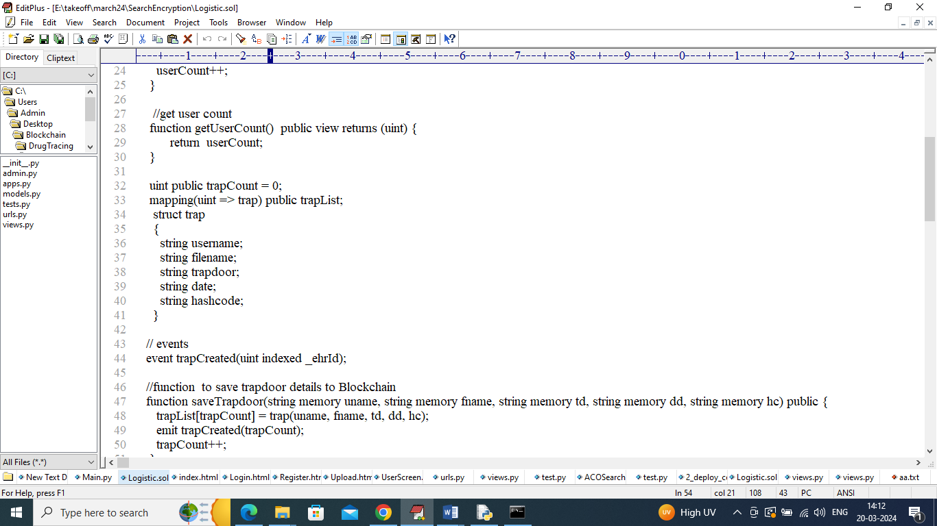
In above smart contract we define function to manage trapdoor for each user file and this smart contract is designed using SOLIDITY programming and we need to deploy above contract in Ethereum Blockchain to call above function to save and get trapdoor data. To deploy above contract in Ethereum we need to follow below steps
- First go inside ‘hello-eth/node-modules/bin’ folder and then double click on runBlochain.bat file to start Ethereum tool and get below screen
- 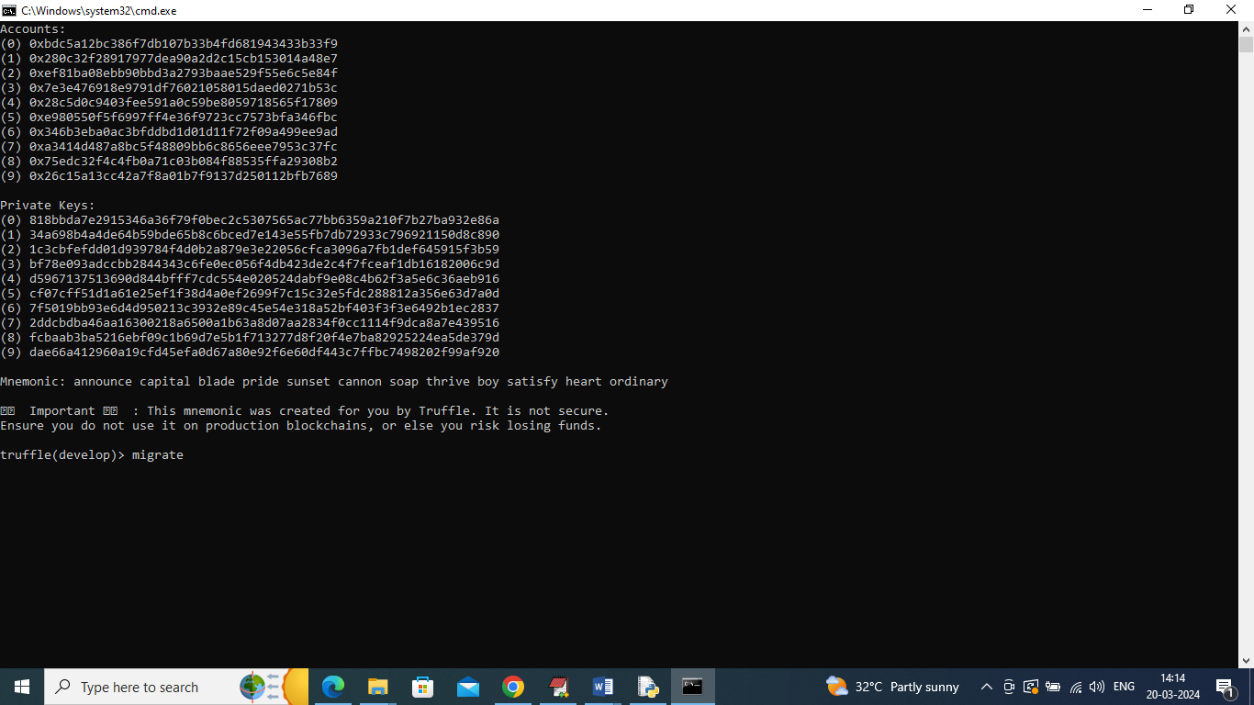
- In above screen Ethereum started with default accounts and private keys and now type command as ‘migrate’ and press enter key to get below page
- 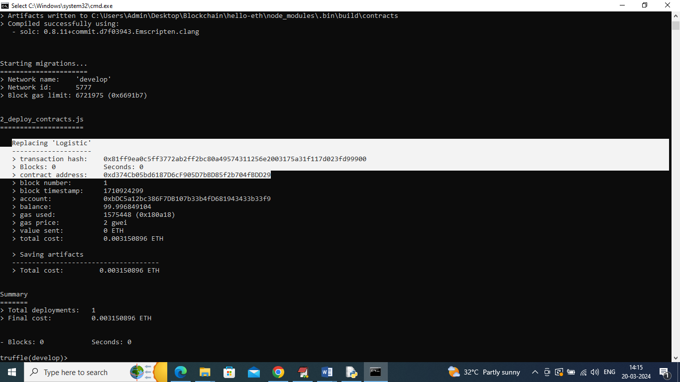
- In above screen in white colour text can see ‘Logistic’ contract deployed and got contract address also and this address need to specify in python code to save and get trapdoor from Ethereum. In below screen showing python code calling above contract
- 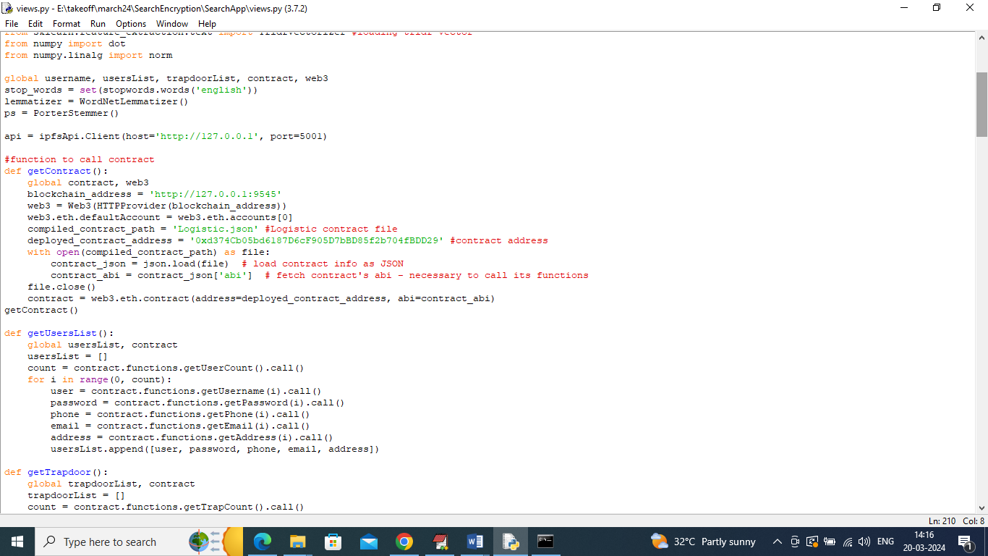
- In above screen read red colour comments to know about contract calling from python. In above screen we have seen contract deployed and running and now double click on ‘runIPFS.bat’ file to start cloud server and get below page
- 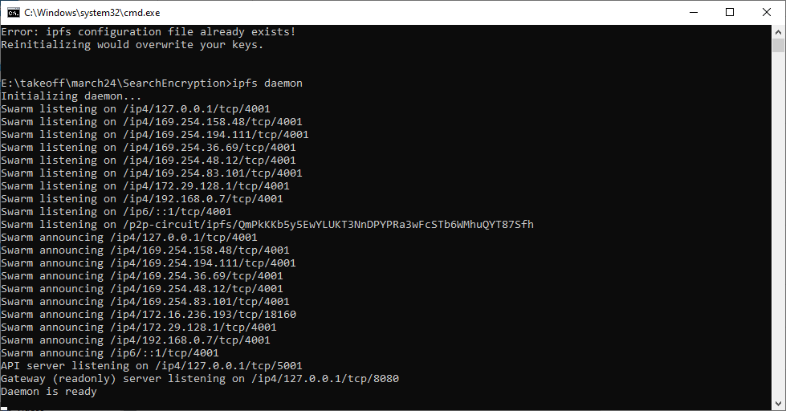
- In above screen IPFS cloud server started and now double click on ‘run.bat’ file to start python web server and get below page
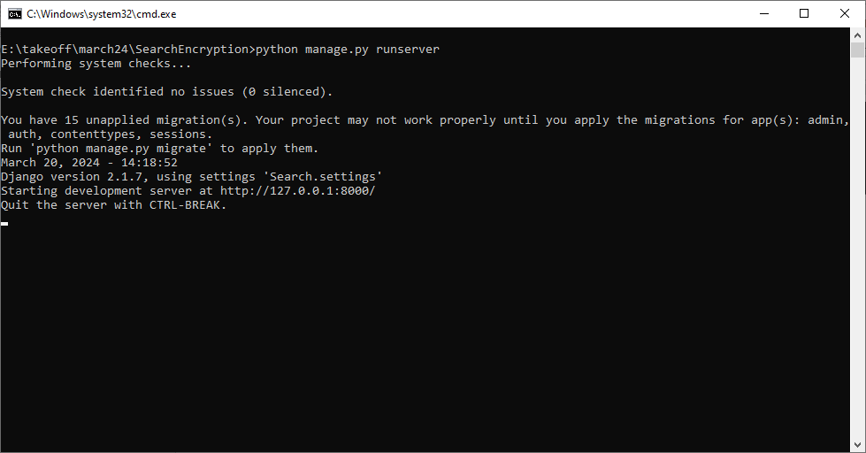
In above screen python web server started and now open browser and enter URL as http://127.0.0.1:8000/index.html and press enter key to get below page
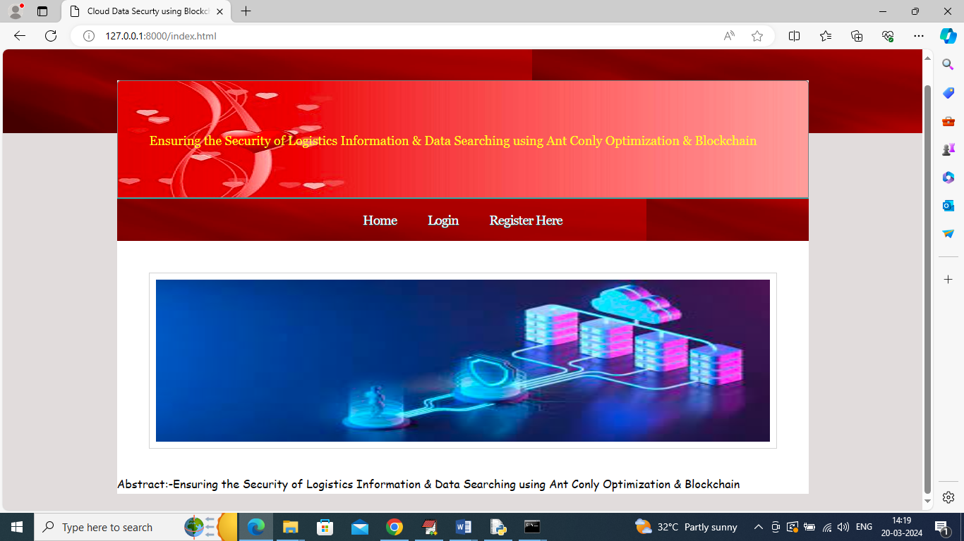
In above screen click on ‘Register Here’ link to get below page
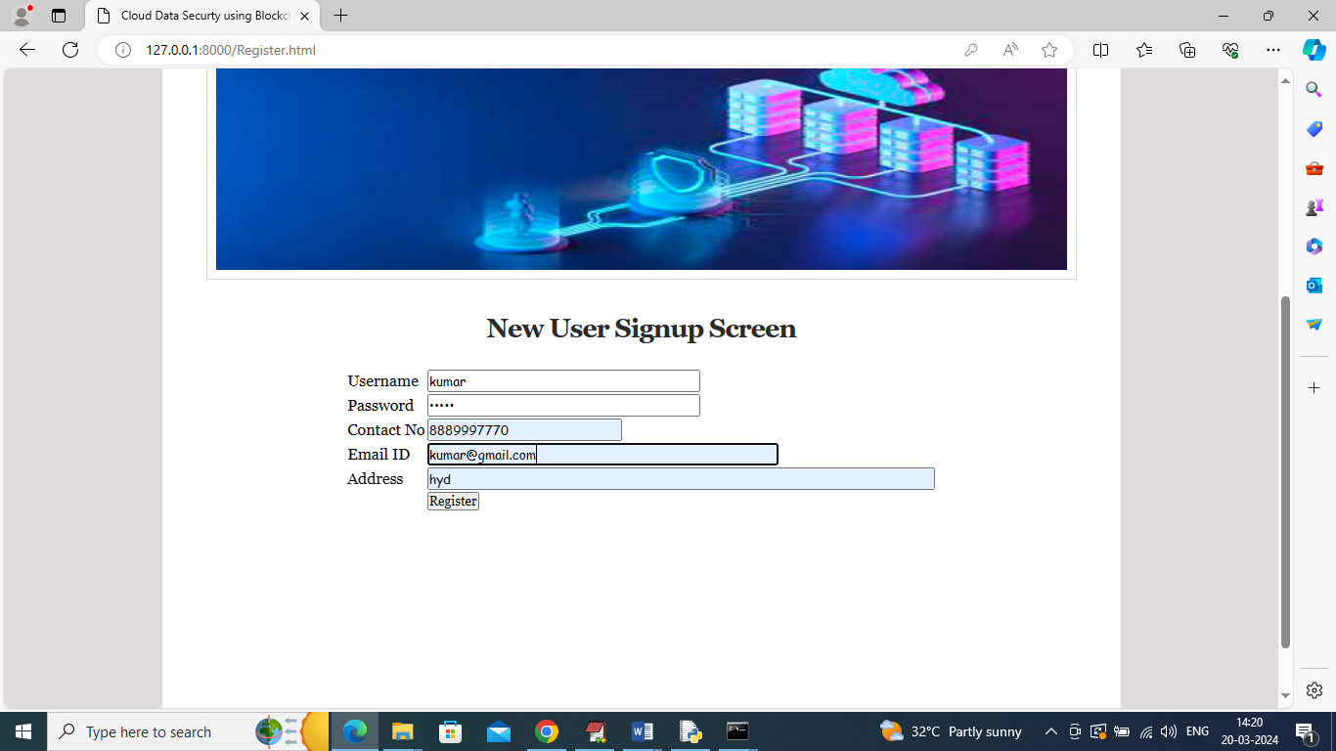
In above screen user is entering sign up details and then press button to get below page
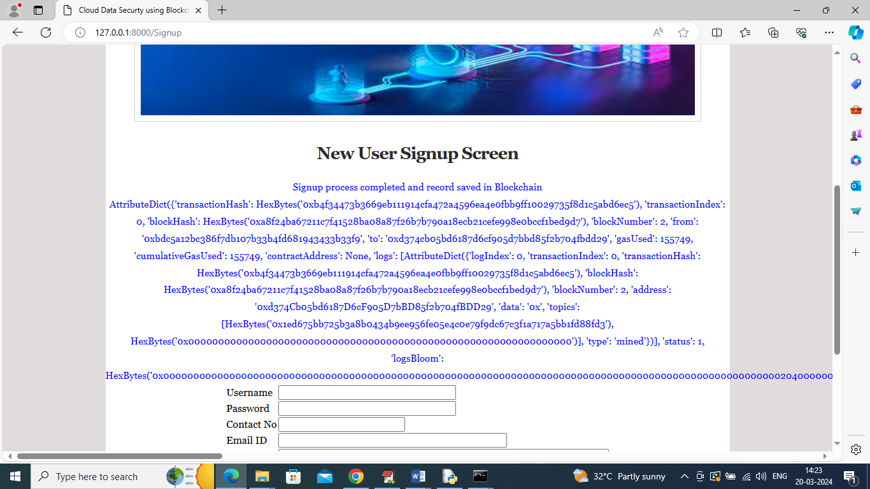
In above screen user sign up details saved in Blockchain and for your understanding I am displaying all response returned from Blockchain after storing record and in above screen can see transaction no, block no, hash code and many other details. Now click on ‘User Login’ link to get below page
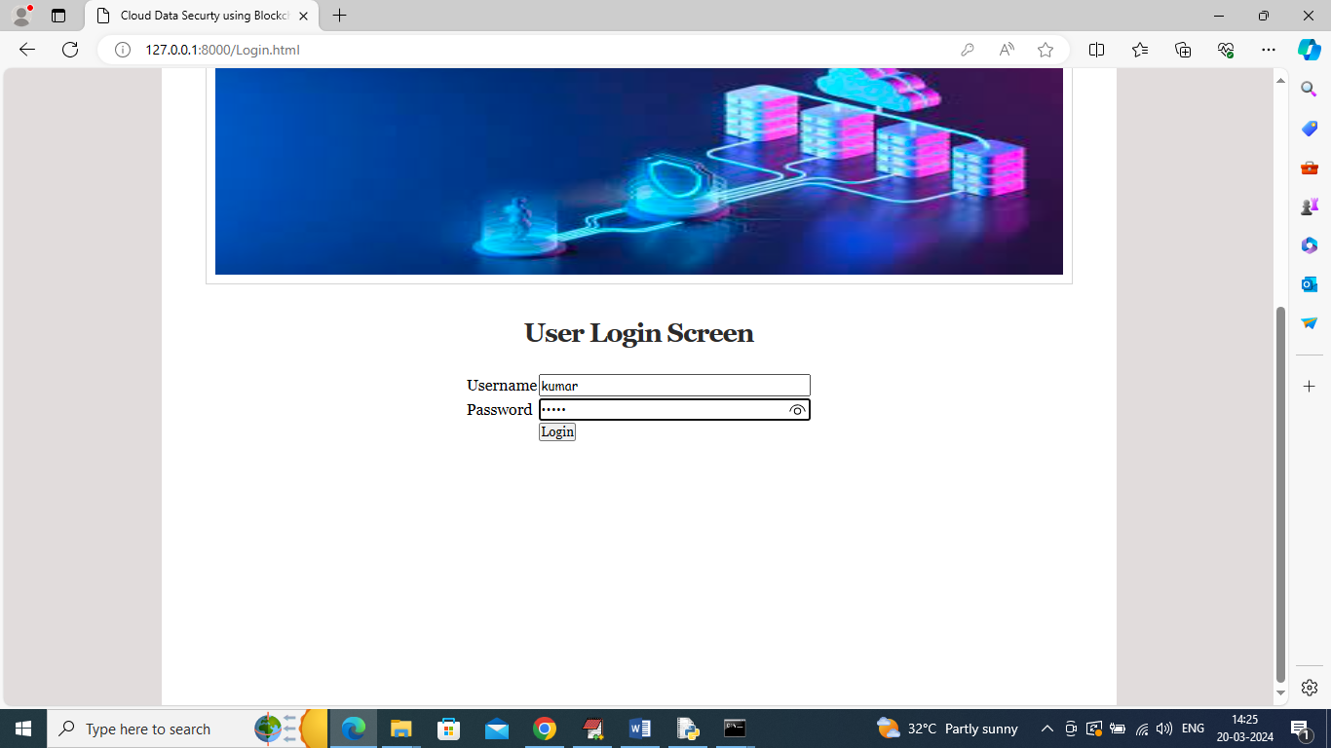
In above screen user is login and after login will get below page
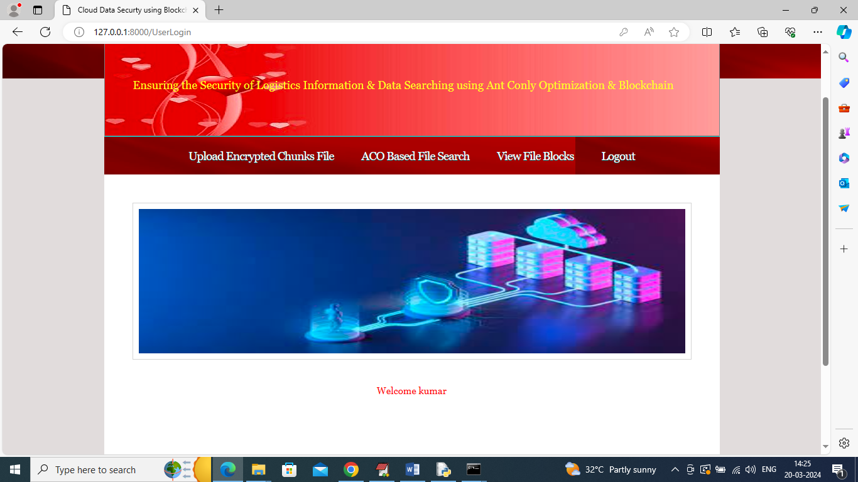
In above screen click on ‘Upload Encrypted Chunks File’ link to get below page to upload file and this file can be any text file or your logistic file
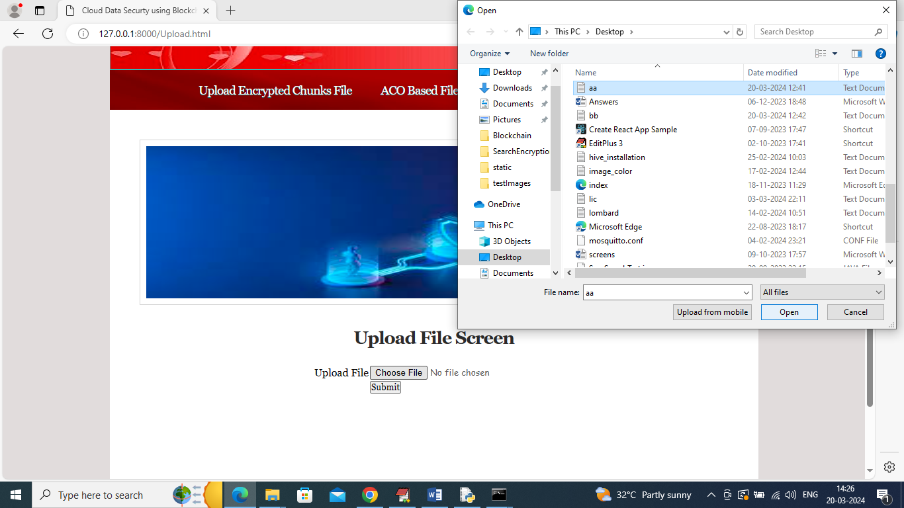
In above screen selecting and uploading aa.txt file and then click on ‘Open’ and ‘submit’ button to convert file into encrypted chunks and then generate trapdoor and then store trapdoor in Blockchain and encrypted chunks in cloud and then wil get below output
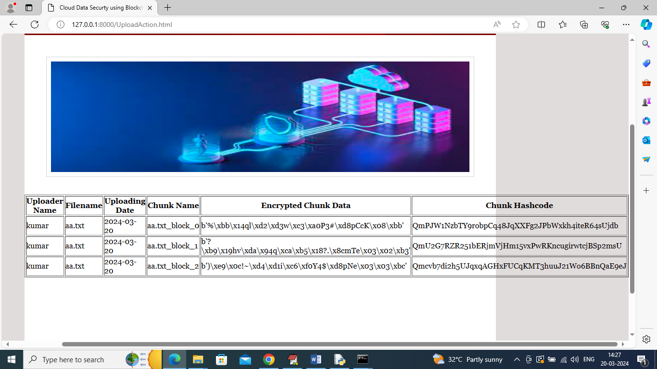
In above screen from uploaded file 3 chunks are created and then can see encrypted data from each chunk and then can see hash code of each chunks and similarly you can upload any number of text file. Here we need to divide file into blocks so we need to use only text file. Here we are using free education purpose Ethereum tool so its gas price will be less so try to upload small size files. Now click on ‘View Blocks’ to retrieve all blocks files and trapdoor from Blockchain
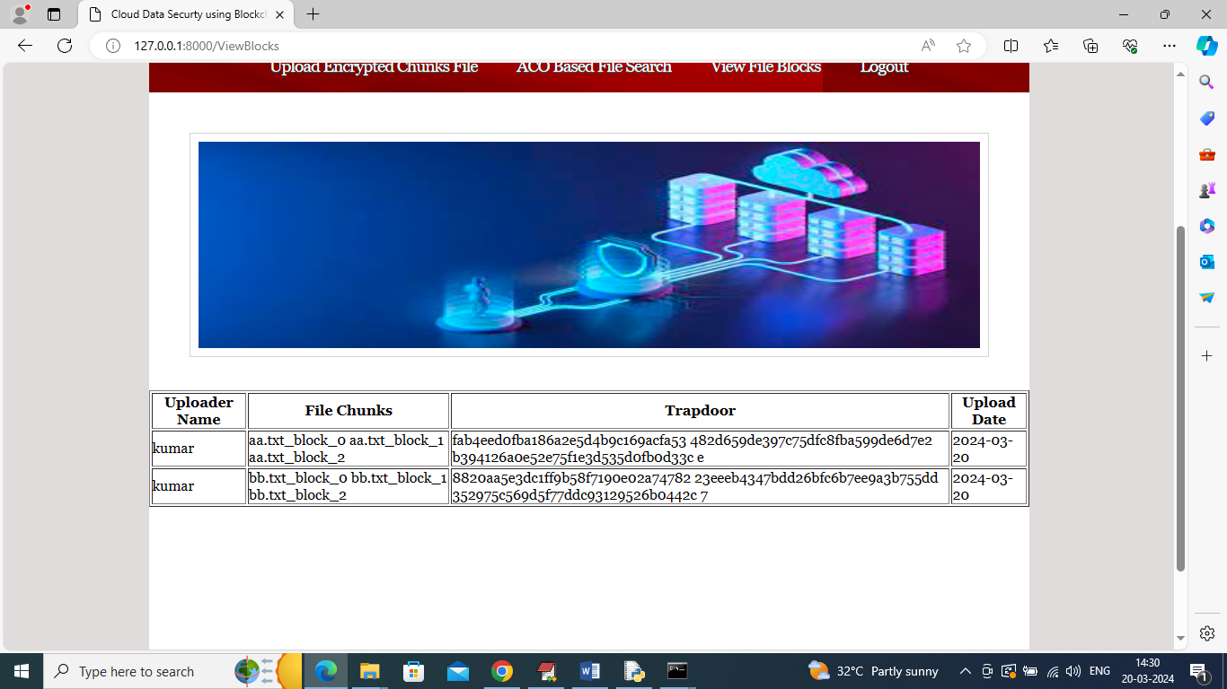
In above screen can see name of uploaded and then can see name of each file in each row and each file will have multiple chunks names and then can see encrypted trapdoor which will search by user in encrypted mode only and then can see date of file upload. Now click on ‘ACO Based File Search’ link to get below screen to search file
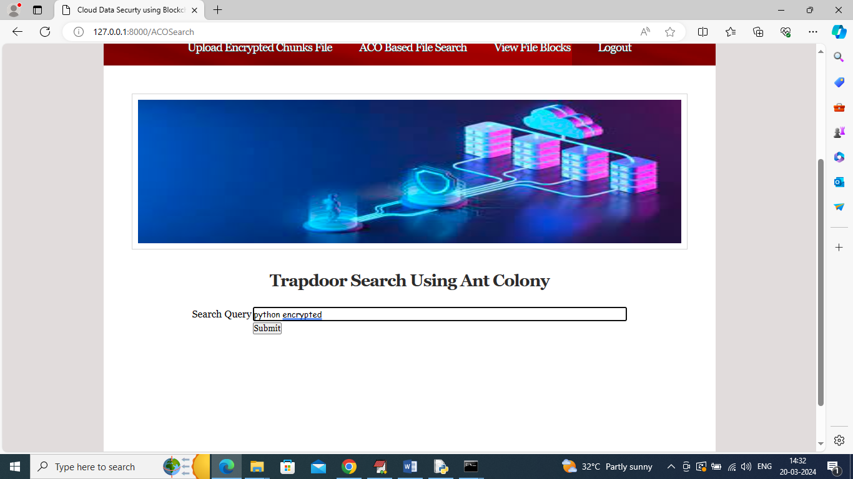
In above screen i gave some keywords and then press button to get list of all files which contains those words
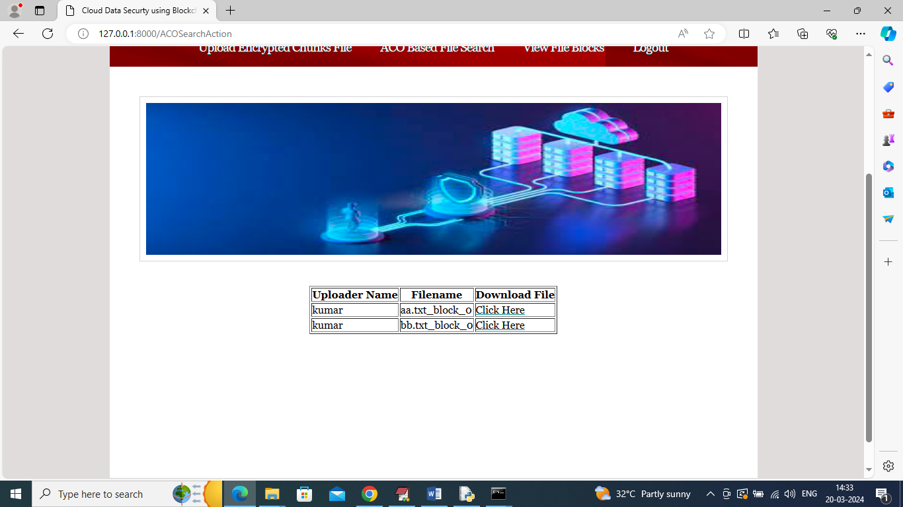
In above screen user can see list of all searched file and then click on ‘Click Here’ link to download desired file in decrypted format
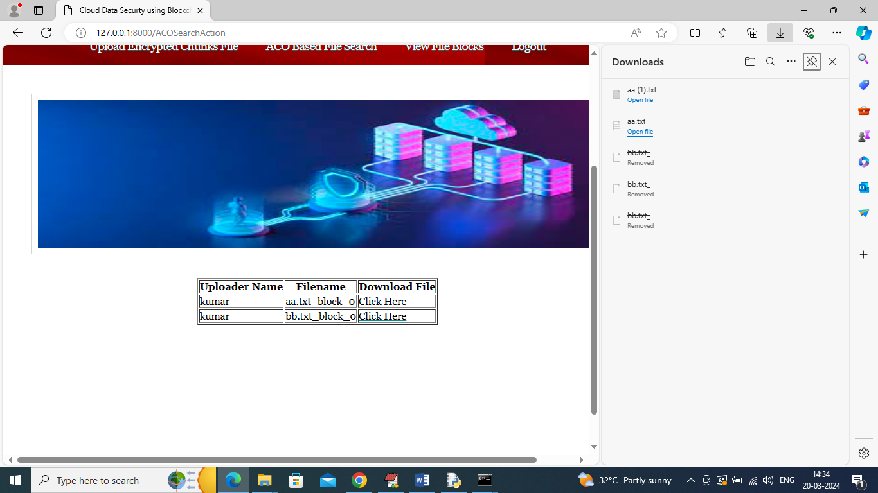
In above screen in right side panel can see file is downloaded and now open that file to view text in decrypted format in below screen
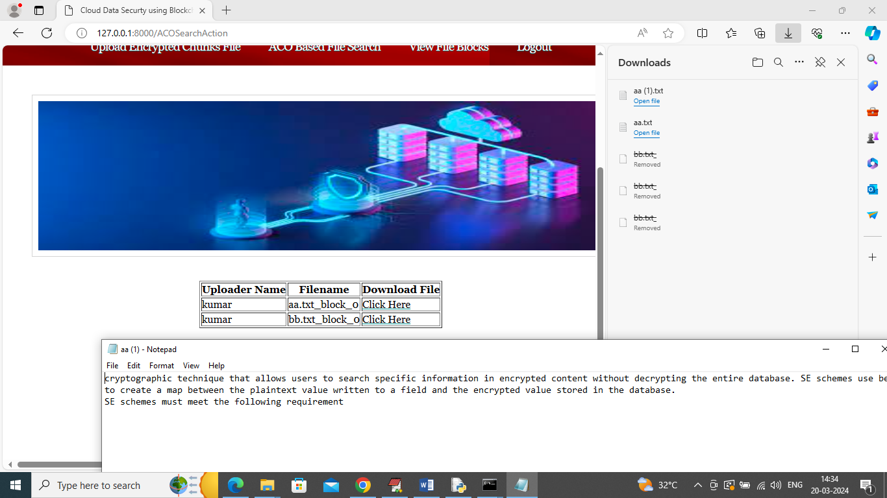
In above screen can see file text in decrypted format.
Similarly by following above screens you can manage encrypted file in cloud and searchable trapdoor in Blockchain to provide security to user data.

