**NAME**: KONAKALLA AKHILA **SUBMISSION**:09-06-2022

**BATCH**: DXC-262-ANALYTICS-B12-AZURE **ASSESSMENT**:9

# Explain the steps with screenshots how to AzureSynapse analytics?

Open Microsoft Azure and search for Azure Synapse Analytics. After open Synapse workspace

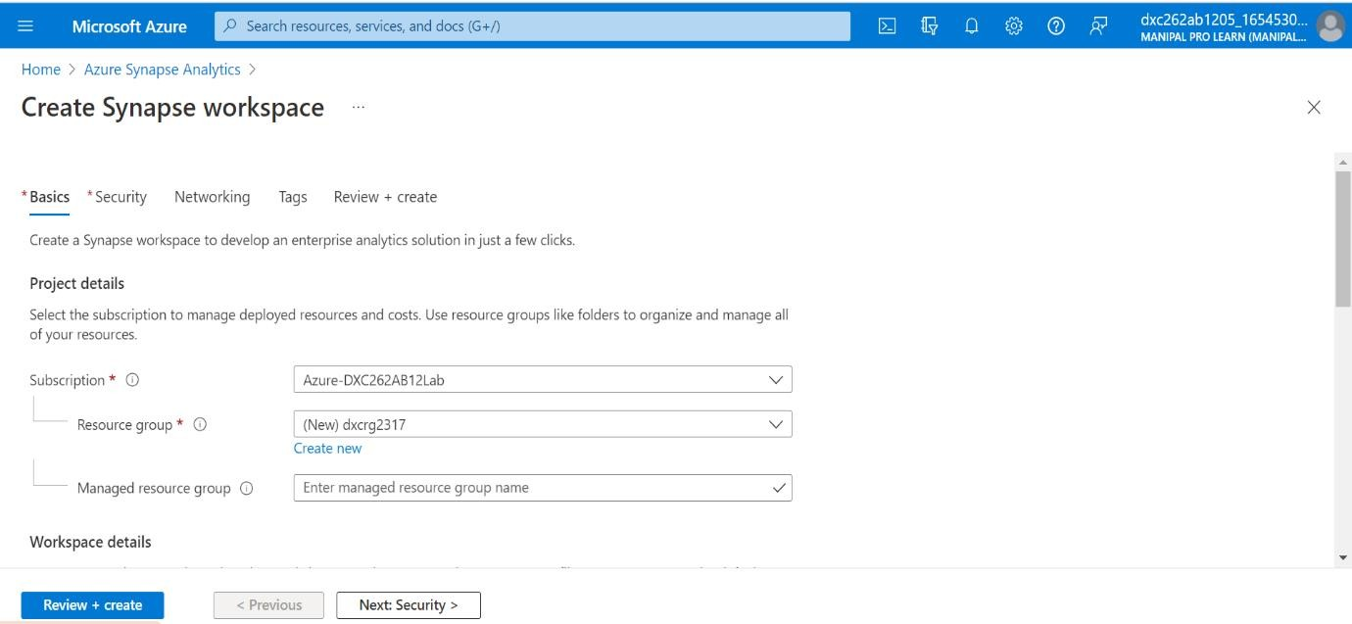

After completing Basic information, continue to security details

Then continue to Network , Tags details and go to Review & Create

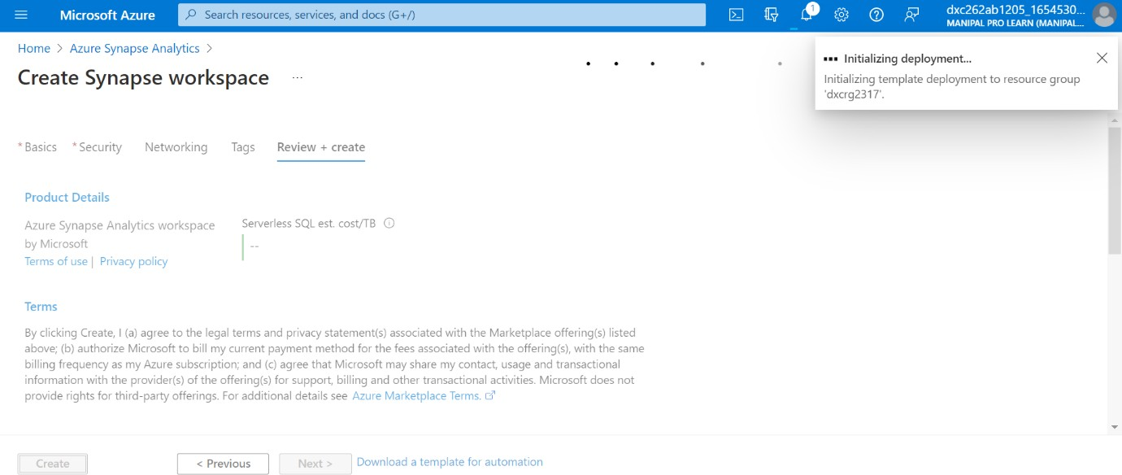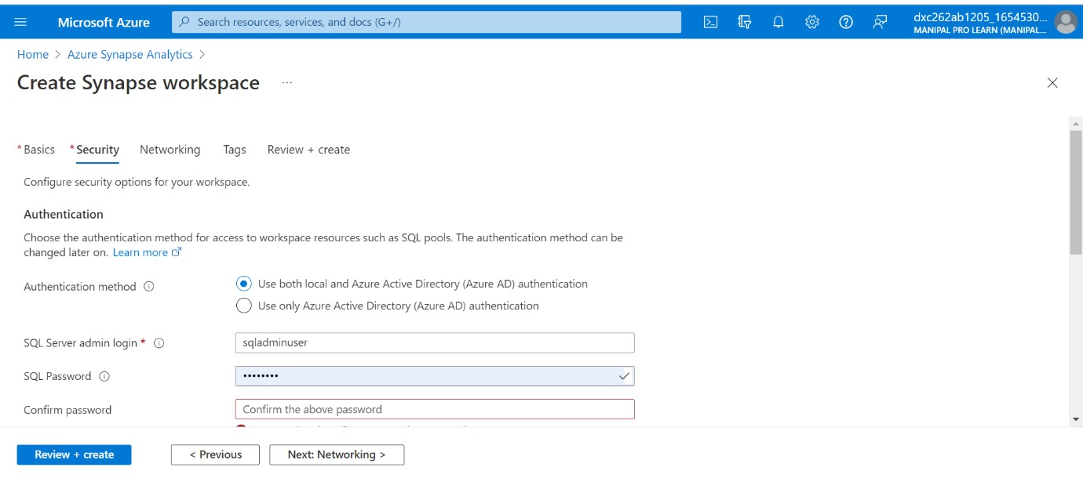

After creating ,deployment starts installing

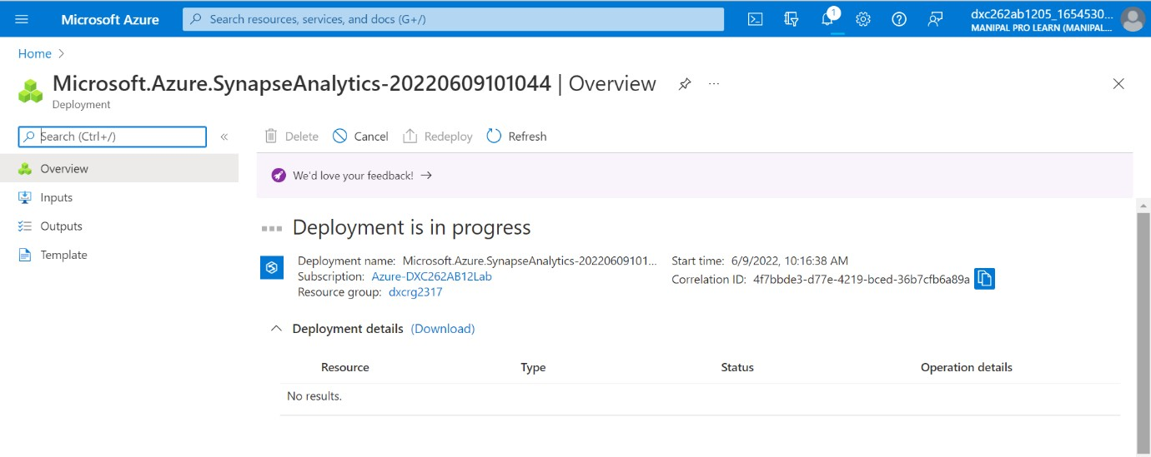

After completing deployment process , go to resource group

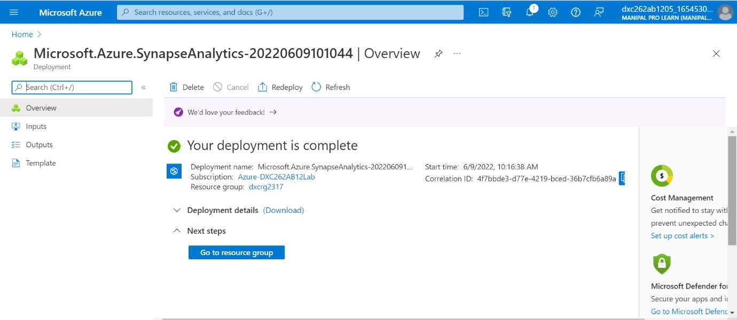

Successfuly created Azure Synapse Analytics

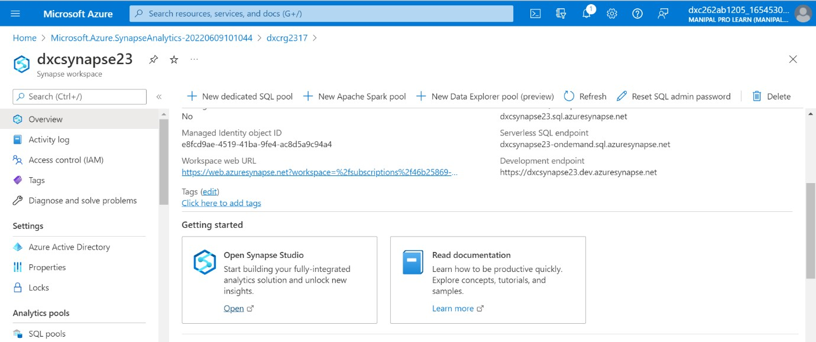

# Explain the steps with screenshots how to SQL Pool in AzureSynapse analytics?

Open AzureSynapse and go to analytics

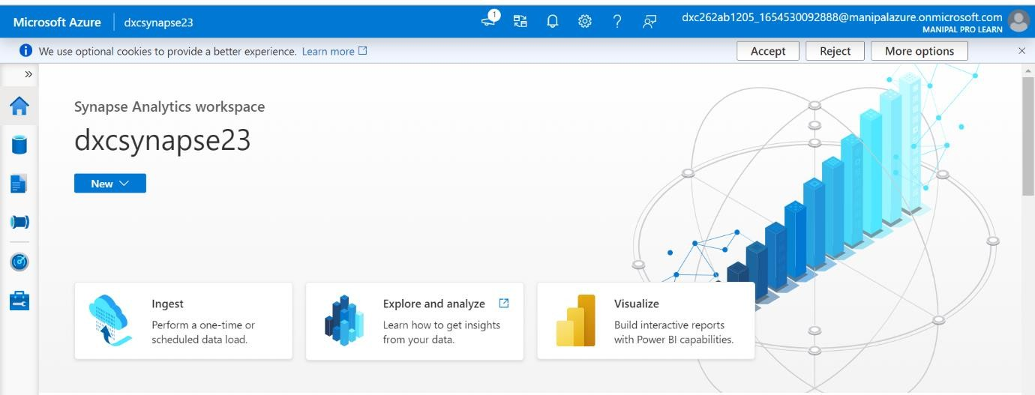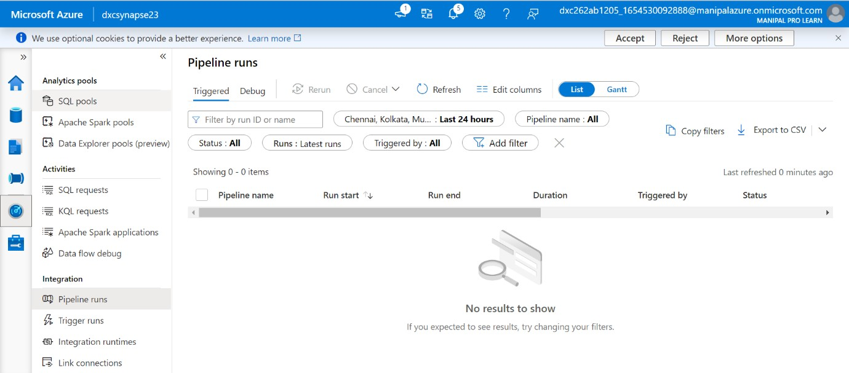

In Analytics pools we can see SQL pools

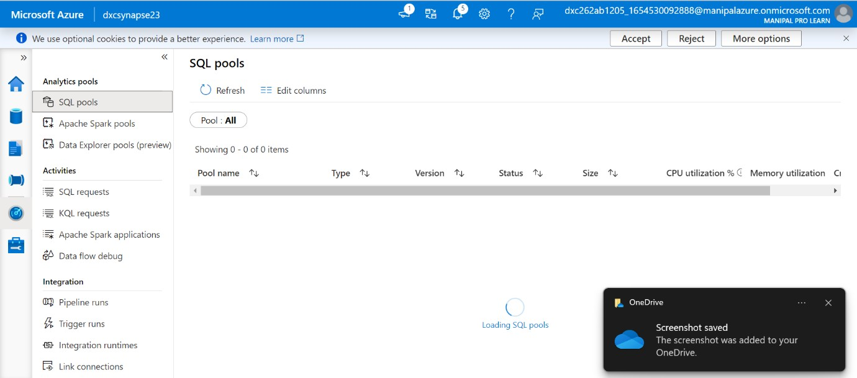

Create a pool Bult-in

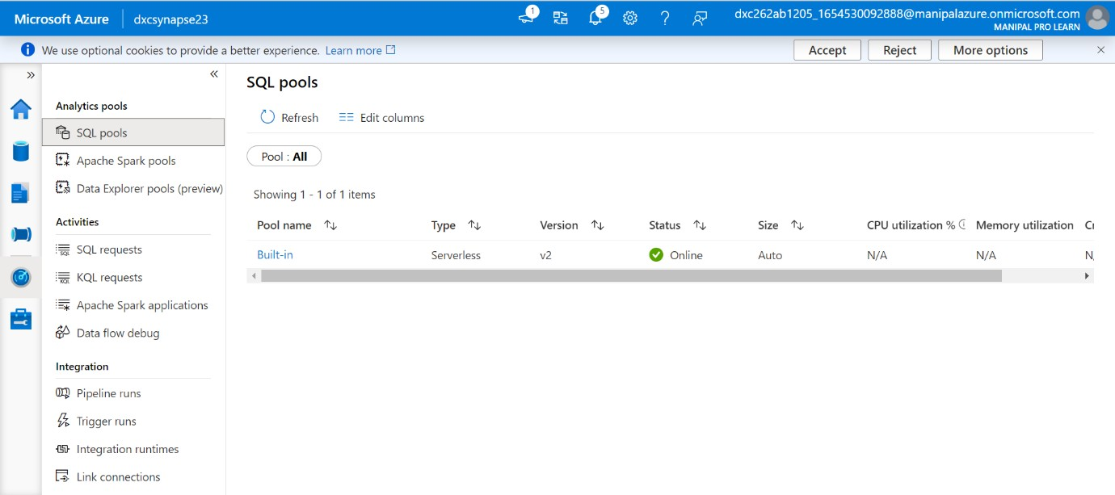

# Explain the steps with screenshots how to import COVID19 dataset in AzureSynapse analytics and run sample 500 rows & display the output?

Open browse gallery & search for Datasets

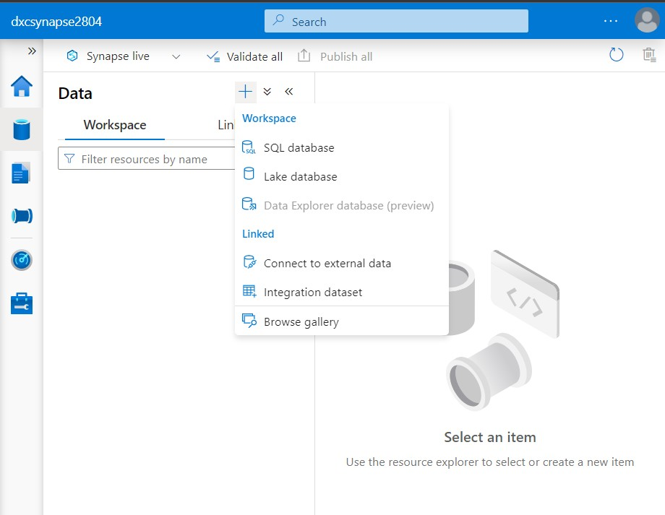

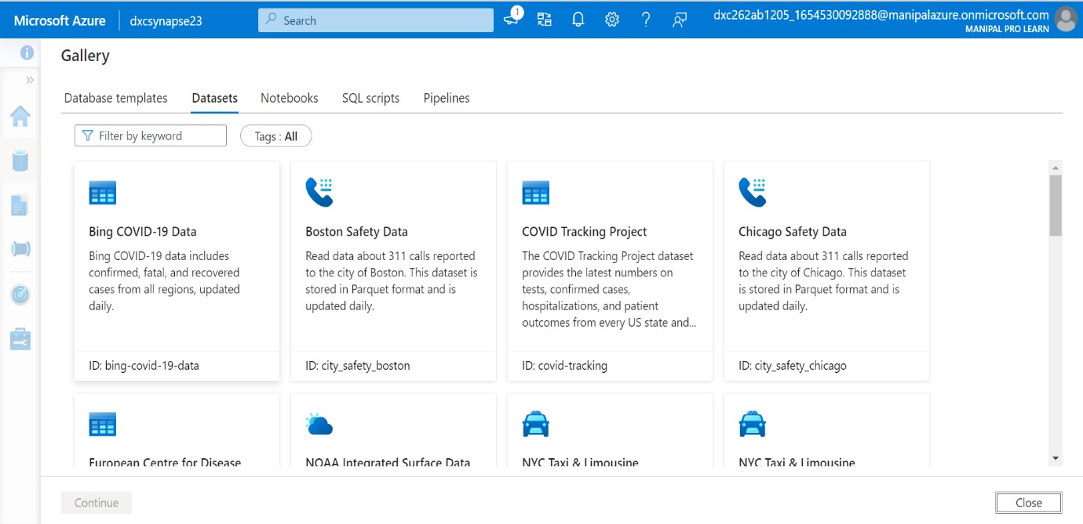

Select Bing COVID-19 Data Set

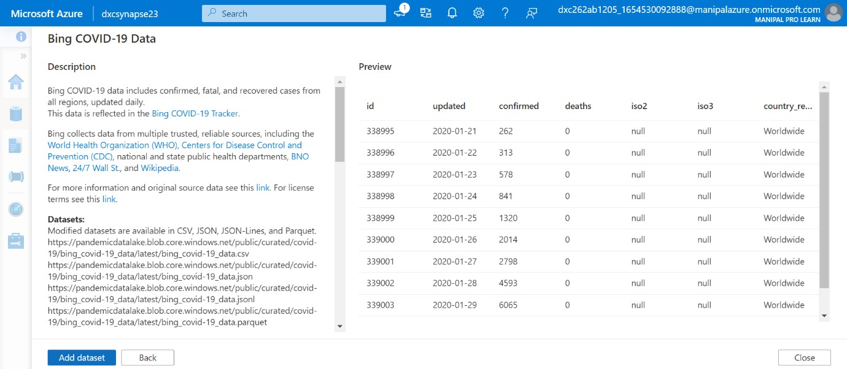

Click on Add dataset and the dataset will be imported. Then run sample 500 rows

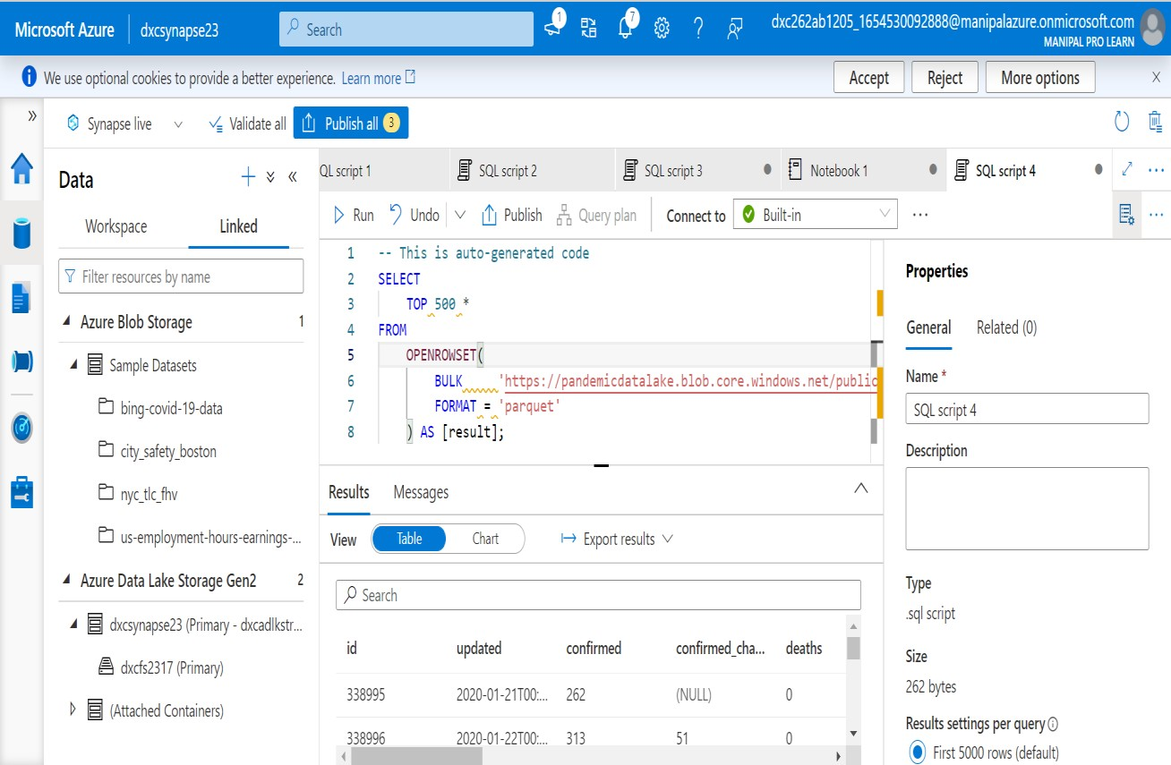

# Explain the steps with screenshots how to input Boston Safety datasets into AzureSynapse analytics using Notebooks ?

In synapse studio

In this Data Tab click on + sign and select Browse gallery

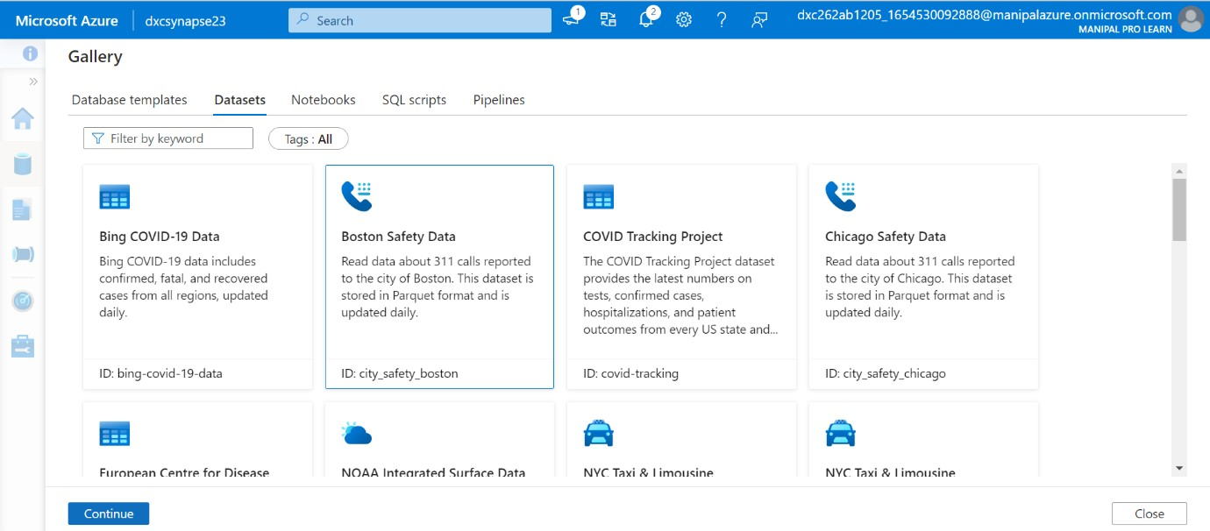In that Datasets-> Select Boston Safety dataset Data and Continue Go to city_safety_boston-> New NoteBook-> Load to Data Frame

Add dataset to the workspace

eg Boon Safety Data

Preview



 

This dataset is stored In Parquet format It is updated daily. and contains 

  



This dataset is stored in the East US Azure region. Allocating compute resources in East us is recommended for affinity.

311 AII

311 AII

311 AII

311 AII



1O/19/2021.. Eton:emen... BlngEt. Open 10/19A02.. Enoroemen.. PaWngfnt. Open 10/19A021.. Eooroemen... PeWngEn... Open

1fl/19€02i.. Eforoenen... PaWngEt.. Op•n



    



can be found from here. Reference Open Dala Commons Public Domain <

10/19/2021 ... Enfor cemen... Parking Enf... Open 



Accept

Rejeci

More options





* AzuceDemLeEeStoogeGen2 % NewsOL%m „ p,gg,

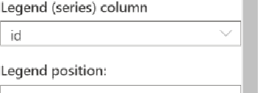b (Attached ConQinefsl 



1 _

We use optional co‹›I‹ies to provide a bmei experience. laem more 0

Accept

ajen

More options







Data





262 bytes

Pasufls settings per query O

@• rust S00o rows fdefa«F›

@ Publishing completed 



Goieral Related (0)



I @ dx‹synapse23 (Primary dxcadlMr... @i dxcM3l7 IPrimary}



On '•' s0o0 rous (detent)

# Explain the steps with screenshots how to create Spark pool in AzureSynapse analytics?

Open AzureSynapse , go to Analutics pools and select Azure tools Apache Spark pool

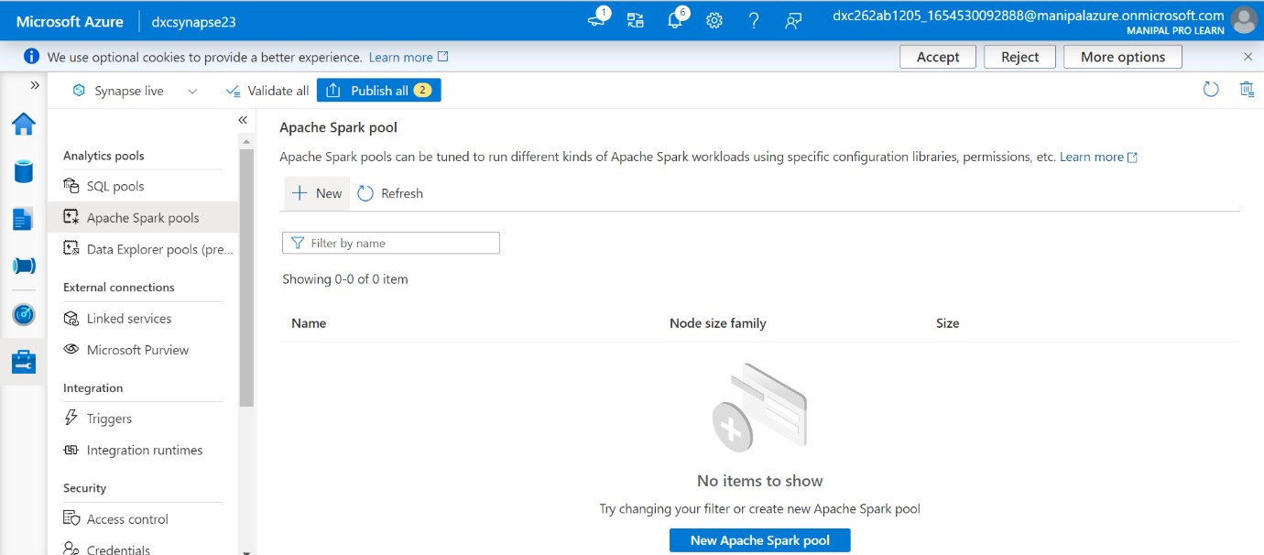

Creating new Apache spark pool

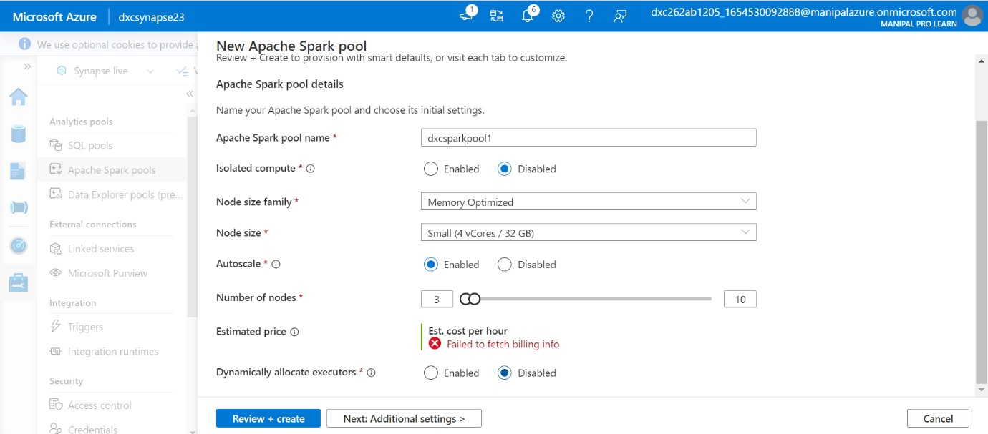

After customizing each and every part , go to review and create

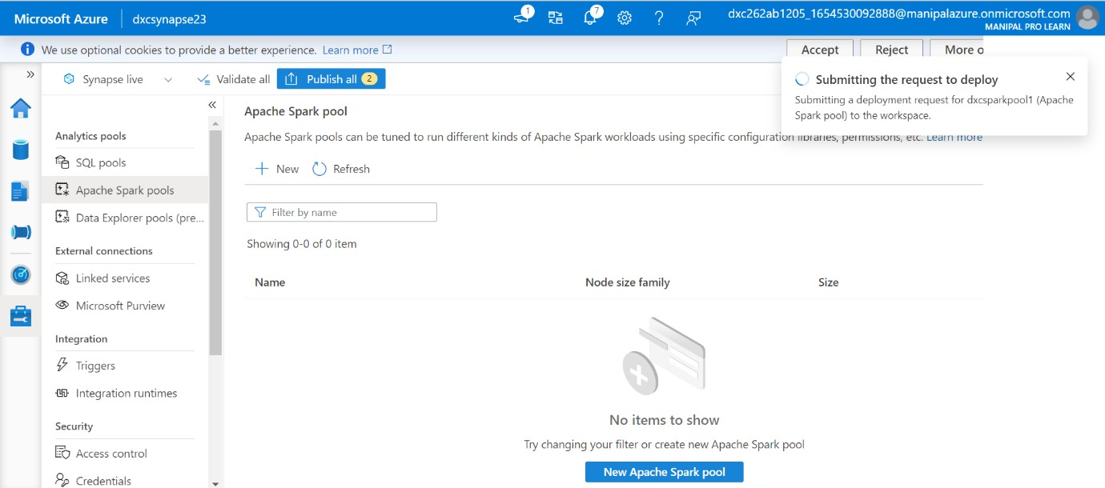

Apache spark pool is created.

1. Explain the steps with screenshots how to create pipeline in AzureSynapse analytics?

Go to Integrate tab-> + click on Pipeline

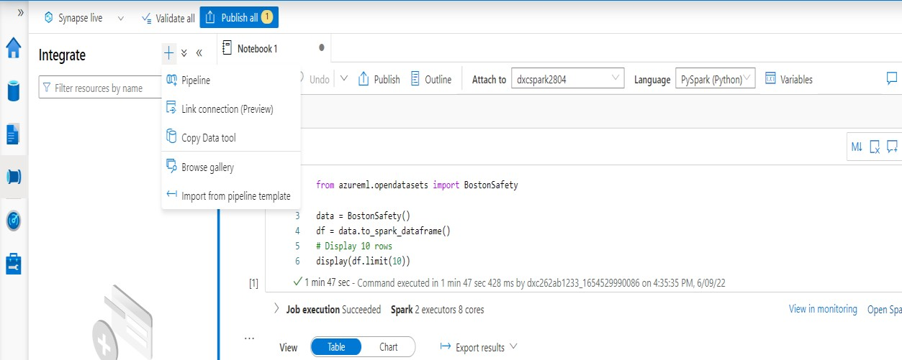

Give the name of the pipeline

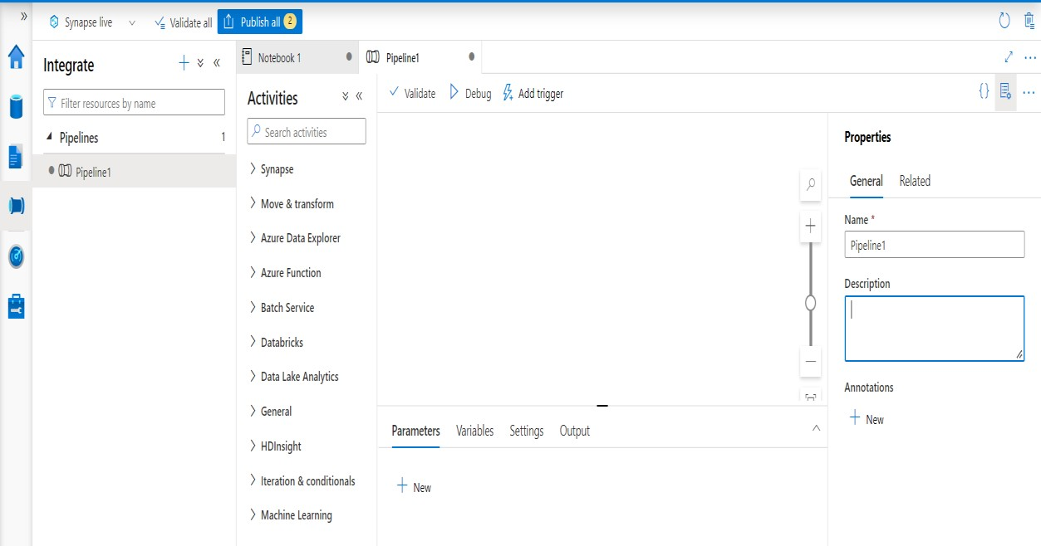

1. **Explain the steps with screenshots how to automate the pipelines in AzureSynapse analytics?**

Pipeline->In Activities ->Synapse->Notebook select notebook1 and drag and drop

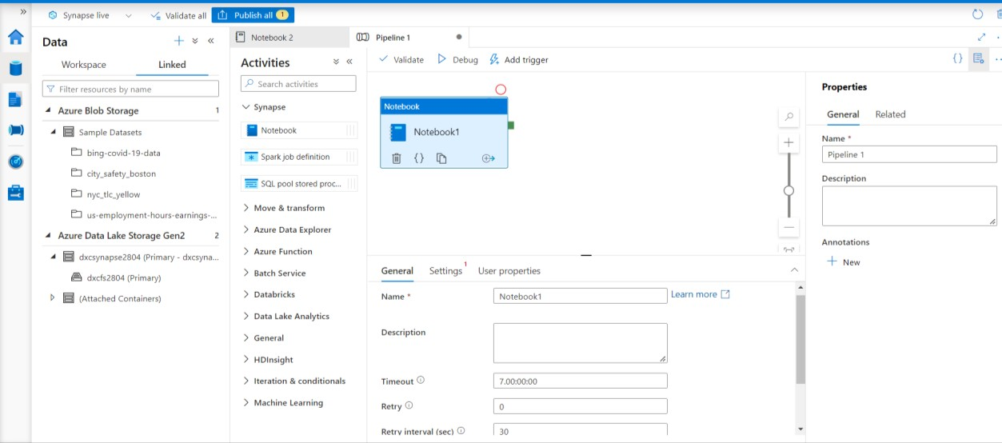

In setting give notebook1 and dxcspark2804 and publish the pipeline and validate

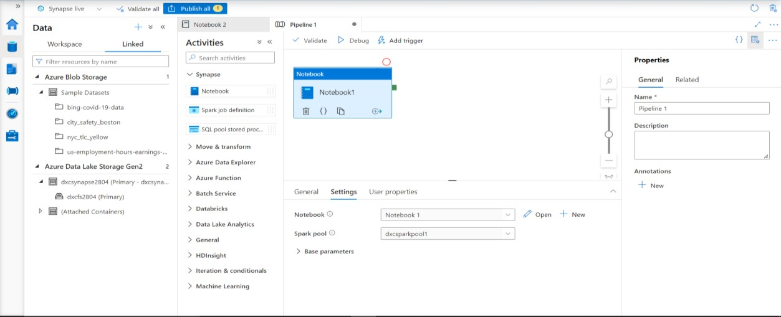

Add trigger->trigger now

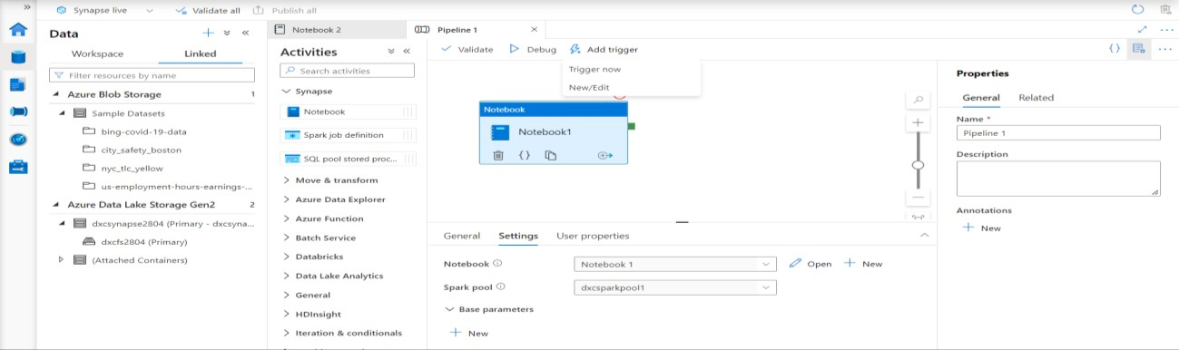

If we want to trigger new/edit in Add trigger we can give the timing it will automatically trigger

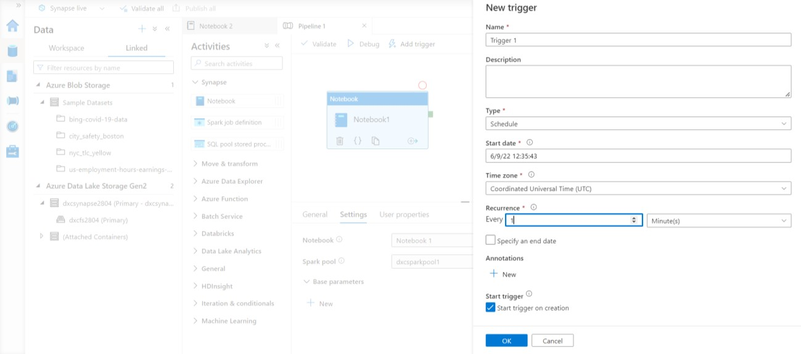

First we need to publish the trigger To check go to monitor tab Trigger run refresh every one minute keep the time zone Chennai it will trigger every time

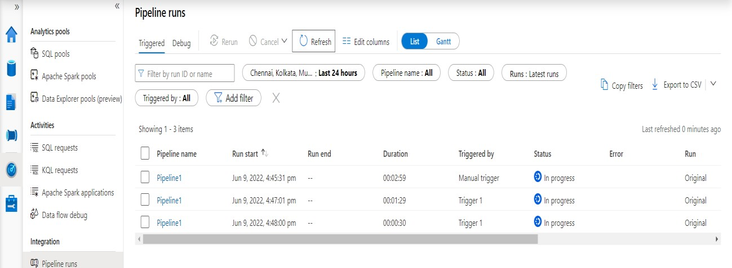

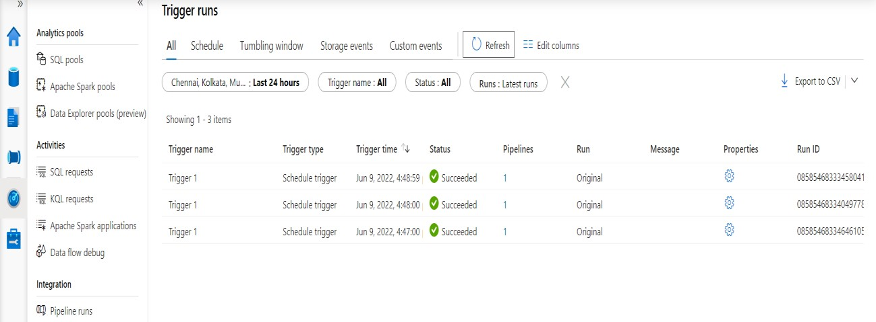

Automation done through this process

1. **Explain the steps with screenshots how to Databricks ?**

Go to Azure and search for Data bricks

give the resource group and workspace name and pricing tier trial

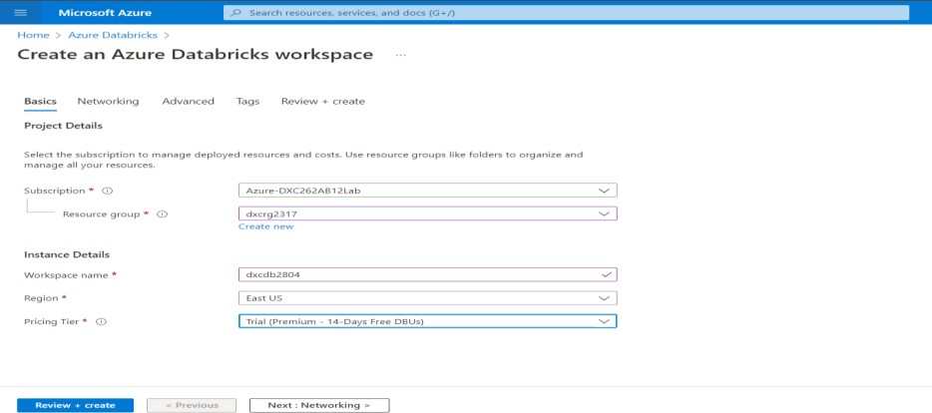

deployment is complete and go to resource

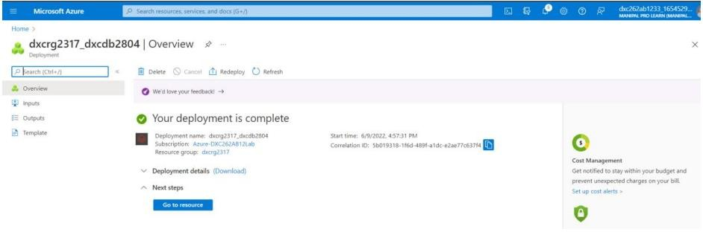

Here Launch WorkSpace

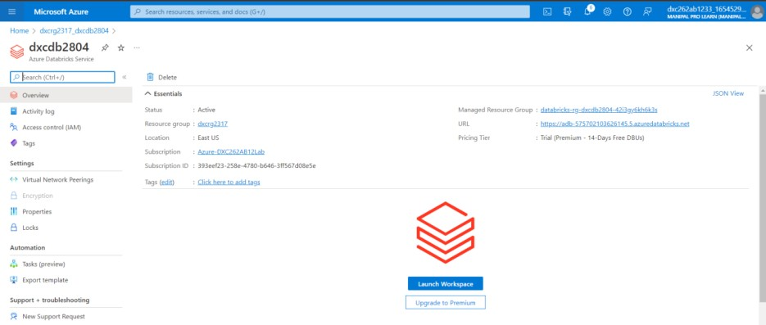

We will get the home page of data bricks

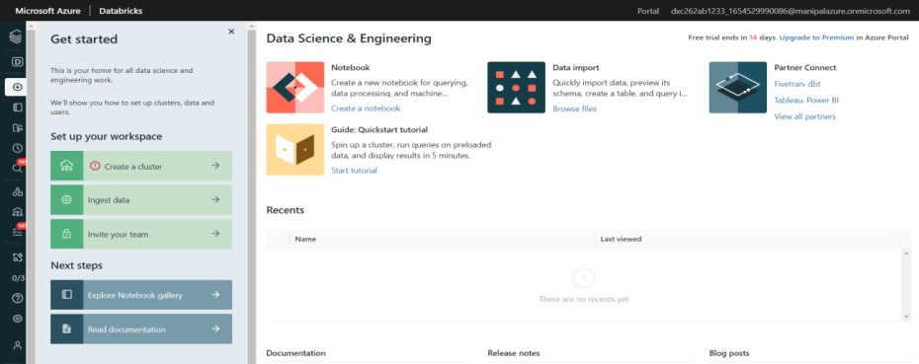

# Explain the steps with screenshots how to create notebooks in Databricks ?

Go to workspace-> Create->notebook

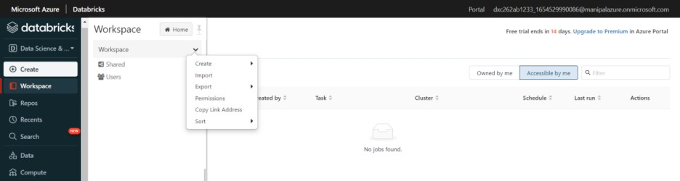

Give the name of the notebook and give the cluster before you created and create the notebook

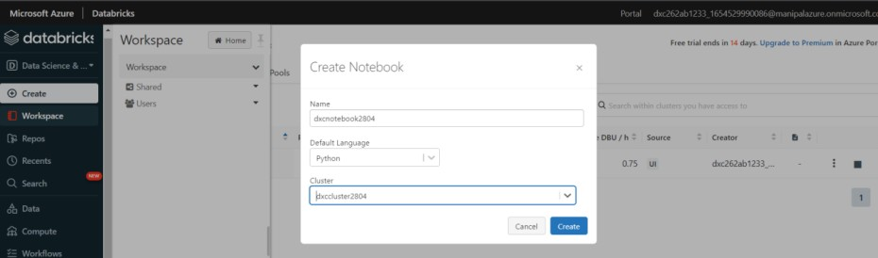

Notebook will be created and we should attach the cluster with out forgetting

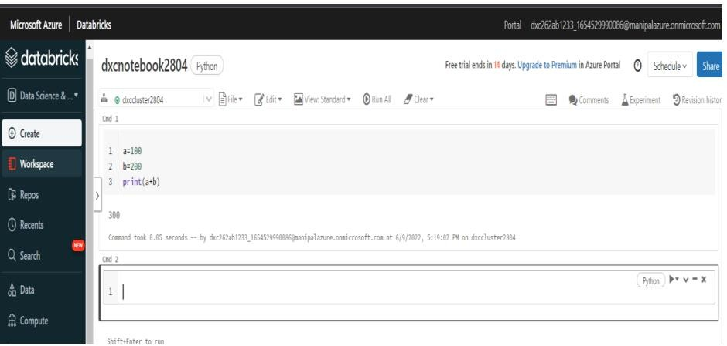

# Explain the steps with screenshots how to insert data into databricks notebook & display the result?

Go to data tab and click create table and drag and drop the data you want to insert

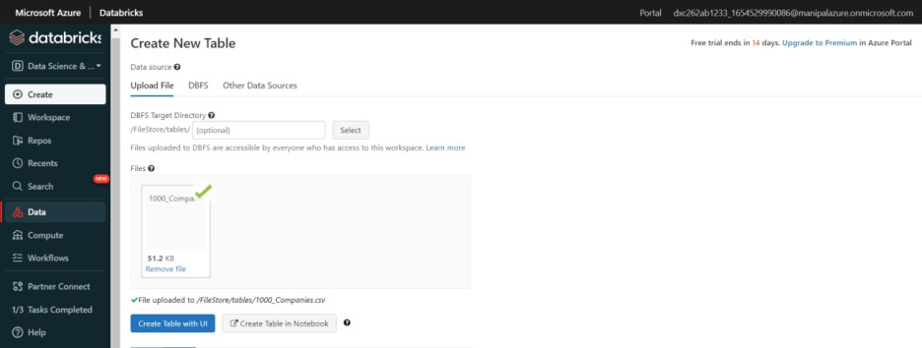

Click on the create Table in Notebook

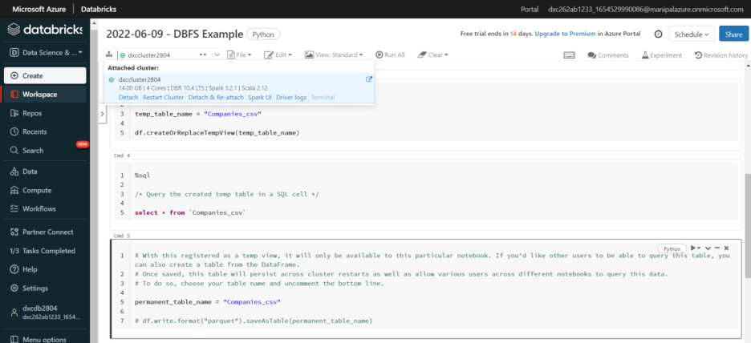

Attach the cluster at the top that you create and remove the 1000_ in the table name and 3 places And click on run all

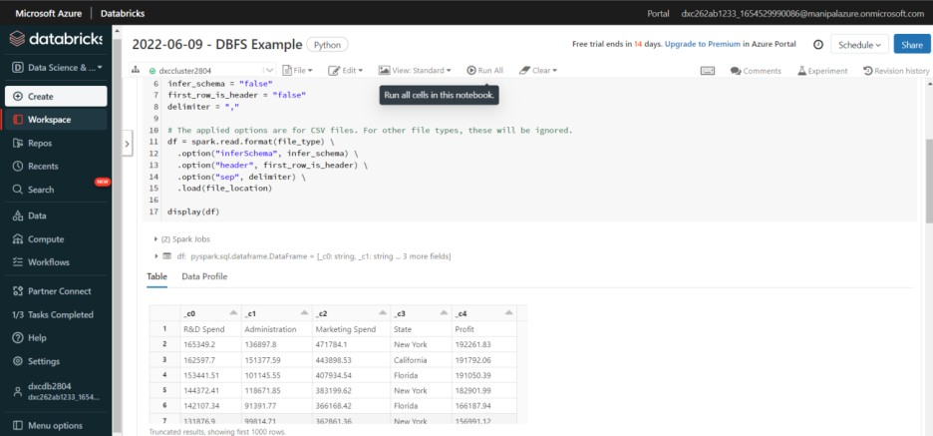

In this we can see the data in tables which we have inserted

# Explain the steps with screenshots how to create cluster in databricks ?

Go to Compute -> Click Create Cluster

Give the name and cluster mode as single node and click Create Cluster

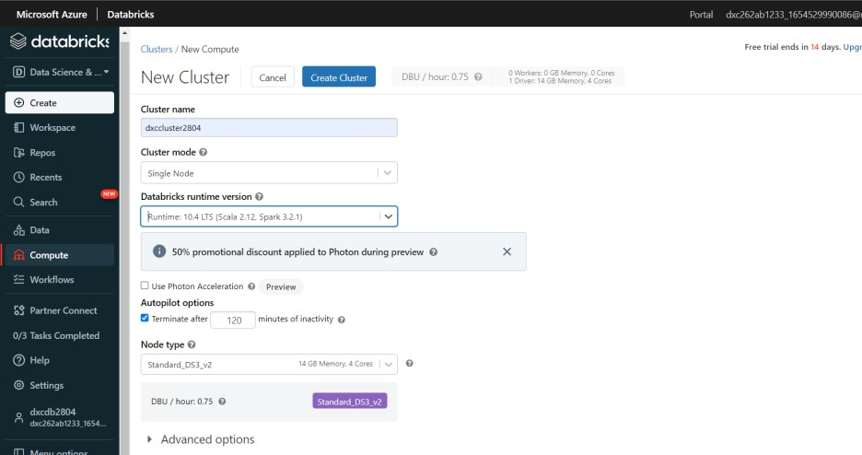

We get a tick mark that we have created a cluster

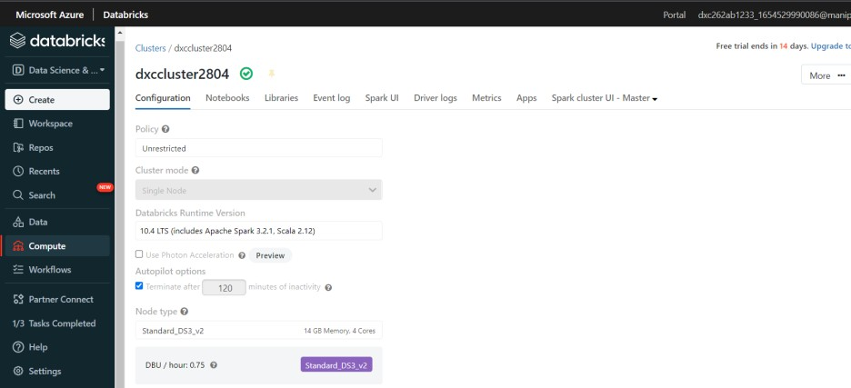

To check the cluster go to compute here it will show the complete details of the cluster

