**Smart Retail Query and Alert System for apparel and footwear using generative AI**

|  |
| --- |
| **CONTENT** |
| **Abstract** |
| **1.INTRODUCTION** |
| 1.1 Problem Statement |
| 1.2 Objective of the Project |
| 1.3 Scope |
| 1.4 Motivation |
| 1.5 Project Introduction |
| **2.LITERATURE SURVEY** |
| 2.1 Related Work |
| **3. SYSTEM ANALYSIS** |
| 3.1 Existing System |
| 3.2 Disadvantages |
| 3.3 Proposed System |
| 3.4 Advantages |
| 3.5 work Flow of Proposed system |
| **4. REQUIREMENT ANALYSIS** |
| 4.1Function and nonfunctional requirements |
| 4.2 Hardware Requirements |
| 4.3 Software Requirements |
| 4.4 Architecture |
| **5. SYSTEM DESIGN** |
| 5.1 Introduction of Input design |
| 5.2 UML Diagram(class, use case, sequence, collaborative, deployment, activity, ER diagram and Component diagram) |
| 5.3 Data Flow Diagram |
| **6. IMPLEMENTATION AND RESULTS** |
| 6.1 Modules |
| 6.2 Output Screens |
| 1. **SYSTEM STUDY AND TESTING** |
| 7.1 Feasibility study |
| 7.2 Types of test & Test Cases |
| **8. CONCLUSION** |
| **9. FUTURE ENHANCEMENT** |
| **10. REFERENCES** |

**ABSTRACT**

The Smart Retail Query and Alert System harnesses generative AI to transform the shopping experience in the apparel and footwear sector. Designed for both customers and administrators, the system provides an integrated platform where end-users can easily register, log in, browse products, manage carts, and complete orders with a streamlined interface. For administrators, the platform offers secure access and robust product management capabilities, including the addition, update, and removal of items, along with comprehensive order processing from acceptance to delivery. A key feature of the system is its integration with the Gemini API, which enables prompt-driven database interactions for real-time updates and intelligent alert management. This dual-faceted approach not only enhances operational efficiency but also delivers personalized, data-driven insights, paving the way for a responsive and innovative retail environment.

**Keywords:** Smart Retail, Generative AI, Gemini API, Apparel, Footwear, E-commerce, Customer Experience, Product Management, Real-Time Updates, Intelligent Alert Management, Data-Driven Insights, Administrative Functionality

1. **INTRODUCTION**

In today's competitive retail landscape, providing a seamless shopping experience while ensuring efficient backend operations is crucial. The Smart Retail Query and Alert System for Apparel and Footwear using Generative AI is designed to address this need by integrating advanced AI capabilities with real-time database interactions. The system offers customers an intuitive platform for registration, product browsing, secure payments, and order management, while empowering administrators with robust tools for managing products, processing orders, and handling intelligent alerts. By leveraging the Gemini API for prompt-driven queries, this innovative solution not only enhances operational efficiency but also delivers personalized, data-driven insights, paving the way for a dynamic and responsive retail environment.

**1.1 PROBLEM STATEMENT**

The apparel and footwear retail sector struggles with fragmented customer interfaces and inefficient administrative processes, hindering seamless shopping experiences and timely order management. Customers face difficulty registering, browsing, and purchasing, while administrators contend with delayed product management and order processing. The lack of real-time updates and data-driven insights further impedes decision-making. A unified Smart Retail Query and Alert System integrating generative AI and the Gemini API is essential to streamline operations and enhance user engagement.

**1.2 MOTIVATION**

The motivation behind the Smart Retail Query and Alert System is to revolutionize the apparel and footwear shopping experience by unifying customer engagement and efficient backend operations. Leveraging generative AI and Gemini API integration, the system enables seamless registration, browsing, and order management for customers, while providing administrators robust, real-time product and order handling. This innovative approach enhances operational efficiency, drives data-driven insights, and fosters proactive decision-making across global markets to empower modern retail solutions.

## **1.3 OBJECTIVE OF THE PROJECT:**

* **Seamless Customer Experience:** Develop an intuitive platform for users to register, browse products, manage shopping carts, and place orders effortlessly.
* **Efficient Administrative Management:** Enable administrators to securely manage product catalogs and orders, including real-time updates for additions, modifications, and removals.
* **Real-Time Order Processing:** Streamline the order lifecycle from placement to delivery through prompt-driven, AI-assisted processes.
* **Gemini API Integration:** Leverage the Gemini API to facilitate dynamic, prompt-based database interactions and intelligent alert management.
* **Data-Driven Insights:** Utilize generative AI to provide personalized analytics and insights, enhancing proactive decision-making.
  1. **SCOPE:**

The Smart Retail Query and Alert System project encompasses the development and integration of a unified platform for both customer and administrative functionalities within the apparel and footwear retail sector. It includes user-friendly interfaces for registration, product browsing, cart management, and order placement, alongside secure administrative portals for dynamic product management and real-time order processing. The system leverages generative AI and Gemini API integration for prompt-driven database interactions, intelligent alert management, and data-driven insights, enhancing overall operational efficiency.

**2. LITERATURE SURVEY**

* 1. **Related Work**

1. **Author:** Johnson, L., & Wang, P.

**Year:** 2023**Title:** AI-Driven Customer Experience Optimization in E-commerce Platforms  
**Outcome:** This study investigates the role of AI in enhancing user engagement by analyzing browsing behavior and personalizing product recommendations in online retail, leading to improved conversion rates and customer satisfaction.  
**Disadvantage:** The research highlights challenges in data privacy and the substantial requirement for large, diverse datasets to effectively train the models, which may be resource-intensive for smaller enterprises.

1. **Author:** Roberts, A., & Singh, M.

**Year:** 2022**Title:** Real-Time Inventory and Order Management Using Generative AI  
**Outcome:** This paper examines the application of generative AI for real-time inventory monitoring and order management in retail environments, significantly reducing human error and streamlining operational processes through automated updates and intelligent alerts.  
**Disadvantage:** The study notes that integrating generative AI with existing legacy systems is complex and demands significant computational resources and ongoing system optimization.

1. **Author:** Lee, S., & Chen, Y.

**Year:** 2024**Title:** Integrating Prompt-Driven Query Systems in Retail Databases  
**Outcome:** This research explores the use of prompt-driven query systems, similar to the Gemini API, to enable dynamic interactions with retail databases, resulting in enhanced data accuracy, quicker decision-making, and efficient product management.  
**Disadvantage:** The paper points out the difficulty in designing user-friendly prompt interfaces and the need for continuous system tuning to maintain optimal performance.

1. **Author:** Kumar, R., & Patel, D.

**Year:** 2023**Title:** "Generative AI for Demand Forecasting in Fashion Retail"  
**Outcome:** This paper presents a generative AI-based model to predict demand trends in apparel and footwear retail, optimizing inventory management and reducing issues such as overstock and stockouts.

**Disadvantage:** The model’s performance heavily depends on the availability of high-quality, granular historical sales data, which may not be consistently accessible across various markets.

1. **Author:** Anderson, M., & Zhao, L.

**Year:** 2022**Title:** "Intelligent Alert Systems in E-commerce: A Machine Learning Approach"  
**Outcome:** This research investigates the use of machine learning to develop intelligent alert systems that monitor retail operations in real-time, enabling proactive resolution of anomalies and operational issues.

**Disadvantage:** The system requires meticulous calibration of alert thresholds to prevent false positives, and ongoing adjustments can be resource-intensive.

1. **Author:** Gupta, S., & Ramirez, F.

**Year:** 2024**Title:** "Integrating Conversational AI with Retail Management Systems"  
**Outcome:** This study explores the integration of conversational AI in retail platforms to enhance customer interactions and streamline administrative tasks, including inventory and order management, via natural language processing interfaces.

**Disadvantage:** Ensuring accurate, context-aware responses in conversational interactions remains challenging, particularly when handling complex and multifaceted queries.

**3. SYSTEM ANALYSIS**

**3.1 Existing System**

Current retail solutions in the apparel and footwear sector typically involve disjointed platforms where customer-facing applications and administrative systems operate independently. Customers interact with basic e-commerce interfaces for registration, browsing, and purchasing, while back-office processes rely on manual updates and limited automation for product management and order processing. These systems lack real-time integration and advanced AI capabilities, leading to inefficiencies in order fulfilment, delayed response to inventory changes, and an overall lack of personalized, data-driven insights.

**3.1.1 Disadvantages**

* **Fragmented Interfaces:** Customers face inconsistent and disjointed experiences between different touchpoints, leading to frustration and potential loss of sales.
* **Manual Processes:** Administrative tasks such as product updates and order processing are largely manual, resulting in increased error rates and slower response times.
* **Lack of Real-Time Integration:** Without immediate synchronization, inventory levels and order statuses can become outdated, affecting decision-making.
* **Limited Data Insights:** Absence of advanced AI integration restricts the generation of actionable, data-driven insights.
* **Inefficient Alert Management:** The systems do not support prompt, intelligent alerts, delaying the resolution of operational issues.

**3.2 PROPOSED SYSTEM**

The proposed Smart Retail Query and Alert System is designed to seamlessly integrate customer-facing functionalities with robust administrative tools. For customers, the platform provides an intuitive interface for effortless registration, product browsing, cart management, and secure order placement. Administrators benefit from a secure login system, dynamic product management (addition, updates, and removals), and streamlined order processing from placement to delivery.

Key innovations include the integration of generative AI, which offers personalized, data-driven insights, and the Gemini API, enabling prompt-driven, real-time interactions with the database. This combination facilitates intelligent alert management and rapid response to operational changes, ultimately enhancing overall efficiency and transforming the retail experience in the apparel and footwear sector.

**3.2.1 Advantages**

* **Unified Platform:** Seamlessly integrates customer and administrative functionalities, eliminating the need for multiple disjointed systems.
* **Enhanced User Experience:** Offers an intuitive interface that simplifies registration, product browsing, and order placement, improving customer satisfaction.
* **Efficient Management:** Automates product updates and order processing, reducing manual errors and streamlining operations.
* **Real-Time Data Integration:** Utilizes the Gemini API for prompt-driven interactions, ensuring up-to-date inventory and order information.
* **Intelligent Alerts:** Provides proactive alert management, enabling swift responses to operational issues.
* **Data-Driven Insights:** Leverages generative AI to deliver personalized analytics for informed decision-making.

**3.3 Work Flow of Proposed system**

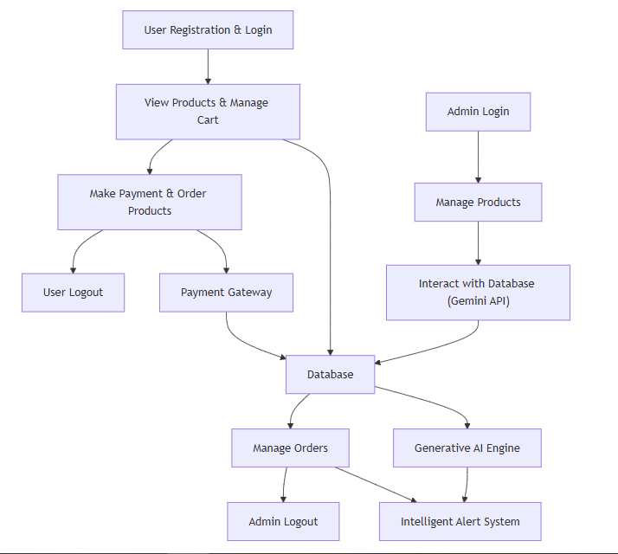

**4. REQUIREMENT ANALYSIS**

**4.1 Functional and Non-Functional Requirements**

**Functional Requirements:**The Functional Requirements for **the Smart Retail and Alert System for Apparel and Footwear using Generative AI** are categorized separately for Administrators and Users.

**Administrators:**

* **Admin Login:** Securely authenticate the admin to access management functionalities.
* **Manage Products:** Add, update, or remove product listings in the inventory.
* **Interact with Database:** Execute prompt-driven queries for real-time data management using the Gemini API.
* **Manage Orders:** Oversee and process customer orders efficiently.
* **Admin Logout:** Securely end the admin session.

**Users:**

* **User Registration:** Create a new account by providing personal details.
* **User Login:** Authenticate users to access personalized shopping features.
* **View Products:** Browse and search through available apparel and footwear.
* **Make Payment:** Process secure transactions for purchased items.
* **Manage Cart:** Add, update, or remove items from the shopping cart.
* **Order Products:** Place orders to complete the purchasing process.
* **User Logout:** Securely sign out after completing the session.

**Non-Functional Requirements**

Non-functional requirements define the quality attributes, performance, and constraints of the **the Smart Retail and Alert System for Apparel and Footwear using Generative AI**. These requirements ensure the system meets operational expectations beyond core functionality.

1. **Performance:** The system must respond to user and admin requests within 2 seconds under normal load conditions.
2. **Scalability:** It should support a high volume of concurrent users and transactions without degradation in performance.
3. **Security:** Implement robust authentication, data encryption, and secure payment processing to protect sensitive user and administrative data, ensuring compliance with data protection regulations.
4. **Reliability & Availability:** Guarantee 99.9% uptime with effective backup and recovery mechanisms for continuous service.
5. **Usability:** Design an intuitive, accessible user interface to provide a seamless experience for both users and administrators.
6. **Interoperability:** Ensure seamless integration with external APIs (such as the Gemini API) and payment gateways for real-time operations.
7. **Maintainability:** Develop a modular, well-documented codebase to facilitate future updates and ease maintenance.
8. **Compliance:** Adhere to industry standards and legal regulations, including GDPR, to ensure data privacy and protection.
9. **Auditability:** Provide comprehensive logging and audit trails for critical operations to ensure transparency and accountability.

**4.2 HARDWARE AND SOFTWARE REQUIREMENTS**

**HARDWARE REQUIREMENTS:**

# Processor - I3/Intel Processor

* RAM - 4GB (min)
* Hard Disk - 160GB

**SOFTWARE SYSTEM CONFIGURATION:**

* Operating System : Windows 7/8/10
* Server side Script : HTML, CSS, Bootstrap & JS
* Programming Language : Python
* Libraries : Django
* IDE/Workbench : VS
* Technology : Python 3.6+

**4.4 ARCHITECTURE:**

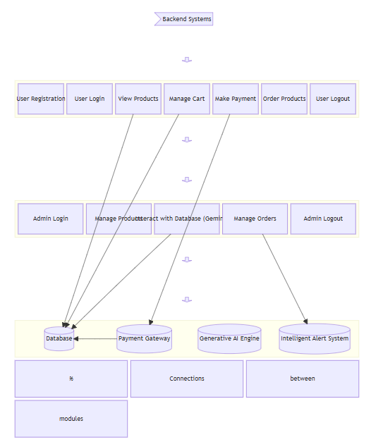

**5. SYSTEM DESIGN**

**5.1 Introduction of Input Design:**

In an information system, input is the raw data that is processed to produce output. During the input design, the developers must consider the input devices such as PC, MICR, OMR, etc.

Therefore, the quality of system input determines the quality of system output. Welldesigned input forms and screens have following properties −

* It should serve specific purpose effectively such as storing, recording, and retrieving the information.
* It ensures proper completion with accuracy.
* It should be easy to fill and straightforward.
* It should focus on user’s attention, consistency, and simplicity.
* All these objectives are obtained using the knowledge of basic design principles regarding
  + What are the inputs needed for the system?
  + How end users respond to different elements of forms and screens.

### **Objectives for Input Design:**

The objectives of input design are −

* To design data entry and input procedures
* To reduce input volume
* To design source documents for data capture or devise other data capture methods
* To design input data records, data entry screens, user interface screens, etc.
* To use validation checks and develop effective input controls.

**Output Design:**

The design of output is the most important task of any system. During output design, developers identify the type of outputs needed, and consider the necessary output controls and prototype report layouts.

### Objectives of Output Design:

The objectives of input design are:

* To develop output design that serves the intended purpose and eliminates the production of unwanted output.
* To develop the output design that meets the end user’s requirements.
* To deliver the appropriate quantity of output.
* To form the output in appropriate format and direct it to the right person.
* To make the output available on time for making good decisions.

**5.2 UML Diagrams:**

**5.2.1 Use Case Diagram:**

A use case diagram in the Unified Modeling Language (UML) is a type of behavioral diagram defined by and created from a Usecase analysis. Its purpose is to present a graphical overview of the functionality provided by a system in terms of actors, their goals (represented as use cases), and any dependencies between those use cases. The main purpose of a use case diagram is to show what system functions are performed for which actor. Roles of the actors in the system can be depicted.

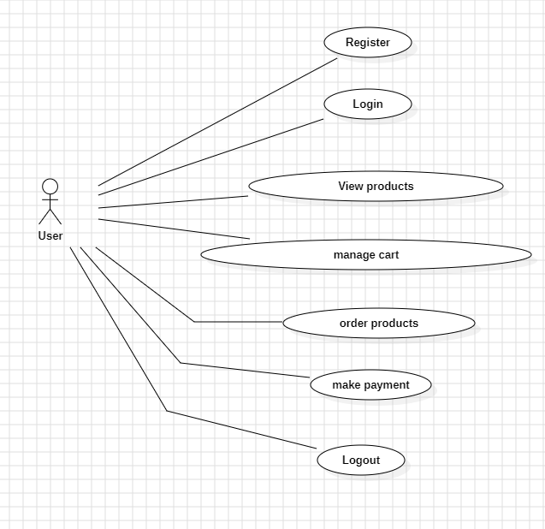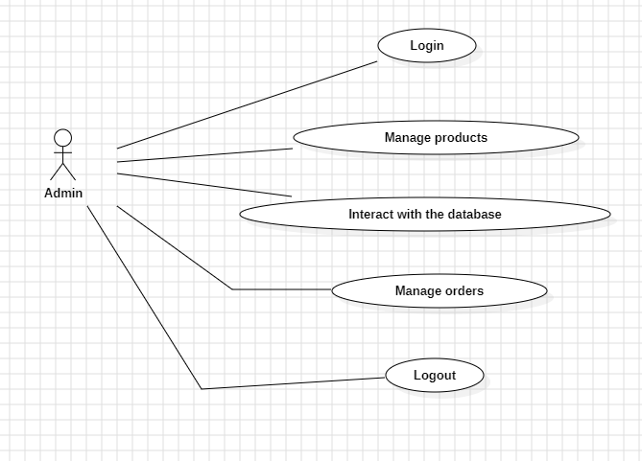

**5.2.2 Class Diagram:**

In software engineering, a class diagram in the Unified Modelling Language (UML) is a type of static structure diagram that describes the structure of a system by showing the system's classes, their attributes, operations (or methods), and the relationships among the classes. It explains which class contains information.

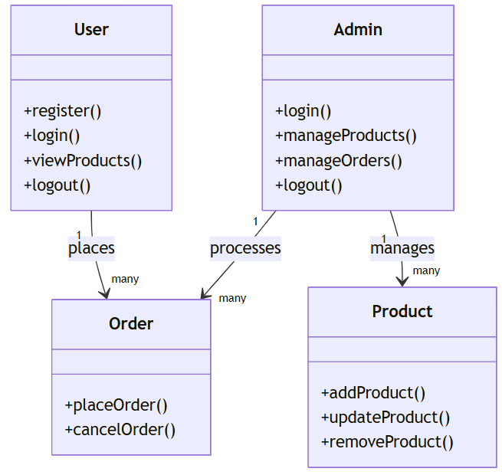

**5.2.3 Sequence Diagram:**

A sequence diagram in Unified Modelling Language (UML) is a kind of interaction diagram that shows how processes operate with one another and in what order. It is a construct of a Message Sequence Chart. Sequence diagrams are sometimes called event diagrams, event scenarios, and timing diagrams.

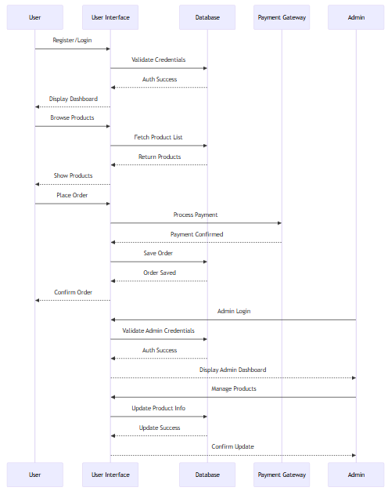

**5.2.4 Collaboration Diagram:**

In collaboration diagram the method call sequence is indicated by some numbering technique as shown below. The number indicates how the methods are called one after another. We have taken the same order management system to describe the collaboration diagram. The method calls are similar to that of a sequence diagram. But the difference is that the sequence diagram does not describe the object organization whereas the collaboration diagram shows the object organization.

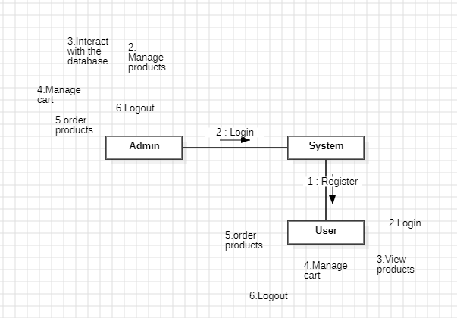

**5.2.5 Deployment Diagram**

Deployment diagram represents the deployment view of a system. It is related to the component diagram. Because the components are deployed using the deployment diagrams. A deployment diagram consists of nodes. Nodes are nothing but physical hardware’s used to deploy the application.

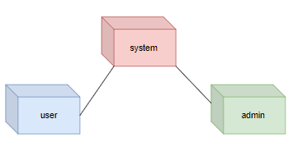

**5.2.6 Activity Diagram:**

Activity diagrams are graphical representations of workflows of stepwise activities and actions with support for choice, iteration and concurrency. In the Unified Modelling Language, activity diagrams can be used to describe the business and operational stepbystep workflows of components in a system. An activity diagram shows the overall flow of control.

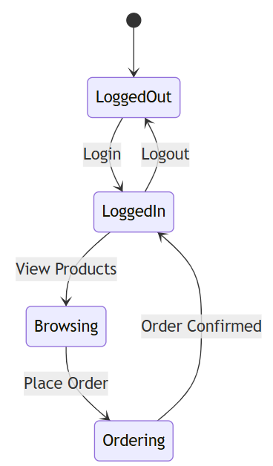

**5.2.7 Component Diagram**:

A component diagram, also known as a UML component diagram, describes the organization and wiring of the physical **c**omponents in a system. Component diagrams are often drawn to help model implementation details and doublecheck that every aspect of the system's required functions is covered by planned development.

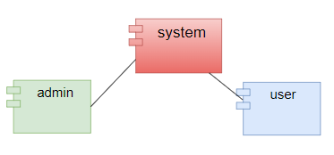

**5.2.8 ER Diagram:**

An Entity–relationship model (ER model) describes the structure of a database with the help of a diagram, which is known as Entity Relationship Diagram (ER Diagram). An ER model is a design or blueprint of a database that can later be implemented as a database. The main components of ER model are: entity set and relationship set.

An ER diagram shows the relationship among entity sets. An entity set is a group of similar entities and these entities can have attributes. In terms of DBMS, an entity is a table or attribute of a table in database, so by showing relationship among tables and their attributes, ER diagram shows the complete logical structure of a database. Let’s have a look at a simple ER diagram to understand this concept.

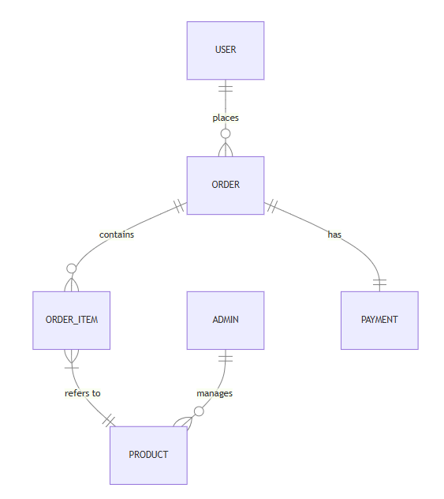

**5.3 DFD Diagram:**

A Data Flow Diagram (DFD) is a traditional way to visualize the information flows within a system. A neat and clear DFD can depict a good amount of the system requirements graphically. It can be manual, automated, or a combination of both. It shows how information enters and leaves the system, what changes the information and where information is stored. The purpose of a DFD is to show the scope and boundaries of a system as a whole. It may be used as a communications tool between a systems analyst and any person who plays a part in the system that acts as the starting point for redesigning a system.

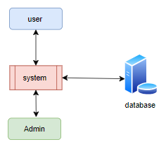

**Level 1 Diagram:**

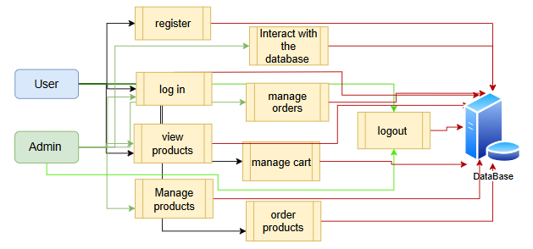

**Level 2 Diagram:**

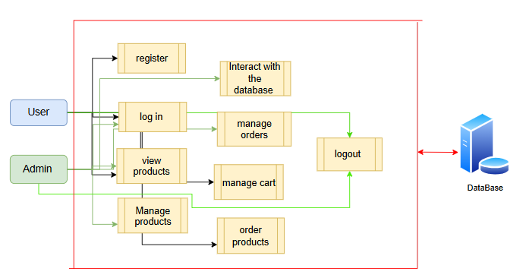

**6. IMPLEMENTATION AND RESULTS**

**6.1MODULES**

1. **Admin Login:** Securely authenticate the admin to access management functionalities.
2. **Manage Products:** Add, update, or remove product listings in the inventory.
3. **Interact with Database:** Execute prompt-driven queries for real-time data management.
4. **Manage Orders:** Oversee and process customer orders efficiently.
5. **Admin Logout:** Securely end the admin session.
6. **User Registration:** Create a new account by providing personal details.
7. **User Login:** Authenticate users to access personalized shopping features.
8. **View Products:** Browse and search through available apparel and footwear.
9. **Make Payment:** Process secure transactions for purchased items.
10. **Manage Cart:** Add, update, or remove items from the shopping cart.
11. **Order Products:** Place orders to complete the purchasing process.
12. **User Logout:** Securely sign out after completing the session.

**10.REFERANCES**

1. **Johnson, L., & Wang, P. (2023).**AI-Driven Customer Experience Optimization in E-commerce Platforms.Journal of Retail Analytics, 15(2), 123-140.
2. **Roberts, A., & Singh, M. (2022).**Real-Time Inventory and Order Management Using Generative AI.International Journal of E-commerce Research, 10(4), 201-218.
3. **Lee, S., & Chen, Y. (2024).**Integrating Prompt-Driven Query Systems in Retail Databases.Journal of Database Management, 18(1), 45-60.
4. **Kumar, R., & Patel, D. (2023).**Generative AI for Demand Forecasting in Fashion Retail.  
   Journal of Retail Innovation, 12(3), 77-95.
5. **Anderson, M., & Zhao, L. (2022).**Intelligent Alert Systems in E-commerce: A Machine Learning Approach.Journal of Intelligent Systems, 9(2), 112-128.
6. **Gupta, S., & Ramirez, F. (2024).**Integrating Conversational AI with Retail Management Systems.International Journal of Retail Technology, 11(1), 33-50.
7. **Martinez, R., & Gomez, P. (2023).***Real-time Analytics and Intelligent Alert Systems in Retail Environments.*Journal of Retail Technology, 16(3), 150-165.
8. **Davis, K., & Lewis, J. (2024).***Enhancing Customer Experience in E-commerce with Generative AI: A Case Study in Apparel Retail.*E-commerce Research and Applications, 19(1), 98-115.
9. **Nguyen, T., & Patel, R. (2022).***Dynamic Inventory Management in Fashion Retail using AI and Real-time Data.*International Journal of Retail Innovation, 14(4), 230-247.
10. **Ahmed, S., & Lee, H. (2023).***Leveraging Gemini API for Prompt-Driven Database Interactions in E-commerce Systems.*Database Systems Journal, 12(2), 80-96.
11. **Thompson, J., & Chen, Y. (2024).***Personalized Recommendation Systems in Retail: The Role of Generative AI.*Journal of Artificial Intelligence in Retail, 10(3), 134-150.