**SMART PARKING**

**PHASE 2: Innovation**

*Where all we need the system?*

Smart parking systems can be beneficial in a variety of locations and scenarios to enhance parking efficiency, reduce congestion, and improve the overall experience for both drivers and parking facility operators.

**Urban Areas:**

City centers, downtown areas, and other urban locations with high traffic and limited parking space.

**Commercial Buildings:**

Office buildings, shopping malls, and retail centers to manage visitor and employee parking.

**Airports:**

Large airports to help travelers find available parking and streamline the parking process.

**Hospitals:**

Medical facilities to ensure patients and visitors can easily locate parking spaces.

**Hotels:**

Hotels and resorts to improve the guest experience and optimize valet services.

**Stadiums and Arenas:**

Sports venues and entertainment facilities to accommodate large crowds and event-specific parking needs.

**Event Venues:**

Conference centers, convention halls, and concert venues to manage parking during events.

**Public Transportation Hubs:**

Bus and train stations, as well as park-and-ride facilities, to assist commuters and travelers.

**University Campuses:**

Colleges and universities to simplify parking for students, faculty, and visitors.

**Residential Areas:**

Residential communities and apartment complexes to allocate parking spaces efficiently.

**Tourist Destinations:**

Tourist attractions, national parks, and heritage sites to improve the parking experience for visitors.

**Smart Cities:**

Entire smart city initiatives can incorporate smart parking systems as part of their urban planning and transportation solutions.

**Industrial Parks:**

Areas with industrial or manufacturing facilities to manage employee and guest parking.

**Public Parking Lots:**

Publicly operated parking lots and garages can benefit from smart systems to enhance user experience and optimize space usage.

**Shopping Districts:**

Popular shopping districts with numerous stores and high foot traffic.

**Park and Ride Facilities:**

Locations where commuters park their vehicles and transfer to public transportation.

**Mixed-Use Developments:**

Complexes that combine residential, commercial, and recreational spaces.

**Electric Vehicle Charging Stations:**

Charging stations for electric vehicles can integrate smart parking features to manage EV charging and parking access.

*The specific needs and features of a smart parking system may vary depending on the location and its unique requirements.*

*Steps for implementation of smart parking system:*

1. **Define Objectives and Requirements:**

Identify the goals and objectives of implementing a smart parking system, such as reducing congestion, improving user experience, and increasing revenue.

Document the specific requirements of the system, including the number of parking spaces, the type of technology to be used, and any regulatory compliance considerations.

1. **Site Assessment:**

Conduct a thorough assessment of the parking area, including its layout, existing infrastructure, and any potential obstacles or challenges.

1. **Select Technology and Vendors:**

Choose the appropriate technology for your smart parking system, which may include sensors, cameras, mobile apps, and IoT devices.

Evaluate and select vendors or solution providers that can meet your requirements and provide ongoing support.

1. **Design the System:**

Work with experts to design the system, considering the placement of sensors, cameras, and other hardware, as well as the network and data infrastructure.

1. **Installation and Hardware Deployment:**

Install parking sensors, cameras, and any other required hardware at the parking facility.

Ensure that the hardware is properly connected and functioning.

1. **Data Collection and Integration:**

Collect data from sensors and cameras and integrate this data into a central management system.

Ensure that data is accurate and up-to-date.

1. **User Interfaces and Mobile Apps:**

Develop user interfaces, such as mobile apps and web applications, for both parking operators and end-users (drivers).

These interfaces should provide real-time information about parking availability, rates, and directions.

1. **Payment and Reservations:**

Implement a secure payment system that allows users to pay for parking electronically.

Offer reservation options for users who want to book parking spots in advance.

1. **Navigation and Wayfinding:**

Implement navigation features to guide drivers to available parking spots.

Use digital or physical signage to direct drivers to the parking area.

1. **Security and Surveillance:**

Enhance security with features like CCTV cameras and alarms to ensure the safety of the parking area.

1. **Regulatory Compliance:**

Ensure that the smart parking system complies with local regulations, permits, and codes.

1. **User Training and Education:**

Provide training to parking operators, staff, and users on how to use the smart parking system effectively.

1. **Testing and Quality Assurance:**

Thoroughly test the system to ensure all components are functioning as expected.

Identify and resolve any issues or bugs.

1. **Launch and Marketing:**

Launch the smart parking system and promote it to the public through marketing campaigns and outreach.

1. **Maintenance and Support:**

Establish a maintenance plan to keep the system running smoothly and provide customer support for users.

1. **Monitoring and Reporting:**

Continuously monitor the system's performance and collect data on usage.

Generate reports for stakeholders to assess the system's impact.

1. **Feedback and Optimization:**

Gather feedback from users and parking operators and use this feedback to make improvements to the system.

1. **Expansion and Scalability:**

Consider the potential for expanding the system to other locations if the initial implementation is successful.

*How cameras and sensors are placed in a smart parking system?*

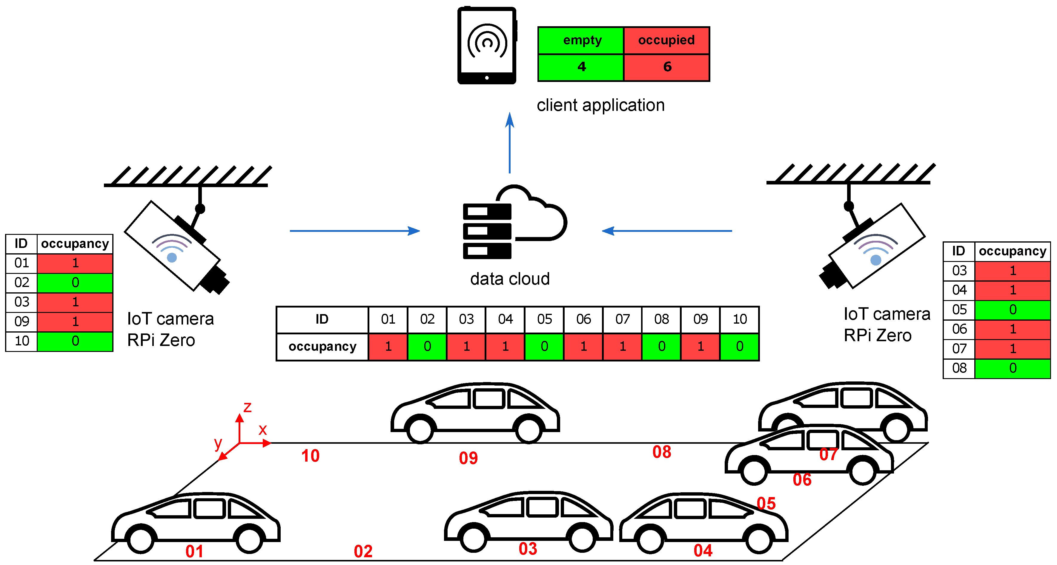

Placing sensors and cameras in a smart parking system is a critical aspect of ensuring the system's effectiveness. The specific placement will depend on the technology used and the design of the parking area.

**Parking Sensors:**

1. **Individual Parking Spaces:**

* In most cases, sensors are installed in individual parking spaces. Typically, one sensor is placed in each parking spot to monitor occupancy.
* The sensor should be positioned in the center of the parking space to maximize its ability to detect the presence of a vehicle. It is often embedded in the ground or affixed to the surface.
* Sensors use various technologies, such as ultrasonic, electromagnetic, or infrared, to detect the presence of a vehicle. The choice of technology may depend on factors like cost, accuracy, and durability.

1. **Entry and Exit Points:**

* Sensors can also be placed at entry and exit points of parking areas to monitor vehicle entry and exit. This can help in counting the number of vehicles in the facility.

1. **Coverage and Overlapping:**

* Ensure that there is adequate sensor coverage with minimal gaps to accurately detect available parking spaces.
* Overlapping coverage can be helpful to cross-verify occupancy data and reduce false readings.

1. **Height and Installation:**

* Consider the height of the sensor placement to prevent damage from vehicle tires or weather conditions.
* Follow manufacturer guidelines for installation, which may involve drilling holes or adhesive mounting, depending on the sensor type.

**Cameras with License Plate Recognition (LPR):**

1. **Entry and Exit Points:**

* Cameras with LPR technology are typically placed at the entry and exit points of the parking area. They capture images of vehicles and their license plates as they enter and exit.

1. **Placement:**

* Cameras are typically angled to capture clear images of license plates on vehicles passing through the entry and exit points.
* The angle and positioning should be optimized for optimal image quality.

1. **Illumination and Lighting:**

* Adequate lighting is crucial for camera systems, especially in low-light conditions. Consider the installation of appropriate lighting to ensure clear images.

1. **Network Connectivity:**

* Ensure that cameras are connected to a network, allowing captured data to be transmitted in real-time to a central system for processing.

1. **Integration:**
2. Integrate the camera system with the parking management software to recognize license plates and correlate this data with parking space occupancy data from sensors.
3. **Privacy and Regulations:**

* Be aware of privacy regulations and local laws when using camera systems, especially those that capture images of individuals. Implement privacy measures and comply with relevant regulations.

*Design of mobile application:*

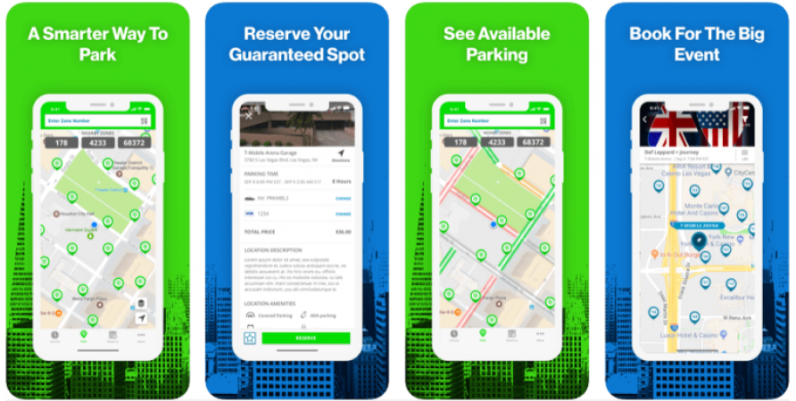

**Features:**

A comprehensive smart parking system mobile application can offer a wide range of features to enhance the parking experience for both drivers and parking facility operators. Here are some key features that can be included in a smart parking app:

**For Drivers:**

1. **Parking Space Availability:**

Display real-time information on available parking spaces in the vicinity, helping drivers find an open spot quickly.

1. **Reservations:**

Allow users to reserve parking spaces in advance, ensuring they have a guaranteed spot when they arrive.

1. **Navigation and Way finding:**

Provide turn-by-turn navigation to the selected parking location and guide users to their reserved space within the facility.

1. **Payment and Digital Wallet Integration:**

Enable users to pay for parking through the app, supporting various payment methods, including credit/debit cards, mobile wallets, and prepaid accounts.

1. **Discounts and Promotions:**

Offer discounts, promotions, and loyalty programs to incentivize app users and boost customer retention.

1. **User Profiles:**

Allow users to create profiles, store vehicle information, and set preferences for a personalized experience.

1. **Parking History:**

Maintain a record of past parking sessions, receipts, and payment history for reference.

1. **Notifications:**

Send push notifications to inform users about parking availability, reservations, payment confirmations, and time limitations.

1. **Feedback and Ratings:**

Enable users to provide feedback on their parking experience and rate parking facilities.

1. **Support and Assistance:**

Offer customer support and access to FAQs or live chat for users who encounter issues or have questions.

1. **Parking Space Size and Amenities:**

Provide information about parking space size, amenities (e.g., EV charging stations), and accessibility features for users with specific requirements.

**For Parking Facility Operators:**

1. **Occupancy Monitoring:**

Offer a dashboard for parking operators to monitor and manage parking space occupancy in real time.

1. **Reservation Management:**

Allow operators to view and manage reservations, including check-ins and check-outs.

1. **Data Analytics:**

Provide analytics and reporting tools to analyze parking data, including usage trends, revenue, and customer behavior.

1. **Payment Processing:**

Enable secure payment processing and revenue tracking for parking operators.

1. **Notifications and Alerts:**

Send notifications to operators about issues or incidents in the parking facility, such as security concerns or equipment malfunctions.

1. **Customer Relationship Management (CRM):**

Help parking operators manage customer data, including reservations, payments, and loyalty program information.

1. **Ticketless Entry and Exit:**

Implement technologies like license plate recognition for seamless entry and exit without physical tickets.

1. **Maintenance Tracking:**

Monitor the status of parking infrastructure and schedule maintenance as needed.

1. **Security and Surveillance:**

Integrate with CCTV cameras and alarms for security monitoring and incident response.

1. **Regulatory Compliance:**

Assist parking operators in complying with local regulations and permit management.

1. **Integration with Parking Sensors:**

Connect with parking sensors and cameras to receive occupancy data and identify vehicle entries and exits.

1. **Marketing and Promotions:**

Allow parking operators to run marketing campaigns, offer discounts, and manage customer loyalty programs.

1. **Administrative Tools:**

Provide tools for parking facility administrators to manage user accounts, pricing, and access control.

1. **Reporting and Financial Management:**

Offer features for financial tracking, invoicing, and reporting.