**Name: AKHILA ANAND**

**Roll No:3**

**Batch:RMCA**

**Date:08-04-2022**

**ADVANCED DTABASE MANAGEMENT SYSTEM LAB**

**Experiment No.: 2**

**Aim**

To familiarize with selecting data from single table

**Question**

1. List all data from table deposite

2. List all data from borrow

3. List all data from customer

4. List all data from branch

5. Give account no and amount of deposite

6. Give customer name and account no of depositors

7. Give name of customers

8. Give name of branches

9. Give name of borrows

10. Give names of customer living in city Nagpur

11. Give names of depositors having amount greater than 4000

12. Give account date of Anil

13. Give name of all branches located in Bombay

14. Give name of borrower having loan number L201

15. Give names of depositors having account at VRCE

16. Give names of all branched located in city Delhi

17. Give name of the customers who opened account date ’1-MAR-95’;

18. Give account no and deposit amount of customers having account opened between '1-MAR-95' AND '17-DEC-95';

19. Give name of the city where branch MG ROAD is located

20. Give details of customer ANIL

**Procedure &Output Screenshot**

1. SELECT * FROM my_accounts.deposit;

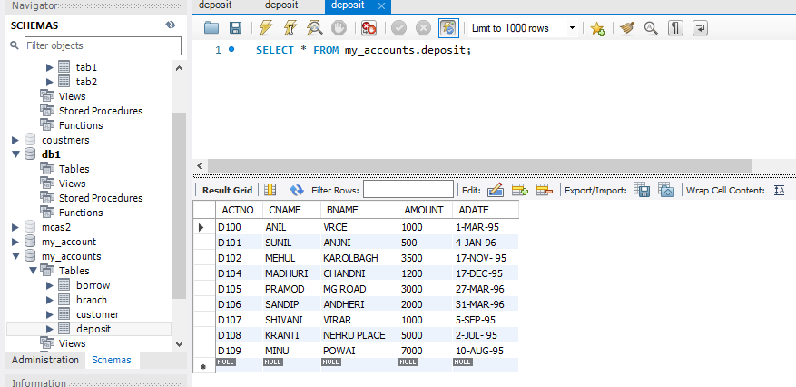

1. SELECT * FROM my_accounts.borrow;

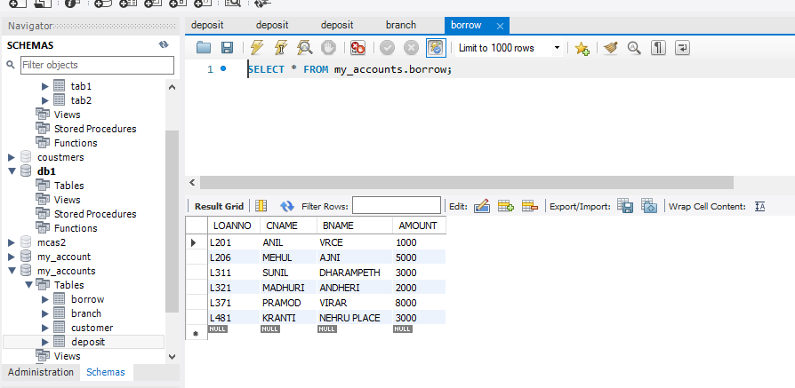

1. SELECT * FROM my_accounts.customer;

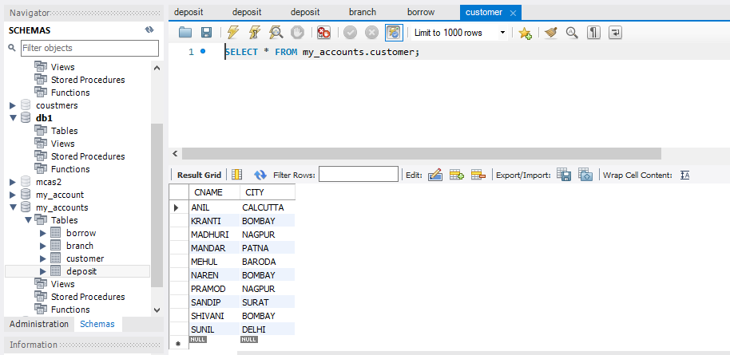

1. SELECT * FROM my_accounts.branch;

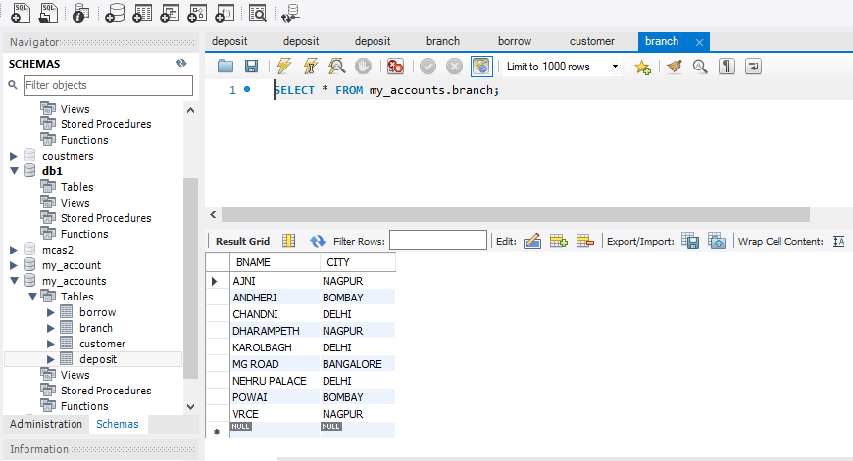

1. SELECT ACTNO,AMOUNT FROM MY_ACCOUNTS.DEPOSIT;

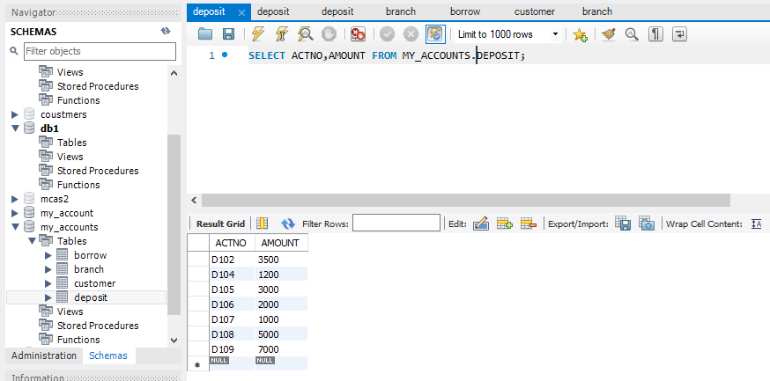

1. SELECT CNAME,ACTNO FROM my_accounts.deposit;

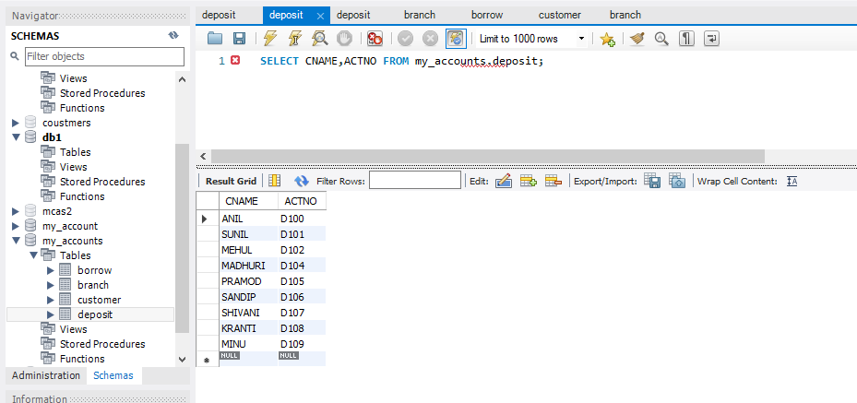

1. SELECT CNAME FROM my_accounts.customer;

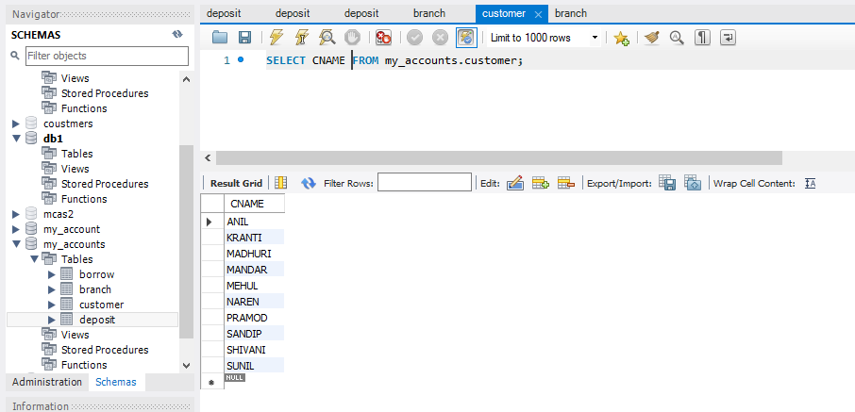

1. SELECT BNAME FROM MY_ACCOUNTS.BRANCH;

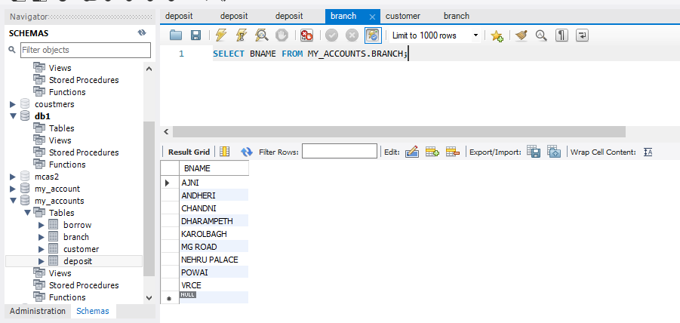

1. SELECT CNAME FROM MY_ACCOUNTS.BORROW;

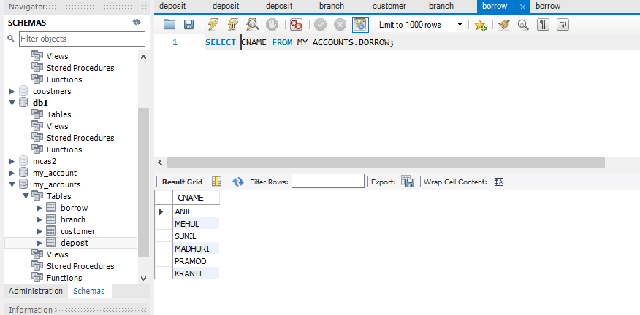

10) SELECT CNAME FROM MY_ACCOUNTS.CUSTOMER WHERE CITY=”NAGPUR”;

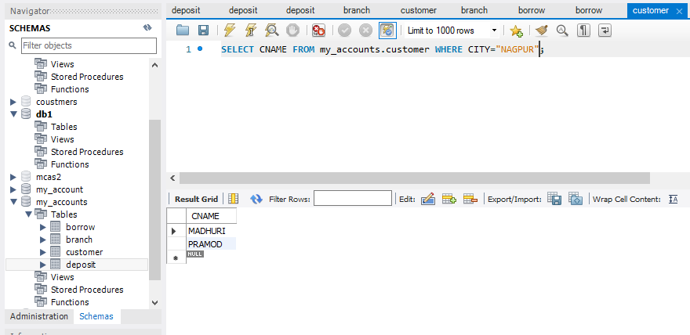

11)SELECT CNAME FROM MY_ACCOUNTS.DEPOSIT WHERE AMOUNT>4000;

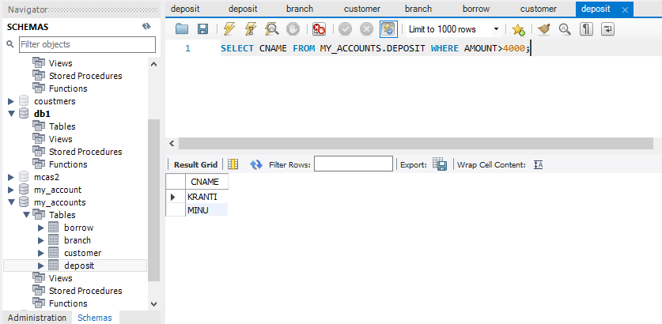

12 SELECT ADATE FROM MY_ACCOUNTS.DEPOSIT WHERE CNAME=”ANIL”;

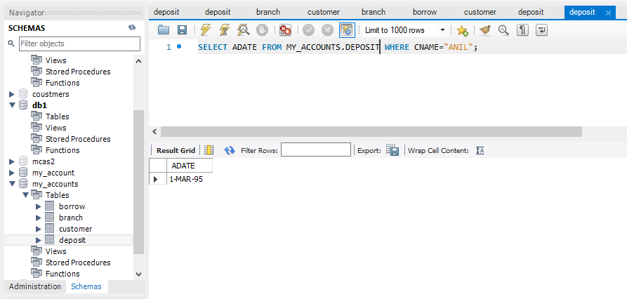

13) SELECT BNAME FROM my_accounts.branch WHERE CITY=”BOMBAY”;

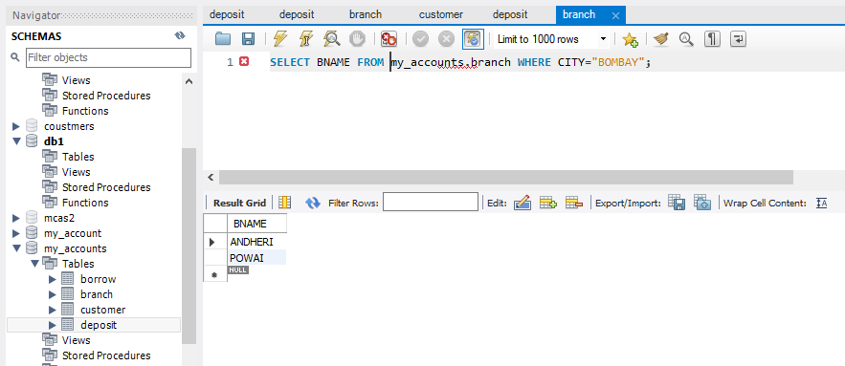

14 )SELECT CNAME FROM my_accounts.borrow WHERE LOANNO=”L201”;

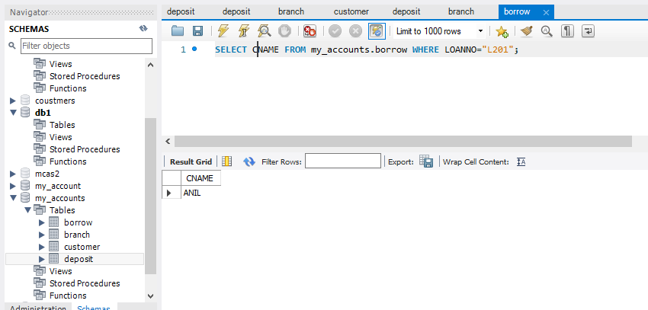

15) SELECT * FROM my_accounts.deposit WHERE BNAME="VRCE";

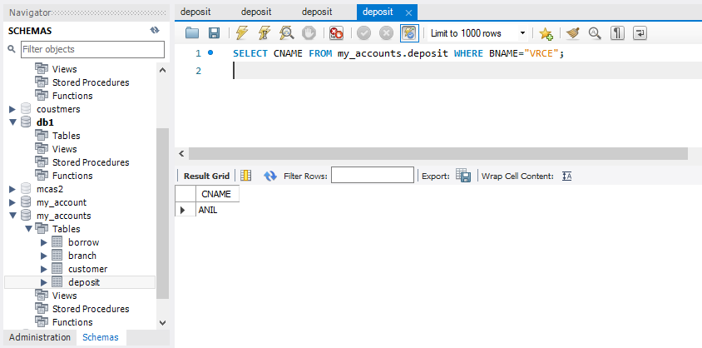

16 )SELECT BNAME FROM my_accounts.branch WHERE CITY="DELHI";

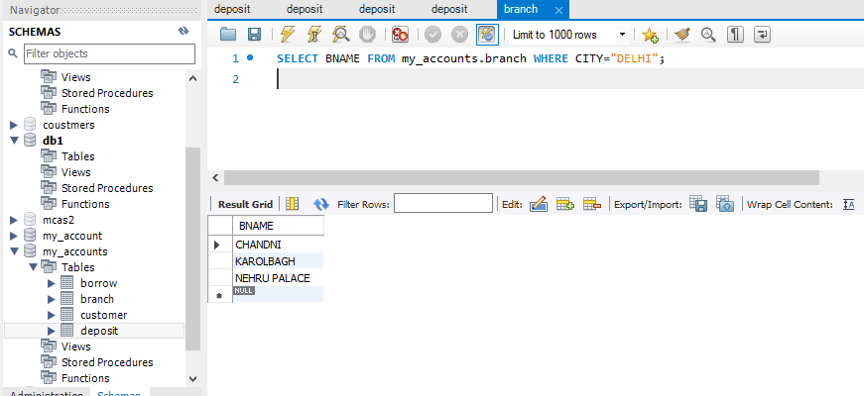

17)SELECT CNAME FROM my_accounts.deposit WHERE ADATE=’1-MAR-95’;

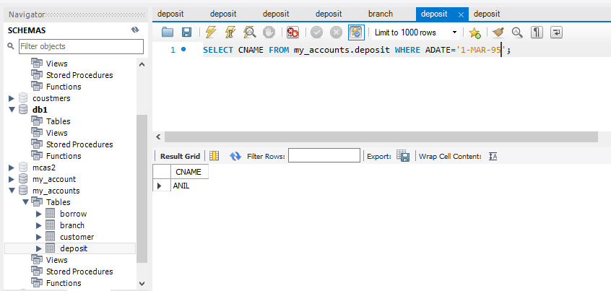

18)SELECT ACTNO,AMOUNT from my_accounts.deposit WHERE ADATE between '1-MAR-95' AND '17-DEC-95';

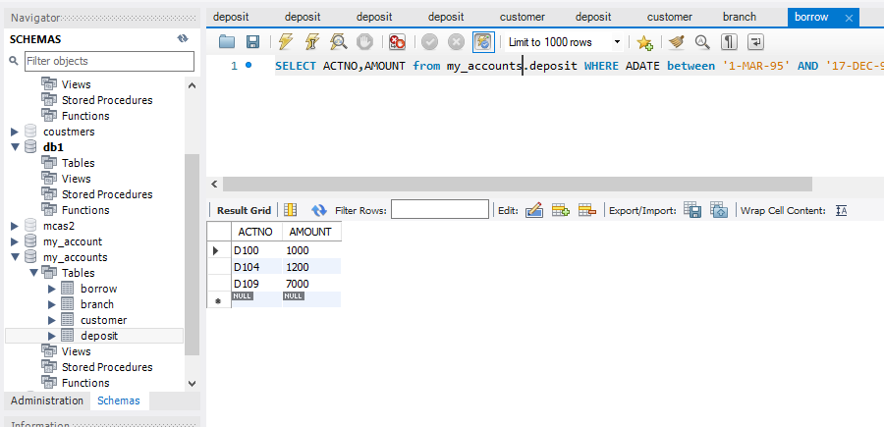

19)SELECT CITY FROM my_accounts.branch WHERE BNAME="MG ROAD";

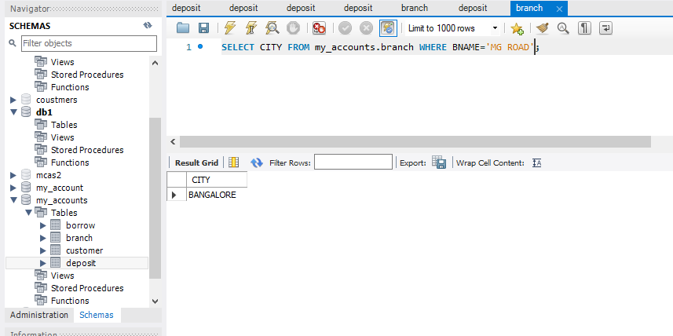

20) SELECT * from my_accounts.customer join my_accounts.borrow on customer.cname=borrow.cname join

my_accounts.deposit on deposit.cname=borrow.cname WHERE customer.cname='ANIL';

