**Name: AKHILA ANAND**

**Roll No:3**

**Batch:RMCA**

**Date:19-04-2022**

**ADVANCED DTABASE MANAGEMENT SYSTEM LAB**

**Experiment No.: 5**

**Aim**

To familiarize with set operations

**Question**

1. List all the customers who are depositors but not borrowers.

2. List all the customers who are both depositors and borrowers

3. List all the depositors having deposit in all the branches where Sunil is having Account

4. List all the customers living in city NAGPUR and having branch city BOMBAY or   DELHI

5. List all the depositors living in city NAGPUR

6. List all the depositors living in the city NAGPUR and having branch in city BOMBAY

7. List the branch cities of Anil and Sunil

8. List the customers having deposit greater than 1000 and loan less than 10000.

9. List the cities of depositors having branch VRCE.

10.List all the cities where branches of Anil and Sunil are locate.

11. List the amount for the depositors living in the city where Anil is living

**Procedure &Output Screenshot**

1)

SELECT CNAME FROM my_accounts.DEPOSIT WHERE DEPOSIT.CNAME NOT IN (SELECT CNAME FROM my_accounts.BORROW);

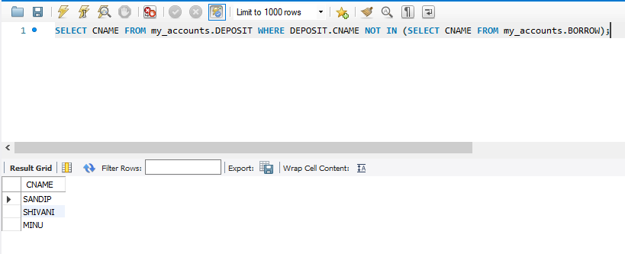

2)

SELECT CNAME FROM my_accounts.DEPOSIT UNION (SELECT CNAME FROM my_accounts.BORROW);

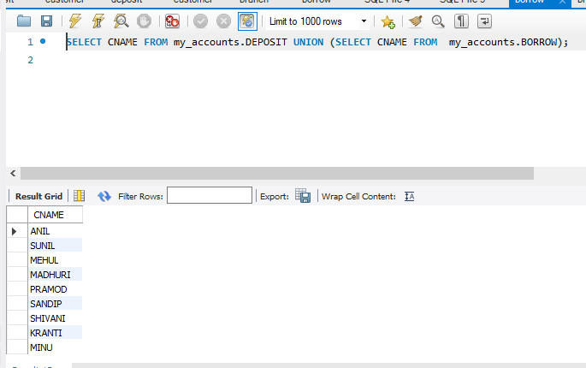

3)

SELECT D1.CNAME FROM my_accounts.DEPOSIT D1 WHERE D1.BNAME IN (SELECT D2.BNAME FROM my_accounts.DEPOSIT D2 WHERE D2.CNAME = 'SUNIL' );

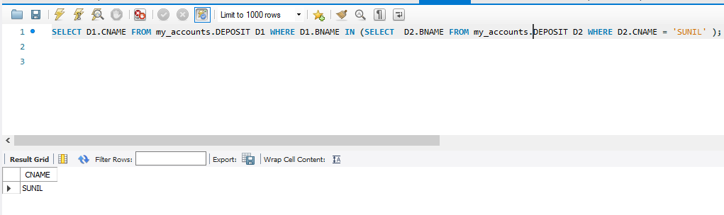

4)

SELECT C1.CNAME FROM my_accounts.CUSTOMER C1,my_accounts.DEPOSIT D1, my_accounts.BRANCH B1 WHERE C1.CITY = 'NAGPUR' AND C1.CNAME = D1.CNAME AND D1.BNAME = B1.BNAME AND B1.CITY IN ('BOMBAY','DELHI');

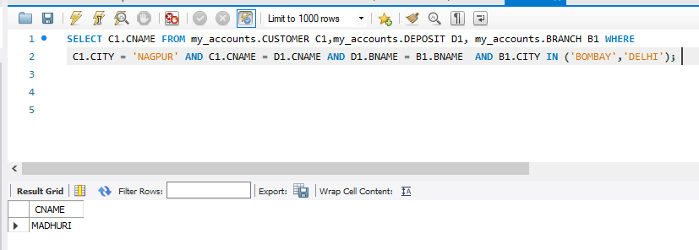

5)

SELECT Distinct(CUSTOMER.CNAME) from my_accounts.CUSTOMER,my_accounts.DEPOSIT WHERE City='NAGPUR';

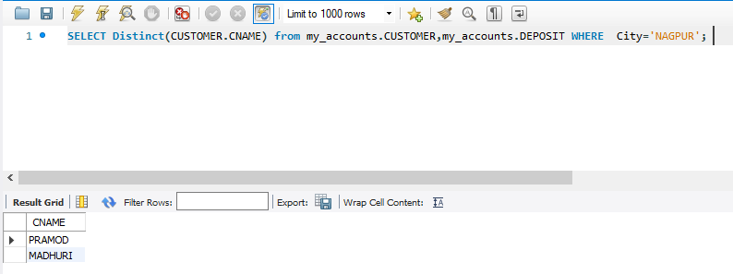

6)

SELECT C1.CNAME FROM my_accounts. CUSTOMER C1,my_accounts. DEPOSIT D1, my_accounts. BRANCH B1 WHERE C1.CITY = 'NAGPUR' AND C1.CNAME = D1.CNAME AND D1.BNAME = B1.BNAME AND B1.CITY IN ('BOMBAY');

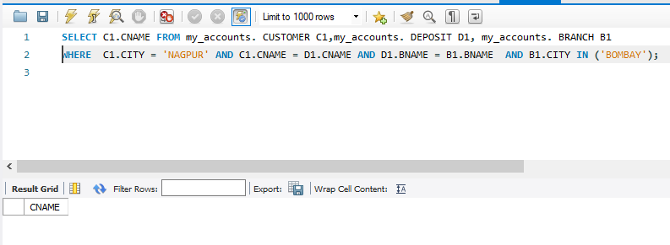

7)

SELECT B1.CITY FROM my_accounts.DEPOSIT D1, my_accounts.BRANCH B1 WHERE D1.BNAME = B1.BNAME AND D1.CNAME IN ('SUNIL' ,'ANIL');

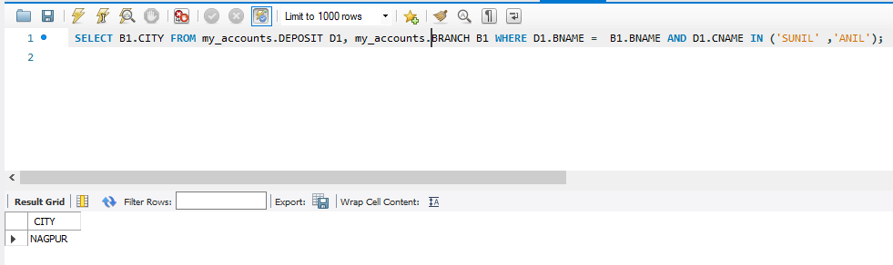

8) SELECT DISTINCT D1.CNAME FROM my_accounts.deposit D1, my_accounts.borrow B1

WHERE D1.AMOUNT>1000 AND B1.AMOUNT<10000;

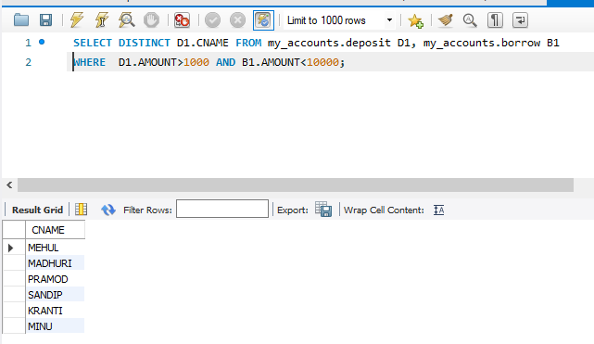

9)

SELECT B1.CITY FROM my_accounts. deposit D1, my_accounts. branch B1

WHERE D1.BNAME=B1.BNAME AND B1.BNAME='VRCE';

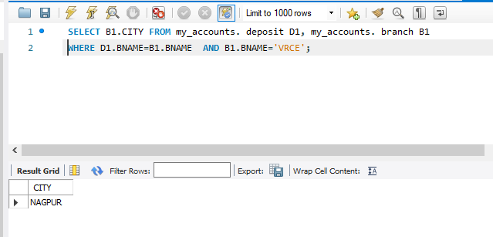

10)

SELECT B1.CITY FROM my_accounts.BRANCH B1 WHERE B1.BNAME IN

(SELECT D1.BNAME FROM my_accounts.DEPOSIT D1 WHERE D1.CNAME IN ('ANIL','SUNIL'));

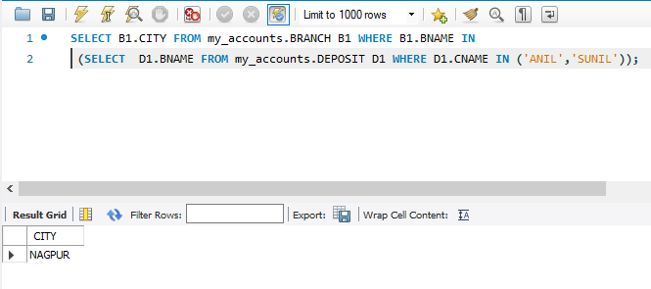

11)

SELECT DISTINCT(D1.CNAME),D1.AMOUNT ,C1.CITY FROM my_accounts.deposit D1, my_accounts.CUSTOMER C1, my_accounts.BRANCH B1WHERE D1.CNAME=C1.CNAME AND C1.CITY IN(SELECT C2.CITY FROM my_accounts.customer C2 WHERE C2.CNAME='ANIL');

