**MOBILE APPLICATION DEVELEPOMENT LAB**

**Name: Akhila Anand**

**Roll No: 3 Batch: RMCA B Date:**

**Experiment No.:** 1

**Aim**

Design a Login Form with username and password using

LinearLayout and toast valid credentials

**Procedure**

**Xml file**

<?xml version="1.0" encoding="utf-8"?>

<RelativeLayout

xmlns:android="http://schemas.android.com/apk/res/android"

xmlns:tools="http://schemas.android.com/tools"

android:layout_width="match_parent"

android:layout_height="match_parent"

tools:context=".MainActivity">

<TextView

android:id="@+id/login"

android:layout_width="match_parent"

android:layout_height="wrap_content"

android:layout_marginTop="30dp"

android:gravity="center_horizontal"

android:padding="5dp"

android:text="Login Form"

android:textAlignment="center"

android:textColor="@color/purple_700"

android:textSize="18sp" />

<TextView

android:layout_width="match_parent"

android:layout_height="wrap_content"

android:text="Username"

android:layout_marginTop="90dp"

android:layout_marginLeft="13dp"/>

<EditText

android:id="@+id/username"

android:layout_width="match_parent"

android:layout_height="wrap_content"

android:layout_below="@id/login"

android:layout_marginStart="10dp"

android:layout_marginTop="50dp"

android:layout_marginEnd="10dp"

android:hint="Enter UserName"

android:inputType="textEmailAddress" />

<TextView

android:layout_width="match_parent"

android:layout_height="wrap_content"

android:text="Password"

android:layout_marginTop="165dp"

android:layout_marginLeft="13dp"/>

<EditText

android:id="@+id/password"

android:layout_width="match_parent"

android:layout_height="wrap_content"

android:layout_below="@id/username"

android:layout_marginStart="10dp"

android:layout_marginTop="20dp"

android:layout_marginEnd="10dp"

android:hint="Enter Password"

android:inputType="textPassword" />

<Button

android:id="@+id/idBtnLogin"

android:layout_width="match_parent"

android:layout_height="wrap_content"

android:layout_below="@id/password"

android:layout_marginStart="10dp"

android:layout_marginTop="20dp"

android:layout_marginEnd="10dp"

android:text="Login" />

</RelativeLayout>

**Java file**

package com.example.program2;

import androidx.appcompat.app.AppCompatActivity;

import android.os.Bundle;

import android.widget.Button;

import android.widget.EditText;

import android.widget.Toast;

public class MainActivity extends AppCompatActivity {

@Override

protected void onCreate(Bundle savedInstanceState) {

super.onCreate(savedInstanceState);

setContentView(R.layout.activity_main);

EditText un =(EditText) findViewById(R.id.username);

EditText pw =(EditText) findViewById(R.id.password);

Button btn =(Button) findViewById(R.id.idBtnLogin);

btn.setOnClickListener(view -> {

String uname = un.getText().toString();

String passwd = pw.getText().toString();

if(uname.equals("ajce") && passwd.equals("123")){

Toast.makeText(this,"Login Success",Toast.LENGTH_SHORT).show();

}

else{

Toast.makeText(this,"invalid username/password",Toast.LENGTH_SHORT).show();

}

});

}

}

**Output**

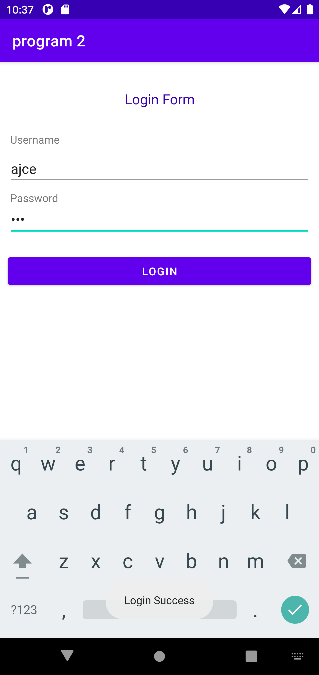

**MOBILE APPLICATION DEVELEPOMENT LAB**

**Name: Akhila Anand**

**Roll No: 3 Batch: RMCA B Date:**

**Experiment No.:** 2

**Aim**

Write a program that demonstrates Activity Lifecycle.

**Procedure**

**Xml :**

<?xml version="1.0" encoding="utf-8"?>

<androidx.constraintlayout.widget.ConstraintLayout

xmlns:android="http://schemas.android.com/apk/res/android"

xmlns:tools="http://schemas.android.com/tools"

xmlns:app="http://schemas.android.com/apk/res-auto"

android:layout_width="match_parent"

android:layout_height="match_parent"

tools:context=".MainActivity">

<TextView

android:layout_width="wrap_content"

android:layout_height="wrap_content"

android:text="hi friends"

android:textColor="@color/teal_200"

android:textSize="30dp"

app:layout_constraintBottom_toBottomOf="parent"

app:layout_constraintStart_toStartOf="parent"

app:layout_constraintEnd_toEndOf="parent"

app:layout_constraintTop_toTopOf="parent" />

</androidx.constraintlayout.widget.ConstraintLayout>

**Java :**

package com.example.program9;

import androidx.appcompat.app.AppCompatActivity;

import android.os.Bundle;

import android.util.Log;

public class MainActivity extends AppCompatActivity {

@Override

protected void onCreate(Bundle savedInstanceState) {

super.onCreate(savedInstanceState);

setContentView(R.layout.activity_main);

Log.d("Lifecycle", "onCreate invoked");

}

@Override

protected void onStart() {

super.onStart();

Log.d("Lifecycle", "onStart invoked");

}

@Override

protected void onResume() {

super.onResume();

Log.d("Lifecycle", "onResume invoked");

}

@Override

protected void onPause() {

super.onPause();

Log.d("Lifecycle", "onPause invoked");

}

@Override

protected void onStop() {

super.onStop();

Log.d("Lifecycle", "onStop invoked");

}

@Override

protected void onDestroy() {

super.onDestroy();

Log.d("Lifecycle", "onDestroy invoked");

}

}

**Output**

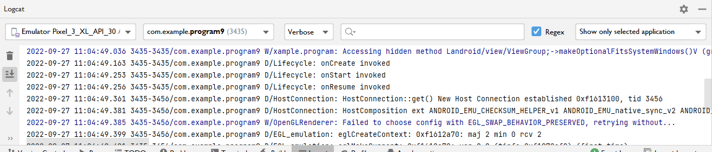

**MOBILE APPLICATION DEVELEPOMENT LAB**

**Name: Akhila Anand**

**Roll No: 3 Batch: RMCA B Date:**

**Experiment No.:** 3

**Aim**

Implementing basic arithmetic operations of a simple calculator.

**Procedure**

**Xml file**

<?xml version="1.0" encoding="utf-8"?>

<LinearLayout xmlns:android="http://schemas.android.com/apk/res/android"

xmlns:tools="http://schemas.android.com/tools"

android:id="@+id/activity_main"

android:layout_width="match_parent"

android:layout_height="match_parent"

android:orientation="vertical"

android:textAlignment="center"

android:weightSum="1">

<TextView

android:text="calculator"

android:layout_width="match_parent"

android:id="@+id/textView"

android:layout_height="30dp"

android:gravity="center_horizontal"

android:textColorLink="?android:attr/editTextColor"

android:textSize="40sp"

android:layout_weight="0.07" />

<EditText

android:layout_width="match_parent"

android:layout_height="wrap_content"

android:inputType="number"

android:ems="10"

android:id="@+id/editOp1"

android:textSize="18sp"

android:gravity="center_horizontal"

android:layout_marginBottom="5dp"

android:visibility="visible"

android:hint="first number"

android:layout_marginLeft="30dp"

android:layout_marginRight="30dp"/>

<EditText

android:layout_width="match_parent"

android:layout_height="wrap_content"

android:inputType="number"

android:ems="10"

android:id="@+id/editOp2"

android:textSize="18sp"

android:gravity="center_horizontal"

android:elevation="1dp"

android:hint="second number"

android:layout_marginLeft="30dp"

android:layout_marginRight="30dp"/>

<LinearLayout

android:orientation="horizontal"

android:layout_width="match_parent"

android:layout_height="wrap_content">

<Button

android:text="+"

android:layout_width="78dp"

android:layout_height="wrap_content"

android:id="@+id/btnadd"

android:layout_weight="0.01"

android:layout_marginLeft="30dp"

android:layout_marginRight="30dp"/>

<Button

android:text="-"

android:layout_width="78dp"

android:layout_height="wrap_content"

android:id="@+id/btnsub"

android:layout_weight="0.01"

android:layout_marginLeft="30dp"

android:layout_marginRight="30dp"/>

</LinearLayout>

<LinearLayout

android:orientation="horizontal"

android:layout_width="match_parent"

android:layout_height="wrap_content">

<Button

android:text="*"

android:layout_width="78dp"

android:layout_height="wrap_content"

android:id="@+id/btnmul"

android:layout_weight="0.01"

android:layout_marginLeft="30dp"

android:layout_marginRight="30dp"/>

<Button

android:text="/"

android:layout_height="wrap_content"

android:id="@+id/btndiv"

android:layout_width="78dp"

android:layout_weight="0.01"

android:layout_marginLeft="30dp"

android:layout_marginRight="30dp"/>

</LinearLayout>

<LinearLayout

android:orientation="horizontal"

android:layout_width="match_parent"

android:layout_height="wrap_content">

<Button

android:text="Clear"

android:layout_width="80dp"

android:layout_height="wrap_content"

android:id="@+id/btnclr"

android:layout_weight="0.03"

android:layout_marginLeft="30dp"

android:layout_marginRight="30dp" />

</LinearLayout>

<EditText

android:layout_width="match_parent"

android:layout_height="wrap_content"

android:inputType="number"

android:ems="10"

android:id="@+id/result"

android:textSize="18sp"

android:text="answer"

android:gravity="center_horizontal"

android:layout_marginLeft="30dp"

android:layout_marginRight="30dp"/>

</LinearLayout>

**Java file**

package com.example.program1;

import androidx.appcompat.app.AppCompatActivity;

import android.os.Bundle;

import android.view.View;

import android.widget.Button;

import android.widget.EditText;

import android.widget.TextView;

import android.widget.Toast;

public class MainActivity extends AppCompatActivity {

private EditText opr1;

private EditText opr2;

private Button btnadd;

private Button btnsub;

private Button btnmul;

private Button btndiv;

private Button btnclr;

private TextView txtresult;

@Override

protected void onCreate(Bundle savedInstanceState) {

super.onCreate(savedInstanceState);

setContentView(R.layout.activity_main);

opr1 = (EditText) findViewById(R.id.editOp1);

opr2 = (EditText) findViewById(R.id.editOp2);

btnadd = (Button) findViewById(R.id.btnadd);

btnsub = (Button) findViewById(R.id.btnsub);

btnmul = (Button) findViewById(R.id.btnmul);

btndiv = (Button) findViewById(R.id.btndiv);

btnclr = (Button) findViewById(R.id.btnclr);

txtresult= (TextView) findViewById(R.id.result);

btnadd.setOnClickListener(new View.OnClickListener() {

@Override

public void onClick(View v) {

if((opr1.getText().length()>0) && (opr2.getText().length()>0)) {

double oper1 = Double.parseDouble(opr1.getText().toString());

double oper2 = Double.parseDouble(opr2.getText().toString());

double result = oper1 + oper2;

txtresult.setText(Double.toString(result));

}

else{

Toast toast= Toast.makeText(MainActivity.this,"Enter The Required Numbers",Toast.LENGTH_LONG);

toast.show();

}

}

});

btnsub.setOnClickListener(new View.OnClickListener() {

@Override

public void onClick(View v) {

if((opr1.getText().length()>0) && (opr2.getText().length()>0)) {

double oper1 = Double.parseDouble(opr1.getText().toString());

double oper2 = Double.parseDouble(opr2.getText().toString());

double result = oper1 - oper2;

txtresult.setText(Double.toString(result));

}

else{

Toast toast= Toast.makeText(MainActivity.this,"Enter The Required Numbers",Toast.LENGTH_LONG);

toast.show();

}

}

});

btnmul.setOnClickListener(new View.OnClickListener() {

@Override

public void onClick(View v) {

if((opr1.getText().length()>0) && (opr2.getText().length()>0)) {

double oper1 = Double.parseDouble(opr1.getText().toString());

double oper2 = Double.parseDouble(opr2.getText().toString());

double result = oper1 * oper2;

txtresult.setText(Double.toString(result));

}

else{

Toast toast= Toast.makeText(MainActivity.this,"Enter The Required Numbers",Toast.LENGTH_LONG);

toast.show();

}

}

});

btndiv.setOnClickListener(new View.OnClickListener() {

@Override

public void onClick(View v) {

if((opr1.getText().length()>0) && (opr2.getText().length()>0)) {

double oper1 = Double.parseDouble(opr1.getText().toString());

double oper2 = Double.parseDouble(opr2.getText().toString());

double result = oper1 / oper2;

txtresult.setText(Double.toString(result));

}

else{

Toast toast= Toast.makeText(MainActivity.this,"Enter The Required Numbers",Toast.LENGTH_LONG);

toast.show();

}

}

});

btnclr.setOnClickListener(new View.OnClickListener() {

@Override

public void onClick(View v) {

opr1.setText("");

opr2.setText("");

txtresult.setText("0.00");

opr1.requestFocus();

}

});

}

}

**Output**

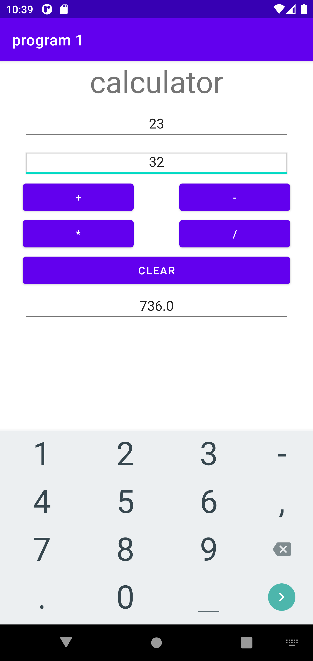

**MOBILE APPLICATION DEVELEPOMENT LAB**

**Name: Akhila Anand**

**Roll No: 3 Batch: RMCA B Date:**

**Experiment No.:** 4

**Aim**

Implement validations on various UI controls

**Procedure**

**Xml file**

<?xml version="1.0" encoding="utf-8"?>

<LinearLayout

xmlns:android="http://schemas.android.com/apk/res/android"

xmlns:tools="http://schemas.android.com/tools"

android:layout_width="match_parent"

android:layout_height="match_parent"

android:orientation="vertical"

tools:context=".MainActivity"

tools:ignore="HardcodedText">

<TextView

android:layout_width="wrap_content"

android:layout_height="wrap_content"

android:layout_gravity="center"

android:textSize="20dp"

android:layout_marginTop="20dp"

android:text="Form Validation"/>

<EditText

android:id="@+id/firstName"

android:layout_width="match_parent"

android:layout_height="wrap_content"

android:layout_marginStart="16dp"

android:layout_marginTop="16dp"

android:layout_marginEnd="16dp"

android:hint="First Name"

android:inputType="text" />

<EditText

android:id="@+id/lastName"

android:layout_width="match_parent"

android:layout_height="wrap_content"

android:layout_marginStart="16dp"

android:layout_marginTop="16dp"

android:layout_marginEnd="16dp"

android:hint="Last Name"

android:inputType="text" />

<EditText

android:id="@+id/email"

android:layout_width="match_parent"

android:layout_height="wrap_content"

android:layout_marginStart="16dp"

android:layout_marginTop="16dp"

android:layout_marginEnd="16dp"

android:hint="Email"

android:inputType="textEmailAddress" />

<EditText

android:id="@+id/password"

android:layout_width="match_parent"

android:layout_height="wrap_content"

android:layout_marginStart="16dp"

android:layout_marginTop="16dp"

android:layout_marginEnd="16dp"

android:hint="Password"

android:inputType="textPassword" />

<LinearLayout

android:layout_width="match_parent"

android:layout_height="wrap_content"

android:layout_marginTop="8dp"

android:gravity="end"

android:orientation="horizontal">

<Button

android:id="@+id/cancelButton"

style="@style/Widget.AppCompat.Button.Borderless"

android:layout_width="wrap_content"

android:layout_height="wrap_content"

android:layout_marginEnd="180dp"

android:text="CANCEL"

android:textColor="@color/black" />

<Button

android:id="@+id/proceedButton"

android:layout_width="wrap_content"

android:layout_height="wrap_content"

android:layout_marginEnd="20dp"

android:backgroundTint="@color/black"

android:text="PROCEED"

android:textColor="@android:color/white"/>

</LinearLayout>

</LinearLayout>

**Java file**

package com.example.program4;

import androidx.appcompat.app.AppCompatActivity;

import android.content.Intent;

import android.os.Bundle;

import android.view.View;

import android.widget.Button;

import android.widget.EditText;

public class MainActivity extends AppCompatActivity {

Button bCancel, bProceed;

EditText etFirstName, etLastName, etEmail, etPassword;

boolean isAllFieldsChecked = false;

@Override

protected void onCreate(Bundle savedInstanceState) {

super.onCreate(savedInstanceState);

setContentView(R.layout.activity_main);

bProceed = findViewById(R.id.proceedButton);

bCancel = findViewById(R.id.cancelButton);

etFirstName = findViewById(R.id.firstName);

etLastName = findViewById(R.id.lastName);

etEmail = findViewById(R.id.email);

etPassword = findViewById(R.id.password);

bProceed.setOnClickListener(new View.OnClickListener() {

@Override

public void onClick(View v) {

isAllFieldsChecked = CheckAllFields();

if (isAllFieldsChecked) {

Intent i = new Intent(MainActivity.this, MainActivity.class);

startActivity(i);

}

}

});

bCancel.setOnClickListener(new View.OnClickListener() {

@Override

public void onClick(View v) {

MainActivity.this.finish();

System.exit(0);

}

});

}

private boolean CheckAllFields() {

if (etFirstName.length() == 0) {

etFirstName.setError("This field is required");

return false;

}

if (etLastName.length() == 0) {

etLastName.setError("This field is required");

return false;

}

if (etEmail.length() == 0) {

etEmail.setError("Email is required");

return false;

}

if (etPassword.length() == 0) {

etPassword.setError("Password is required");

return false;

} else if (etPassword.length() < 8) {

etPassword.setError("Password must be minimum 8 characters");

return false;

}

return true;

}

}

**Output**

