**Name: Akhila Anand**

**Roll No: 3 Batch: RMCA B**

**MOBILE APPLICATION DEVELEPOMENT LAB**

**Experiment No.:** 1

**Aim**

Designa registration activity and store registration details in local

Memory of phone using intent and sharedpreferances

**Procedure:**

**Xml :**

<?xml version="1.0" encoding="utf-8"?>

<LinearLayout xmlns:android="http://schemas.android.com/apk/res/android"

xmlns:app="http://schemas.android.com/apk/res-auto"

xmlns:tools="http://schemas.android.com/tools"

android:orientation="vertical"

android:layout_width="match_parent"

android:layout_height="match_parent"

tools:context=".MainActivity">

<TextView

android:layout_width="wrap_content"

android:layout_height="wrap_content"

android:text="prgm4 shared preference "

android:id="@+id/textView"

android:layout_alignParentTop="true"

android:layout_centerHorizontal="true"

android:textSize="29dp" />

<EditText

android:layout_width="wrap_content"

android:layout_height="wrap_content"

android:id="@+id/editText"

android:layout_below="@+id/textView2"

android:layout_marginTop="67dp"

android:hint="Name"

android:layout_alignParentLeft="true"

android:layout_alignParentStart="true"

android:layout_alignParentRight="true"

android:layout_alignParentEnd="true" />

<EditText

android:layout_width="wrap_content"

android:layout_height="wrap_content"

android:id="@+id/editText3"

android:layout_below="@+id/editText2"

android:layout_alignParentLeft="true"

android:layout_alignParentStart="true"

android:layout_alignParentRight="true"

android:layout_alignParentEnd="true"

android:hint="Email" />

<EditText

android:layout_width="wrap_content"

android:layout_height="wrap_content"

android:id="@+id/editText2"

android:layout_below="@+id/editText"

android:layout_alignParentLeft="true"

android:layout_alignParentStart="true"

android:layout_alignParentRight="true"

android:layout_alignParentEnd="true"

android:hint="Pass" />

<Button

android:layout_width="wrap_content"

android:layout_height="wrap_content"

android:text="Save"

android:id="@+id/button"

android:layout_below="@+id/editText3"

android:layout_centerHorizontal="true"

android:layout_marginTop="50dp" />

</LinearLayout>

**Java :**

package com.example.program8;

import androidx.appcompat.app.AppCompatActivity;

import android.content.Context;

import android.content.SharedPreferences;

import android.os.Bundle;

import android.view.View;

import android.widget.Button;

import android.widget.EditText;

import android.widget.Toast;

public class MainActivity extends AppCompatActivity {

EditText ed1,ed2,ed3;

Button b1;

public static final String MyPREFERENCES = "MyPrefs" ;

public static final String Name = "nameKey";

public static final String Phone = "phoneKey";

public static final String Email = "emailKey";

SharedPreferences sharedpreferences;

@Override

protected void onCreate(Bundle savedInstanceState) {

super.onCreate(savedInstanceState);

setContentView(R.layout.activity_main);

ed1=(EditText)findViewById(R.id.editText);

ed2=(EditText)findViewById(R.id.editText2);

ed3=(EditText)findViewById(R.id.editText3);

b1=(Button)findViewById(R.id.button);

sharedpreferences = getSharedPreferences(MyPREFERENCES, Context.MODE_PRIVATE);

b1.setOnClickListener(new View.OnClickListener() {

@Override

public void onClick(View v) {

String n = ed1.getText().toString();

String ph = ed2.getText().toString();

String e = ed3.getText().toString();

SharedPreferences.Editor editor = sharedpreferences.edit();

editor.putString(Name, n);

editor.putString(Phone, ph);

editor.putString(Email, e);

editor.commit();

Toast.makeText(MainActivity.this,"Thanks",Toast.LENGTH_LONG).show();

}

});

}

}

**OUTPUT**

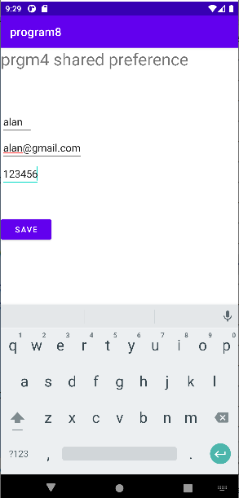



**Experiment No.:** 2

**Name: Akhila Anand**

**Roll No: 3 Batch: RMCA B**

**Aim:**



Design a simple calculator using GridLayout and Cascaded LinearLayout

**Procedure:**

XML Code

<?xml version="1.0" encoding="utf-8"?>

<LinearLayout xmlns:android="http://schemas.android.com/apk/res/android"

xmlns:app="http://schemas.android.com/apk/res-auto"

xmlns:tools="http://schemas.android.com/tools"

android:layout_width="match_parent"

android:orientation="vertical"

android:layout_height="match_parent"

android:id="@+id/mainlay"

tools:context=".FacebookLoginActivity">

<ImageView

android:layout_width="match_parent"

android:layout_height="230dp"

android:src="@drawable/fb_subbg"

android:scaleType="centerCrop"/>

<TextView

android:layout_width="wrap_content"

android:layout_height="wrap_content"

android:text="Nederlands . Polski . More ..."

android:textAlignment="center"

android:layout_marginTop="5dp"

android:layout_gravity="center"/>

<LinearLayout

android:layout_width="match_parent"

android:layout_height="wrap_content"

android:paddingHorizontal="30dp"

android:layout_marginTop="50dp"

android:orientation="vertical">

<EditText

android:id="@+id/fb_id"

android:layout_width="match_parent"

android:layout_height="wrap_content"

android:hint="Phone or email"

android:digits=""

android:inputType="text"/>

<EditText

android:id="@+id/fb_pass"

android:layout_width="match_parent"

android:layout_height="wrap_content"

android:layout_marginTop="20dp"

android:hint="Password"

android:inputType="textPassword"/>

<Button

android:id="@+id/fb_loginbtn"

android:layout_width="match_parent"

android:layout_height="60dp"

android:text="Log In"

android:layout_marginTop="20dp"

android:textAllCaps="false"

android:backgroundTint="#3F51B5"/>

<TextView

android:layout_width="wrap_content"

android:layout_height="wrap_content"

android:text="Forgot Password?"

android:textStyle="bold"

android:textColor="#3F51B5"

android:textSize="17sp"

android:textAlignment="center"

android:layout_gravity="center"

android:layout_marginTop="10dp"/>

<LinearLayout

android:layout_width="match_parent"

android:layout_height="wrap_content"

android:orientation="horizontal"

android:layout_gravity="center"

android:gravity="center"

android:layout_marginTop="40dp"

android:weightSum="3">

<com.google.android.material.divider.MaterialDivider

android:layout_width="0dp"

android:layout_height="1dp"

android:layout_weight="1.45"

android:background="#CCCCCC"/>

<TextView

android:layout_width="wrap_content"

android:layout_height="wrap_content"

android:text="OR"

android:textAlignment="center"

android:layout_weight="0.2"/>

<com.google.android.material.divider.MaterialDivider

android:id="@+id/divider_2"

android:layout_width="0dp"

android:layout_height="1dp"

android:layout_weight="1.45"

android:background="#CCCCCC"/>

</LinearLayout>

<Button

android:layout_width="match_parent"

android:layout_height="wrap_content"

android:text="Create New facebook Account"

android:layout_marginTop="20dp"

android:textAllCaps="false"

android:backgroundTint="#4CAF50"/>

</LinearLayout>

</LinearLayout>

------------------------------------------------------------------- Java Code -------------------------------------------------------------------

package com.example.loginformques01;

import androidx.appcompat.app.AppCompatActivity;

import android.os.Bundle;

public class FacebookLoginActivity extends AppCompatActivity {

@Override

protected void onCreate(Bundle savedInstanceState) {

super.onCreate(savedInstanceState);

setContentView(R.layout.activity_facebook_login);

}

}

**Name: Akhila Anand**

**Roll No: 3 Batch: RMCA B**

**Experiment No.:** 3

**Aim:**



Create a Facebook page using Relative Layout; set properties using .xml file

**Procedure:**

**Xml file**

<?xml version="1.0" encoding="utf-8"?>

<RelativeLayout xmlns:android="http://schemas.android.com/apk/res/android"

xmlns:tools="http://schemas.android.com/tools"

android:layout_width="match_parent"

android:layout_height="match_parent"

tools:context=".MainActivity">

<TextView

android:layout_width="wrap_content"

android:layout_height="wrap_content"

android:text="FACEBOOK"

android:textColor="#4267B2"

android:textSize="30dp"

android:textStyle="bold"

android:layout_marginLeft="125dp"

android:layout_marginTop="60dp"/>

<TextView

android:text="Log in to Facebook"

android:layout_width="match_parent"

android:layout_height="wrap_content"

android:layout_marginTop="140dp"

android:textSize="30dp"

android:textStyle="bold"

android:gravity="center_horizontal"

/>

<EditText

android:layout_width="match_parent"

android:layout_height="wrap_content"

android:inputType="number"

android:ems="10"

android:textSize="18sp"

android:gravity="center_horizontal"

android:elevation="1dp"

android:hint="Email address or phone number"

android:layout_marginLeft="30dp"

android:layout_marginRight="30dp"

android:layout_marginTop="200dp"

/>

<EditText

android:layout_width="match_parent"

android:layout_height="wrap_content"

android:inputType="number"

android:textSize="18sp"

android:gravity="center_horizontal"

android:hint="password"

android:layout_marginLeft="30dp"

android:layout_marginRight="30dp"

android:layout_marginTop="260dp"/>

<Button

android:text="Log In"

android:layout_width="wrap_content"

android:layout_height="wrap_content"

android:layout_marginLeft="150dp"

android:layout_marginRight="150dp"

android:layout_marginTop="330dp"

android:backgroundTint="#4267B2"

/>

<TextView

android:text="Forgotten account? · Sign up for Facebook"

android:layout_width="match_parent"

android:layout_height="wrap_content"

android:textSize="17dp"

android:textStyle="italic"

android:gravity="center_horizontal"

android:layout_marginTop="400dp"

android:textColor="#4267B2"

/>

</RelativeLayout>

**Output:**

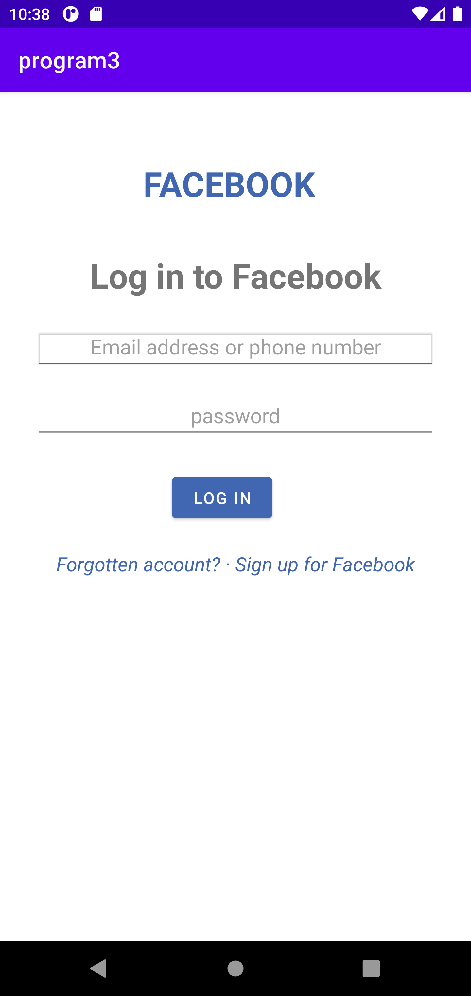

**Name: Akhila Anand**

**Roll No: 3 Batch: RMCA B**

**Experiment No.:** 4

**Aim:**



Develop an application that toggle image using FrameLayout

**Procedure:**

XML Code

<?xml version="1.0" encoding="utf-8"?>

<FrameLayout xmlns:android="http://schemas.android.com/apk/res/android"

xmlns:app="http://schemas.android.com/apk/res-auto"

xmlns:tools="http://schemas.android.com/tools"

android:layout_width="match_parent"

android:layout_height="match_parent"

android:orientation="vertical"

tools:context=".FrameLayoutImageToggleActivity">

<ToggleButton

android:id="@+id/toggle_img_btn"

android:layout_width="60dp"

android:layout_height="60dp"

android:textOff=""

android:textOn=""

android:background="@drawable/ic_unlocked"

android:layout_gravity="center"/>

</FrameLayout>

**Java code**

package com.example.loginformques01;

import androidx.appcompat.app.AppCompatActivity;

import android.os.Bundle;

import android.widget.FrameLayout;

import android.widget.Toast;

import android.widget.ToggleButton;

public class FrameLayoutImageToggleActivity extends AppCompatActivity {

ToggleButton toggle_img_btn;

@Override

protected void onCreate(Bundle savedInstanceState) {

super.onCreate(savedInstanceState);

setContentView(R.layout.activity_frame_layout_image_toggle);

toggle_img_btn= findViewById(R.id.toggle_img_btn);

toggle_img_btn.setOnClickListener(v->{

if(toggle_img_btn.isChecked()){

toggle_img_btn.setBackgroundDrawable(getResources().getDrawable(R.drawable.ic_locked));

Toast.makeText(getApplicationContext(), "Application Locked Successfully.", Toast.LENGTH_SHORT).show();

}

else{

toggle_img_btn.setBackgroundDrawable(getResources().getDrawable(R.drawable.ic_unlocked));

Toast.makeText(getApplicationContext(), "Application Unlocked Successfully.", Toast.LENGTH_SHORT).show();

}

});

}

}