

**NETWORKING & SYSTEM ADMINISTRATION LAB**

**Experiment No.: 23**

**Aim**

Installing docker on ubuntu.

**Procedure and Output Screenshot**

## Steps for Installing Docker:

1. Open the terminal on Ubuntu.

2. Remove anyDocker file that are running in the system, using the following command:

**$ sudo apt-get remove docker docker-engine docker.io**

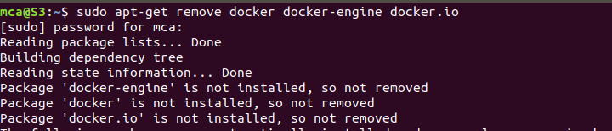

After entering the above command, you will need to enter the password of the root and press enter.

3. Check if the system is up-to-date using the following command:

**$ sudo apt-get update**

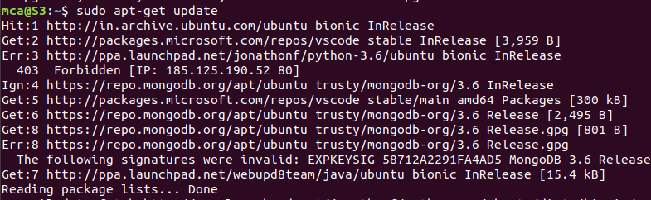

4. Install Docker using the following command:

| **$ sudo apt install docker.io** |
| --- |

You’ll then get a prompt asking you to choose between y/n - choose ***y***

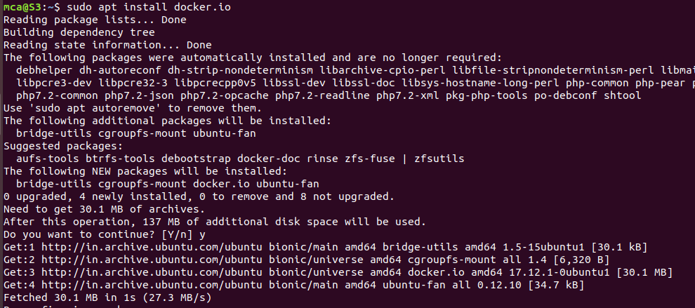

5. Install all the dependency packages using the following command:

**$ sudo snap install docker**



6. Before testing Docker, check the version installed using the following command:

**$ docker --version**



7. Pull an image from the Docker hub using the following command:

| **$ sudo docker run hello-world** |
| --- |

Here, ***hello-world*** is the docker image present on the Docker hub.

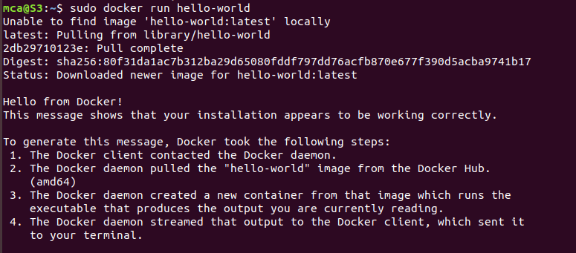

8. Check if the docker image has been pulled and is present in your system using the following command:

**$ sudo docker images**



9. To display all the containers pulled, use the following command:

**$ sudo docker ps -a**



10. To check for containers in a running state, use the following command:

| **$ sudo docker ps** |
| --- |

