**Name: AKHILA ANAND**

**Roll No:3**

**Batch:S2 RMCA**

**Date:05\04\2022**

**NETWORKING & SYSTEM ADMINISTRATION LAB**

**Experiment No.: 2**

**Aim:**

Hardware Components

**Procedure:**

**1)MOTHERBOARD**

The motherboard is defined as a circuit board for the computer system, also called logic board or mainboard. In the computer system, the biggest component is the motherboard that controls all the components of the computer system and establishes a link between all components.

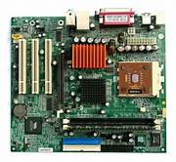

**2)CPU (Central Processing Unit)**

A CPU, or central processing unit, is the brain of a computer. The CPU processes information and runs programs.It functions as a control unit that executes programs according to instructions in its program memory.The CPU contains elements such as registers, an arithmetic logic unit (ALU), and control logic for sequencing instructions.

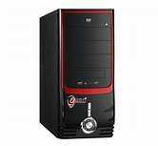

### 3) KEYBOARD

A keyboard is an input device that you use to enter data into a computer.It's also called the input device for your computer. Keyboards are used with PCs, laptops, tablets, and other devices.There are many different types of keyboards, but the most common one is the QWERTY keyboard.A QWERTY keyboard has all the letters in alphabetical order on it.This is different from some other types of keyboards, like Dvorak or Colemak keyboards.For example, these keyboards have keys arranged differently than what you’re used to seeing on a QWERTY keyboard.And that means that typing on these keyboards will feel like typing in another language at first! But don’t worry - once you get accustomed to it, it feels natural.

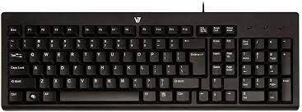

### 4) MONITOR

Personal computers use a monitor to display data, run the software, and interact with the user.A monitor is an electronic visual display that connects to your computer or laptop.It is used for displaying images, text, videos, games, web pages, and more.Monitors are available in different sizes depending on the needs of the person using them.The most common types of monitors are CRT (cathode ray tube), LCD (liquid crystal display), and LED (light-emitting diode).

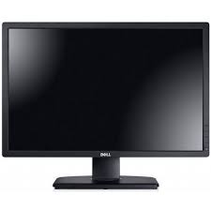

**5) MOUSE**

A mouse is a hardware input device that is used to move the cursor or pointer on computer screens.It can also be used to run computer programs, select items in a graphical user interface, and manipulate objects in the computer world.Some common examples of how it can be used are clicking on buttons, scrolling up and down the screen, selecting files, opening folders, and so on.

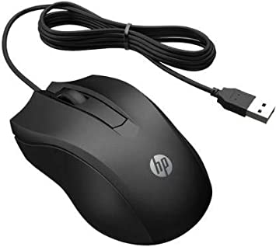

### 6) RAM Memory

A computer's RAM is a type of computer memory that stores information so the CPU can access it directly.Computer systems use main memory to store both data and programs.The more RAM you have, the more data your system can process at one time.This will lead to more efficient operations on your computer, which translates into better performance for the user.

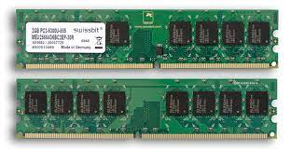

### 

### 7)ROM Memory

ROM stands for a type of memory chip that can be read from but not written to.In other words, it's a form of data storage that can't be changed after being programmed.It's sometimes called "non-volatile" memory because the stored information will remain even when not powered up or in use.ROM is often used to store a computer's basic start-up instructions and certain types of data, such as your car's onboard computer system and a calculator's data tables

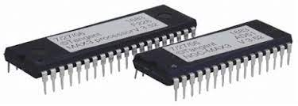

**8)PRINTER**

A printer is a hardware output device that is used to generate hard copy and print any document. A document can be of any type such as a text file, image, or the combination of both. It accepts input command by users on a computer or on other devices to print the documents. For example, if you have to submit a project report at your college, you need to create a soft copy of your report and print it with the help of the printer.

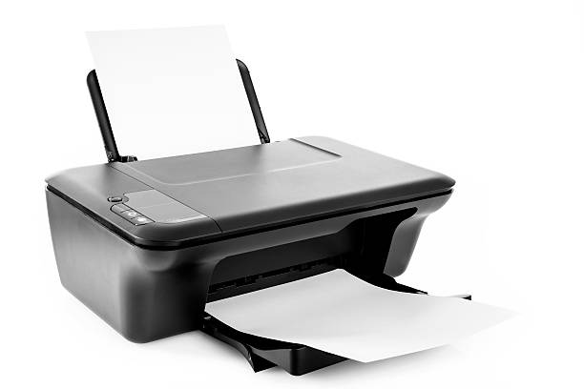

**9)PROCESSOR**

A processor is an integrated electronic circuit that performs the calculations that run a computer. A processor performs arithmetical, logical, input/output (I/O) and other basic instructions that are passed from an operating system (OS). Most other processes are dependent on the operations of a processor.

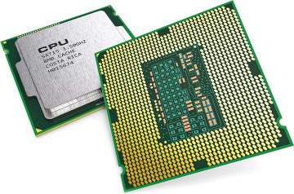

**10)Flash memory card**

The keyboard is the piece of [computer hardware](https://www.lifewire.com/computer-hardware-2625895) used to input text, characters, and other commands into a computer or similar device.Even though the keyboard is an external [peripheral device](https://www.lifewire.com/peripheral-device-2625951) in a desktop system (it sits outside the main [computer housing](https://www.lifewire.com/what-is-a-computer-case-2618149)), or is "virtual" in a tablet PC, it is an essential part of the complete computer system.

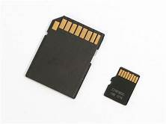

**11)GPU[GRAPHICS PROCESS UNIT]**

A **graphics processing unit** (**GPU**) is a specialized electronic circuit designed to rapidly manipulate and alter [memory](https://en.wikipedia.org/wiki/Memory_(computing)) to accelerate the creation of images in a frame buffer intended for output to a display device. GPUs are used in embedded systems, mobile phones personal computers, workstations and game consoles.

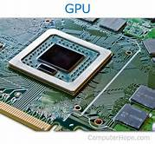

**12)STORAGE**

Primary Storage Devices: It is also known as internal memory and main memory. This is a section of the CPU that holds program instructions, input data, and intermediate results. It is generally smaller in size.



 

 

 

 

 

 