**Experiment No.: 3**

**Aim**

Familiarization of basic linux command.

**Procedure**

1.pwd

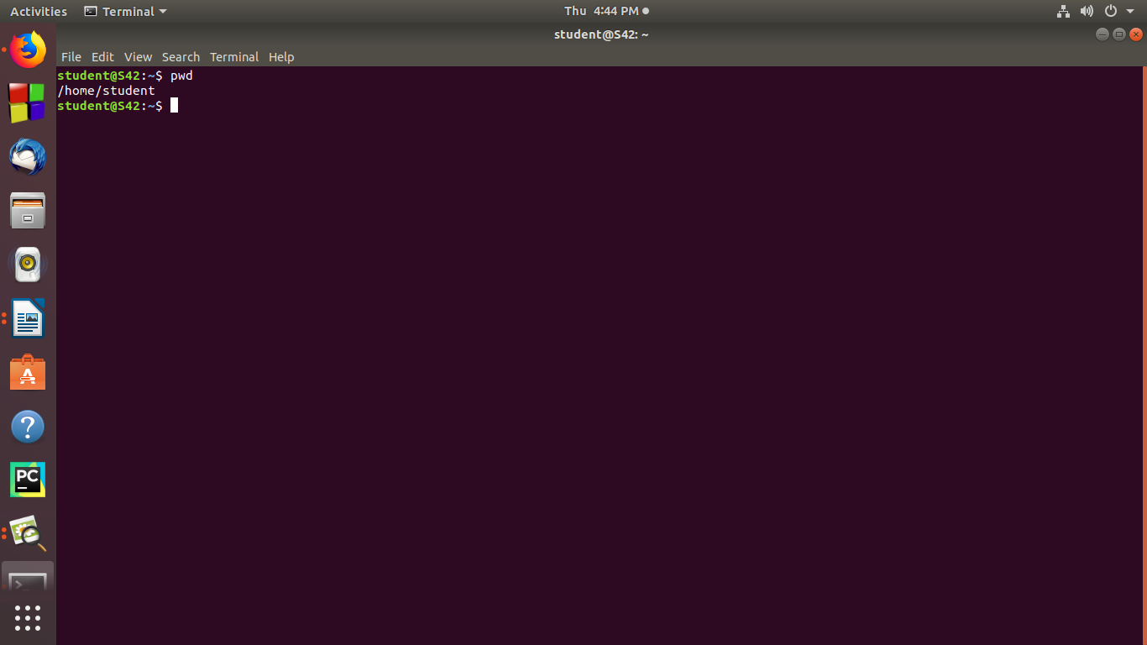

2.mkdir

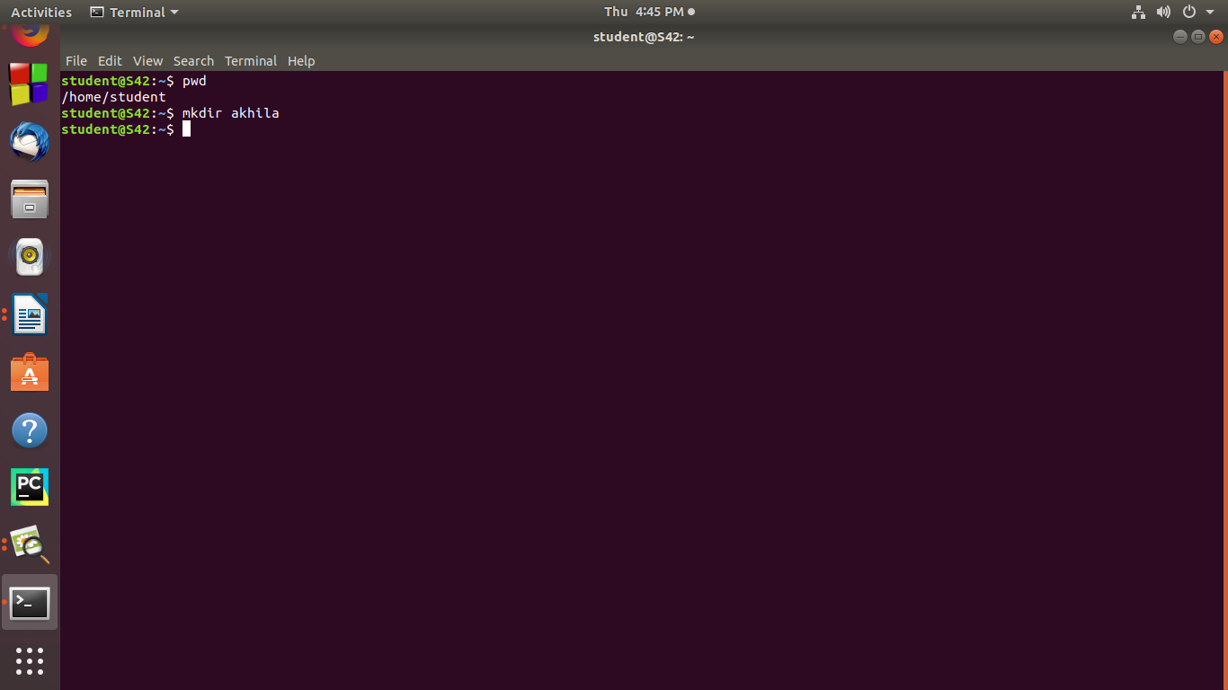

3.ls

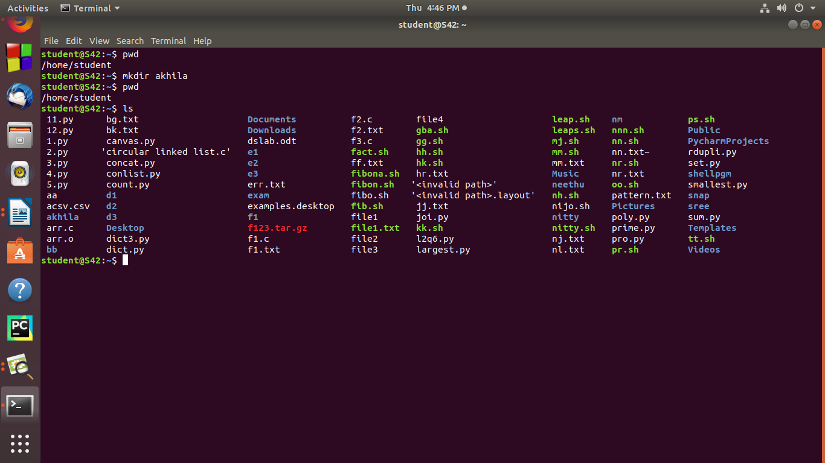

4.ls -l

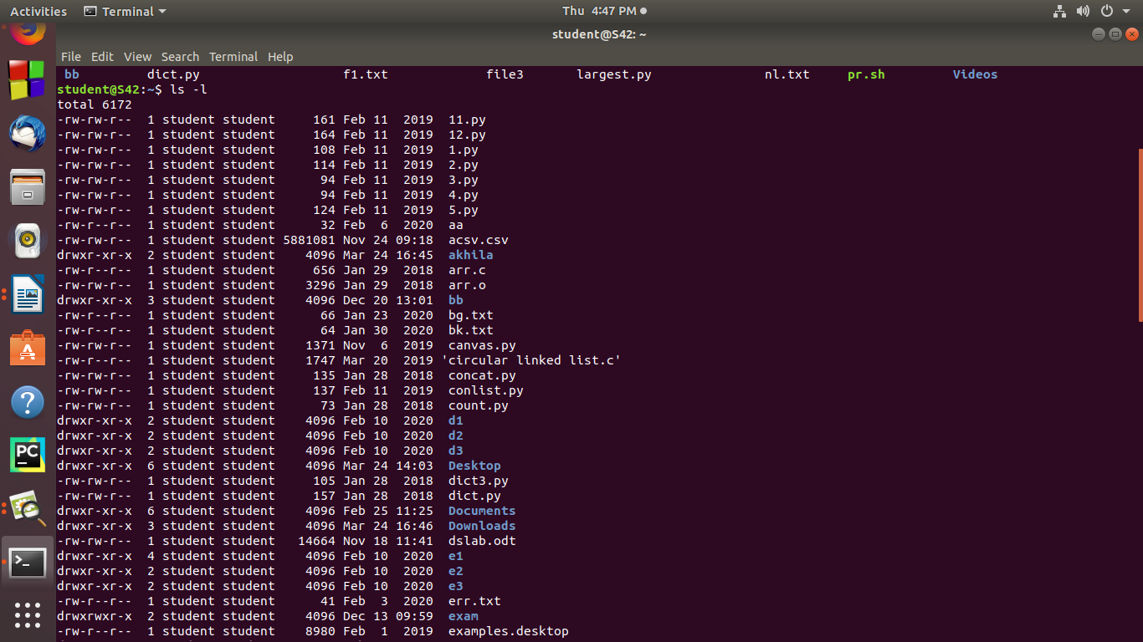

5.lr -r

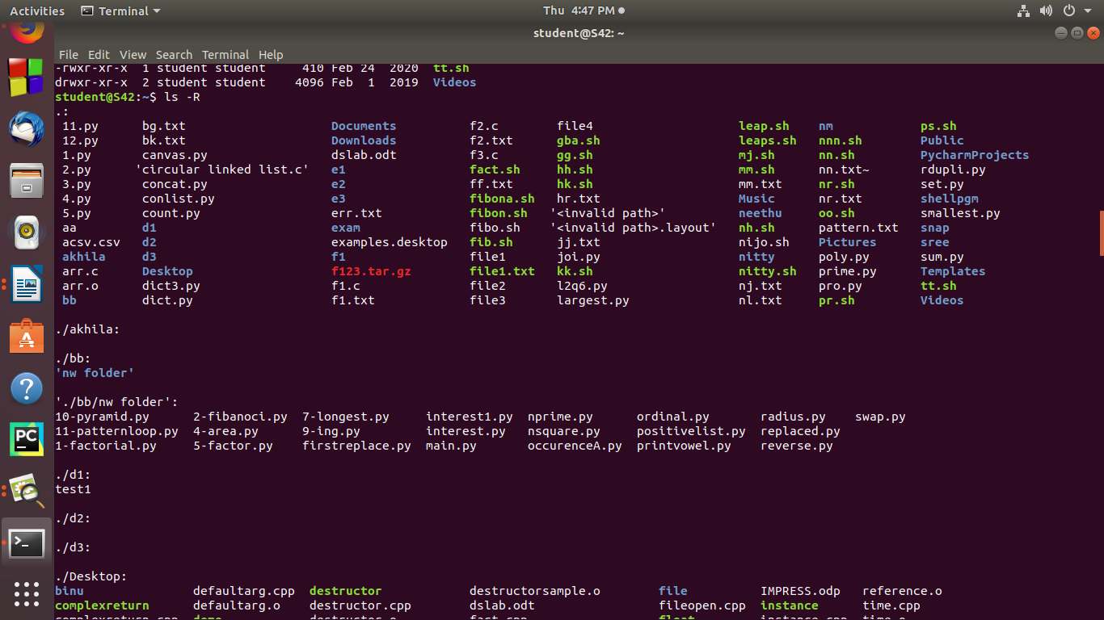

6.ls -a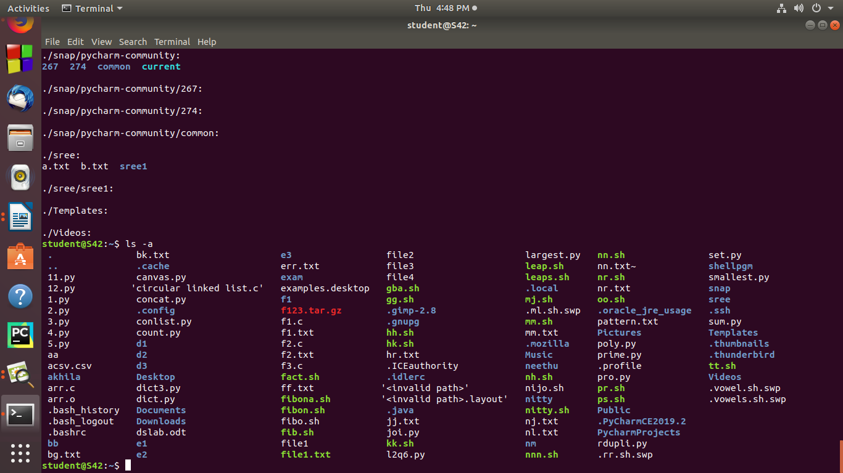

7.ls -t

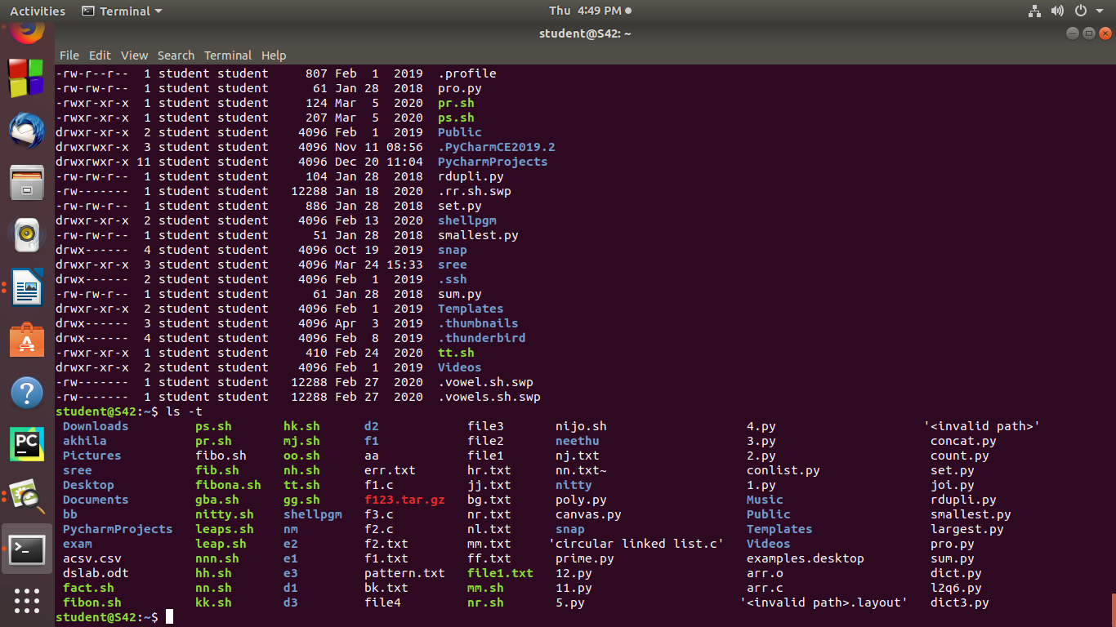

8 cd



9 cd ..



10 cd -



11 cat

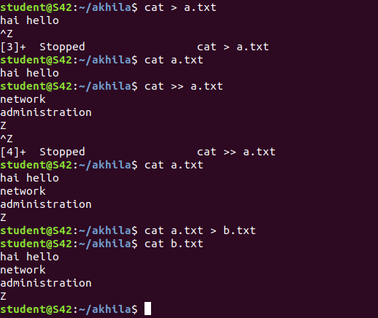

12 cat >> a.txt



13 cat a.txt



14 cat a.txt > b.txt

cat b.txt

