**Name: AKHILA ANAND**

**Roll No:3**

**Batch:S2 RMCA**

**Date:31-04-2022**

**NETWORKING & SYSTEM ADMINISTRATION LAB**

**Experiment No.: 4**

**Aim**

Familirization of Linux command.

**Procedure:**

**1.cat**

The **'cat'** command can be used to display the content of a file.

**Syntax:**

cat <filename>

**Output:**

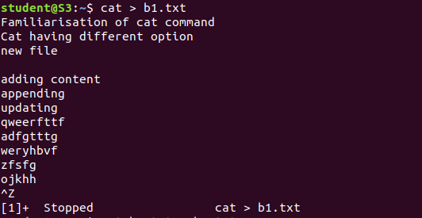

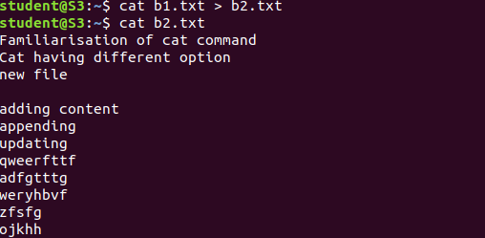

**2.cat -n**

The **'cat -n'** option displays line numbers in front of each line in a file.

**Syntax:**

1. cat -n <fileName>

**Output:**

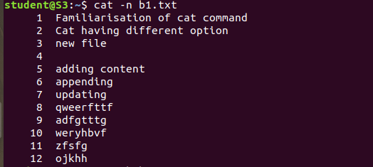

**3.cat -b**

The **'cat -b'** option removes the empty lines.

**Syntax:**

cat -b (file name)

**Output:**

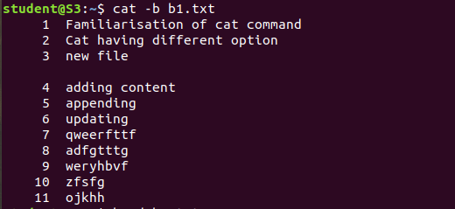

**4.Head command**:

Head prints the first N number of data of the given input. By default, it print first 10 lines of each given file.

**Output:**

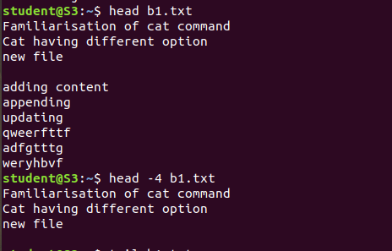

**5.Tail command**

The **tail command,**as the name implies, print the last N number of data of the given input. By default it prints the last 10 lines of the specified files.

**Output:**

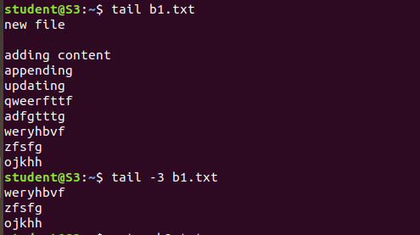

**6.cut -d**

**cut -d, --delimiter=DELIM:** It is used to cut a specific section by a delimiter.

**Output:**

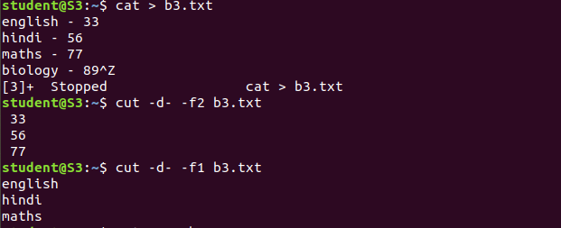

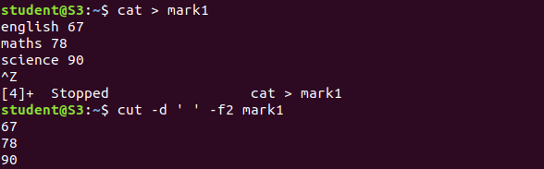

**7. cut -b**

**cut -b, --bytes=LIST:** It is used to cut a specific section by bytes.

**Output:**

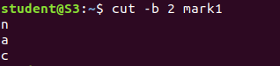

**8. cut --complement:**

 It is used to complement the set of selected bytes, characters or fields

**Output:**

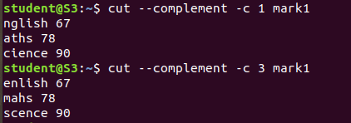

**9.Paste command**:

 It is used to join files horizontally (parallel merging) by

outputting lines consisting of lines from each file specified, separated by

**tab** as delimiter, to the standard output.

**Output:**

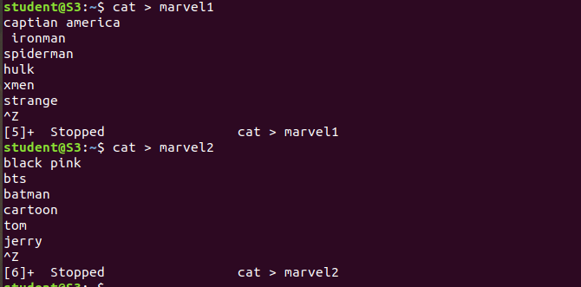

**Output:**

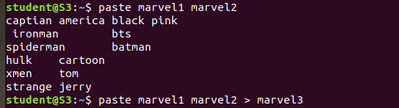

**10.** **paste -d (delimiter):**

 Paste command uses the tab delimiter by default for merging the files. The delimiter can be changed to any other character by using the **-d** option.

**11.paste-s (serial):**

We can merge the files in sequentially manner using the -s option. It reads all the lines from a single file and merges all these lines into a single line with each line separated by tab. And these single lines are separated by newline.

**Output:**

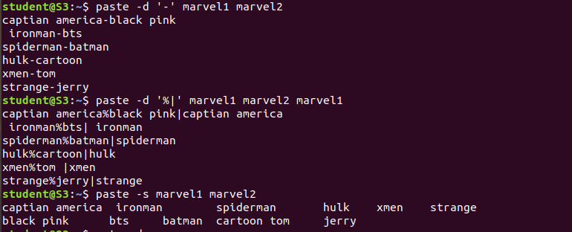

**Output:**

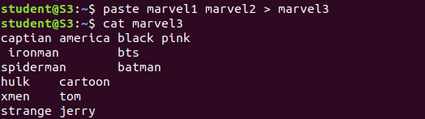

**12.more:**

View the text byin the command prompt displaying one screen at a time ,in case

the file in large.

