**Name: AKHILA ANAND**

**Roll No:3**

**Batch:S2 RMCA**

**Date:04\04\2022**

**NETWORKING & SYSTEM ADMINISTRATION LAB**

**Experiment No.: 5**

**Aim**

Familiarization of basic linux commands.

**Procedure:**

**1.cp**

cp command used to copy .

**Output:**

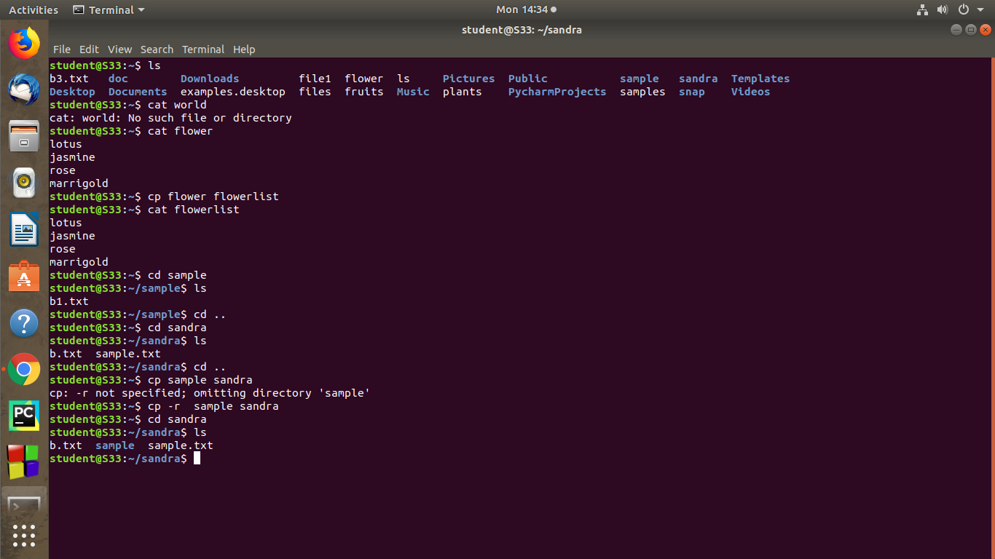

**2. cp -r**

cp -r command is used to copy entire directory.

**Output:**

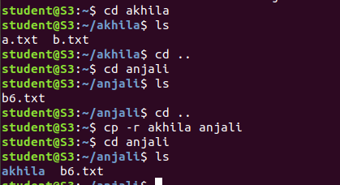

**3. cp -i**

This command is used to ask permission to overwrite.

**Output:**

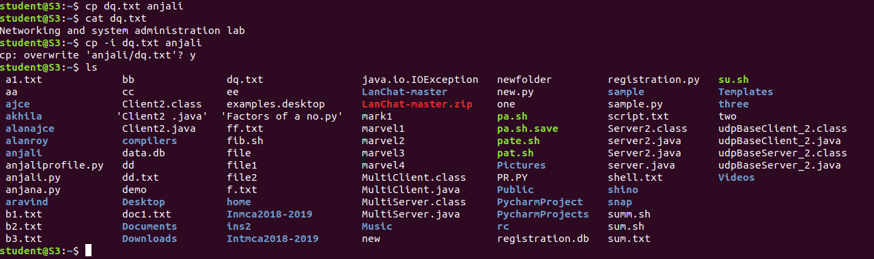

4.**mv** – mv command is used to move a file to another directory.

**Output:**

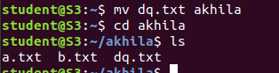

**5.mv -i**

This command is used to ask permission to move one directory to another

directory.

**Output:**

