**NETWORKING & SYSTEM ADMINISTRATION LAB**

**Name: AKHILA ANAND**

**Roll No:3**

**Batch:S2 RMCA**

**Date:21/04/22**

**Experiment No.: 6**

**Aim**

Familiarization of Linux Commands.

**Procedure and Output Screenshot**

**1.read**

read command in Linux system is used to read from a file descriptor. Basically, this command read up the total number of bytes from the specified file descriptor into the buffer. If the number or count is zero then this command may detect the errors.

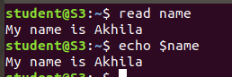

**2.locate**

locate command in Linux is used to find the files by name. There is two most widely used file searching utilities accessible to users are called find and locate. The locate utility works better and faster than find command counterpart because instead of searching the file system when a file search is initiated, it would look through a database. This database contains bits and parts of files and their corresponding paths on your system.

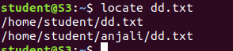

**3.locate -i**

locate command in Linux is used to find the files by name.

-i, –ignore-case : Ignore case distinctions when matching patterns.

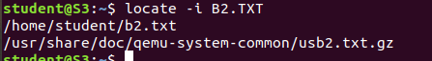

**4.find**

The Linux find command is one of the most important and frequently used command command-line utility in Unix-like operating systems. The find command is used to search and locate the list of files and directories



**5.grep**

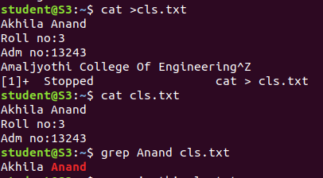The grep command can search for a string in groups of files. When it finds a pattern that matches in more than one file, it prints the name of the file, followed by a colon, then the line matching the pattern.



**grep options**

**6.grep -i**

-i : Ignores, case for matching

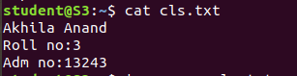



**7.grep -v**

-v : This prints out all the lines that do not matches the pattern



**8.grep -A1**

-A n : Prints searched line and nlines after the result.



**9.grep -B1**

-B n : Prints searched line and n line before the result.

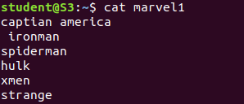



**10.grep -C1**

-C n : Prints searched line and n lines after before the result.

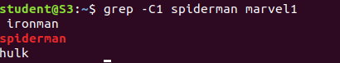

**11.df**

The df command is known as the “disk free” command gives the estimation of the total amount of the disk memory space used by the input files and stored files in memory directories. It is used to measure and identify the memory usage of specific files and directories that take up a large sum of the disk memory usage.

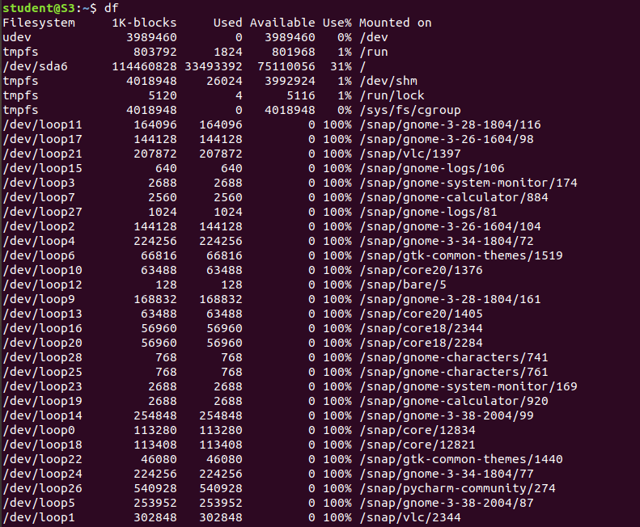

**12.df -m**

It is used to display in megabytes.

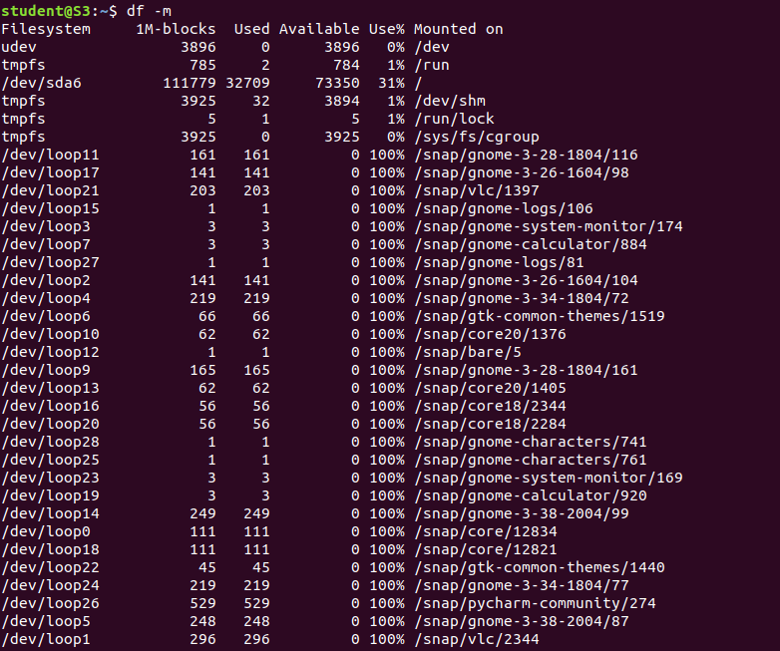

**13.du**

**du** command, short for disk usage, is used to estimate file space usage.

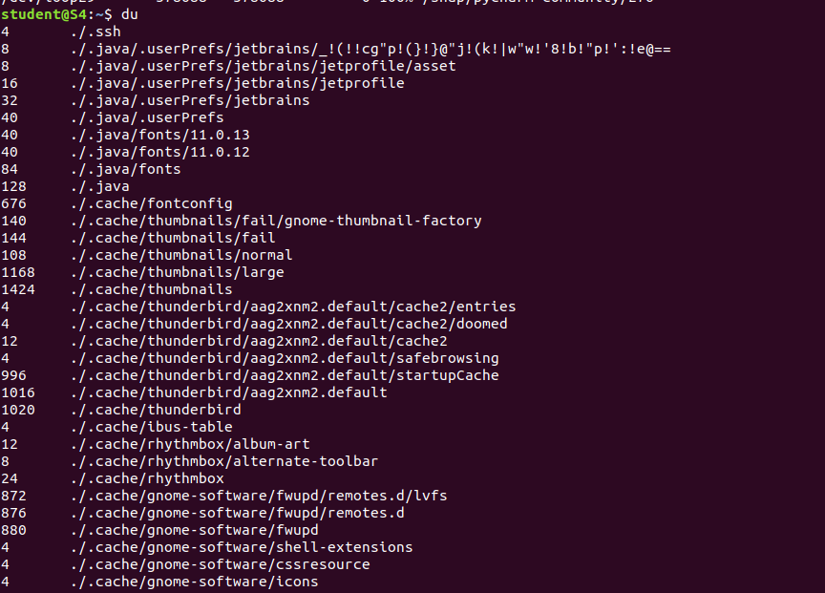

**14.wc**

wc stands for **word count**. As the name implies, it is mainly used for counting purpose.

It is used to find out **number of lines**, **word count**, **byte and characters count** in the files specified in the file arguments.

By default it displays **four-columnar output.**

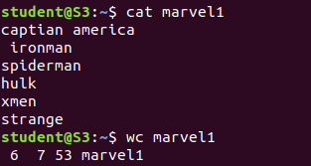

**wc options**

**14.wc -c**

**-c:** This option displays **count of bytes** present in a file.



**15.wc -w**

**-w:** This option prints the **number of words** present in a file.



**16.wc -l**

**-l:** This option prints the **number of lines** present in a file.



**17.wc -m**

**-m:** Using **-m** option ‘wc’ command displays **count of characters** from a file.

