**CONTENTS**

**OVERVIEW** 2

**ARCHITECTURE** 3

**PROJECT STRUCTURE:** 4

**UDP SERVER COMMUNICATION:** 6

**IMPLEMENTATION OF CONCURRENCY & SYNCHRONIZATION:** 6

**OPERATIONS**: 6

**CHALLENGES FACED:** 7

**TEST CASES:** 8

**OVERVIEW:**

The Distributed Class Management System, is a distributed system that performs various functionalities to maintain information across servers while maintaining concurrency by synchronizing the functionalities. This is to make sure that when the functions are executed across multiples servers, the actions performed do no not cause error or interfere with other processes. To do so, UDP communication has been established between the servers.

**ARCHITECTURE**:

In DCMS, the Managers in each of the different locations would be acting as the Clients in the System. The Managers are each assigned with a unique manager ID with which they communicate with Servers to perform the necessary operations. There are Servers in 3 locations MTL, LVL and DDO. The Client and Server communicate using the **Common Object Request Broker Architecture** (**CORBA**) which is the key implementation of this assignment. The Clients and Server maintain separate Logs of the actions performed.

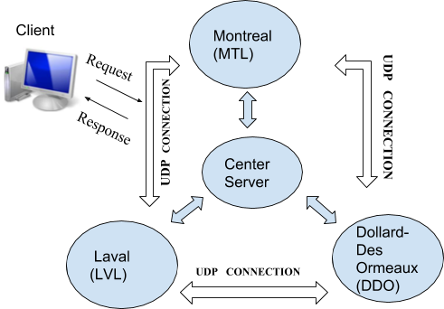

[[Wikipedia]](https://en.wikipedia.org/wiki/Common_Object_Request_Broker_Architecture) The CORBA specification dictates there shall be an ORB through which an application would interact with other objects. This is how it is implemented in practice.

1. The application simply initializes the ORB, and accesses an internal *Object Adapter*, which maintains things like reference counting, object (and reference) instantiation policies, and object lifetime policies.
2. The Object Adapter is used to register instances of the *generated code classes*. Generated code classes are the result of compiling the user IDL code, which translates the high-level interface definition into an OS- and language-specific class base for use by the user application. This step is necessary in order to enforce CORBA semantics and provide a clean user process for interfacing with the CORBA infrastructure.

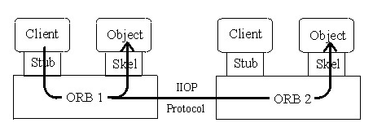

# **PROJECT STRUCTURE:**

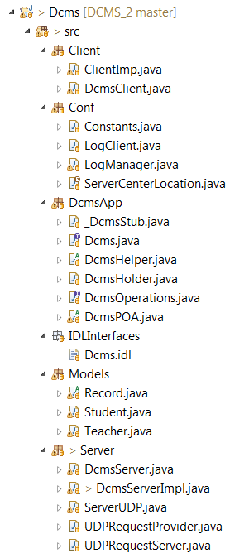

The Use-case diagram and the Class diagrams of the implementation are illustrated below:

**USE-CASE DIAGRAM:**

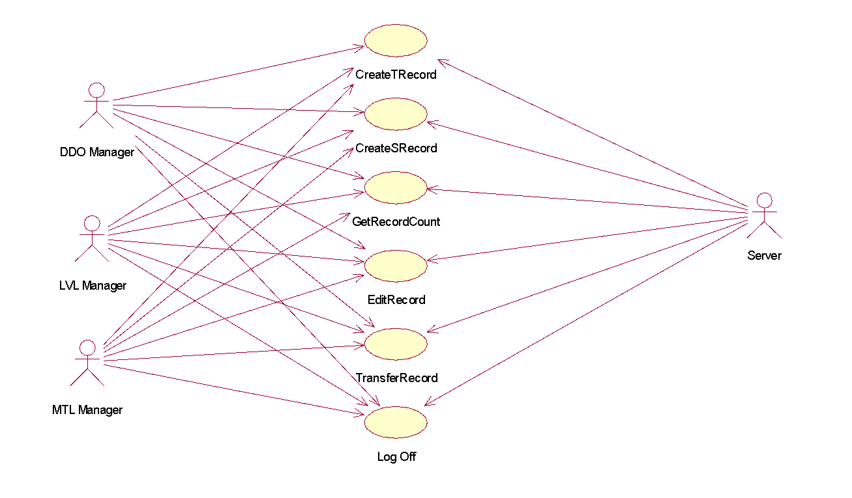

**CLASS DIAGRAM:**

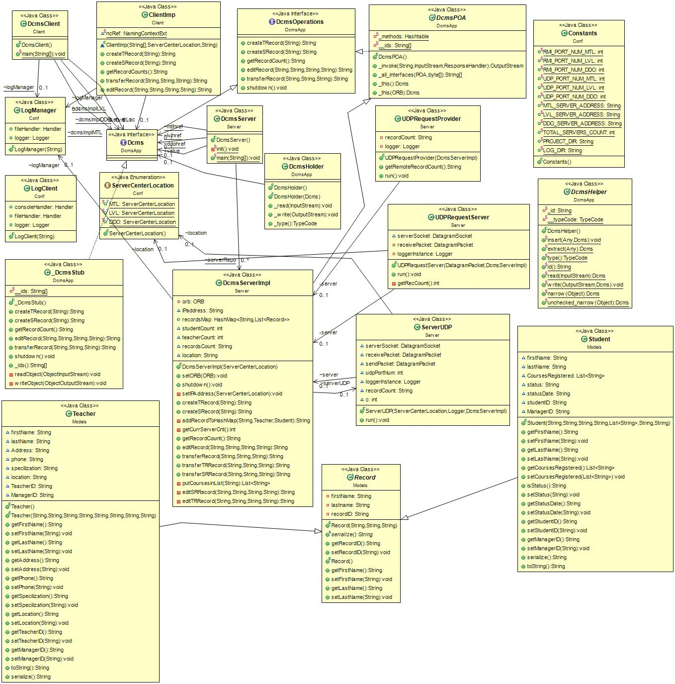

# **UDP SERVER COMMUNICATION:**

[[Wiki](https://en.wikipedia.org/wiki/User_Datagram_Protocol)pedia] UDP uses a simple [connectionless communication](https://en.wikipedia.org/wiki/Connectionless_communication) model with a minimum of protocol mechanism. UDP provides [checksums](https://en.wikipedia.org/wiki/Checksum) for data integrity, and [port numbers](https://en.wikipedia.org/wiki/Port_numbers) for addressing different functions at the source and destination of the datagram.

The Servers in the 3 locations communicate using this protocol for serving the client’s Get Record Count operation.

# **IMPLEMENTATION OF CONCURRENCY & SYNCHRONIZATION:**

[[Wikipedia]](https://en.wikipedia.org/wiki/Synchronization_(computer_science)) Thread synchronization is defined as a mechanism which ensures that two or more concurrent [processes](https://en.wikipedia.org/wiki/Process_(computer_science)) or [threads](https://en.wikipedia.org/wiki/Thread_(computer_science)) do not simultaneously execute some particular program segment known as [critical section](https://en.wikipedia.org/wiki/Critical_section). Processes' access to critical section is controlled by using synchronization techniques. When one thread starts executing the [critical section](https://en.wikipedia.org/wiki/Critical_section) (serialized segment of the program) the other thread should wait until the first thread finishes. If proper synchronization techniques are not applied, it may cause a [race condition](https://en.wikipedia.org/wiki/Race_condition#Software) where the values of variables may be unpredictable and vary depending on the timings of [context switches](https://en.wikipedia.org/wiki/Context_switch) of the processes or threads.

The DCMS implementation needs to be synchronized as multiple clients communicate with a server in the same location. We have implemented synchronization with the synchronized functionality that’s available in JAVA. The server methods are all synchronized and the methods that are used to communicate from clients are all thread safe in both client-server communication and server-server communication.

# **OPERATIONS**:

1. **CREATE TEACHER RECORD**

Stores the details of the Teacher into the server’s hash map and assign a unique ID to every Teacher in the system.

1. **CREATE STUDENT RECORD**

Stores the details of the Student into the server’s hash map and assign a unique Student ID to every Student in the system.

1. **GET RECORD COUNT**

Gets the count of the records from all the three servers across the system- Montreal (MTL), Laval (LVL) and Dollard-des Ormeaux (DDO), using UDP communication and return the actual data to the Client (Manager).

1. **EDIT RECORD**

Edits the existing records in the servers’ hashmaps i.e. records created via methods createTRecord() and createSRecord(). Upon success or failure it returns a message to the manager and the logs are updated with this information.

1. **TRANSFER RECORD**

This method, transfers the record among the servers, by deleting the record in the current server’s hashmap and adding the record to remote server.

**CHALLENGES FACED:**

**Using CORBA Architecture:**

Implementing the CORBA architecture and understanding the basic functionality of CORBA was challenging.

**Maintaining Concurrency:**

Synchronizing the right functions to regulate the concurrent access took some understanding of the working.

**UDP Connection establishment:**

Establishing UDP connection among the 3 servers was time-consuming and challenging.

**Transfer Record Implementation:**

Transferring the records among the three servers and communicating accordingly was also challenging.

**Altering Previous Code**:

IDL interface implementation involved many data type changes in the existing server code.

**TEST CASES:**

|  |  |  |  |
| --- | --- | --- | --- |
| **Test ID** | **Test Description** | **Expected Result** | **Actual Result** |
| T1 | Client requests to create a record and Insert teacher record to server’s hashmap | Record should be inserted into hashmap. | Record was inserted into hashmap successfully. |
| T2 | Client requests to create a record and Insert student record to server’s hashmap | Record should be inserted into hashmap. | Record was inserted into hashmap successfully. |
| T3 | Login using valid credentials.  Test Data: (MTLXXXX / LVLXXXX / DDOXXX) | Successful login. | Yes, logged in. |
| T4 | Login using invalid credentials. | Unable to login. | Yes, unable to login. |
| T5 | Get record count from all servers. | Returns the record count to all the servers. | Yes, successfully gets the record count |
| T6 | Edit SR/TR record, with valid student ID. | Successfully edited the record. | Yes, successfully edited the record. |
| T8 | Validation of Phone number, status, location, Courses registered. | Request  . | The system  does not allow any values other that (Active/Inactive) for Status field of  the Student Record. |
| T9 | Validating input for Location field while editing record. | The user  should be able to enter only 3 values (MTL/LVL/DDO) | The user was  able to enter only 3 values (MTL/LVL/DDO) |
| T10 | The user  should not be allowed to edit any fields other than Address, Phone and  Location for the Teacher Record. | The system should not allow editing of any field  except Address, Phone and Location. | The system did not allow editing of any field  except Address, Phone and Location. |
| T11 | The user  should not be allowed to edit any fields other than Course Registered, Status  and Status Date for the Student Record. | The system  should not allow editing of any field except Course Registered, Status and  Status Date. | The system  did not allow editing of any field except Course Registered, Status and  Status Date. |
| T12 | Checking  whether record count function returns records in the all the server including  the records which has last name starting with the same letter. | The system  should return the total count of the records in the server | The system  did return the total count of the all the records in the server. |
| T13 | The user should not be allowed to transfer a record to its own server. | The server should deny the process. | System made sure that the transfer did not happen. |
| T14 | While transferring the record, the record ID must be incremented according to the other server’s hashmap data. | The server must make the necessary change to the recordID. | The ID was increment when another data of same ID was present to make the insertion into the hashmap. |