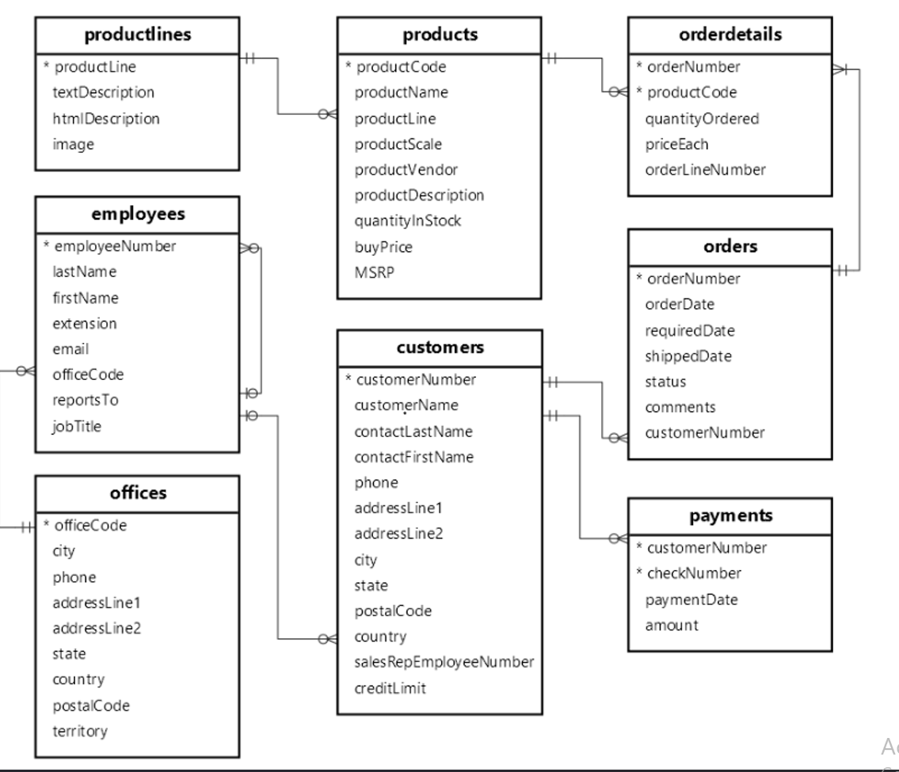
The fields above mentioned in the * are the Primary keys of that table
eg: *officeCode, *CustomerNumber etc.
. CREATE TABLES using the below structure and insert data into it
-- OFFICES
CREATE TABLE offices (
officeCode VARCHAR(10) PRIMARY KEY,
city VARCHAR(50),
phone VARCHAR(50),
addressLine1 VARCHAR(100),
addressLine2 VARCHAR(100),
state VARCHAR(50),
country VARCHAR(50),
postalCode VARCHAR(15),
territory VARCHAR(50)
);
-- EMPLOYEES
CREATE TABLE employees (
employeeNumber INT PRIMARY KEY,
lastName VARCHAR(50),
firstName VARCHAR(50),
extension VARCHAR(10),
email VARCHAR(100),
officeCode VARCHAR(10),
reportsTo INT,
jobTitle VARCHAR(50),
FOREIGN KEY (officeCode) REFERENCES offices(officeCode),
FOREIGN KEY (reportsTo) REFERENCES employees(employeeNumber)
);
-- CUSTOMERS
CREATE TABLE customers (
customerNumber INT PRIMARY KEY,
customerName VARCHAR(100),
contactLastName VARCHAR(50),
contactFirstName VARCHAR(50),
phone VARCHAR(50),
addressLine1 VARCHAR(100),
addressLine2 VARCHAR(100),
city VARCHAR(50),
state VARCHAR(50),
postalCode VARCHAR(15),
country VARCHAR(50),
salesRepEmployeeNumber INT,
creditLimit DECIMAL(10,2),
FOREIGN KEY (salesRepEmployeeNumber) REFERENCES employees(employeeNumber)
);
-- PRODUCTLINES
CREATE TABLE productlines (
productLine VARCHAR(50) PRIMARY KEY,
textDescription TEXT,
htmlDescription TEXT,
image TEXT
);
-- PRODUCTS
CREATE TABLE products (
productCode VARCHAR(15) PRIMARY KEY,
productName VARCHAR(100),
productLine VARCHAR(50),
productScale VARCHAR(10),
productVendor VARCHAR(50),
productDescription TEXT,
quantityInStock INT,
buyPrice DECIMAL(10,2),
MSRP DECIMAL(10,2),
FOREIGN KEY (productLine) REFERENCES productlines(productLine)
);
-- ORDERS
CREATE TABLE orders (
orderNumber INT PRIMARY KEY,
orderDate DATE,
requiredDate DATE,
shippedDate DATE,
status VARCHAR(20),
comments TEXT,
customerNumber INT,
FOREIGN KEY (customerNumber) REFERENCES customers(customerNumber)
);
-- ORDERDETAILS
CREATE TABLE orderdetails (
orderNumber INT,
productCode VARCHAR(15),
quantityOrdered INT,
priceEach DECIMAL(10,2),
orderLineNumber INT,
PRIMARY KEY (orderNumber, productCode),
FOREIGN KEY (orderNumber) REFERENCES orders(orderNumber),
FOREIGN KEY (productCode) REFERENCES products(productCode)
);
-- PAYMENTS
CREATE TABLE payments (
customerNumber INT,
checkNumber VARCHAR(50),
paymentDate DATE,
amount DECIMAL(10,2),
PRIMARY KEY (customerNumber, checkNumber),
FOREIGN KEY (customerNumber) REFERENCES customers(customerNumber)
);

INSERT SAMPLE DATA
Offices
INSERT INTO offices VALUES
('1', 'New York', '1234567890', '5th Ave', NULL, 'NY', 'USA', '10001', 'NA'),
('2', 'London', '9876543210', 'Baker St', NULL, NULL, 'UK', 'NW1', 'EMEA');
Employees
INSERT INTO employees VALUES
(1001, 'Smith', 'John', 'x101', 'john@company.com', '1', NULL, 'Manager'),
(1002, 'Doe', 'Jane', 'x102', 'jane@company.com', '1', 1001, 'Sales Rep'),
(1003, 'Brown', 'Mike', 'x103', 'mike@company.com', '2', 1001, 'Sales Rep');
Customers
INSERT INTO customers VALUES
(2001, 'ABC Corp', 'Lee', 'Chris', '1111111111', 'Street 1', NULL, 'NYC', 'NY', '10001', 'USA', 1002, 50000),
(2002, 'XYZ Ltd', 'Kim', 'Pat', '2222222222', 'Street 2', NULL, 'London', NULL, 'NW1', 'UK', 1003, 70000),
(2003, 'Global Inc', 'Singh', 'Raj', '3333333333', 'Street 3', NULL, 'Delhi', NULL, '110001', 'India', 1002, 60000);
Product Lines
INSERT INTO productlines VALUES
('Cars', 'Car models', NULL, NULL),
('Bikes', 'Bike models', NULL, NULL);
Products
INSERT INTO products VALUES
('P101', 'Toyota Camry', 'Cars', '1:18', 'Toyota', 'Sedan model', 100, 20.00, 30.00),
('P102', 'Honda Civic', 'Cars', '1:18', 'Honda', 'Compact model', 150, 18.00, 28.00),
('P201', 'Yamaha Bike', 'Bikes', '1:12', 'Yamaha', 'Sport bike', 200, 10.00, 15.00);
Orders
INSERT INTO orders VALUES
(3001, '2024-01-01', '2024-01-05', '2024-01-03', 'Shipped', NULL, 2001),
(3002, '2024-02-01', '2024-02-05', '2024-02-04', 'Shipped', NULL, 2002),
(3003, '2024-03-01', '2024-03-06', NULL, 'Pending', NULL, 2003);
Order Details
INSERT INTO orderdetails VALUES
(3001, 'P101', 10, 30.00, 1),
(3001, 'P201', 5, 15.00, 2),
(3002, 'P102', 7, 28.00, 1),
(3003, 'P101', 3, 30.00, 1);
Payments
INSERT INTO payments VALUES
(2001, 'CHK001', '2024-01-10', 300.00),
(2002, 'CHK002', '2024-02-10', 500.00),
(2003, 'CHK003', '2024-03-10', 150.00);

EASY LEVEL (1–20)
- List all customers ordered by customerName.
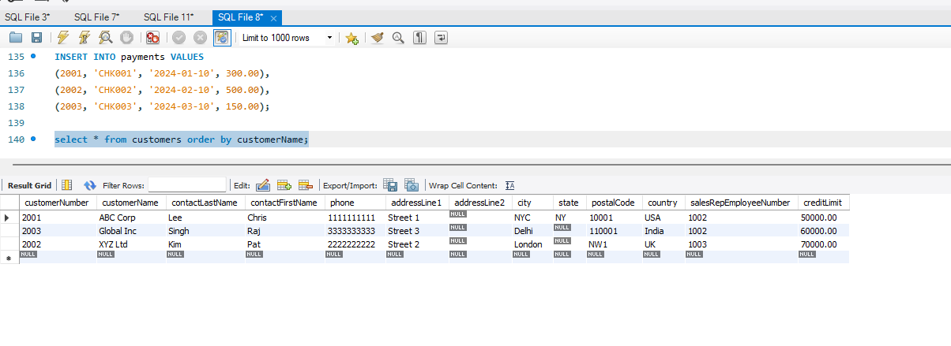
- Display all products ordered by buyPrice descending.
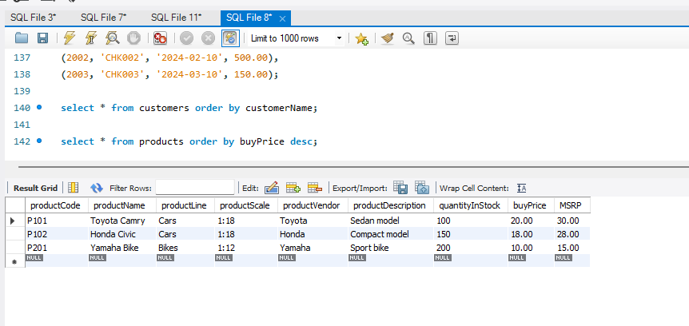
- Show all employees ordered by lastName.
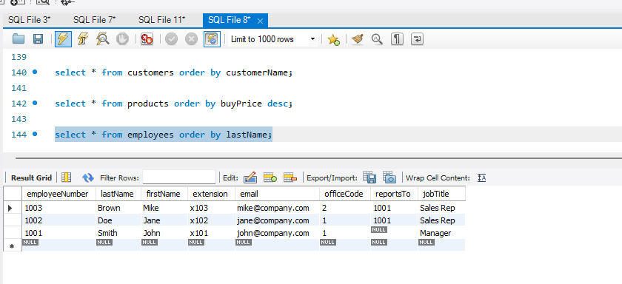
- List all offices sorted by country.
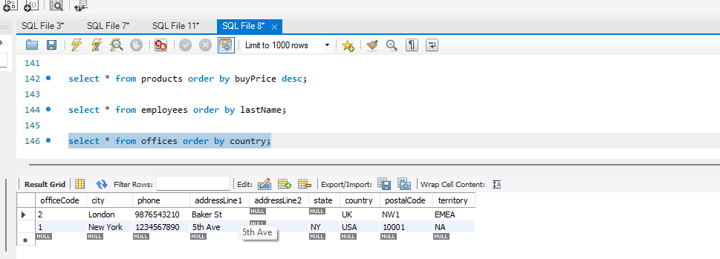
- Get all orders sorted by orderDate descending.
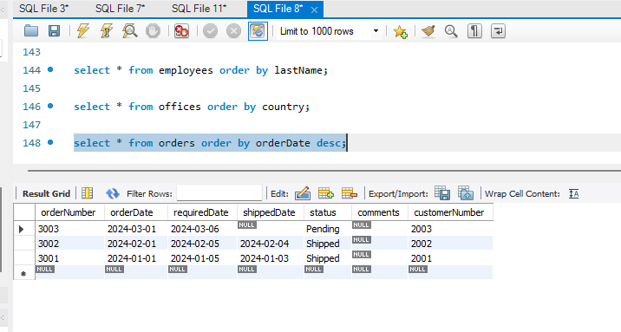
- Show customer names with their sales representative (employee name).
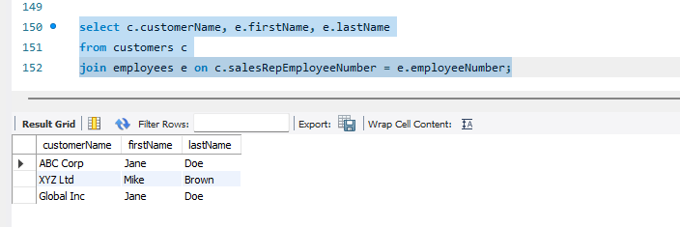
- List all products with their product line.
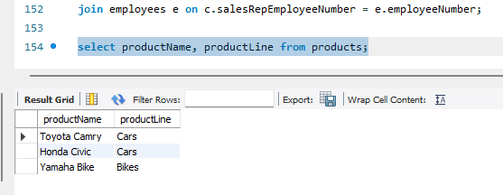
- Display orders with customer names.
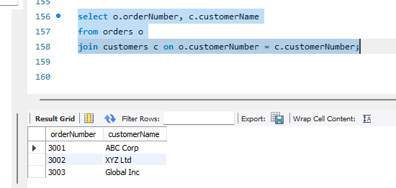
- Show order details with product names.
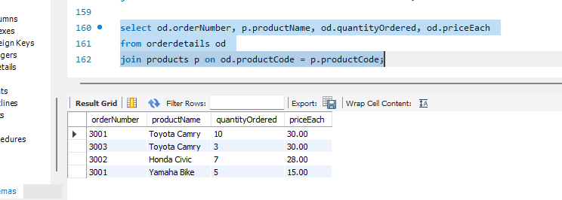
- List payments with customer names.
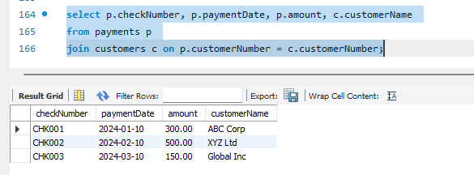
- Count total number of customers.
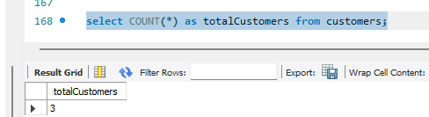
- Count total number of orders.
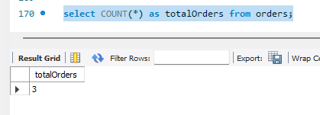
- Find average buyPrice of products.
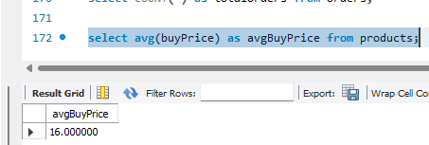
- Find maximum MSRP from products.
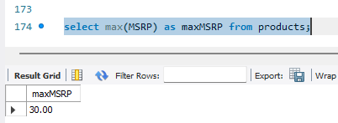
- Find total number of employees.
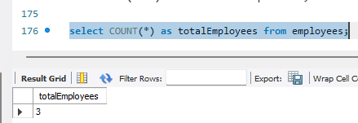
- Count customers per country.
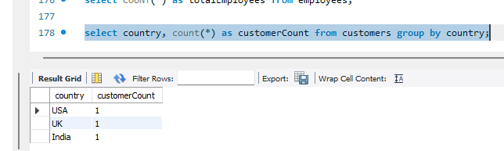
- Count orders per status.
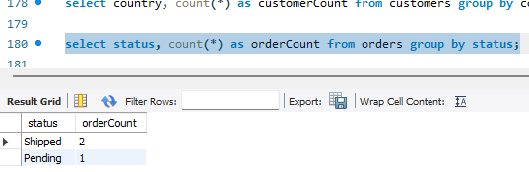

- Count products per product line.
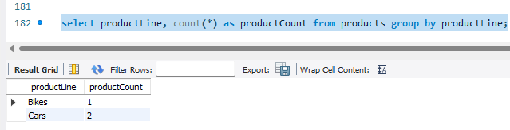

- Find average credit limit per country.
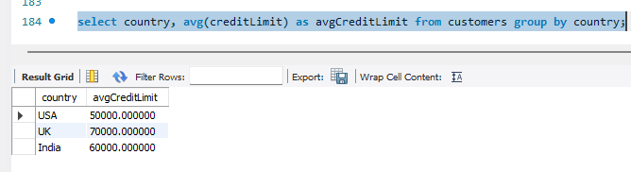
- Count employees per office.
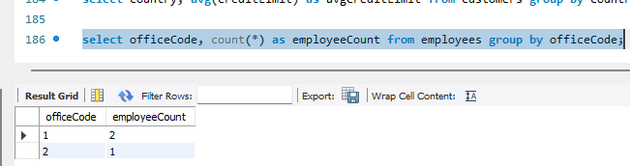

MEDIUM LEVEL (21–50)
- Count number of orders per customer.
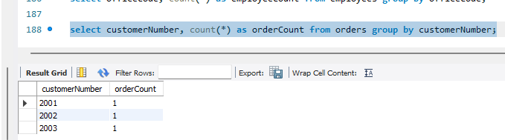
- Find total payment amount per customer.
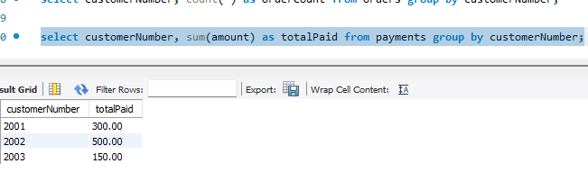
- List total quantity ordered per product.
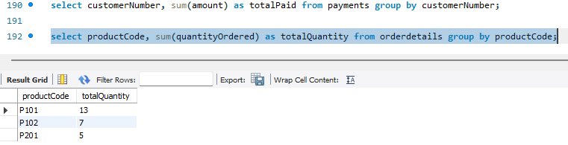
- Show total revenue per product (quantityOrdered * priceEach).
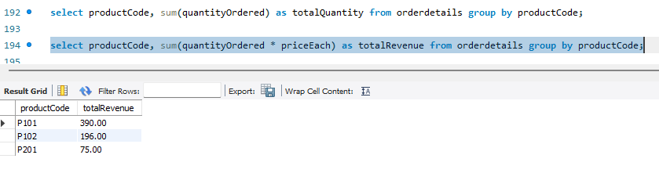
- Find number of customers handled by each employee.
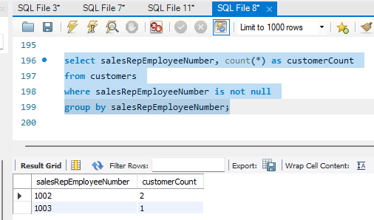
- Find customers with more than 5 orders.
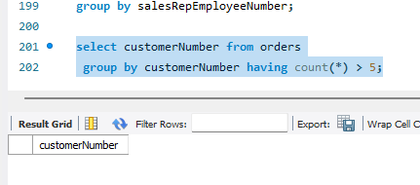
- List products with total quantity ordered > 100.
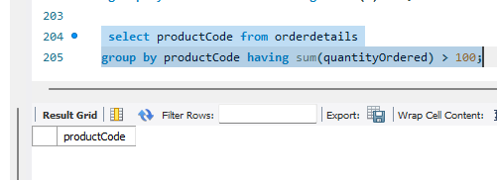
- Find employees managing more than 3 customers.
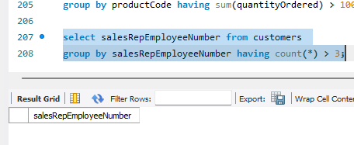
- Show countries with more than 10 customers.
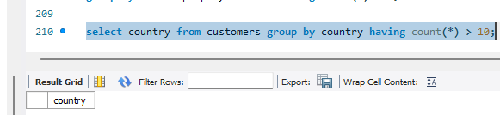
- Find product lines having more than 5 products.
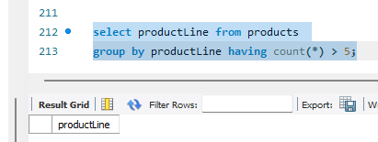
- List top 5 customers by total payment amount.
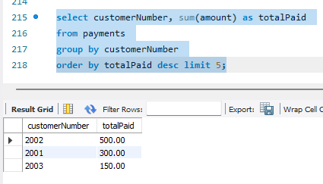
- Show products ordered by total sales descending.
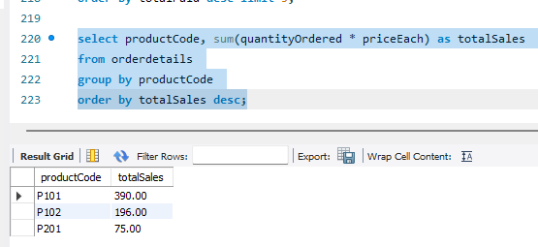
- List employees sorted by number of customers handled.
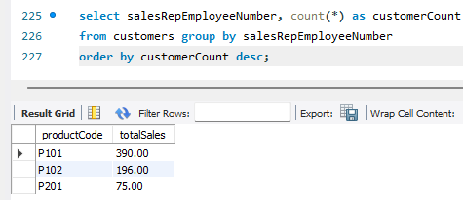
- Show countries sorted by total customers.
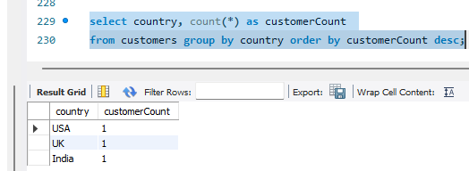
- Display top 10 most ordered products.
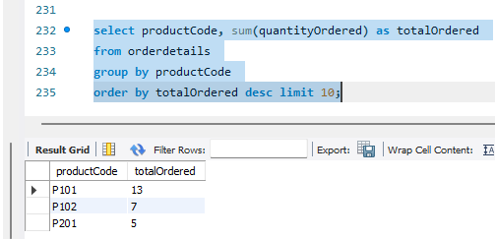
Multi-table JOINS
- Get customer name, order number, and product name.
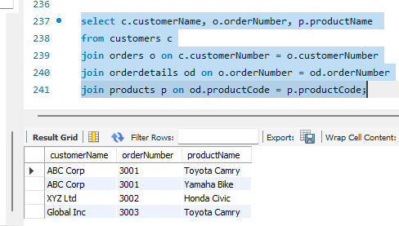
- Show employee name, customer name, and total payments.
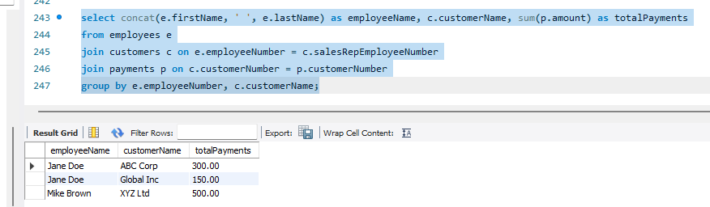
- List order details with product line and quantity ordered.
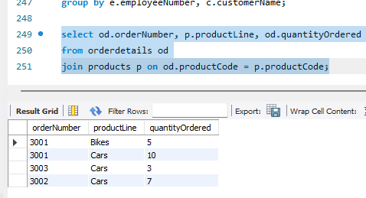
- Display office city with employee count.
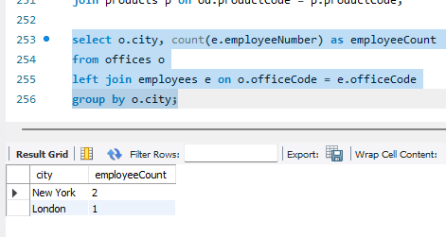
- Show product vendor with total quantity sold.
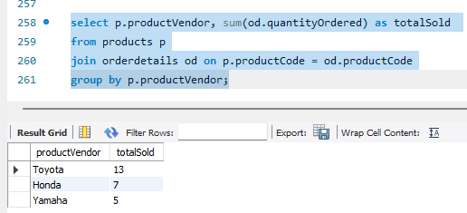

Advanced Aggregations
- Find average order value per customer.
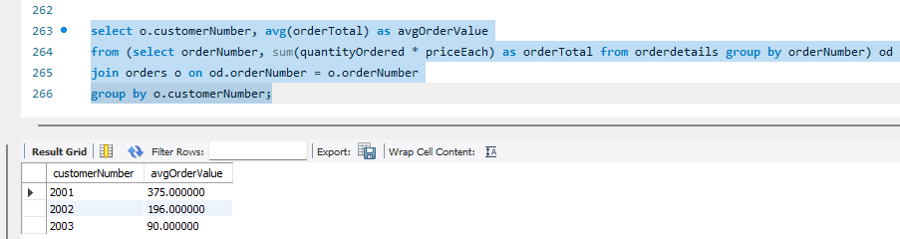
- Show total revenue generated per country.
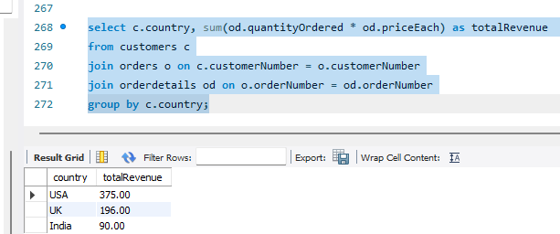
- Find customers whose total payments exceed 50,000.
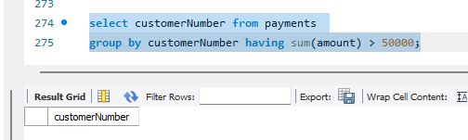
- List products where average order quantity > 50.
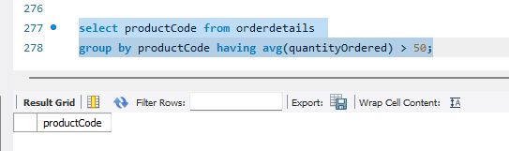
- Find top 3 product lines by total revenue.
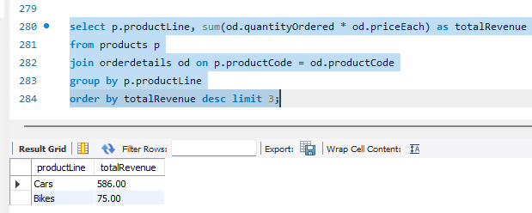
- Show customers with credit limit > average credit limit.
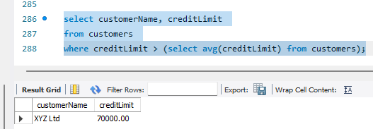
- Find orders where total amount > 10,000.
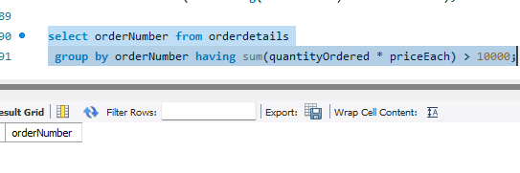
- List employees working in offices with more than 5 employees.
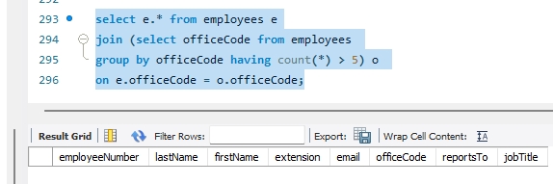
- Find products with stock less than average stock.
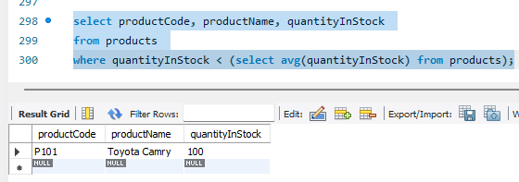
- Show customers who made more than 3 payments.
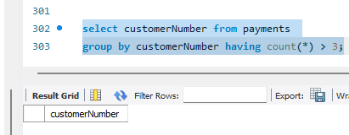
ADVANCED SQL QUESTIONS (51–80)
Complex Joins + Aggregation
51. Find total revenue generated by each customer (include customer name), sorted by highest revenue.
52. List customers who have placed orders but made no payments.
53. Find total number of products ordered by each customer along with total amount spent.
54. Show product-wise revenue and total quantity sold, sorted by revenue descending.
55. Find employees along with total sales (revenue) generated from their customers.
GROUP BY + HAVING (Advanced)
56. Find customers whose total purchase amount is greater than the average purchase amount of all customers.
57. List products that have been ordered in more than 2 different orders.
58. Find customers who ordered more than 3 different products.
59. Show product lines where total revenue exceeds 500.
60. Find countries where average customer credit limit is greater than 60,000.

Multi-level Joins
61. Show customer name, order number, product name, and quantity ordered for all orders.
62. Find employee name, office city, and number of customers handled.
63. Display product line, product name, and total revenue generated.
64. Show order number, customer name, and total order value.
65. List employees whose customers have placed more than 5 orders in total.

Aggregation with Filtering
66. Find customers whose total payments are less than their total order value.
67. List products where total quantity sold is less than average quantity sold across all products.
68. Find customers who have not placed any orders but have made payments.
69. Show employees who have not been assigned any customers.
70. Find orders that contain more than 1 product (multi-line orders).
71. Find top 3 customers based on total order value.
72. Show top 5 products based on total revenue.
73. List top 2 employees based on sales generated.
74. Find top 3 countries by number of customers.
75. Show top 5 most expensive products based on MSRP.
76. Find average order value per customer and list only those above overall average.
77. Show product-wise average price sold (priceEach) vs MSRP difference.
78. Find percentage contribution of each product to total revenue.
79. Calculate average quantity ordered per order for each customer.
80. Find customers whose largest single order value exceeds 10,000.

