CYBER WEEK 3 CHALLENGES

Short note on DOCKER:
Docker is a tool that helps developers package their applications and all the parts it needs to run (like libraries and settings) into a container. Think of it like putting an app into a box that works everywhere, no matter what computer or server you're using. This box (called a container) includes everything needed to run the app, so it doesn't matter if the app works on your laptop but not on your friend's computer—Docker solves that problem.
Here's a simple breakdown:

Containers: These are like lightweight virtual machines, but much faster and more efficient. They make sure your application runs the same way everywhere, whether on your computer, on a server, or in the cloud.

Images: Before you create a container, you need an image. An image is like a blueprint or a recipe that tells Docker what to include in the container (like the operating system, libraries, and the app itself). When you run an image, Docker creates a container from it.

Docker Engine: This is the software that actually runs the containers on your computer or server. It's like the engine in a car that makes it go.

Why Docker is Useful:

Consistency: The app will work the same way everywhere, even if you run it on different machines.
Efficiency: Containers use less system resources than virtual machines, meaning they start faster and take up less space.
Portability: You can move containers from one machine to another easily—whether from your local computer to a cloud service or between servers.

Example:

Imagine you’re building a website. You develop it on your laptop, and it works great. But when you try to run it on a different machine (like a server), it doesn’t work—because that machine might be missing some important software that your app needs. With Docker, you can package everything your website needs in a container, and when you run it on the server, it will work just like it did on your laptop.

In short, Docker makes software development and deployment easier, more reliable, and faster by using containers!

chall1:
docker pull vasudevb25/s3recruitmentchalls:chall1
by this i have pulled the images and the files in to my machine
then, runned it by
docker run -it -p 3000:3000 vasudevb25/s3recruitmentchalls:chall1
- docker run: This command is used to create and start a new container from a specified image.
- -it: This flag combines two options:
  - -i: Runs the container in interactive mode, keeping the standard input open.
  - -t: which allows you to interact with the container as if it were a terminal.
- -p 3000:3000: This option maps port 3000 of the host machine to port 3000 of the container. This means that any service running inside the container on port 3000 will be accessible from the host machine on the same port.
- vasudevb25/s3recruitmentchalls:chall1: This specifies the Docker image to use. In this case, it is the image vasudevb25/s3recruitmentchalls with the tag chall1.
The webpage shown in localhost:3000 =>
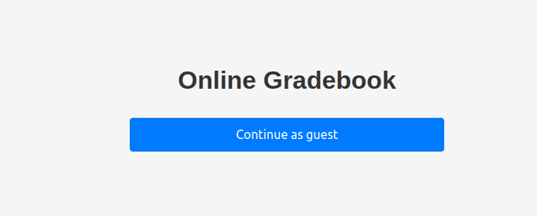
Then by clicking on continue as guest:

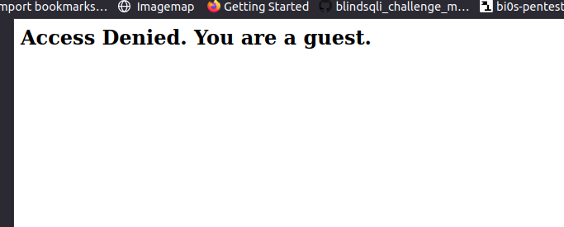
It is says that ur a guest. So by checking the source code and inspecting
in the storage section we see the cookie “isAdmin” set to 0 i.e, false
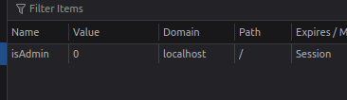

by changing it to 1 i.e, True
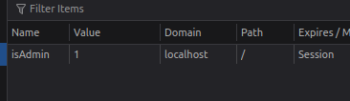

Then, by saving and refreshing the page we get as:
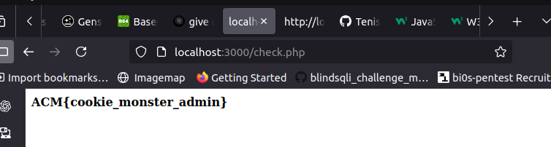
ABOUT THE VULNERABILITY:
Session Hijacking: it means if a application does not validate the authenticity of the cookie, an attacker can impersonate an admin user, potentially leading to unauthorized actions within the application
Insecure Cookie Management: If the cookie is not secured with attributes like HttpOnly or Secure, it can be easily intercepted or manipulated by an attacker

chall2:
By , going to the localhost:3000 we se a webpage with a home page, about page, contact page
by visiting and checking the source code i didn’t get much information
So, i guess some files may be hidden so i check for hidden files for the url http:/127.0.0.1:3000 by using dirb command
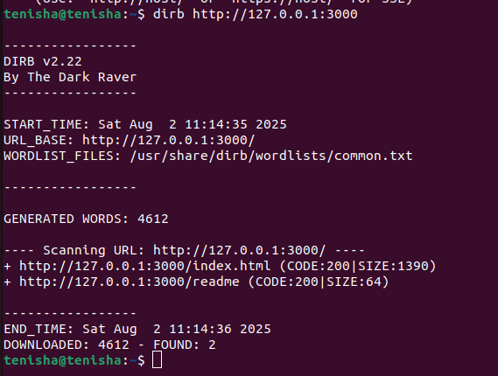
By, going to the url http://127.0.0.1:3000/readme a file named readme
by opening it

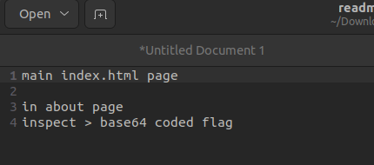

by, going to about page and inspect i got a encoded base64

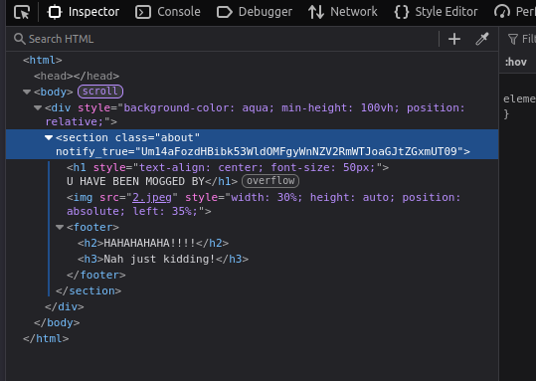
By decrypting the base64 for the first time:

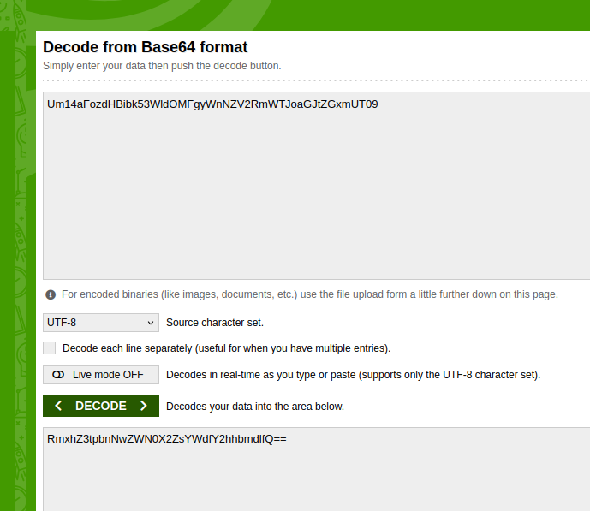
The decoded one is also a base64 type. So, i decoded it again and it revealed a flag

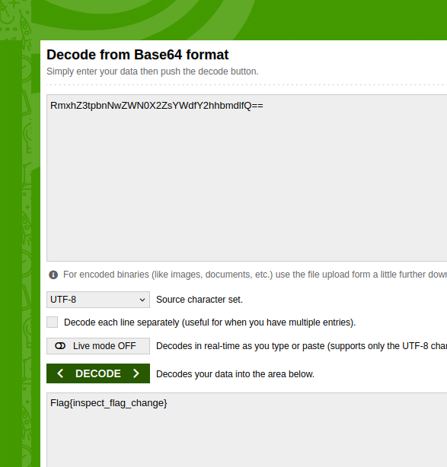
Ig, this a fake flag as the format should be of the format ACM{...}

chall3:
by going to the url we get a webpage Secure Customer Portal
it has a username and password textfields
By checking the source code
it has a <script src="secure.js"></script> by going to thst secure.js
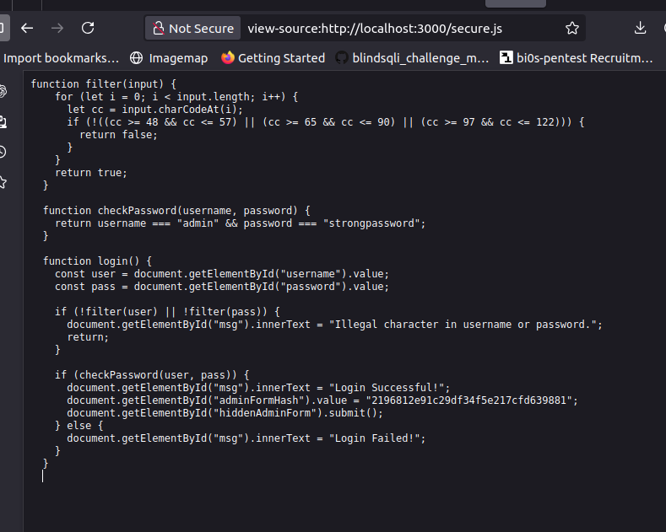
chall4:
chall5:

- Input Filtering:
  - The filter function checks if the input string contains only alphanumeric characters (digits, uppercase letters, and lowercase letters). If any character falls outside this range, it returns false.
- Password Check:
  - The checkPassword function verifies if the provided username is "admin" and the password is "strongpassword".
- Login Function:
  - The login function retrieves the username and password from input fields, applies the filter function to both, and checks the credentials using checkPassword.
  - If the credentials are correct, it displays a success message and submits a hidden form. If not, it shows a failure message.

it has a username and a password with that credentials we can login and we get the flag

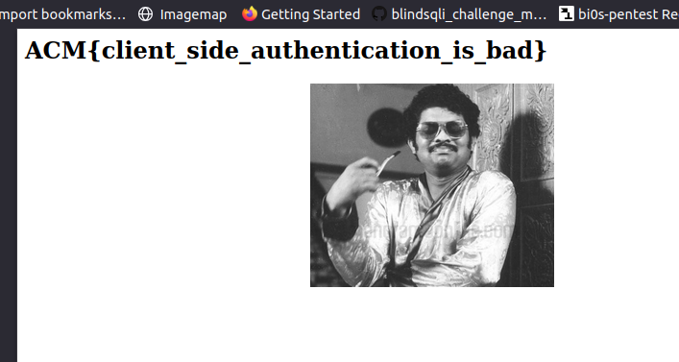
Client-side authentication refers to the process of verifying a user's identity and granting access to resources or functionalities based on that verification, primarily using client-side technologies such as JavaScript, HTML, and CSS.

chall4:
the webpage username and a password field. It also has a use coupon code as 58
By, checking the source code we see <script src="index.js"></script> by opening index.js:
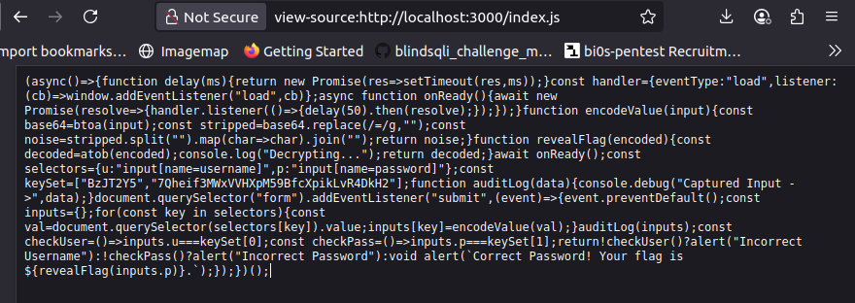
code is an asynchronous JavaScript function that handles a form submission for user authentication.

Flow of the Code
- Asynchronous Function: The entire code is wrapped in an asynchronous arrow function.
- Delay Function:
  - delay(ms): Returns a promise that resolves after a specified number of milliseconds.
- Event Handler Setup:
  - handler: An object that sets up an event listener for the "load" event of the window.
- onReady Function:
  - Waits for the window to load and introduces a 50ms delay before resolving.
- Encoding Function:
  - encodeValue(input):
    - Encodes input to Base64 using btoa.
    - Removes padding (=) from the Base64 string.
    - Returns the resulting string.
- Reveal Flag Function:
  - revealFlag(encoded):
    - Decodes a Base64-encoded string using atob.
    - Logs a message to the console.
- Await onReady:
  - Ensures the code execution waits until the page is fully loaded.
- Selectors and Key Set:
  - selectors: Maps keys to input field selectors for username and password.
  - keySet: Contains the correct username and password values.
- Audit Log Function:
  - auditLog(data): Logs captured input data to the console for debugging.
- Form Submission Event Listener:
  - Listens for the form's submit event:
    - Prevents default form submission.
    - Captures and encodes username and password inputs.
    - Logs the captured inputs.
    - Checks if the encoded inputs match the values in keySet.
    - Alerts the user about incorrect credentials or reveals the flag if correct.
Then, i have got a hint by senior(vasudev) he has said that the coupon code has something within
So,
The coupon code is the hint ‘58’
By converting 58 to base64 we get Ntg=
in the keyset the padding is removed but the password in the keyset is already 32 characters and the username has 7 charcters with padding we can make it as 8 characters

i thought that the keyset values are the encoded values with the padding removed so i added padding but the decoded charcters were not printable

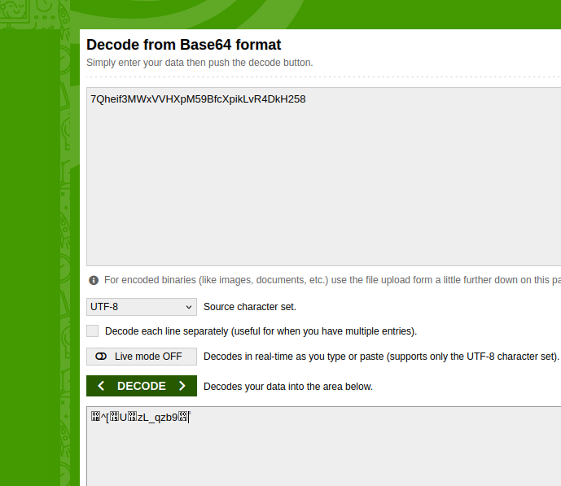

Then, i thought why not it could be base58 then i tried it with the online tool:https://www.dcode.fr

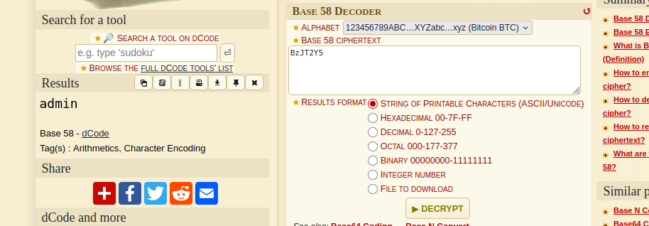
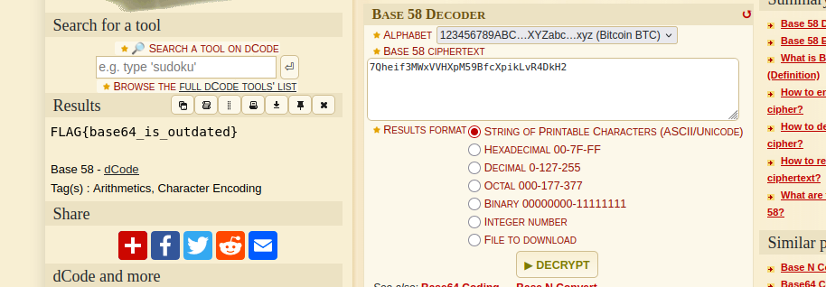
By this i got a flag
chall5:
In the webpage it has a comment filed
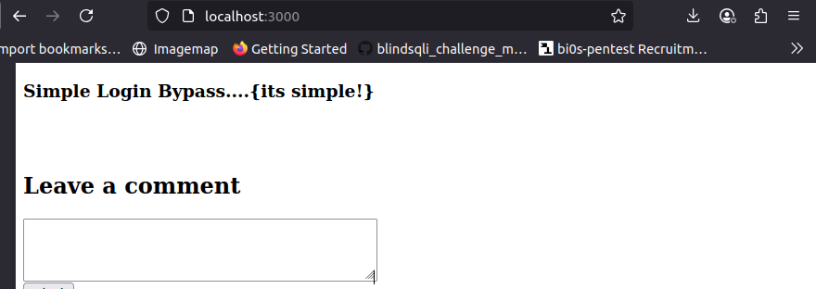
by checking the session section

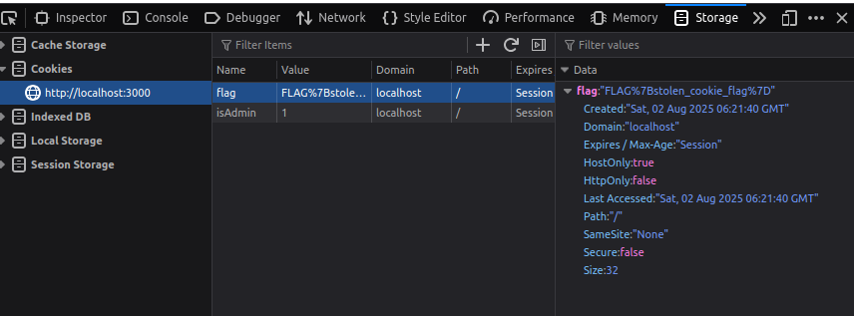
I thought it is the flag
Another potential way to get the flag:
But, when i checked for login bypass i came across xss vulnerability and html injection
i tried xss using <script>alert(...)</script>
It showed a pop up box

