Implementation of a Mini File System (MiniFS)
A Project Based Learning Report Submitted in partial fulfilment of the requirements for the award of the degree

of

Bachelor of Technology
in The Department of Computer Science and Engineering
Operating Systems / System Programming (25CS2104E)

Submitted by
2510030277: Akhila Goud
2510030283: Nandini
2510030272: Sharanya
2510030286: Akshara

Under the guidance of
Dr. Seenu



Department of Computer Science and Engineering
Koneru Lakshmaiah Education Foundation, Aziz Nagar
Aziz Nagar – 500075

Abstract

A file system is the part of an operating system that decides how data is named, stored, protected and retrieved on a storage device. Modern file systems such as ext4, NTFS and APFS are large and complex, but their core ideas can be understood by building a small one. This project presents the design and implementation of a Mini File System (MiniFS) written in C using Linux system programming interfaces. MiniFS treats an ordinary host file as a virtual disk and organises it into a superblock, an inode bitmap, a data-block bitmap, an inode table and data blocks. It supports hierarchical directories, file creation, reading, writing and deletion, and metadata queries through a command-line shell.
All disk access uses the system calls open(), pread(), pwrite(), fsync() and close(), so the project connects operating system theory with practical system programming. The report describes the on-disk layout, the allocation strategy, directory handling, the experimental set-up and the test results. The work shows that a compact file system of about one thousand lines of C code can demonstrate allocation, indexing, consistency and persistence clearly, and it provides a base for extensions such as journaling and permissions.
Keywords: File system, inode, superblock, bitmap allocation, directory, system calls, Linux, C programming.

List of Figures

Figure 1: Overall architecture of MiniFS
Figure 2: On-disk layout of the virtual disk
Figure 3: Structure of an inode with direct and indirect pointers
Figure 4: Directory tree used during testing

List of Tables
Table 1: MiniFS design parameters
Table 2: Shell commands and the operations they use
Table 3: Functional test cases
Table 4: Comparison of MiniFS with a full-featured file system

Table of Contents
1. Introduction
2. Methodology
a. Selecting the Disk Model
b. On-Disk Layout
c. Inode Structure and Block Allocation
d. Directory Management
e. System Programming Interface
3. Experiments
4. Results
5. Conclusion and Future Work
References

Design and Implementation of a Mini File System (MiniFS)

Introduction
Every program that saves a document, loads a photograph or writes a log depends on the file system, yet most users never see it. A file system gives raw storage a useful shape. It converts a long array of fixed-size blocks into named files and directories, keeps track of which blocks are free, records metadata such as size and timestamps, and tries to keep all of this consistent even when a machine loses power. Because it sits between applications and hardware, the file system is one of the most important subsystems of an operating system, and it is a standard topic in every Operating Systems course.
Production file systems are difficult to study directly. The Linux ext4 driver, for example, contains tens of thousands of lines of code with journaling, extents, delayed allocation and many compatibility features. For a student, the essential ideas are easily hidden under this complexity. A mini file system removes the clutter and keeps only the pieces that define the concept: a superblock describing the volume, bitmaps recording free space, inodes storing file metadata, data blocks storing content, and directories mapping names to inode numbers. These structures follow the classic UNIX design described in the operating systems literature [1], [2].
System programming is the second half of this project. System programmers write software that talks directly to the operating system through its kernel interface rather than through high-level libraries. In Linux this means using system calls such as open(), pread(), pwrite(), fsync() and close() on file descriptors, handling error codes through errno, and working with raw byte layouts using structures and fixed-width integers [3]. MiniFS is built entirely in this style. The virtual disk is a normal file opened with open(), and every block read or write is a pread() or pwrite() at a computed byte offset. Because no external library hides the storage details, the programmer must decide how bytes are arranged, how they are aligned and when they are flushed.
The objectives of the project are as follows. First, to design a simple but complete on-disk format that can be created, mounted and unmounted. Second, to implement inode-based file storage with direct and single-indirect block pointers. Third, to implement hierarchical directories so that paths such as /docs/notes.txt can be resolved. Fourth, to provide a shell with commands such as format, mkdir, ls, create, write, cat, rm and stat. Fifth, to test the system for correctness, persistence and resource reuse, and to compare its behaviour with the theory taught in class.
The remainder of the report is organised as follows. Section 2 explains the methodology, including the disk model, layout, inode design, directory handling and the system call interface. Section 3 describes the experiments and the test environment. Section 4 presents the results. Section 5 concludes the work and lists possible future improvements.

METHODOLOGY

Selecting the Disk Model
A real disk can only be accessed with administrator privileges, and a mistake can destroy user data. To avoid this, MiniFS uses a regular file named disk.img as a virtual block device. The file is created with a fixed size and is divided into blocks of 1024 bytes. All reads and writes are performed in whole blocks, which mimics the behaviour of a real block device and keeps the code simple. Figure 1 shows the layered architecture of the system and Table 1 lists the main design parameters.
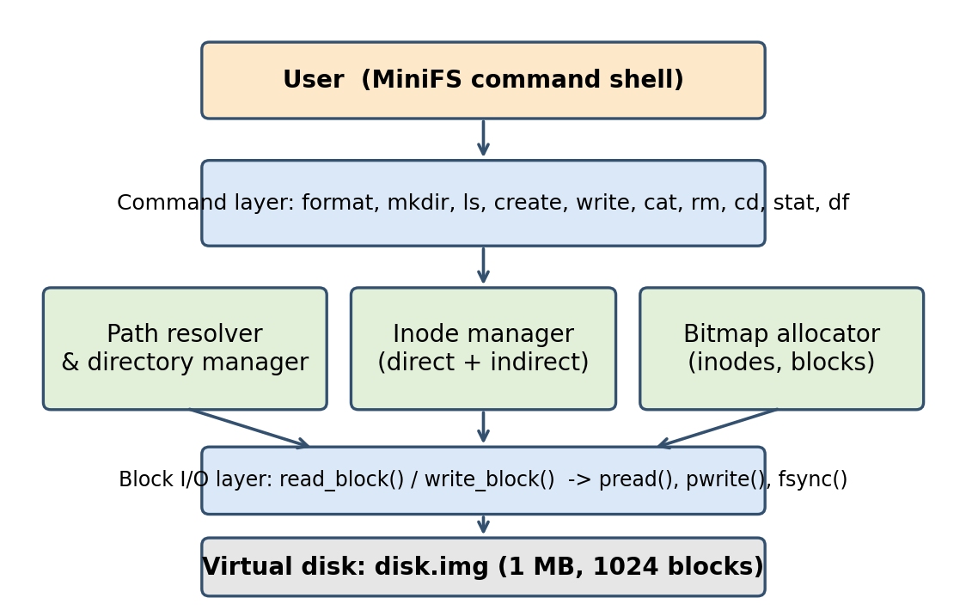
Figure 1: Overall architecture of MiniFS
Table 1: MiniFS design parameters
Parameter | Value
Virtual disk size | 1 MB (1024 blocks)
Block size | 1024 bytes
Maximum number of inodes | 128
Inode size | 64 bytes
Direct pointers per inode | 10
Single-indirect pointers | 1 (256 block numbers)
Maximum file size | about 266 KB
Maximum file name length | 28 characters
Directory entry size | 32 bytes

On-Disk Layout
The virtual disk is divided into five regions as shown in Figure 2. Block 0 holds the superblock, which stores a magic number used to identify a valid MiniFS volume, the block size, the total number of blocks and inodes, the number of free blocks and inodes, and the starting block of every other region. Block 1 holds the inode bitmap and block 2 holds the data bitmap; each bit records whether an inode or a data block is in use. The inode table follows and occupies 8 blocks (128 inodes of 64 bytes each). Everything after the inode table is the data region, where file contents, directory contents and indirect blocks are stored.
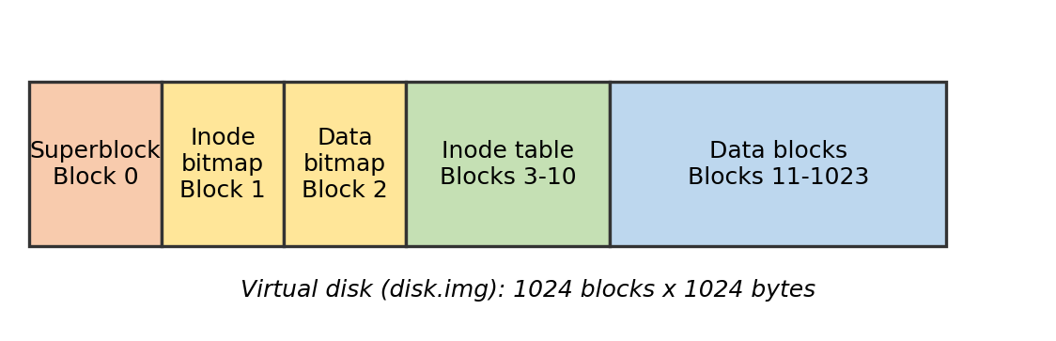
Figure 2: On-disk layout of the virtual disk
When the format command is executed, the program zeroes the entire image, writes the superblock, marks inode 0 as the root directory, allocates one data block for the root directory and writes the updated bitmaps. When the program starts, it reads the superblock and checks the magic number; if it does not match, the volume is rejected as unformatted. This simple check prevents the program from interpreting random data as metadata.

Inode Structure and Block Allocation
An inode is a fixed-size record that stores everything about a file except its name. In MiniFS an inode contains the file type (regular file or directory), the size in bytes, the link count, creation and modification timestamps, ten direct block pointers and one single-indirect pointer, as shown in Figure 3. Small files of up to 10 KB are reached through the direct pointers. Larger files use the indirect block, which is itself a data block containing 256 four-byte block numbers. This two-level scheme is the same idea used in the original UNIX file system and keeps access to small files fast while still allowing larger files.
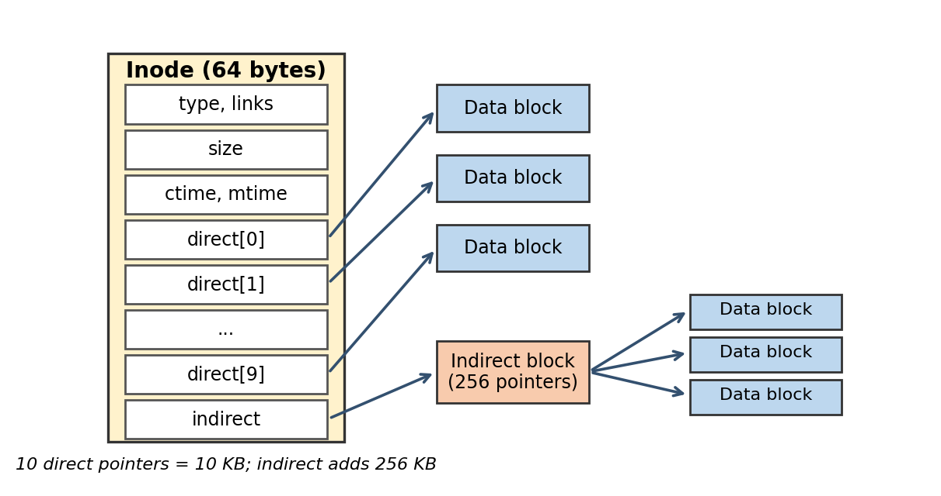
Figure 3: Structure of an inode with direct and indirect pointers
The C definition of the inode is shown below.
typedef struct {
uint16_t type; /* 0 = free, 1 = file, 2 = directory */
uint16_t links; /* hard link count */
uint32_t size; /* file size in bytes */
uint32_t ctime; /* creation time */
uint32_t mtime; /* last modification time */
uint32_t direct[10]; /* direct block numbers */
uint32_t indirect; /* single-indirect block number */
uint8_t pad[4]; /* padding to 64 bytes */
} inode_t;

Free space is managed with bitmaps. To allocate a block, the program scans the data bitmap for the first zero bit, sets it to one, decrements the free-block counter in the superblock and returns the block number. To free a block, the bit is cleared and the counter is incremented. The same procedure is applied to inodes. This first-fit strategy is easy to implement and is adequate for a small volume, since the cost is a linear scan of at most 1024 bits.
Writing to a file follows these steps: locate the inode, compute the block index from the byte offset, allocate a new block if that index has no block yet, read-modify-write the block, update the file size and modification time, and finally write the inode back to the inode table. Deleting a file frees each data block, frees the indirect block if present, clears the inode and removes the directory entry.

Directory Management
A directory in MiniFS is simply a file whose contents are an array of 32-byte entries. Each entry has a 4-byte inode number and a 28-byte null-terminated name. An entry whose inode number is zero and whose name is empty is unused and can be reused by the next create operation. Every directory contains the special entries "." and ".." so that relative navigation is possible.
Path resolution splits a path at each slash and walks the tree one component at a time. Starting at the root inode (for absolute paths) or at the current working directory (for relative paths), the program reads the directory blocks, searches for the component name and moves to the corresponding inode. If a component is missing or is not a directory, the lookup fails and the shell prints an error. The time taken by a lookup is proportional to the depth of the path and the number of entries in each directory on the way.

System Programming Interface
All interaction with the virtual disk is done through POSIX system calls, which form the central system programming component of the project. The helper functions read_block() and write_block() call pread() and pwrite() with the offset block_no x 1024. After every metadata update, fsync() is called so that data reaches the storage device. The shell itself is a simple loop that reads a line using fgets(), tokenises it with strtok() and dispatches to the matching function. Table 2 maps each shell command to the main operations it uses.
Table 2: Shell commands and the operations they use
Command | Purpose | Main operations
format | Create a new empty file system | open(), ftruncate(), pwrite(), fsync()
mkdir name | Create a directory | Inode and block allocation, pwrite()
ls [path] | List directory entries | pread() on directory blocks
create name | Create an empty file | Inode allocation, directory update
write name text | Write data to a file | Block allocation, pwrite(), fsync()
cat name | Display file contents | pread() through direct and indirect blocks
rm name | Delete a file | Bitmap update, directory entry removal
cd path / pwd | Change or print working directory | Path resolution
stat name | Show file metadata | Inode read, time conversion
df | Show free blocks and inodes | Superblock read

Error handling follows the usual UNIX convention. Each function returns 0 on success and a negative value on failure, and the shell prints a message such as "no space left", "file exists" or "not a directory". The program is compiled with gcc using the flags -Wall -Wextra -g so that warnings are caught early, and memory problems are checked with Valgrind.

EXPERIMENTS
The experiments were carried out on a Linux system (Ubuntu 22.04) with gcc 11. The virtual disk was a 1 MB file stored on the local drive. The aim was to verify that every feature behaves according to the design, that data survives a restart, and that blocks and inodes are correctly reused after deletion. The test directory tree used is shown in Figure 4: a root directory with the sub-directories docs and src and a few files of different sizes in each.
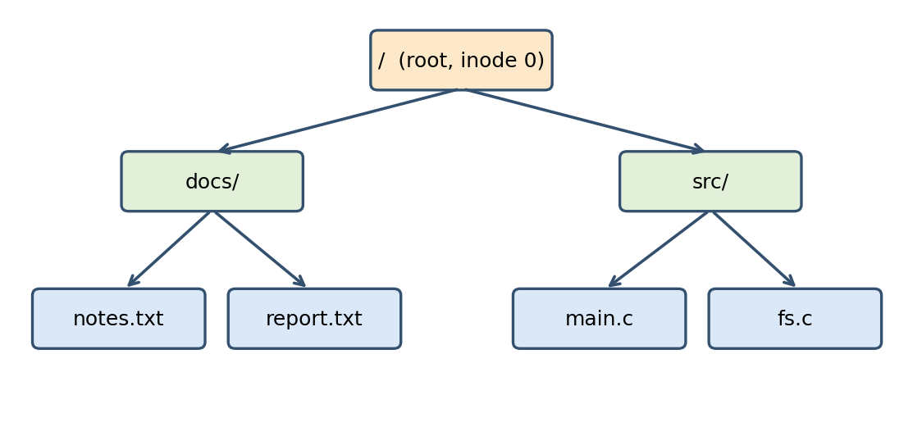
Figure 4: Directory tree used during testing
Four groups of tests were designed. The first group checked formatting and mounting: the program must reject an unformatted image and accept a formatted one. The second group checked file operations: creation, writing small data (under 1 KB), medium data (about 8 KB, direct pointers only) and large data (about 100 KB, which needs the indirect block), and reading each file back for comparison. The third group checked directories: creating nested directories, resolving absolute and relative paths, listing contents and refusing to remove non-empty directories. The fourth group checked resource management: filling the disk until allocation fails, deleting files, and confirming that the free-block count returns to its original value.
To test persistence, the shell was closed after writing files and started again with the same disk.img. The contents were then compared with the original data using the cmp and diff utilities. Table 3 summarises the main test cases.
Table 3: Functional test cases
No. | Test case | Expected behaviour
1 | Mount unformatted image | Rejected with a magic-number error
2 | format, then df | All inodes except root free; free blocks equal total minus metadata
3 | create and stat a file | Size is 0, type is regular file
4 | write 500 bytes, then cat | Same 500 bytes returned
5 | write 8 KB (direct blocks) | File readable; 8 data blocks used
6 | write 100 KB (indirect block) | File readable; indirect block allocated
7 | mkdir nested three levels | Absolute and relative paths resolve
8 | create duplicate name | Error: file exists
9 | rm file, then df | Blocks and inode returned to the free pool
10 | Fill the disk | Error: no space left; existing files intact
11 | Restart, then cat | Data identical after remounting

RESULTS
All functional tests listed in Table 3 produced the expected behaviour. Files written through direct pointers and through the indirect block were returned byte for byte unchanged when compared using cmp. After restarting the shell, the directory tree and file contents were intact, which confirms that metadata and data were correctly persisted by pwrite() and fsync().
Resource accounting also behaved correctly. Creating and then deleting a group of files returned the free-block and free-inode counts to the values recorded immediately after formatting, which shows that no blocks were leaked. When the disk was deliberately filled, the allocator reported that no space was left and did not corrupt existing files. Duplicate names and invalid paths were rejected with clear messages. A sample session is shown below.
minifs> format
minifs> mkdir docs
minifs> cd docs
minifs> create notes.txt
minifs> write notes.txt "Hello from MiniFS"
minifs> cat notes.txt
Hello from MiniFS
minifs> stat notes.txt
Type: file Size: 17 bytes Blocks: 1
minifs> df
Free blocks: 1011 Free inodes: 125

In terms of design trade-offs, the first-fit bitmap allocator and the linear directory search are simple but would be slow for very large volumes, while the 64-byte inode and 1 KB block size keep internal fragmentation small for the small files used in the tests. Table 4 compares MiniFS with a full-featured file system to show which features are intentionally left out.
Table 4: Comparison of MiniFS with a full-featured file system
Feature | MiniFS | ext4 (typical)
Block mapping | 10 direct + 1 indirect | Extents
Directory lookup | Linear search | Hashed B-tree
Crash consistency | fsync() only | Journaling
Permissions and ownership | Not supported | Full UNIX permissions
Maximum file size | about 266 KB | Terabytes
Code size | about 1,000 lines | Tens of thousands of lines

CONCLUSION and FUTURE WORK
In this project, a Mini File System was designed and implemented in C using Linux system calls. The system demonstrates the main concepts of an operating system file system: a superblock describing the volume, bitmaps for free-space management, inodes with direct and indirect pointers, directories mapping names to inodes, and a shell interface for users. The experiments showed that files and directories can be created, read, modified and deleted correctly, that data persists across restarts, and that space is reclaimed after deletion. Building the project gave practical understanding of block-level I/O, byte-level data layout, error handling and the use of fsync() for durability, which are difficult to appreciate from theory alone.
Several directions remain for future work. A journal or write-ahead log could be added so that the file system recovers from crashes without corruption. Double-indirect blocks would remove the file-size limit. Permissions, ownership and access timestamps would bring the system closer to POSIX behaviour. A consistency checker similar to fsck could detect orphaned blocks and invalid pointers. Finally, MiniFS could be mounted as a real file system using FUSE, allowing standard tools such as ls and cp to operate on it.

References
- A. Silberschatz, P. B. Galvin and G. Gagne, Operating System Concepts, 10th ed., Wiley, 2018.
- R. H. Arpaci-Dusseau and A. C. Arpaci-Dusseau, Operating Systems: Three Easy Pieces, Arpaci-Dusseau Books, 2018.
- M. Kerrisk, The Linux Programming Interface, No Starch Press, 2010.
- M. K. McKusick, W. N. Joy, S. J. Leffler and R. S. Fabry, "A Fast File System for UNIX," ACM Transactions on Computer Systems, vol. 2, no. 3, pp. 181-197, 1984.
- W. R. Stevens and S. A. Rago, Advanced Programming in the UNIX Environment, 3rd ed., Addison-Wesley, 2013.

