Program:

<html>

<title>exe41</title>

<style>

input[type=text]

{

background-color:blue;

}

input[type]=password

{

background-color:green;

}

</style>

</head>

<body>

<p><b>Enter the details</b></p>

<div>

<form>

<label for="0">Name</label>

<input type="name" id="0" name="0" ><br>

<label for="1">Password</label>

<input type="password" id="1" name="1">

</form>

</div>

</body>

</html>

Ouput:

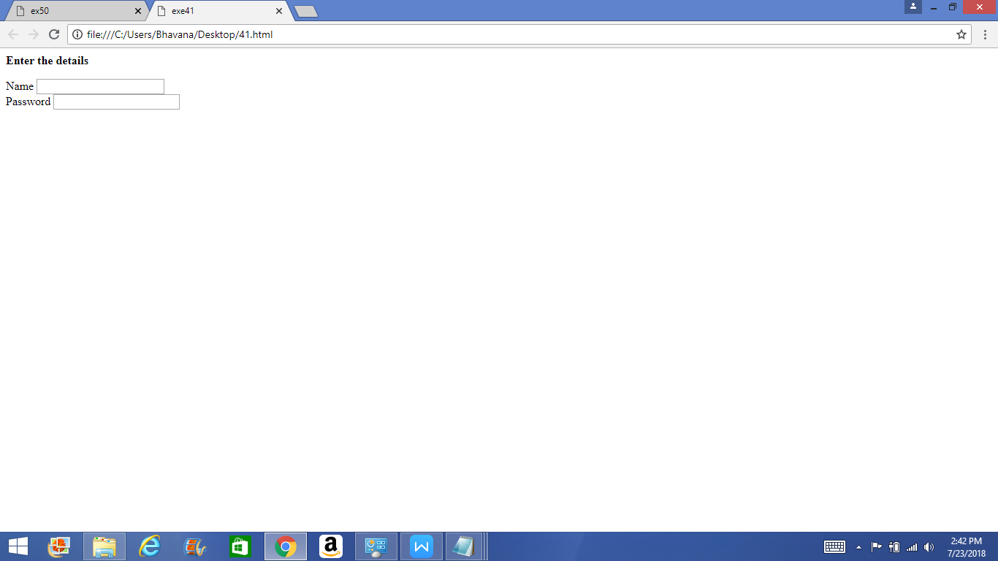

<html>

<title>exe43</title>

<style>

input[type]=text

{

background-color:hotpink;

}

</style>

</head>

<body>

<p><b>Enter the name</b></p>

<form>

<label ="two">Name</label>

<input type="text" id="two" name="name" placehoder="your name">

<input type="reset" value="reset">

</form>

</body>

</html>

Ouput:

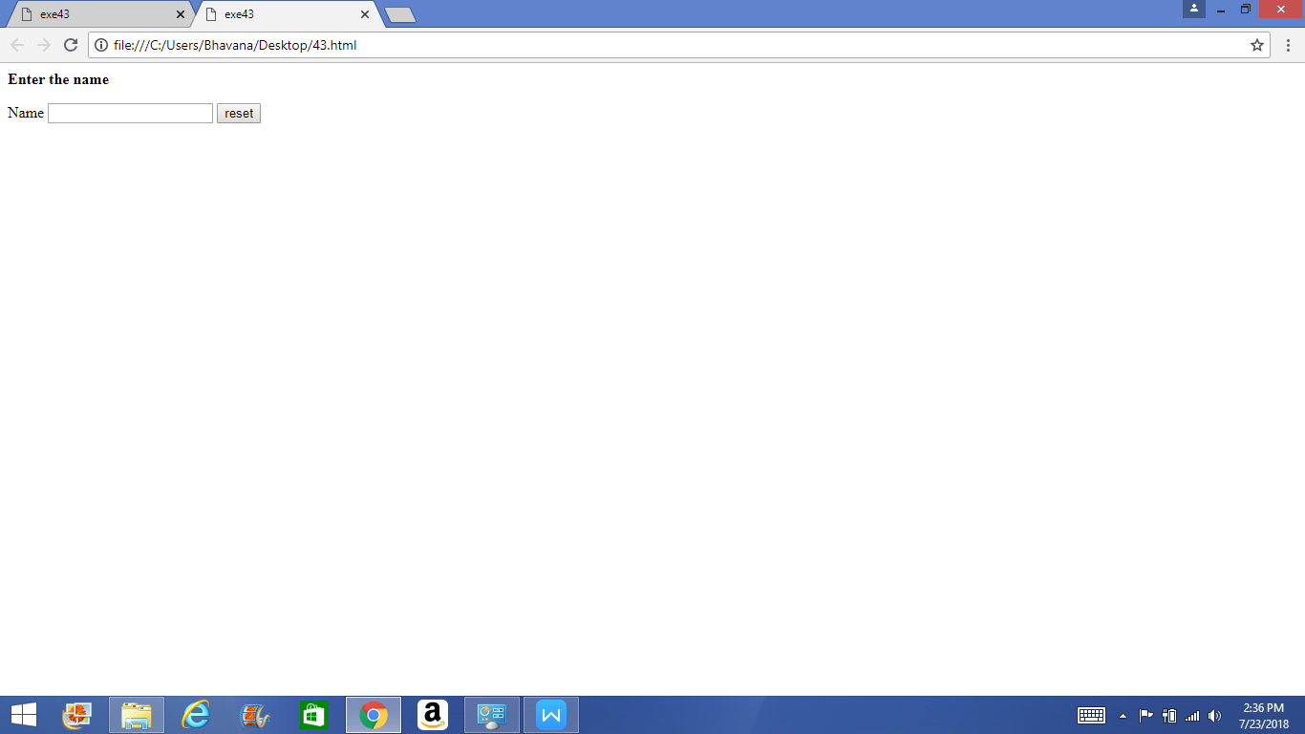

<html>

<title>exe44</title>

<style>

input[type=text]

</style>

</head>

<body>

<p><b>Enter the comment</b></p>

<div>

<form>

<label for="1">Message</label>

<input type="text" id="1" name="1"><br>

<label for="0">Number</label>

<input type="number" id="0" name="0">

<input type="submit" id="0" value="send">

</form>

</div>

</body>

</html>

Output:

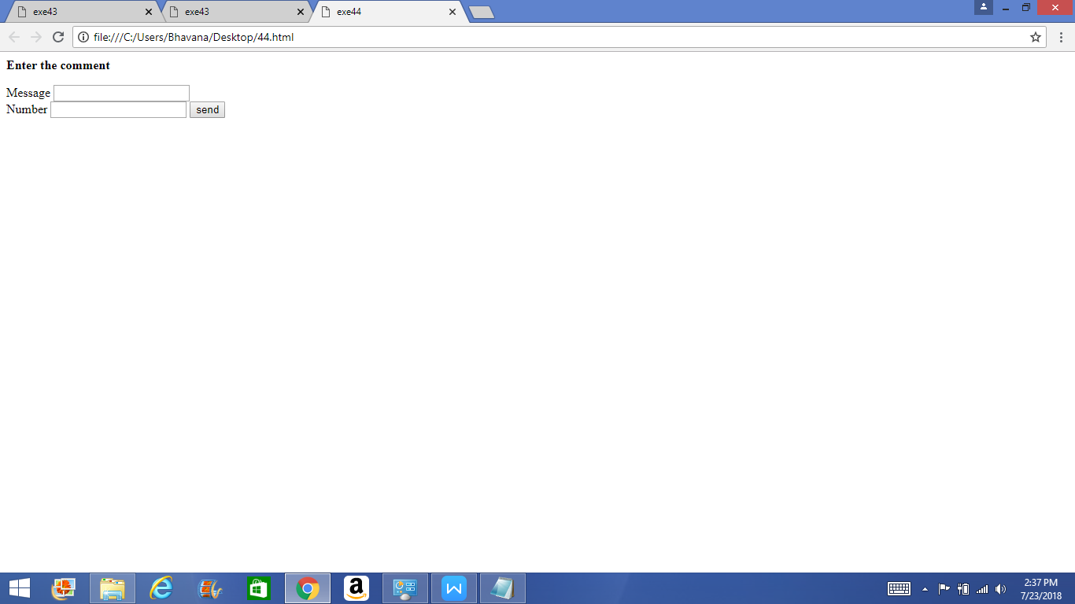

<html>

<title>exe45</title>

<style>

input[type=text]

{

background-color:blue;

}

</style>

</head>

<body>

<p><b>SELECT THE GENDER</b></p>

<div>

<form>

<label for="0">Male</label>

<input type="checkbox" id="0" name="0"><br>

<label for="0">Female</label>

<input type="checkbox" id="0" name="0">

<input type="submit" id="0" value="submit">

</form>

</div>

</body>

</html>

Output:

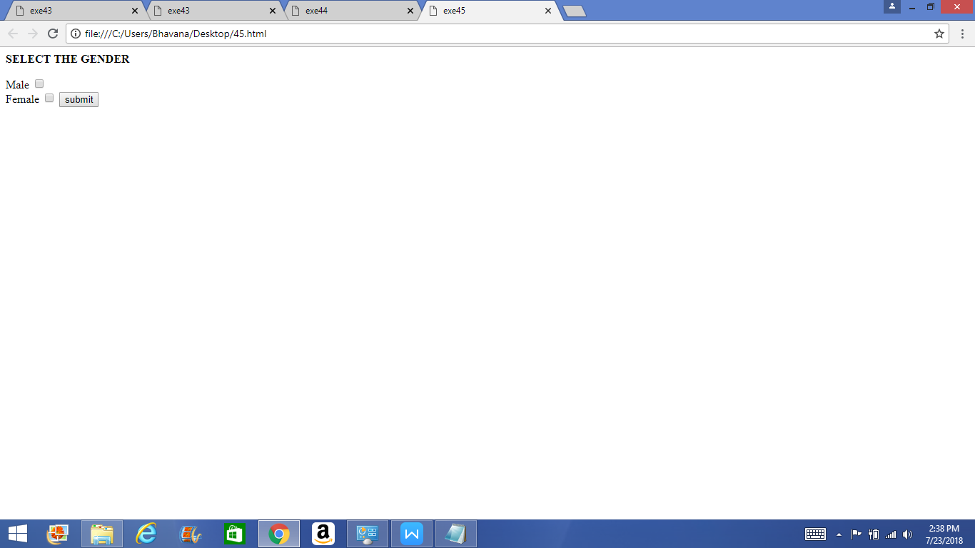

<html>

<title>exe47</title>

<style>

input[type=text]

{

background-color:red;

}

</style>

</head>

<body>

<p><b>Select the number</b></p>

<form>

<p>SELECT </p>

<select>

<option value="1">1</option>

<option value="2">2</option>

<option value="3">3</option>

<input type="submit" value="submit">

</select>

</form>

</body>

</html>

Ouput:

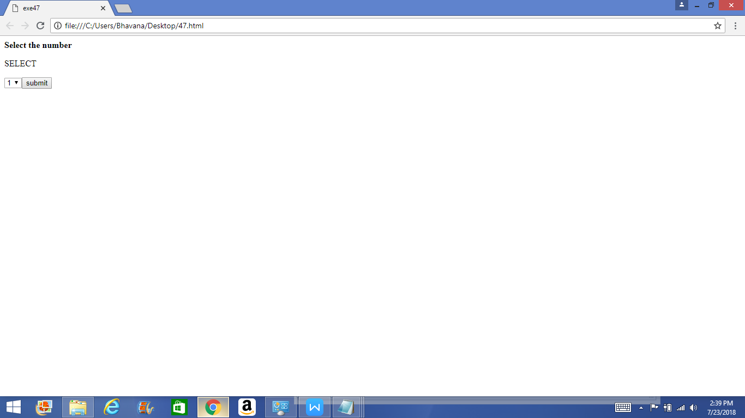

<html>

<title>exe48</title>

<style>

input[type=text]

{

background-color:red;

}

</style>

</head>

<body>

<p><b>Select the number</b></p>

<form>

<p>SELECT </p>

<select>

<option value="1">1</option>

<option value="2">2</option>

<option value="3">3</option>

<input type="hidden" value="submit">

</select>

</form>

</body>

</html>

Output:

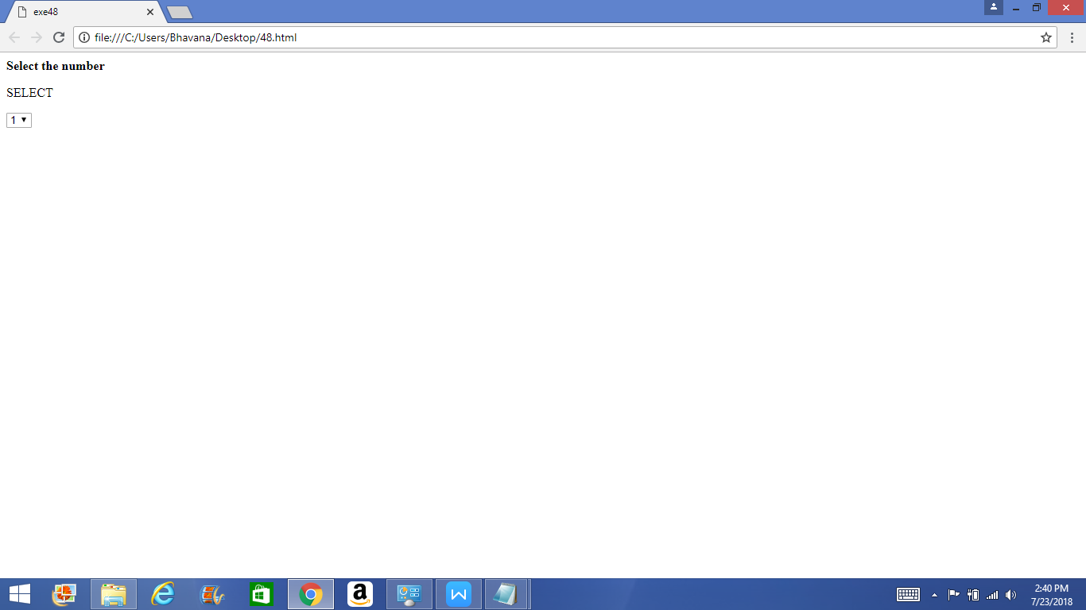

<html>

<title>exe49</title>

<body>

<p>choose file</p>

<forms>

<input type="file" >

</forms>

</head>

</html>

Output:

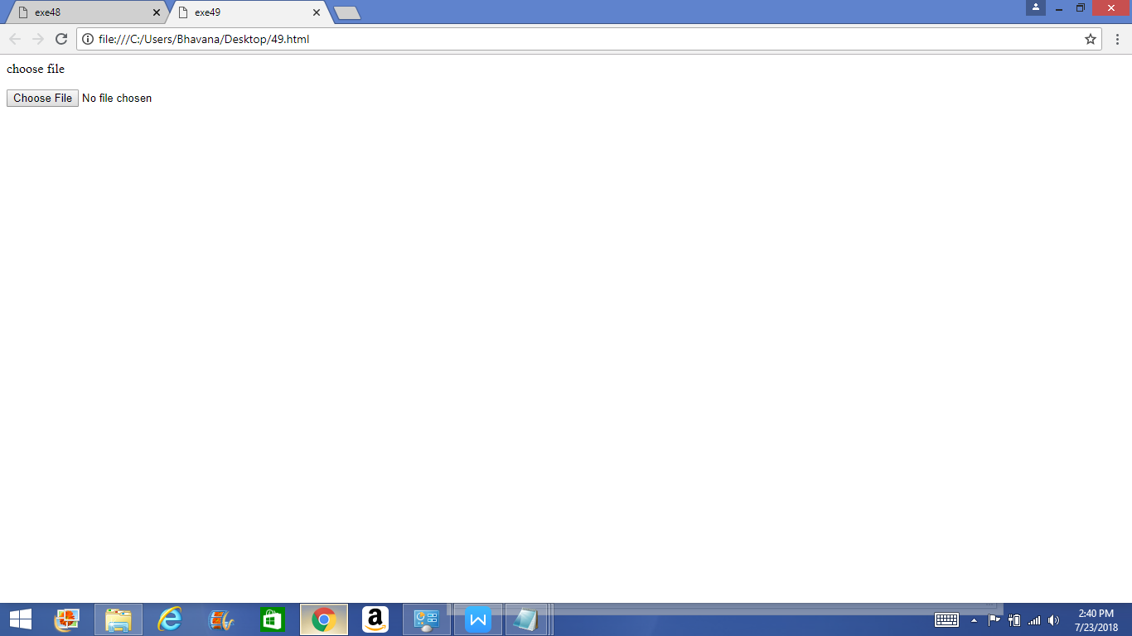

<html>

<head>

<title>ex50</title>

</head>

<body>

<textarea rows="6" cols="15">

Enter the text in this area</textarea><br>

<textarea rows="6" cols="20">

This area is of 6 rows and 20 columns space for texting

</textarea><br>

<br>

</body>

Output:

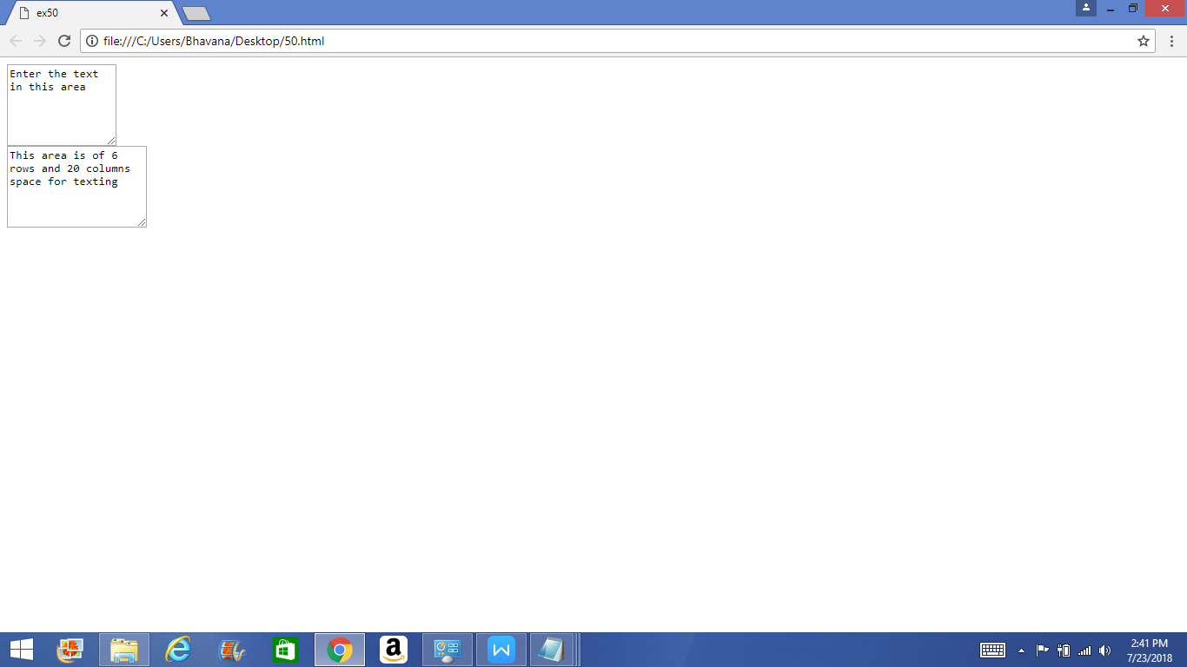

<html>

<title>exe41</title>

<style>

input[type=text]

{

background-color:blue;

}

input[type]=password

{

background-color:green;

}

</style>

</head>

<body>

<p><b>Enter the details</b></p>

<div>

<form>

<label for="0">Name</label>

<input type="name" id="0" name="0" ><br>

<label for="1">Password</label>

<input type="password" id="1" name="1">

</form>

</div>

</body>

</html>

