DBSE & DBD WEEK 1 PRACTICAL

Name: M.Akhila
Roll No: 2520030511
Course Code: 25CS1302E

WEEK 1: DDL COMMANDS AND CONSTRAINTS
Aim:
To practice Data Definition Language (DDL) commands and constraints using MySQL Workbench.
Software Used:
MySQL Workbench
Database Name:
bookflow_db

SQL Operations Performed:
- Created a database named bookflow_db.

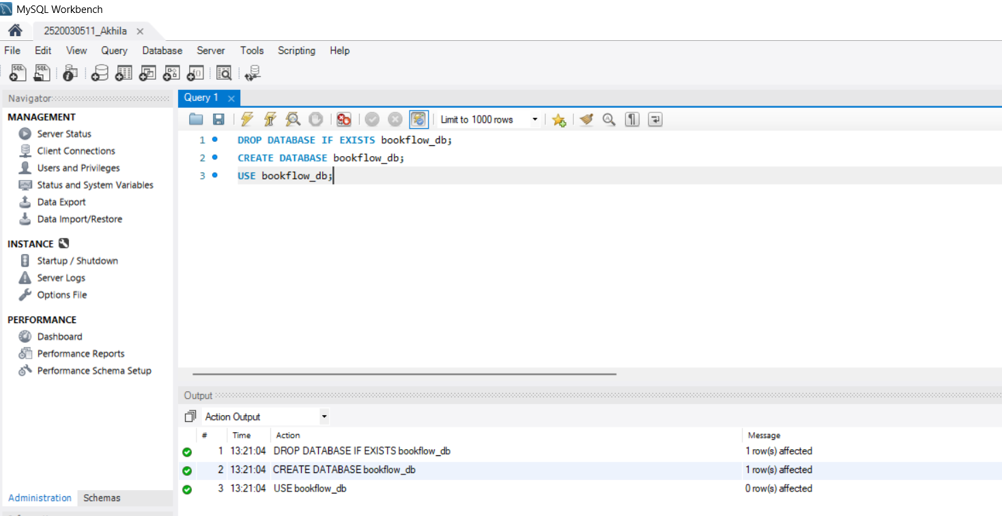

- Table Creation (DDL) with Constraints
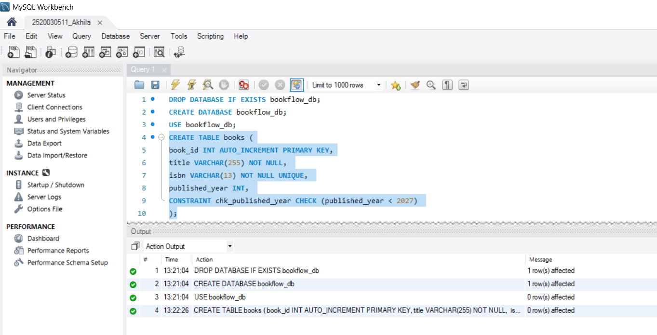

- Create the members table

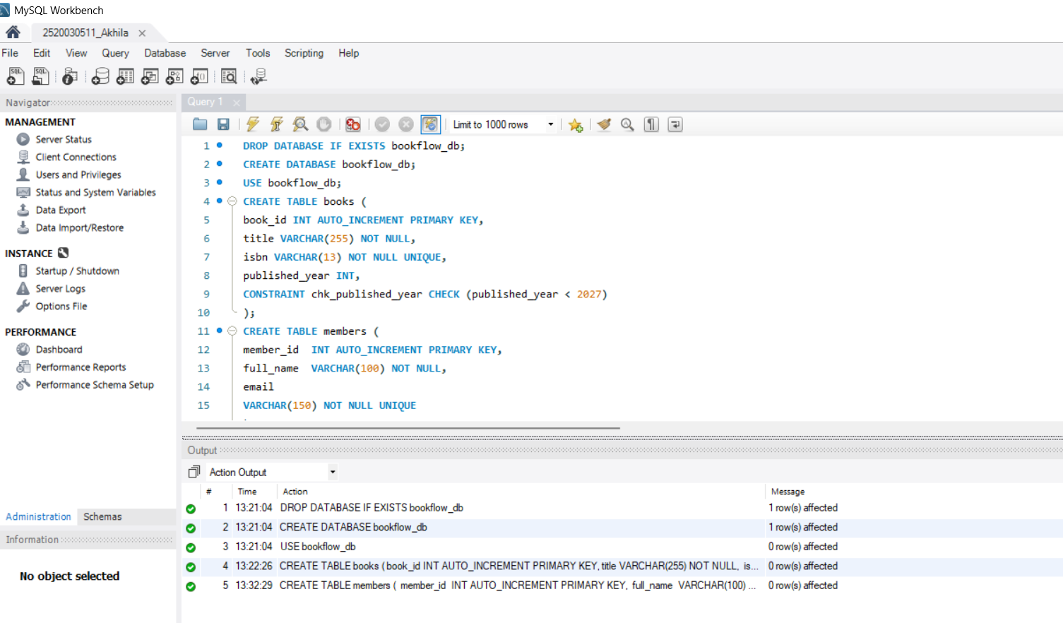
- Inspect the table structures

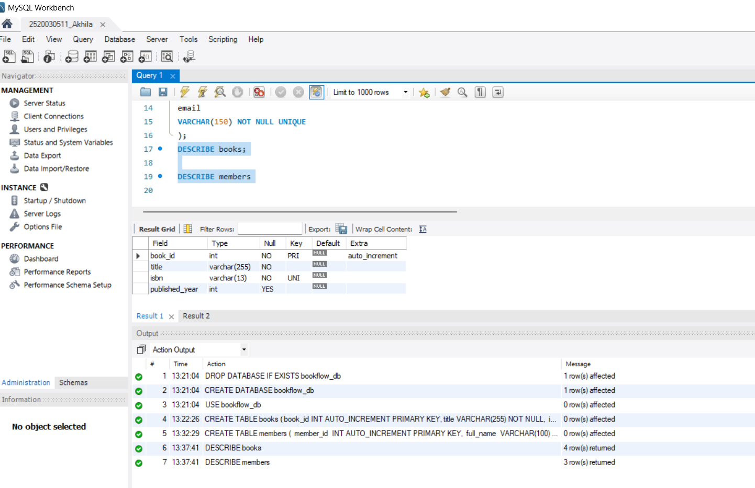

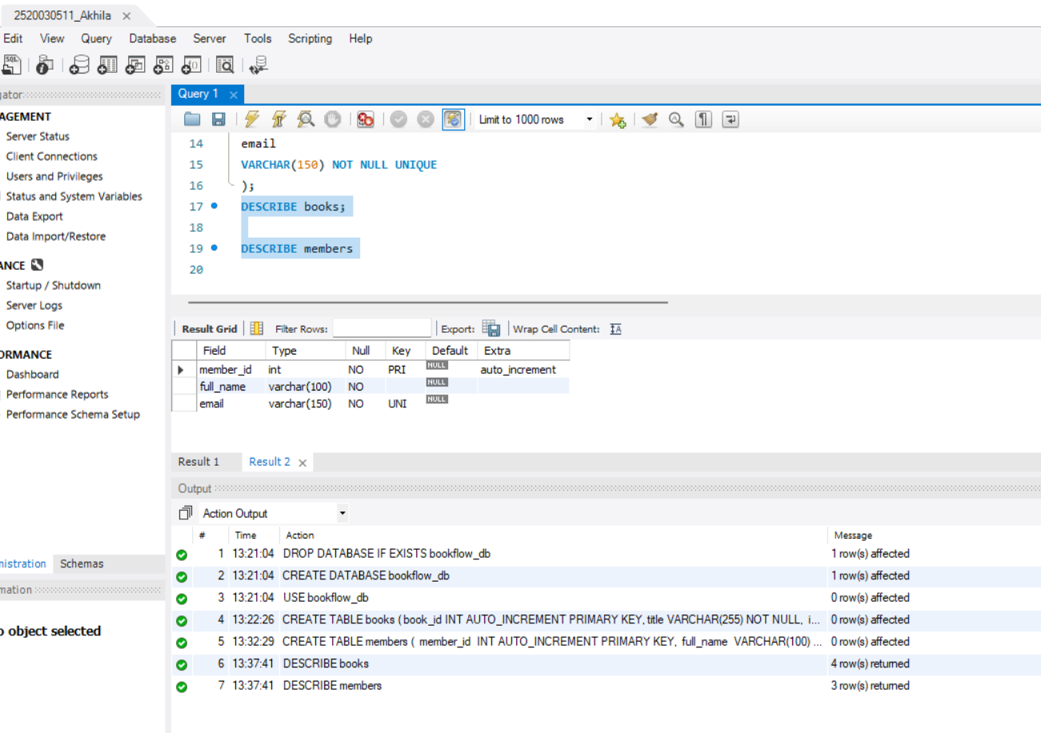

- Insert 3 books
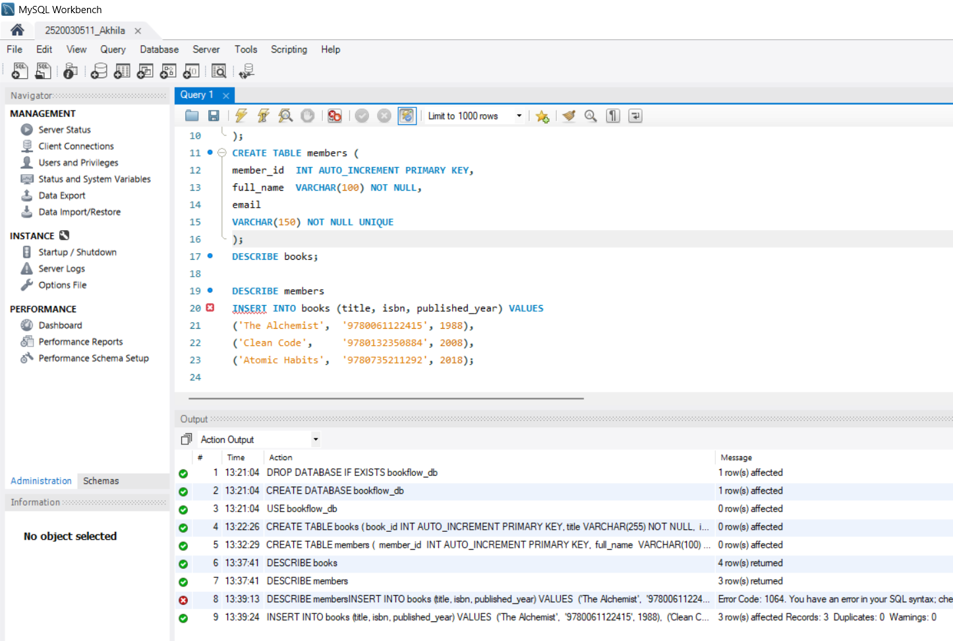

- Insert 3 members

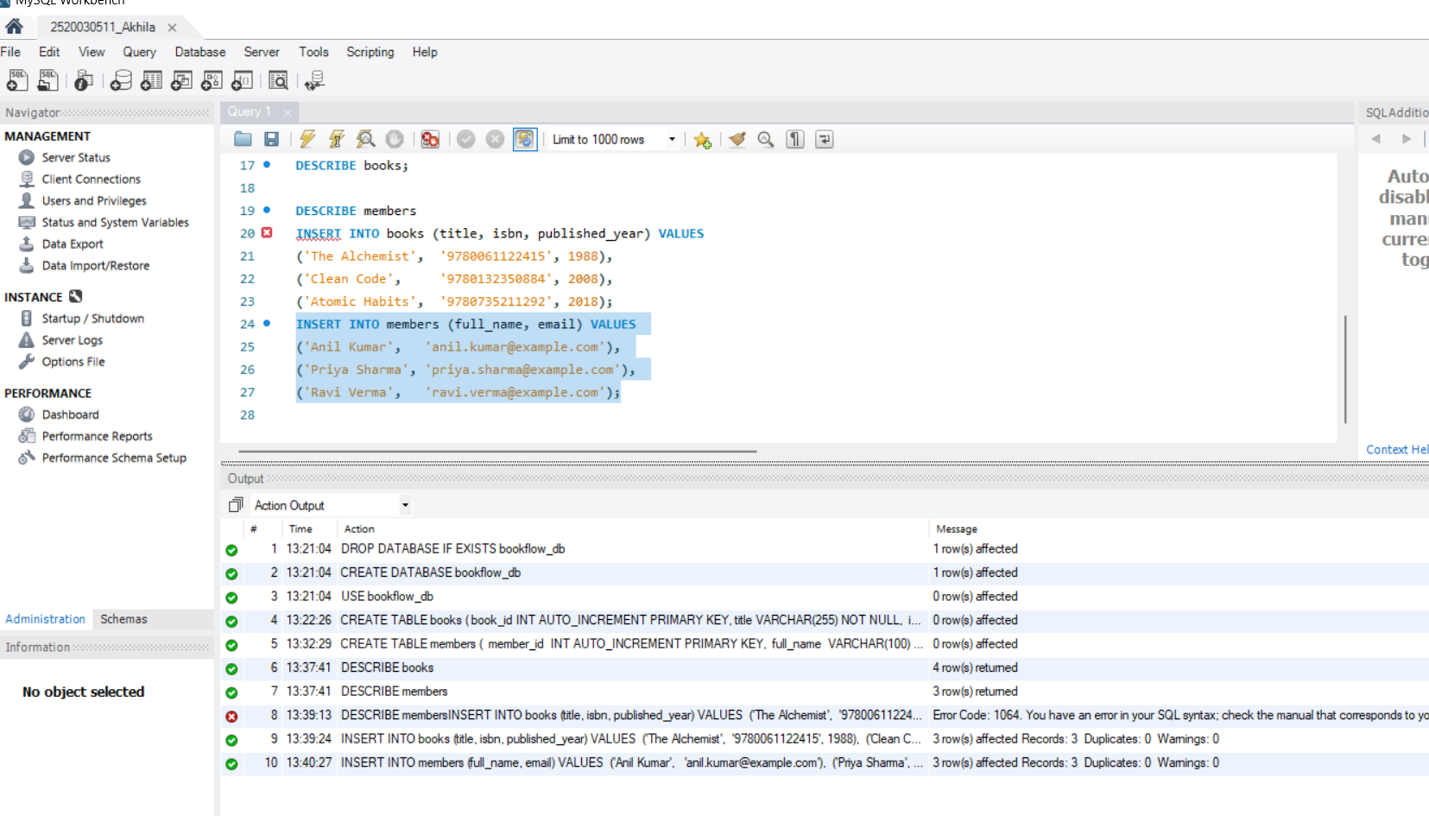
- Tested UNIQUE, NOT NULL and CHECK constraints

