HandsMenThreads: Elevating the Art of Sophistication in Men’s Fashion

Prepared for Project Review
Salesforce Platform Developer Project

HANDSMEN THREADS
A centralized Salesforce solution for customer, product, order, inventory and loyalty operations
Project Information | Details
Platform | Salesforce Lightning Platform
Application | HandsMen Threads
Project Type | CRM / Business Process Automation
Core Areas | Customers • Products • Orders • Inventory • Loyalty
Automation | Flows • Email Alerts • Apex • Scheduled Jobs
Prepared By | Munagala Venkata Siva Sai Naga Sri Akhila
Institution / Department | Velagapudi Ramakrishna Siddhartha Engineering College
Academic Year | 2026–2027

Project documentation prepared from the implemented Salesforce screens and configuration evidence.

Contents
- 1. Project Overview
- 2. Objectives
- 3. Requirement Summary
- 4. Solution Design
- 5. Salesforce Application and Data Configuration
- 6. Data Validation and Business Rules
- 7. User Access and Security
- 8. Email Templates and Notifications
- 9. Salesforce Flows
- 10. Apex and Programmatic Automation
- 11. Scheduled Processing
- 12. End-to-End Business Workflow
- 13. Testing and Validation
- 14. Results and Benefits
- 15. Future Enhancements
- 16. Conclusion
Note: Figure captions identify the implementation screenshots supplied for this project. The documentation is organized independently from the reference document and uses the supplied project screenshots as the primary visual evidence.

1. Project Overview
HandsMen Threads is implemented as a Salesforce Lightning application intended to centralize the operational information of a men’s fashion business. The solution brings customer records, products, orders, inventory and marketing-related information into one Salesforce workspace. The implementation combines declarative configuration with programmatic automation so that routine business actions can be handled consistently.
The project focuses on reducing manual effort in activities such as order confirmation, stock monitoring and loyalty-status processing. The supplied implementation evidence shows custom objects and fields, validation rules, profiles, roles, users, permission sets, email templates, record-triggered flows, a scheduled loyalty flow, Apex logic and scheduled jobs.
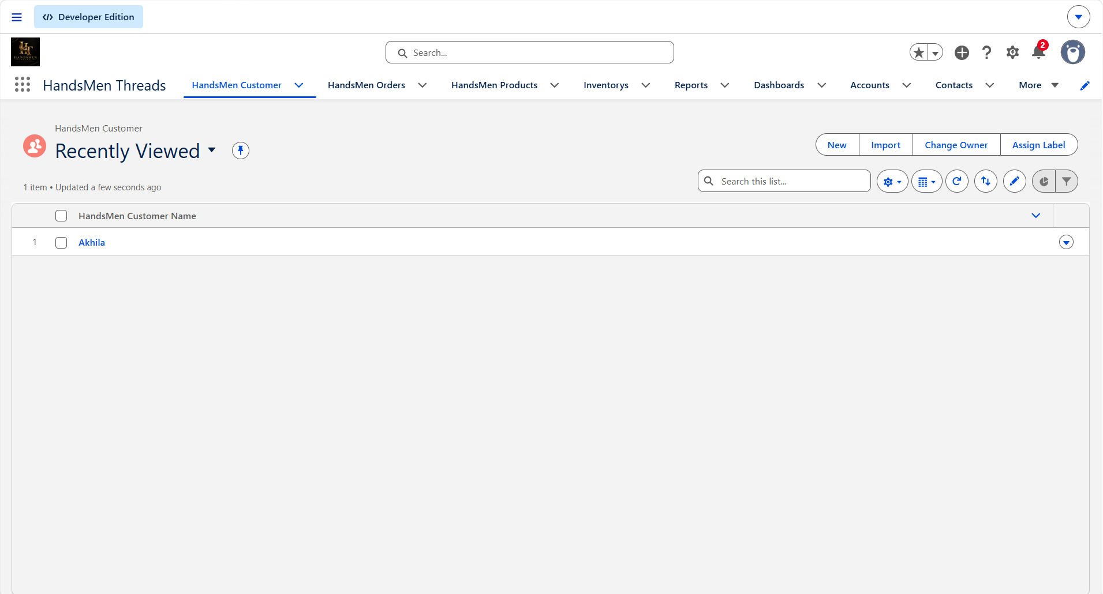
Figure 1. HandsMen Threads Lightning application workspace.

1.1 Business Context
A fashion-retail workflow typically involves several connected activities: maintaining customer information, maintaining products and stock, creating orders, validating order data, communicating order status, and keeping loyalty information current. The HandsMen Threads application models these activities within Salesforce so that information can be maintained from a common interface.

1.2 Solution Scope
Area | Purpose
Customer Management | Maintain customer details and purchase-related information.
Product Management | Maintain product information and product-related attributes.
Order Management | Create and maintain orders, status and order amount information.
Inventory Management | Track stock quantities and identify low-stock situations.
Loyalty Management | Classify customers using purchase totals and update loyalty status.
Communication | Use email templates and alerts for business notifications.
Security | Use profiles, roles and permission sets to control access.
Automation | Use Flow, Apex and scheduled processing for recurring activities.

2. Objectives
The implementation is designed around the following objectives:
- Create a centralized Salesforce environment for customer, product, order and inventory information.
- Automate important customer and operational notifications instead of relying entirely on manual communication.
- Apply validation rules and Apex checks so that business data follows the defined rules.
- Use Salesforce Flow for record-based and scheduled automation.
- Provide role-based access using profiles, roles and permission sets.
- Process recurring inventory and loyalty activities through scheduled Apex and batch-oriented processing.
- Maintain a consistent view of customer loyalty status based on purchase information.

2.1 Expected Operational Outcome
The intended outcome is a more structured operating model in which users enter business data once and Salesforce performs the relevant checks, notifications and scheduled processing. This creates traceable automation while keeping the underlying records available for normal Salesforce reporting and administration.

3. Requirement Summary

3.1 Functional Requirements
Requirement | Implemented Approach
Customer records | HandsMen Customer custom object and Lightning records.
Product records | HandsMen Product custom object with product and stock information.
Order records | HandsMen Order custom object with customer, product, status and amount information.
Inventory monitoring | Inventory object with stock quantity and low-stock automation.
Order confirmation | Record-triggered Flow connected to an Order Confirmation Email Alert.
Low-stock notification | Record-triggered Flow on Inventory connected to a Low Stock Alert.
Loyalty classification | Scheduled Flow evaluates purchase totals and updates loyalty status.
Data validation | Validation rules and Apex logic prevent invalid business values.
Access management | Profiles, roles, users and permission sets.
Recurring processing | Scheduled jobs for inventory and loyalty processing.

3.2 Non-Functional Requirements
- Data integrity through validation and controlled automation.
- Security through Salesforce access-control mechanisms.
- Maintainability through separate declarative and programmatic automation components.
- Scalability through scheduled and batch-oriented processing.
- Usability through a dedicated Lightning application and business-specific navigation.

4. Solution Design
The solution can be viewed as four connected layers: data, business rules, automation and user access. The custom objects hold the business information; validation rules and Apex enforce rules; Flow, email alerts and scheduled processing automate actions; and profiles, roles and permission sets control who can perform those actions.

4.1 High-Level Architecture
Layer | Components in the project
Data Layer | HandsMen Customer, HandsMen Product, HandsMen Order, Inventory and Marketing Campaign objects.
Business Rules | Validation rules for order, inventory and customer data; Apex order-handling validation.
Automation Layer | Record-triggered Flows, scheduled loyalty Flow, email alerts, Batch/Scheduled Apex.
Access Layer | Profiles, roles, users and permission sets.
User Experience | HandsMen Threads Lightning application with business-specific tabs.

4.2 Main Data Objects
Object | Role in the application
HandsMen Customer | Stores customer details, total purchases and loyalty status.
HandsMen Product | Stores product information and stock-related values.
HandsMen Order | Stores order information, status and total amount.
Inventory | Tracks inventory information and stock quantity.
Marketing Campaign | Supports promotional and marketing activity management.
The reference project specification identifies key automation fields including Total_Purchases__c, Loyalty_Status__c, Stock_Quantity__c and Total_Amount__c. These fields connect the data model to the automation rules described later in this document.

5. Salesforce Application and Data Configuration

5.1 Customer and Order Object Configuration
The supplied screenshots show the HandsMen Customer and HandsMen Order objects in Salesforce Object Manager. Their Fields & Relationships views provide the foundation for storing the records used by the application.
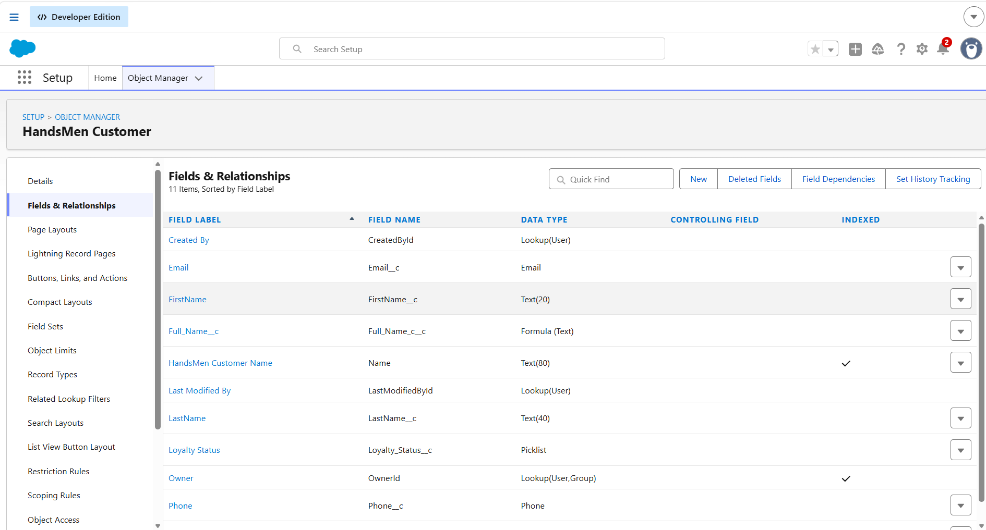
Figure 2. HandsMen Customer – Fields & Relationships configuration.
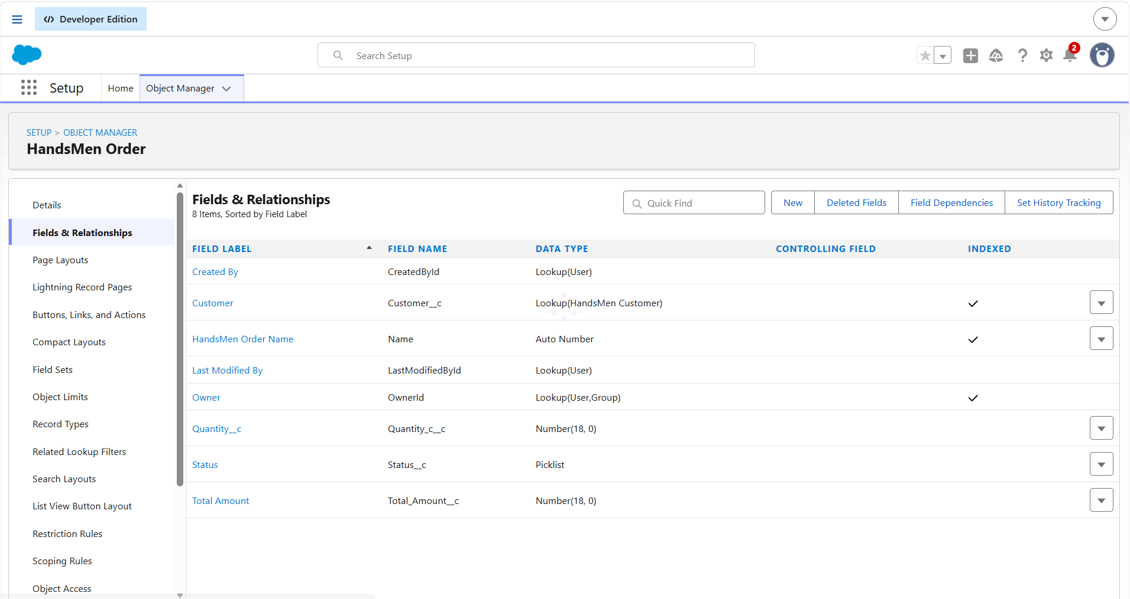
Figure 3. HandsMen Order – Fields & Relationships configuration.

5.2 Product Object Configuration
The HandsMen Product object is configured to hold product-level information required by the business process. The visible fields include product information and values used for inventory-related processing.
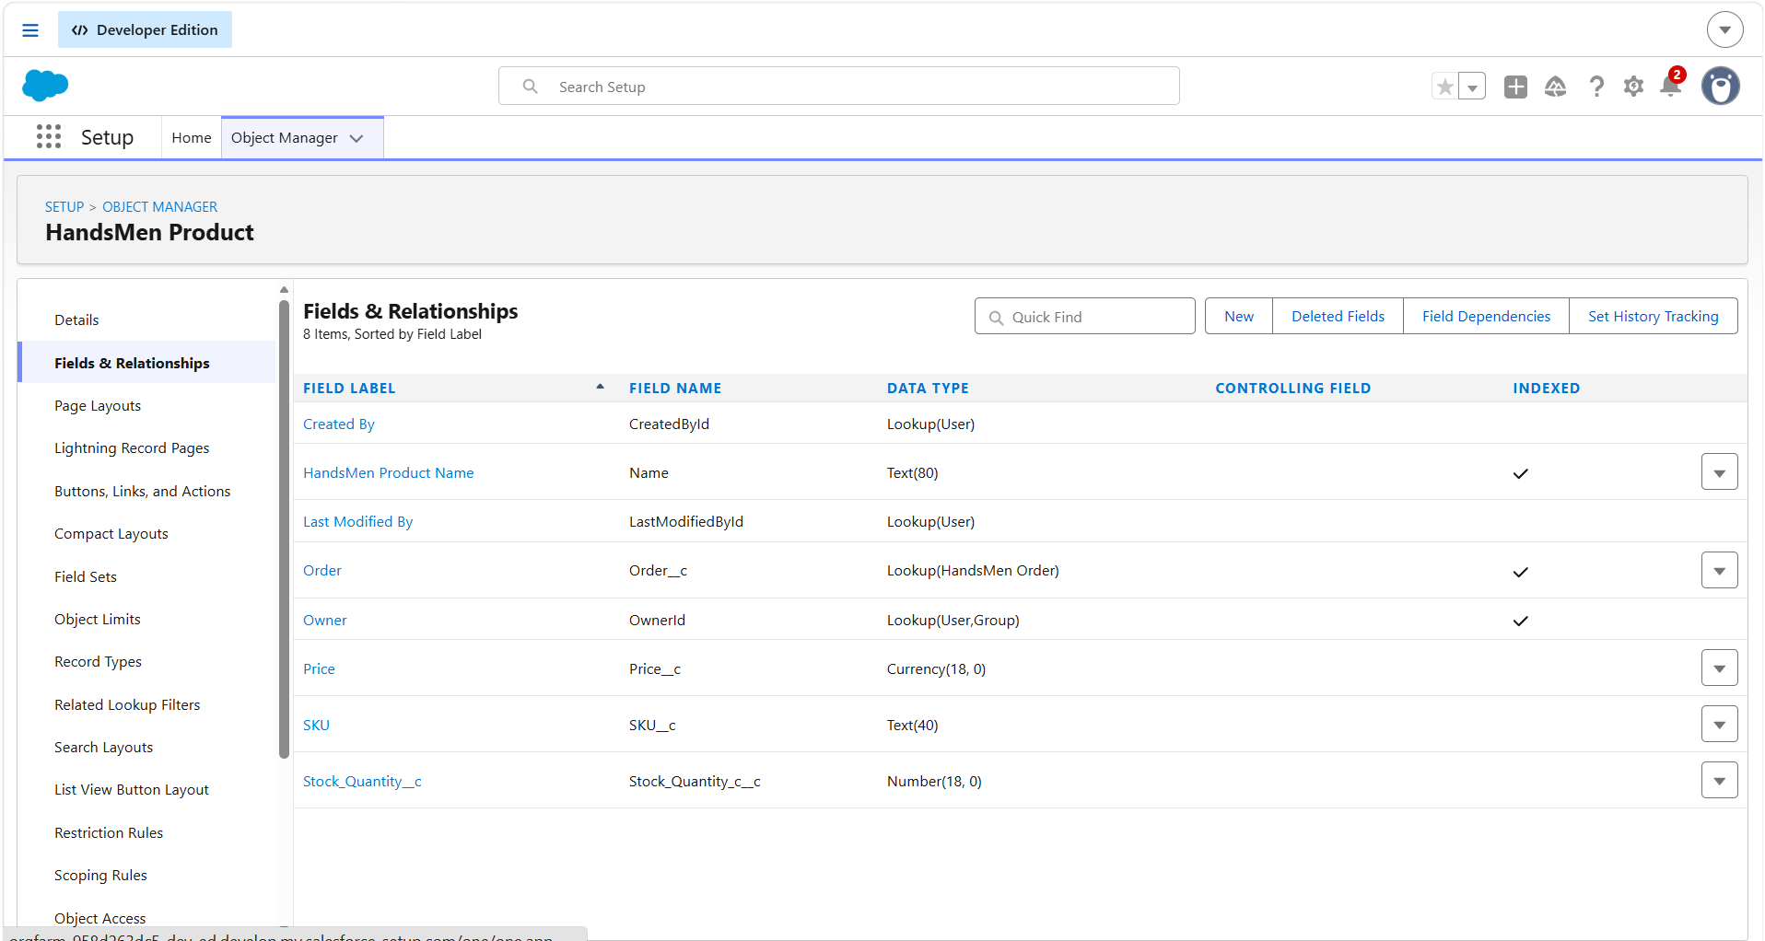
Figure 4. HandsMen Product – Fields & Relationships configuration.

6. Data Validation and Business Rules
Validation is used at two levels in the implementation. Salesforce Validation Rules stop records from being saved when a configured condition is violated, while Apex logic provides additional status-dependent checks for order quantities.

6.1 Order Validation
The project specification documents a validation rule on HandsMen Order that checks Total_Amount__c. The condition is Total_Amount__c <= 0, with the error message “Please Enter Correct Amount.” This prevents an order with a non-positive total amount from being saved.
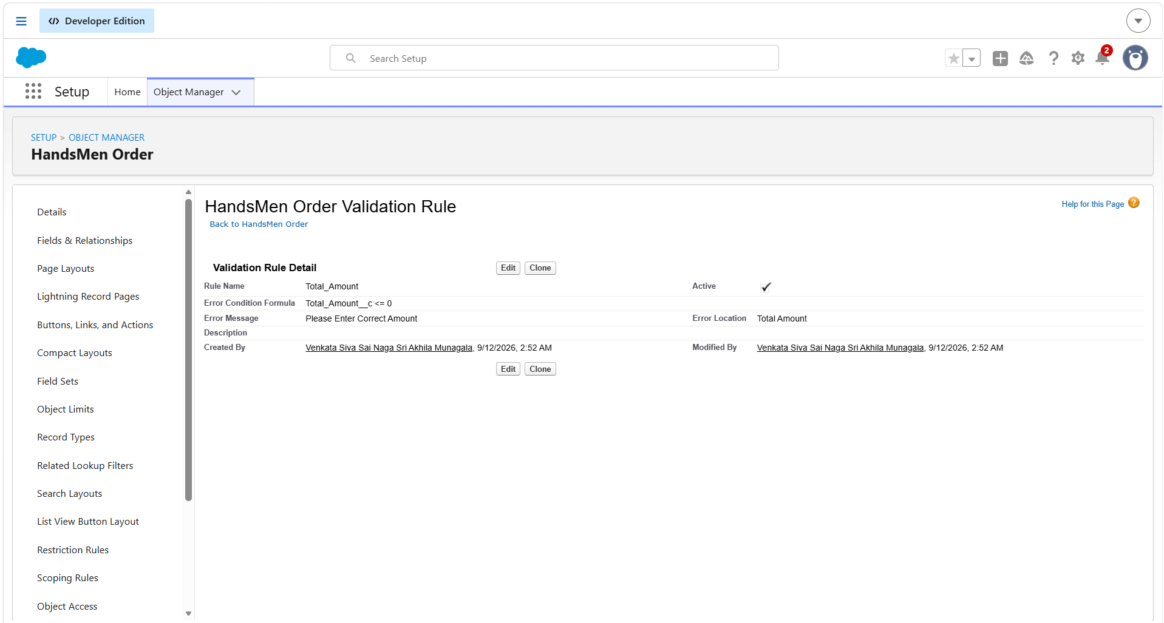
Figure 5. HandsMen Order validation-rule configuration.

6.2 Customer and Inventory Validation
Separate validation-rule configurations are visible for the HandsMen Customer and Inventory objects. These rules support the project’s objective of preventing invalid or inconsistent business data from entering the system.
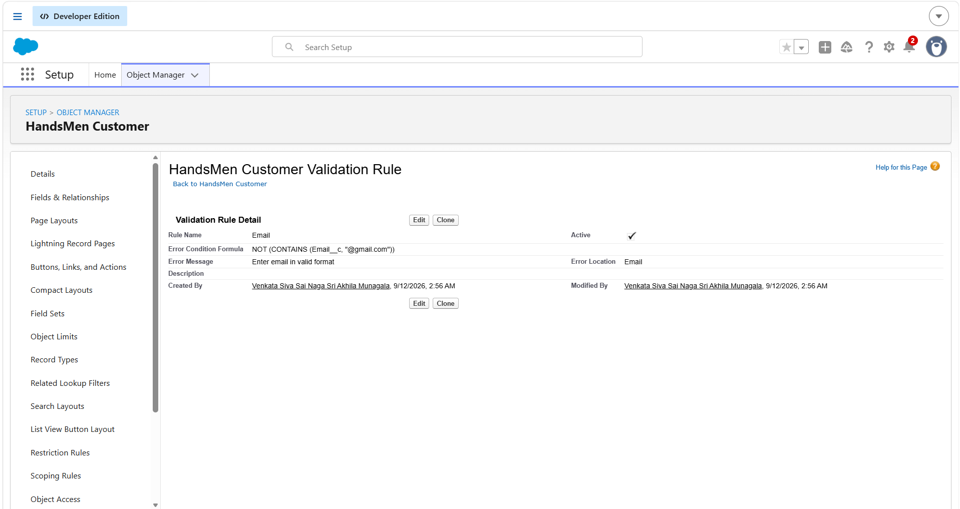
Figure 6. HandsMen Customer validation-rule configuration.

6.3 Apex Order Quantity Validation
The supplied Apex screenshot shows an OrderTriggerHandler method that validates order quantity according to the order status. The logic checks the quantity for Confirmed, Pending and Rejection states and adds a record-level error when the corresponding quantity rule is not satisfied. This provides programmatic validation in addition to declarative validation rules.
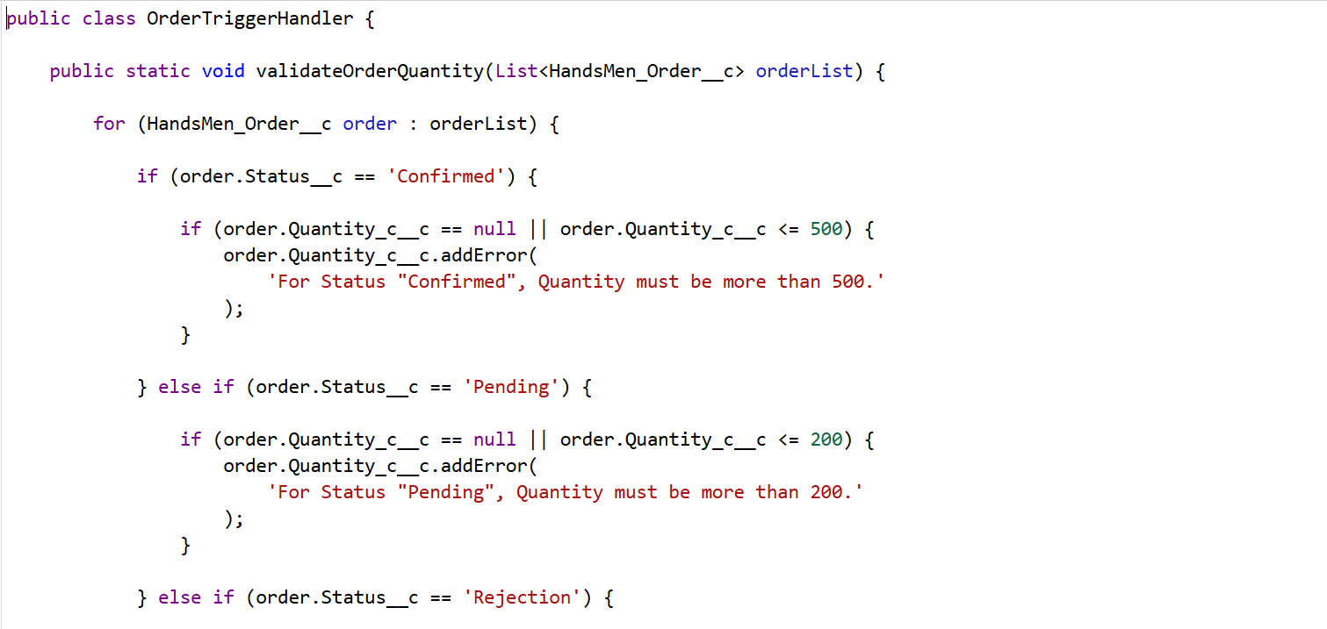
Figure 7. OrderTriggerHandler validation logic.
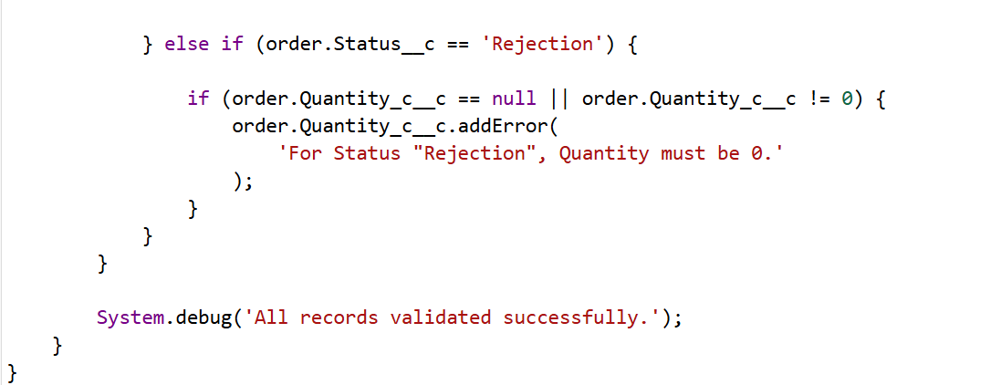
Figure 8. Continuation of order quantity validation logic.

7. User Access and Security
Salesforce access is organized through profiles, roles, users and permission sets. The reference material describes profiles as controlling permissions and roles as supporting the hierarchy used for record visibility. The supplied screenshots provide implementation evidence for each of these configuration areas.

7.1 Profile Configuration
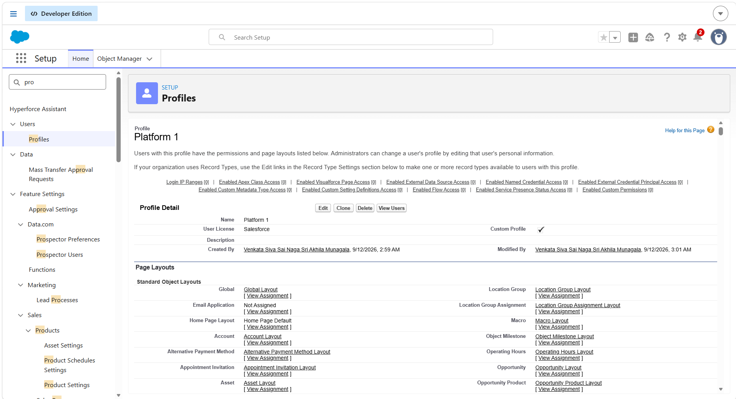
Figure 9. Platform 1 profile and page-layout/permission configuration.
The project uses a Salesforce user profile to define the baseline permissions available to a user. The reference configuration gives access to the relevant product and inventory objects according to the user’s responsibilities.

7.2 Role Hierarchy
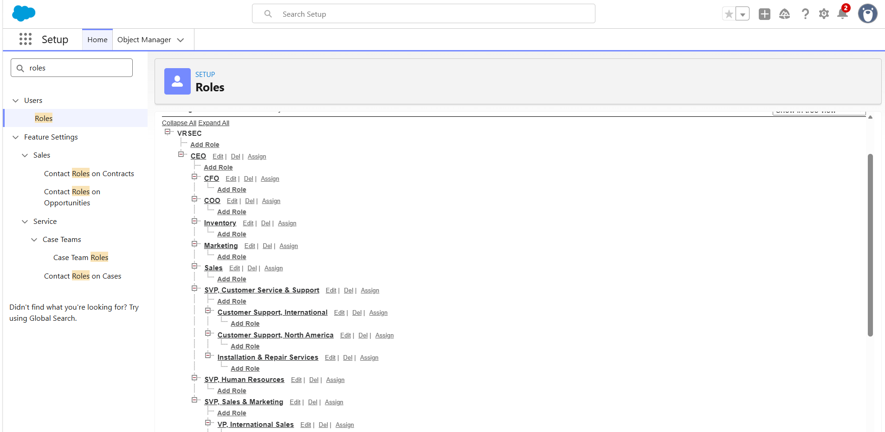
Figure 10. HandsMen Threads role hierarchy.
The role hierarchy shown in the implementation includes business responsibilities such as Inventory Manager, Marketing Manager and Sales Manager under the organizational hierarchy. Roles provide a structure for record visibility and managerial access.

7.3 User Setup and Permission Set
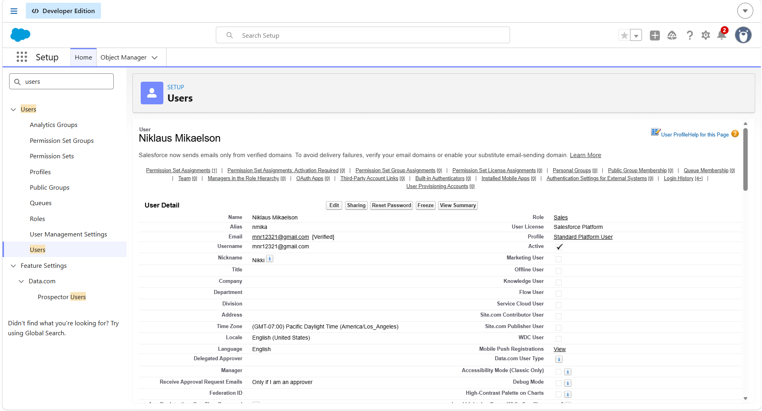
Figure 11. Configured Salesforce user record.
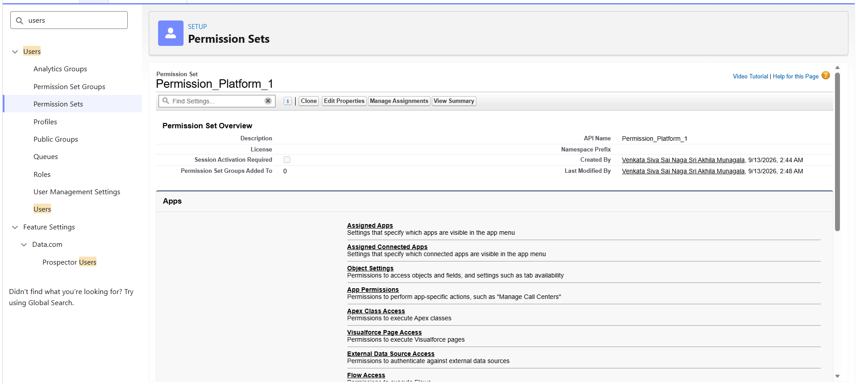
Figure 12. Permission Set configuration and assigned access.
Permission Sets are used to add targeted permissions without changing the user’s base profile. This provides flexibility when a user requires additional access for a particular responsibility.

8. Email Templates and Notifications
The application uses reusable Salesforce email templates so that important customer and inventory communications can be generated consistently. Three business communication patterns are represented in the implementation: order confirmation, low-stock notification and loyalty-program communication.

8.1 Order Confirmation Email
The Order Confirmation template is used by the order automation when an order reaches the required confirmed status. The reference documentation identifies this as a core automated communication.
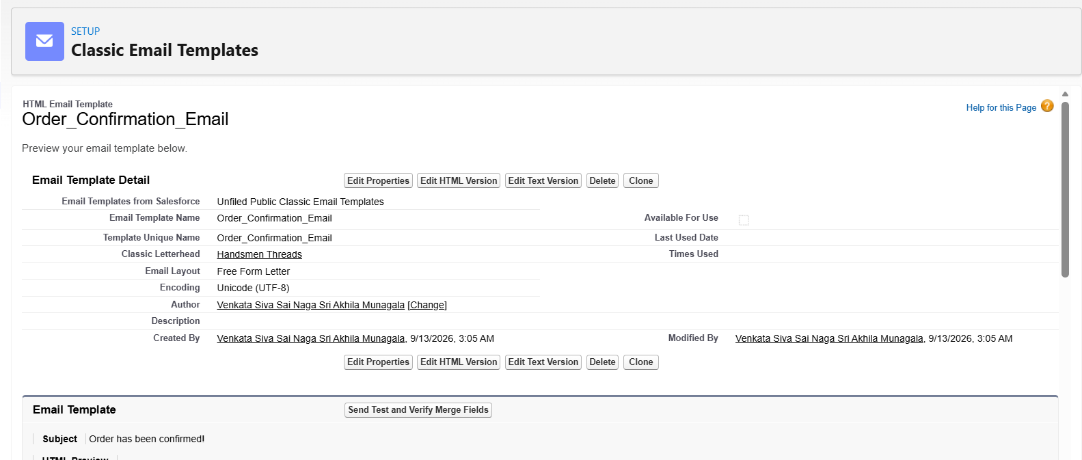
Figure 13. Order Confirmation email template.

8.2 Low Stock Alert
The Low Stock Alert template communicates that inventory has reached the configured low-stock condition and requires attention. It is connected to the inventory automation described in the next section.
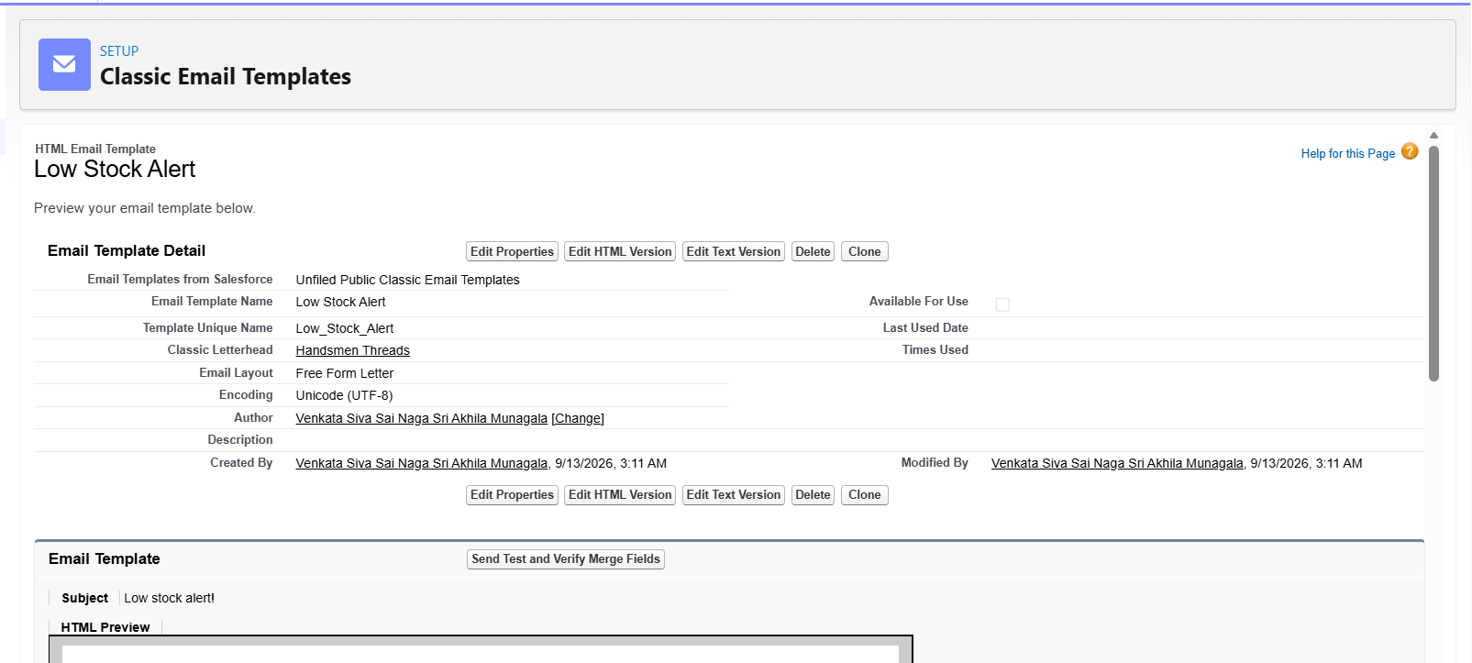
Figure 14. Low Stock Alert email template.

8.3 Loyalty Program Email
The Loyalty Program Email supports communication related to the customer’s loyalty status or program information. The template provides a reusable communication layer for loyalty-related automation.
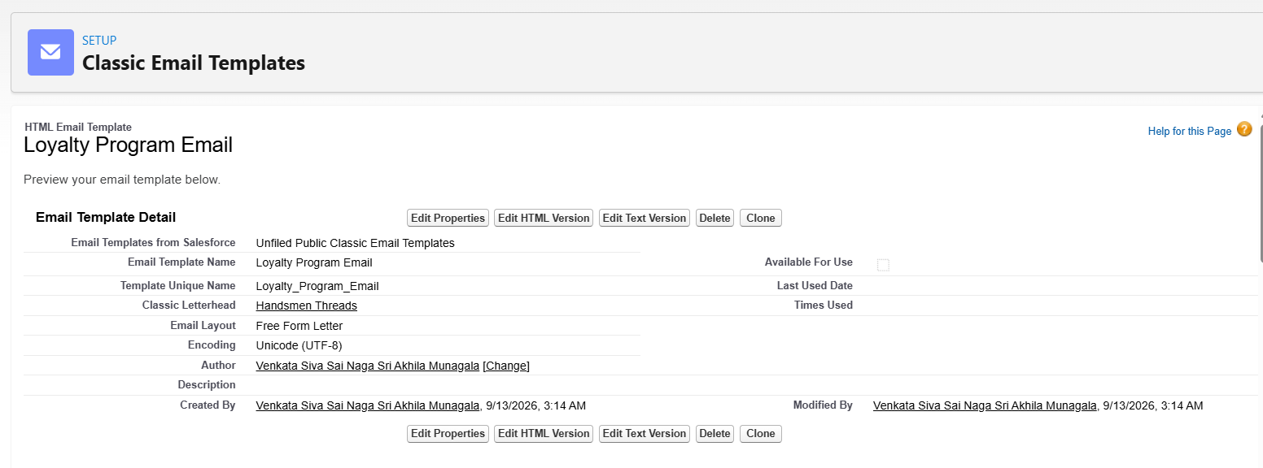
Figure 15. Loyalty Program email template.

9. Salesforce Flows
Flows provide the declarative automation layer of the project. The implementation contains record-triggered automation for orders and inventory and a scheduled process for loyalty-status maintenance.

9.1 Order Confirmation Flow
A record-triggered Flow is configured on HandsMen Order. When an order is updated according to the configured condition, the flow runs immediately and invokes the Send Order Confirmation Email action.
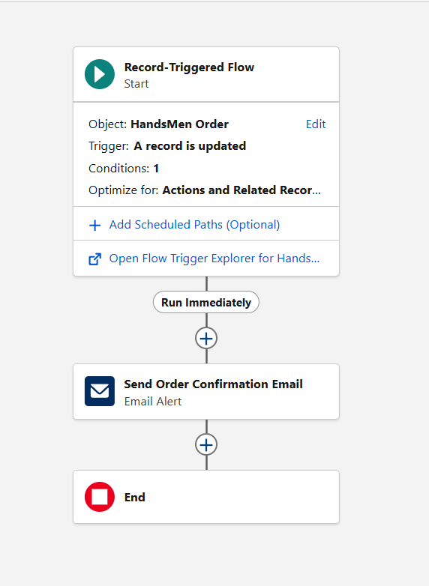
Figure 16. Record-triggered Order Confirmation Flow.

9.2 Stock Alert Flow
A record-triggered Flow is configured for Inventory. When stock meets the configured low-stock condition, the flow invokes the Send Stock Alert Email action. This reduces the need for manual stock monitoring.
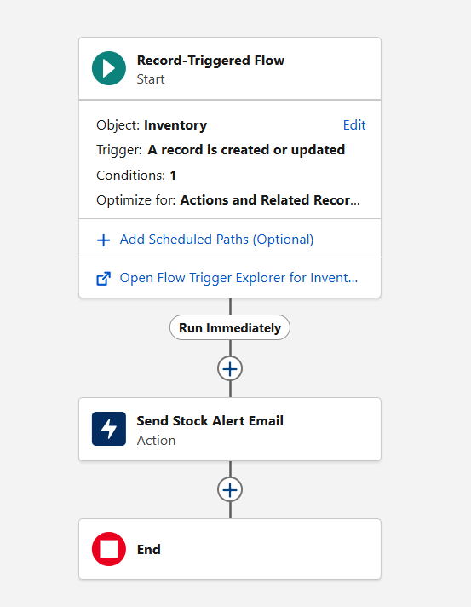
Figure 17. Record-triggered Inventory Stock Alert Flow.

9.3 Loyalty Status Update Flow
The scheduled loyalty flow retrieves customer records, loops through them, evaluates Total_Purchases__c and updates Loyalty_Status__c according to the configured ranges. The documented classification is: more than 1000 → Gold, less than 500 → Bronze, and values between those thresholds → Silver.
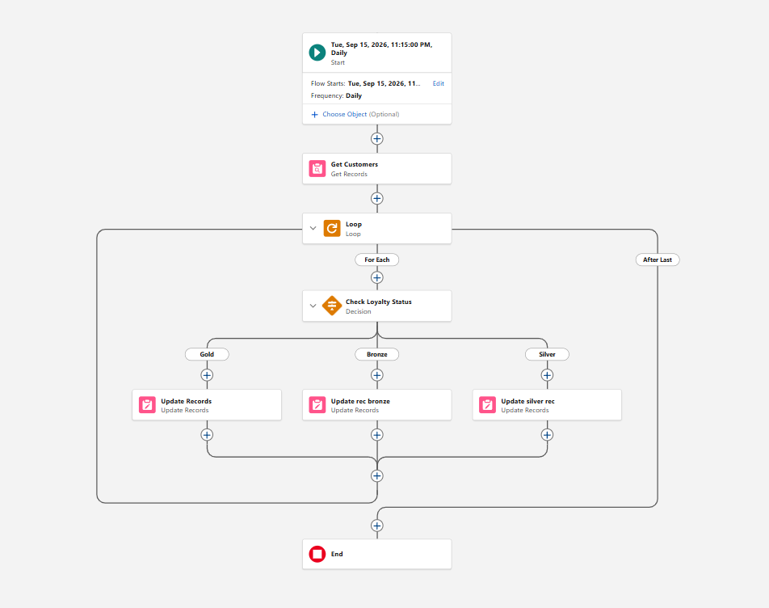
Figure 18. Scheduled Loyalty Status Update Flow.

10. Apex and Programmatic Automation
Apex is used where the project requires programmatic business logic or scheduled processing beyond the declarative Flow configuration. The implementation evidence includes order-handling logic and recurring inventory and loyalty processing.

10.1 Order Trigger and Handler
The order-handling implementation separates the trigger entry point from the handler logic. The handler performs status-based quantity validation and uses addError() to prevent an invalid order from being committed.
Figure 19. OrderTriggerHandler programmatic validation.
Figure 20. Continuation of the order validation logic.

10.2 Inventory Batch Processing
The project specification describes an Inventory Batch Job using Database.Batchable<SObject> together with Schedulable. The batch identifies low-stock HandsMen Product records and applies the configured restocking logic; the documented implementation increases stock by 50 units for qualifying products. It is scheduled daily at 2:00 AM.

10.3 Loyalty Points Batch
A Loyalty Points Batch is used for periodic loyalty-related processing. It is launched by the Loyalty Points Scheduler so that the processing can run automatically according to the configured schedule.

11. Scheduled Processing
Scheduled processing ensures that recurring activities do not depend on a user manually opening the application. The supplied Scheduled Jobs screenshot provides evidence that scheduled Apex jobs are configured in the Salesforce environment.
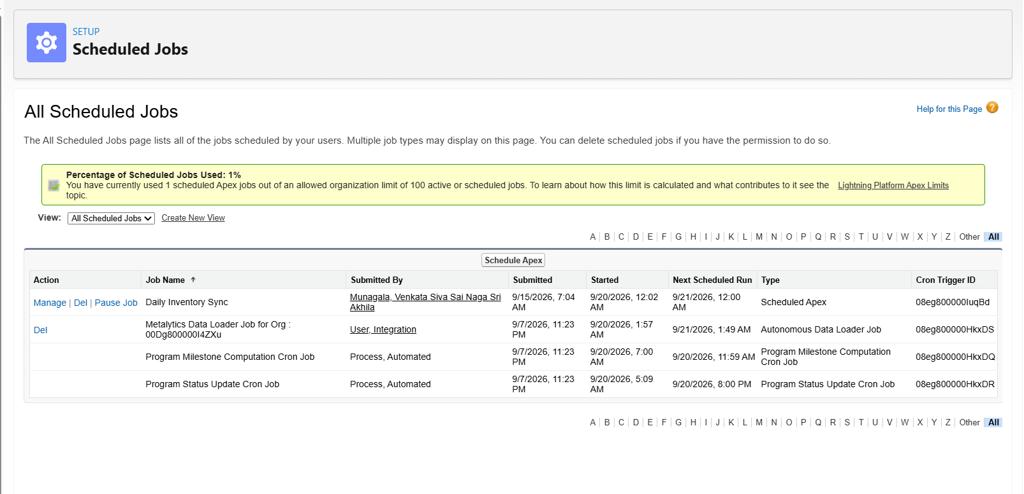
Figure 21. Salesforce Scheduled Jobs showing configured recurring processing.

11.1 Loyalty Points Schedule
The reference implementation schedules the Loyalty Points Scheduler as “Loyalty Points Calculation - Weekly,” running every Sunday at 12:00 AM. The job is verified through Salesforce Scheduled Jobs.

11.2 Inventory Schedule
Inventory synchronization/restocking is documented as a daily scheduled operation at 2:00 AM. This schedule supports periodic processing of products that meet the low-stock criteria.

12. End-to-End Business Workflow
The following sequence describes how the major components work together in a typical HandsMen Threads transaction. It is written as an implementation-oriented workflow rather than a copy of the reference document.
Step | Process
Customer creation | A sales user creates or updates a HandsMen Customer record. Validation rules check configured customer data requirements.
Product setup | Product information and stock-related values are maintained through HandsMen Product and Inventory records.
Order creation | A HandsMen Order is created and associated with the relevant customer/product information.
Business validation | Validation rules and Apex order-handling logic check the order amount and status-dependent quantity requirements.
Order confirmation | When the configured confirmation condition is met, the Order Confirmation Flow sends the corresponding email alert.
Inventory response | Inventory automation monitors stock levels and can send a Low Stock Alert when the configured threshold is reached.
Loyalty processing | The scheduled loyalty flow evaluates customer purchase totals and updates the loyalty status.
Recurring jobs | Scheduled Apex processes inventory and loyalty-related operations without requiring manual execution.
This workflow demonstrates the main design principle of the project: Salesforce records act as the central source of business data, while validation, Flow, email automation and Apex operate around those records.

13. Testing and Validation
The project includes multiple configuration points where behavior can be validated. Testing should confirm both successful processing and prevention of invalid actions.
Test Area | Expected Result
HandsMen Order amount validation | An order with Total_Amount__c <= 0 is prevented from being saved and shows the configured error.
Customer validation | Invalid customer data is rejected according to the configured validation condition.
Inventory low-stock automation | A qualifying inventory update triggers the Low Stock Alert action.
Order confirmation automation | A qualifying order status update triggers the Order Confirmation email alert.
Loyalty status automation | Customer purchase totals are mapped to Gold, Silver or Bronze according to the configured thresholds.
Order quantity Apex validation | Invalid status-dependent quantity values generate an Apex validation error.
Scheduled processing | Configured scheduled jobs appear in Salesforce Scheduled Jobs and execute according to their schedules.
Access control | Users receive the permissions assigned through their profile, role and permission set configuration.

13.1 Evidence from the Implementation
The supplied screenshots show the configured validation rules, permission setup, email templates, Flow diagrams, Apex code and Scheduled Jobs page. Together, these provide configuration-level evidence for the major functional areas of the project.

14. Results and Benefits

Centralized information
Customer, product, order and inventory information is represented within one Salesforce application, reducing fragmentation between business activities.

Reduced manual communication
Email alerts connected to Flow allow routine order and stock communications to be generated automatically.

Improved data quality
Validation rules and Apex checks prevent defined invalid values from being committed.

Controlled access
Profiles, roles and permission sets provide a structured approach to user permissions.

Recurring automation
Scheduled Flow and Apex processing allow loyalty and inventory activities to run without manual intervention.

Extensible platform
The design leaves room for dashboards, customer-facing experiences, richer loyalty capabilities and AI-assisted features.

15. Future Enhancements
The current implementation establishes the core CRM and automation foundation. The following enhancements can extend the system while preserving the existing object and automation structure:
- Customer portal for viewing profiles, orders, order status and loyalty information.
- Mobile-friendly workflows for sales and inventory users.
- Advanced dashboards for sales, inventory, customer purchases and loyalty activity.
- AI-supported product recommendations based on customer purchase history.
- Messaging integration for order, inventory and loyalty notifications.
- More advanced inventory forecasting and automated restocking strategies.
- Expanded loyalty rewards, points, membership benefits and personalized offers.
These enhancements are consistent with the future-scope directions identified in the project reference material.

16. Conclusion
The HandsMen Threads Salesforce project demonstrates how a Lightning application can combine custom data structures, security configuration, validation, Flow automation, email communication and Apex processing into one operational CRM solution. The implementation is centered on business records and uses automation to respond to important events and recurring schedules.
The supplied implementation screenshots show the configuration of the application, custom objects, validation rules, access controls, email templates, Flows, Apex logic and Scheduled Jobs. The resulting design provides a structured foundation for managing customer and fashion-retail operations while leaving clear opportunities for further enhancement.

Key Takeaway
The project is not limited to storing records in Salesforce; it demonstrates a complete automation-oriented workflow in which data entry, validation, notifications, scheduled processing and access control work together as a single CRM solution.

Appendix A – Screenshot Index
Figure | Evidence
1 | HandsMen Threads Lightning application
2–4 | Custom object Fields & Relationships: Customer, Order, Product
5–7 | Validation and configuration evidence
8–9 | Apex order quantity validation
10–13 | Profile, role, user and permission-set configuration
14–16 | Order Confirmation, Low Stock and Loyalty email templates
17–19 | Order, Inventory and Loyalty Flow diagrams
20–21 | Apex OrderTriggerHandler screenshots
22 | Salesforce Scheduled Jobs

