CS5700 - Project Assignment 2

Constraint Satisfaction Problems

You’ll exercise the map coloring problem through the Missouri County graph that is shared in Figure 1. You are allowed to use the colors: Red, Green, Blue, White, Black, Magenta, Cyan, and Orange. No adjacent states will be in the same color. If you can find the assignment with the least number of different colors, you get the FULL points. Please show me the steps in your solution and the Final mapping in the output screen.

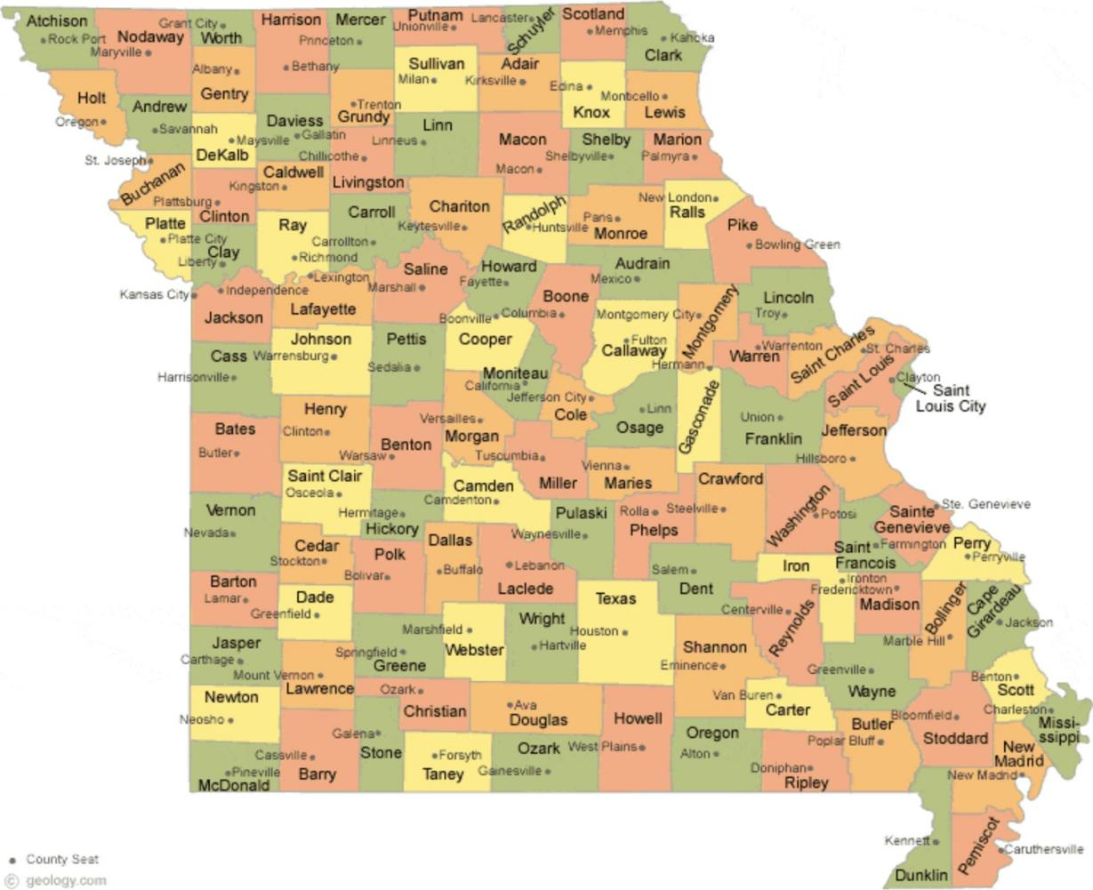

Figure 1: Contiguous Missouri graph

* You can start from any county that you prefer and keep going until all of the counties have been colored.
* No two adjacent counties will be in the same color.