CS5700 - Project Assignment

Graph Search Algorithms

# Exercise 1

Implement a Depth-First Search algorithm to find the path from the start node ’S’ to the goal node ’G’. Please consider the topology that is shared in Figure 1.

* Your implementation should correctly navigate this graph using DFS to find a path from ’S’ to ’G’.
* Your DFS algorithm should output the path from ’S’ to ’G’ as a sequence of nodes.

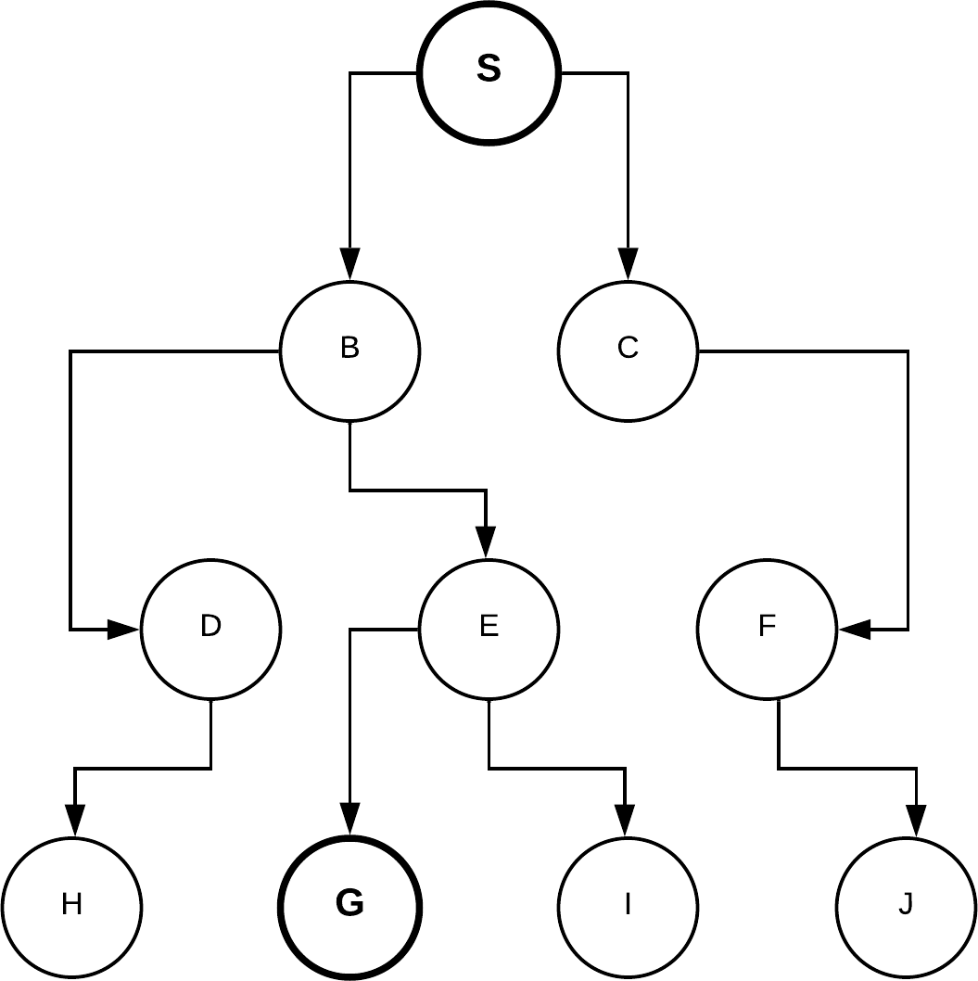

Figure1