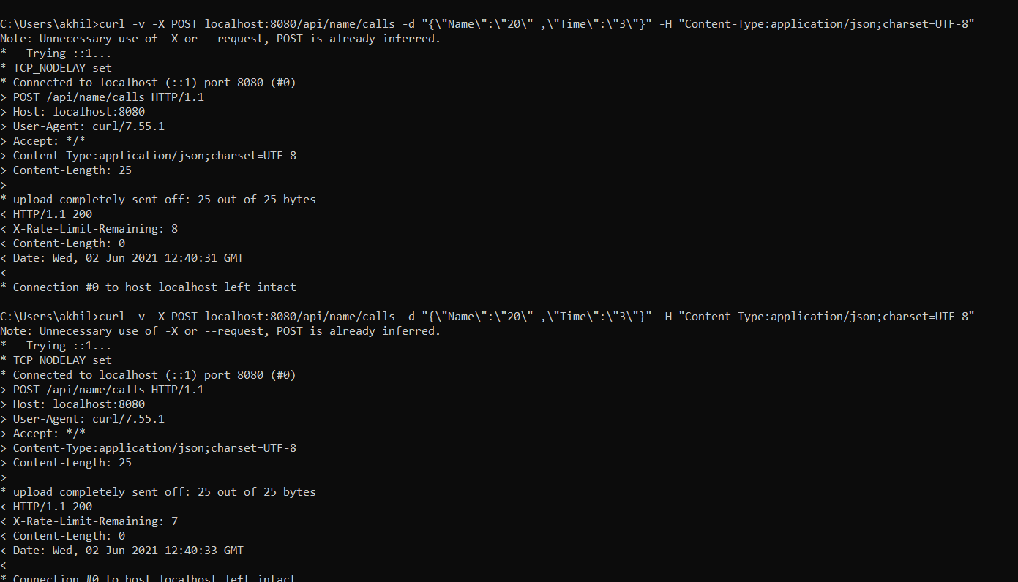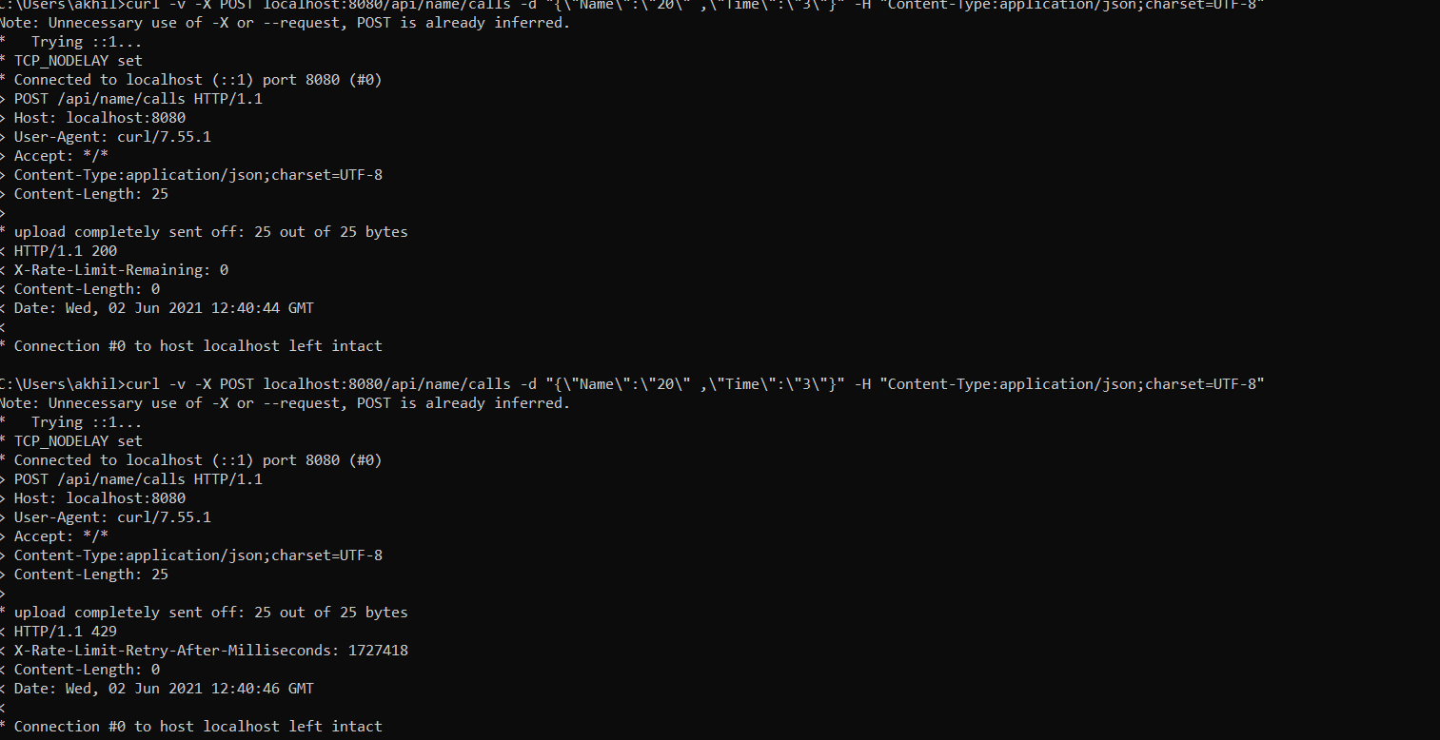  
  
  
Here I have restricted the Api call to 20 times per user per one hour   
  
solution: it gave us error after the user attempted it more than 20 times per hour.