Table of Contents

1. About Us 3
2. Track Record 3
4. Service Offering Portfolio 4
6. Project Goal 6
7. Scope of Work 6
8. System Features: 7
7.1.1 Type of users 7
2. Implementation of AI in Online Grocery Application 43
9. Assumptions & Dependencies 46
12. Backend Architecture 50
13. Design Standards 53
• Flat Designs Methodology: iOS - iPhone 53
• Material Design Methodology: Android Phone 53
14. Testing Standards 53
15. Delivery Standards 53
16. Testing Methodologies 54

Project Goal

The objective behind commencement of this project is to create online grocery delivery application facilitating doorstep deliveries of groceries and other home essentials in major cities of North America.
The platform will partner with many local stores to increase their revenue growth through online sale.
The app will let the users shop from local grocery stores online, to which a “personal shopper” will be assigned to fulfill and deliver the order at their doorsteps.

Shoppers will be the part-time workers. Shoppers will receive grocery request on their phone and shop all necessary items on behalf of the customer/user. They collect all mentioned items from the list and deliver it to the customer doorstep in a minimal time frame.

Beside that, the application includes a social channel connecting vendors and buys, creates a professional community for users. Sellers have a place to promote their sales, a tool to run their marketing campaigns through the social channel's features: stories, posts, videos. Store owner can add product tag/link to their images/captions to navigate buyers direct to the product's page.

In general, the ultimate goal of this project is providing DAAS ( Delivery as a service) for both customers and sellers; while additionally offering SAAS (software as a service) for sellers to help them managing the fulfillment process and marketing tools.

Scope of Work

Users
Users will be able to place their order through the app. They will select their preferable stores to order foodstuffs, write delivery instructions, and can pay by online using credit/debit cards. The app will allow user to mention tips for the shoppers. In the checkout mode, app will allow user to select suitable time slots to have their groceries delivered to them. Users will leave their options and place the order. Once the order is placed, the platform prompts the user with “Delivery (date)” as well as a message to add items before the order is delivered. The users can watch their Shopper as they pick items off store shelves, scanning items from their mobile app as they go, substituting items if not found, or giving the user refunds where necessary.
After that, the user will need to wait for their shopper to arrive at the delivery location. The user will rate the shopper substitutions and the shoppers too.

Shoppers type (delivery)
Their will two shoppers type, in-store shopper and full service shopper (referred as shoppers). In-store shopper will help the vendors for picking up items. Full service shoppers i.e. Shoppers will set the working hours and region in which they want to deliver groceries. The shopper will receive batch requests from app users and swipe to accept it. The shopper will reach the grocery store to start shopping. As soon as the shopper is appropriately navigated inside the store, the app guides ahead in picking items as per the order list. Once an item is found by the shopper, they click and mark it as found, moving ahead in the list. The shopper will scan the item’s barcode with their phone’s in-app camera. In-case of un-available items the shoppers will add the replacement item and let the customers know of the changes made in the order list. After completing the shopping the shopper will proceed to the checkout screen to swipe the card and do payment for the order. On swiping over the “Swipe to start delivery” slider, the app will create a route on the shopper’s navigation app. Following the directions, the shopper will be able to deliver the order with ease.

Grocers/vendors
The local vendors/stores will be provided with the web-based panel to create their profiles, upload their items with complete details. To increase sales and interaction will app users the grocers will promote their items in the form of stories which users can view, like and share with their family friends. The vendors will be able to view all the incoming orders and built up commission on each order.

System Admin
The system admin will oversee the entire system and will be provided with web-based panel to manage and control the platform. The admin will view all the registered users, shoppers and vendors on the app. The admin will do the background check of the shoppers. The admin will keep track of all the transactions that took place on the system. The admin will process payments of shoppers and vendors on daily/ weekly basis.

Exclusive Features:
    - Three languages (English, Chinese, Vietnamese)
    - Redesign of all screens and pages in high quality with practical approach and usability tests
    - Elastic Search

System Features:

7.1.1 Type of users
- End User/ Customer– Mobile Application
- Shopper types/delivery person- Mobile Application
- In-store shopper: a person is assigned for a specific store with high volume by Admin. He will be picking the items in this store during his scheduled shifts. After finishing check out step, he will transfer the items for a delivery guys. The concept and workflow would mostly be the same as restaurant delivery service. Who is a delivery guys here?

- Full service shopper (Shopper): this person will be responsible for both picking the items and delivery to the customers. In case a store has in-store shopper assigned, this person will take care only the delivery service.
- Vendors/Grocers- Web based panel
- System Admin- Web based Panel
      - End-User (Customer):
      - App installation
        - Users will be able to download the mobile app from Google Play and Apples iTunes. After downloading, app will be installed on user device.
        - User will launch the app and splash screen will be displayed as welcome screen each time the app is opened.

      - Sign-up/ Registration:
        - User will register on the system by entering following information-

- Full name
- Phone number (verified by the OTP)
- Email address (Needs to verify the email also)
- Postal code: The postal code must be valid This need to be verify by the client.
- Password
- I accept terms and conditions (checkbox)
- Sign up (button)
        - On submitting the above mentioned details, the entered mobile number will be verified through the received OTP. Once verified, user’s account will get created successfully.
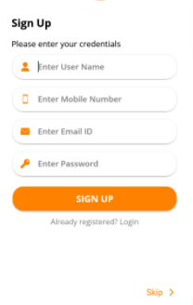

Fig: Sign-up Screen

      - Login:
        - User will be able to login via:
- Email and Password
OR
- Mobile number and OTP (sent to the registered mobile number)
        - User will be able to view their account after successful Login.
        - User will be able to request for their password in case they forget their password.

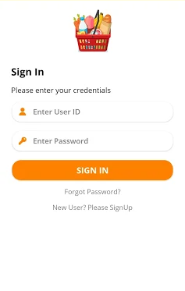
Fig: Sign-in Screen

      - Social Media Login
        - Users will be able to login to the system with their existing social media accounts such as Facebook and Google, Apple.
        - System will fetch the basic details such as username and profile picture from the respective social account.

      - Forgot Password:
        - Enter the registered email id and get the reset password link on email.
        - Set password

      - Location (ZipCode/ Address)
        - Zip Code: The app will request User to enter their zip code/postal code in order to check whether the app provides its services in that particular region or not
        - If the app avail it’s services in the specified region then it will display list of vendors/grocers (registered) that operates in that region.
        - If app doesn’t work for the given region then it will show a message to User stating ‘we currently don’t offer services in your region ’.
        - Map: The app will request user enter their complete address. The app will give address suggestion on map search where user can adjust and pin their actual location.

      - Purchase Membership
        - The user will be able to purchase the membership on the app in order to get following privileges-
- Free delivery
- Order at earliest- Within one hour or two
        - User will have to pay pre-defined membership amount mentioned to activate it.
        - The payment will be done online though credit/debit card. Third party payment gateway will be integrated with the system to process payments.
        - The user will be able to view status of opted membership plan such as-
- Name of plan
- Date of activation
- Date of expiration
- Description

      - View grocers/vendors
        - Once the User enters the zip code the app will display list of registered vendors that operates in that particular region or city
        - The grocers list will be displayed with following elements of information-
- Name of grocers/vendor
- Grocer/vendor logo (clickable)
        - On clicking the grocer’s logo, User will navigate to the item listing screen of that particular grocer/vendor.

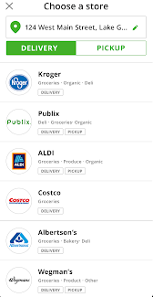
Fig: Choose a grocer screen

      - View Item (grocery) category sub-category Screen
        - On selecting the grocer from ‘grocer listing screen’ User will be re-directed to the item/grocery listing screen of that particular grocer
        - User will be able to look across all the category and subcategory of grocery and can select the desired one from it. For ex,
- Beverages
- Fruits and veg
- Baked goods
- Ice cream
- Snacks
- Dairy and milk products etc.
        - These categories will be further divided into sub categories; User will be able to view the item/grocery under them.
        - Grocery items: The items listed on the grocery listing screen will be displayed with following elements of information-
- Item name
- Item thumbnail image
- Price
- Discounted price
- Add to cart button
- Add to favorite (heart icon)
        - View stories: The users will be able to view stories uploaded by the respective grocers on their profile with video, image and caption.
        - The users will be able to like the story, comment on it or share it to friends on application.

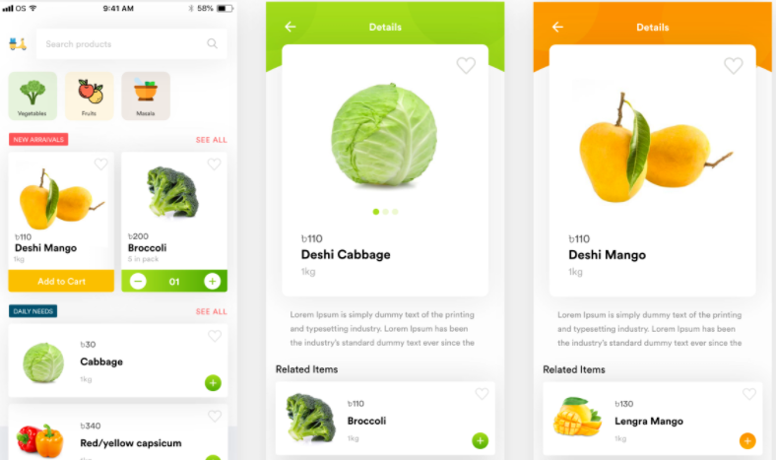
Fig: Grocery Item Listing and detail Screen

      - Search Grocery/item
        - Item/grocery search bar: User will be able to search the grocery item by-
- Item category
- Item sub-category
- Keyword searching
        - Based on the searched item, the search results will display items with product name, image and price.
        - Item description: On clicking on any item users will be able to view the description of the respective item as:
- Item Name
- Item Photo
- Description
- Item price
- Add Instructions
- Add quantity
- Add to bucket

      - Search result screen
        - Based on the entered keyword the search results will display following information:
- Image of the item (Thumbnail)
- Item Name
- Item Price
- Add to Cart
- Add to favorite (heart icon)

        - Users will choose desired grocery item which will redirect them to the item detail screen.
        - A list of categories/subcategories will be imported into database. Each item added by grocer will be assigned under these categories/subcategories

      - Item Detail Screen
        - The item detail screen will consist of following information:
- Item’s image
- Item Summary (if any)
- Price per unit
- Quantity selector
- Add to cart (button): After selecting the item and viewing its details, User will be able to add product to the cart.
- Add to favorite (heart icon)
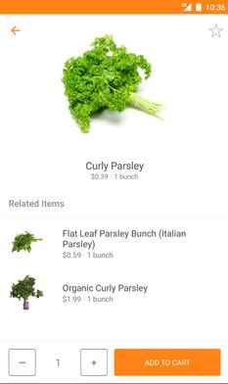
Fig: Add to cart screen

      - Shopping Cart
        - User will be able to view selected item (grocery) in the shopping cart.
        - The shopping cart will contain following information related to added item:
- Item Name
- Image ( small thumbnail image)
- Description
- Quantity
- Price per item
- Total Price
        - Actions on Shopping list: The user will be able to perform following actions on the shopping list:
- Add/remove: User will be able to add/remove and update the item list in the cart screen.
- Add instruction: The user will be able to add instruction for each item in the shopping list.
- Change quantity of item
- Add replacement: The user will be able to add replacement of the item, in case the item won’t be available at the store. The app will display similar items to add in list as a replacement for each item that already exists in the list. The replacement item will be displayed with item name, image, quantity (same as of listed item), and amount.
- Approve (button): On clicking the approve button, the respective item will be added as a replacement for the listed item in shopping list.
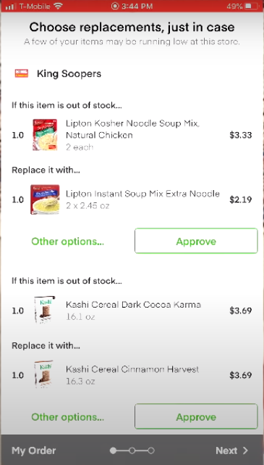
Fig: Item Replacement

        - Apply promo code: There will be option to apply discount code/promo code. When valid discount code is applied the cost will get reduced as per discount amount or percentage of that discount code which will be manageable by respective grocer.
        - Share the cart: The app will allow user to share the cart with family and friends by inviting them on the platform. The user will have to enter the email address and name of invitee/user. The cart link will be shared to the respective user’s email address. The user will have to download the application, log in and continue shopping in the shared cart.
        - After reviewing everything User will continue to checkout screen to proceed for payment.

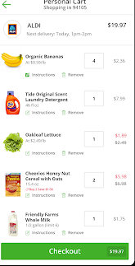
Fig: Cart Screen
      - Checkout screen
        - Users will be able to do final checkout by adding delivery address and doing the final payment by selecting payment method. Users will have to follow following steps to place a order-

- Sign up/sign in account: If the User is not logged in or guest user then he will be required to either login or register into the application in order to proceed further

- Select Delivery type: There will be following options of delivery available for users-
- Delivery: If user wants shopper to pick the ordered items from the store and get it delivered to his/her doorstep then can opt this.
- Pick-up: It will allow shopper to pick-up the item/groceries from store ultimately saving the purchasing time of user. The user can pick-up from the store premises once the order is done.

- Add delivery address (if delivery is selected): User will be able to either choose saved address or would provide new address. To enter new address user will have to enter following details-
- Address line: User will be able to add the address manually or using the integrated map by locating the location pin.
- Street
- Landmark
- Zip code
- Add delivery Instruction
- Mobile number/Email address
- Choose delivery time: User will have option to choose the delivery time or schedule the delivery for later date and time. For ex-
- For today: Within 2 hours, 3 hours- Based on the availability at the store.
- For later day: Choose date and time
- Add tip amount: The user will be able to add tip amount for shoppers. There will be some pre-defined options, such as 2%, 5%, 10%etc. The user can add custom tip amount in text field which will be sent to the shopper after successful completion of the order.

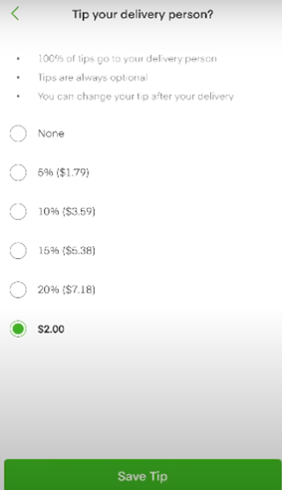
Fig: Tip the shopper

- Review order: The user will be able to review order before placing the order. The review order screen will display following information-
- Number of items in shopping list
- Name of item
- Price
- Price breakdown-
- Items subtotal
- Delivery fee
- Service tax
- Tip amount (if included)
- Service fee
- Deducted amount due to applied promo code/discount code.
Note: The users with membership will not get charged for delivery fee.
- Payment: User will be able to select the payment method for the order. There will be various options available such as bank transfer, credit card/debit card etc. Users will have option to save the card details for future purchase.
        - User will receive order confirmation message once the order is placed successfully.
        - The app will navigate the users to home screen with a dialog box designating their order delivery time and a link to their shopping and delivery order information.

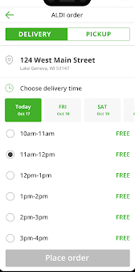
Fig: Select delivery date and time

      - Order Edition
        - Once the order is placed, the platform will prompt the user with “Delivery (date)” as well as a message to add items before the order is delivered.
        - User will be able to make changes in the order x minutes (let’s say 1 hour) before the delivery time. If the shopper has already continued shopping, then user will not be able to alter the order.
        - The user will either have to pay for the addition of item in the list or system will refund the amount against the removed item from the list.

      - Chat with shopper and replace items
        - The app will allow both user and shopper to communicate during the purchase of grocery items.
        - The user may get message from the shopper in case the item is out of stock or not available at the store.
        - The user will get following actions to perform-
- Approve replaced item (button): If the customer approves the item which has been replaced with item previously added to the shopping list by the user.

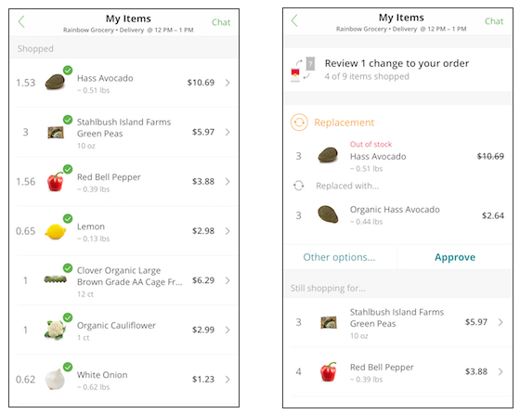
Fig: Item replacement Screen

- Refund (button): In case the user request for refund for out of stock item in the shopping list.
        - The successfully found items will be shown with a green tick-mark. The un-available items will be shown with replacement item requested by the shopper.

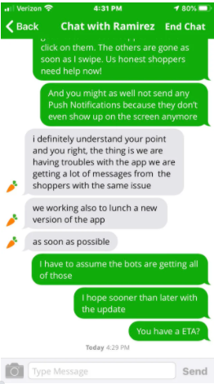
Fig: Chat Screen

      - Order Tracking
        - User will be able to track the order status through live tracking.
        - There will be following status associated with the order such as-
- Order received: When the order is assigned to the shopper
- In progress: This status appears when the shopper is actually buying groceries at the grocery store.
- Shopping complete: The status will be shown when the shopper is done with the shopping.
- In transit: If the shopper is heading way to user’s location, then it will show this status.
- Complete: Once the shopper delivers the order at user’s location, the complete status will be shown.
        - Once the order is placed, User will view the details of assigned shopper details such as-
- Shopper name
- Shopper profile picture
- Call button
- Message button: User and shopper will be able to chat with each other in case the items in the shopping list are out of stock.
        - The user will be notified when shopper enters the store and start buying the groceries.
        - At the time of delivery the user will be able to track the shoppers’ location on in app map along with ETA.
        - On completion of the order, the revised order amount will get deducted from user’s amount.

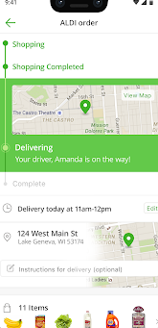
Fig: Order Track Screen

      - Pick-Up Orders
        - The user will be able to pick up the order from grocery store once the shopper has pick-up the groceries.
        - the pick-up order screen will display following elements of information-
- store name
- directions: There will be in app-google navigation to get directions.
- Day and time of order (let’s say today, 2 pm)
- You order: Number of items in the order
- I’m at the store (button): The user can tap this button to notify the respective shopper that he/she arrived at the store.
- I’m on my way (button): The user can tap this button if he/she is in transit.
        - The user can pick-up the store and mark the order done. The payment amount for the order will get deducted from the user’s account. Shopper will also notify

      - Rate the shopper
        - On the completion of the order, the user will be requested via notification to rate the shopper from 1 to 5 star, after certain time (7 days or so).
        - User will be able to manually rate the store as well.
        - The ratings will get recorded for the respective order and will influence the average rating of the shopper.
        - The user will also be able to rate the replacement/substitutions done by the shopper.
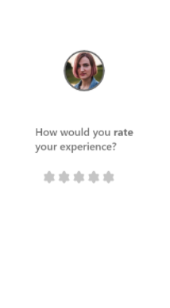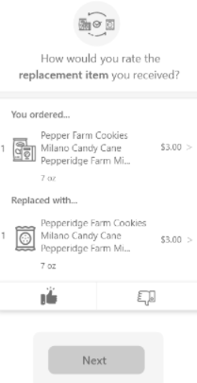
Fig: Rate The Shopper Screen

      - My orders
        - User will be able to view the list of current and past orders in chronological order from this section
        - The listed orders will be displayed with details such as –
- Order ID
- Order date
- Total ordered items
- Order amount
- Store name
- Current status
        - User will be able to view the details of order by tapping on it. The user will navigate to the order detail screen.
        - Actions: User will be able to perform following actions on the order:
- Change order (conditions applied): The user will be able to edit/add or change the quantity of grocery items added in the shopping list.
- Edit replacement: The user will be able to change replacement items for the shopping items through this option.
        - User will be able to filter the orders by time range, order status and order id.

      - Profile settings
        - Profile settings: User will be able to add/remove/change their personal details anytime they want. Users will be able to set-up/create their profile by mentioning following information-
- User name
- Profile picture
- Email address
- Phone number
        - Address: User will be able to add/ edit address.
        - Cards: User will be able to view his card details and add/ edit new cards for payments to make it default payment method.
        - Password: User will be able to edit password by entering old password and then new password.

      - Notifications:
        - General notification: Users will get system generated and custom alerts or admin side notifications on various events in the app-
- When order is placed
- When shopper is assigned to the order
- When the status of ordered item gets updated
- When shopper reaches the store and start the purchase
- When order item is not found
- When shopper request the replacement item
- When the order gets successfully delivered

        - User will get notifications for similar grocery item based on most viewed, shortlisted and searched items (ML)
        - Users will receive notifications that are sent by the admin.
        - The notifications sent by admin will remain in the history for 7 days.
      - CMS screens
        - The app will consist of various static informational screens for assistance of users such as-
- About: Users will be able to view information about the services the app is providing and how the application works?
- Privacy policy
- Terms and conditions
- FAQ
- Contact us

    - Grocer/vendor Panel
The grocer/vendors will have a web based panel to access the features.

      - Sign up
        - Grocers/Vendors will be able to register on the web panel by filling up following details. Once approved by the admin, they will be able to manage item catalog and receive orders.
        - To create an account, grocer will have to input following details-
- Name of grocer/vendor
- Upload company logo
- Short description
- Business owner name
- Open-close time
- Add availability time-slots for each weekday
- Upload ID card for authentication
- Accept terms and conditions
        - On submitting these details, the account will be created but will remain in-active until its approved by system admin

      - Login
        - Admin will also be able to create the grocers/vendors account and share the credentials over email
        - Vendors will be able to login by filling the following details:
- Email address
- Password
        - Vendors would be able to request for their password in case they forget their password.

      - Change Password:
        - Enter Old Password
        - Set New password

      - Profile Setup
        - Grocer will set up their profile by submitting required fields such as –
- Store/company name
- Company logo
- Banner Images upload
- Contact number: Grocer will add more contacts on clicking the “add more” button.
- Alternate email
- Location ( name of area) or enter zip code: Grocer will add the zip code under which he/she provide services
- Store address
- Availability time-slots
        - Vendor will be able to update profile details when required

      - Item/grocery management
        - Item management section will allow the vendor to manage all the grocery items they have listed through their account.
        - Vendors will be able to add/edit/delete the items.
        - Vendors will be able to add new items by entering following details:
- Assign Category ( from predefined list)
- Assign Sub category ( from predefined list)
- Upload product/item image
- Name
- Quantity Description ( whether in 6 packs, 100 etc)
- Measurement value ( gms or gallon etc )
- Item price per unit
- Add replacement/similar item: The vendor will be able to load replacement items for each item created.
- Create barcode: For each item, the system will generate the barcode that will consist of item’s information.

The system wont generate the bar code, CSV upload of barcode.

        - Vendor will be able to view all the listed items and add, edit the details.
        - Vendors will be able to remove items from inventory except if there is a order in progress for that particular item.

      - Stories Creation
        - The vendors will be able to create stories to promote their business and products.
        - To add a story, vendor will have to enter following details-
- Upload story/image
- Add Text
- Create story (button): On clicking this button, the story will get posted on the profile which will be visible to the users on the platform.
        - The story will remain on the profile for 24 hours. The vendors will be able to view total view, total likes and comments on it.
        - The vendors will have option to reply on the comment from app users.

      - Promotion/coupon code Management
        - Vendors will create promotion or discount code to redeem via points in following manner-
- Coupon/discount/gift code
- Maximum order value **That need to be correct.
- Type: Percentage of discount, cash back, credit
- Maximum usage/redemption number
- List of targeted users (CSV file)
- Expiration date
- Activating/De-activating option

        - Vendors will be able to edit/update, remove or deactivate any these coupon code

      - Order management
        - Order management section will allow vendors to view list of items ordered by users.
        - The orders placed from the users will be displayed to vendors
        - Vendor will view order list with following details:-
- Order Date: This is the date on which the order was placed by the user.
- Order No
- Total no of grocery items
- Total price
- Time of order placed
- Delivery date and time slot
        - On clicking on any order, will open the details of that order such as
- Item Name
- Each item Quantity
- Price per item
        - With each order, vendor will be to view & filter according to status such as-
- Order received
- order in-progress
- order complete
        - Vendor will be able to search any order by dates or by entering keywords

      - Profile (My account)
        - My Profile: Vendor will be able to view their business details as their name, email id, store location, phone number, etc.

        - Earnings: Vendor will be able to view all the pay-outs (commission) on the orders and filter them by monthly, weekly, yearly basis.

        - My bank Details: Vendor will be able to add their bank account details in the section to get the online payments from system admin by the end of the month.

    - Shopper Application (Full Time Shopper)
The shopper will use a shopper application to pick up and deliver the ordered item to the user. The high-level features are listed below:

      - Registration
        - The shopper will be able to register themselves by entering following details-
- First name
- Last name
- Email address
- Cell phone number
- Zip code
- Referral code (if any)
- Continue (button)
        - After submitting the details the, shopper will get registered into the system.

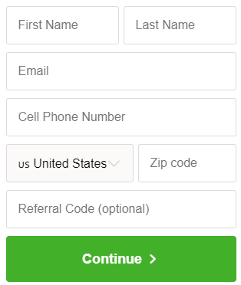
Fig: Sign-up Screen

      - Login
        - The shoppers will sign in by entering the credentials details i.e.
- Email id
- Password
        - After login, shopper can navigate through the application.
        - Shopper will also be able to use forgot password functionality in case the password has been forgotten.

      - Background Check
        - The app will request shopper to enter following details in order to clear the background check-
- Bank account details
- Upload identification proof document
- Upload driver’s license document
- Identification number
- Shopper preferences- Full service/half service (pick-up orders)
- watch training videos
- Agree with terms and conditions of the application and background check.
        - On clearing the background check the shopper will be issued a physical/digital debit card from the platform to make payments for the groceries.

      - Dashboard
        - The dashboard will display following elements of information-
- Promotions- Ex, on completing 25 batches in any zone
        - Select shift hours: The app will prompt the shopper to enter shift hours within which he/she will be delivering groceries to the customers.
        - Shopper will be able to view various information on the dashboard such as-
- View scheduled and current orders
- Messages from customer/user
- Total earning etc.

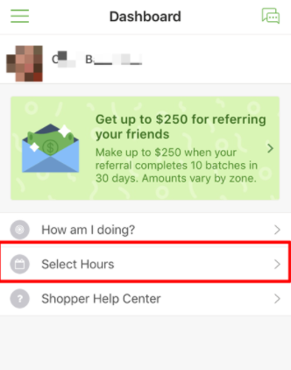
Fig: Dashboard Screen

      - Refer A Friend
        - The shopper will be able to refer the application to family/friends and get referral amount.
        - The app will display referral code which user can share with his/her friend. When his friends opens the application and enter the referral code along with other terms such as- complete x batches in x days, then both the referrer and the referee will get the referral amount.

      - View order Requests
        - A shopper will be able to view scheduled orders listed as per the shift timings declared by him/her. The shopper can also pick an order from the list as per the scheduled time of delivery.
        - The shopper will receive order requests based on the region and the shift timing selected. A full service shopper can receive up to 2 orders at a time, based on some criteria:
- If the 2 orders at one store, and the 2 customers live nearby each other (ideally 5 minutes driving)
- If the 2 orders for the same customer, and the 2 stores location are nearby as well.

        - The shopper will be able to view the batch (combined 2 or 3 orders) or order details i.e.
- Store name
- Store’s location
- Miles away from shopper’s location
- Number of orders
- Order type: Full service or pick-up only
- Total items\units
- Earning estimate: The earnings will be shown based on number of items in the shopping list along with the tip amount by user.
- Date and time or time slot
        - Shopper will either accept, or decline the request. The customer will get notification for the same. What if shopper canceled the request?
As we have mentioned that a full time shopper can only accept two orders at a time but what if there are only single shopper at a particular location and he is fully booked at the time?

        - There will be following scenarios associated with the order requests such as-
- If the schedule is filled with two Shoppers, the first Shopper to have signed up for these hours will receive the first request.
- If more orders become available, subsequent orders will be assigned to the second shopper.
- In some cases, the shopper may or may not receive a second order. But as soon as the request is received, it is assigned to the next shopper.
        - Accepting the order: There will be following cases:
- If a shopper is on a schedule in the region when a batch or shop request appears, the shopper can choose to accept the order with a countdown timer lasting 4 minutes.
- In case the shopper does not accept, the platform prompts a request for a reason why the order was not picked.
- If the shopper is not on schedule in the region and the order was pushed to On-Demand, the shopper will just see “Accept order” for a single-batch request.

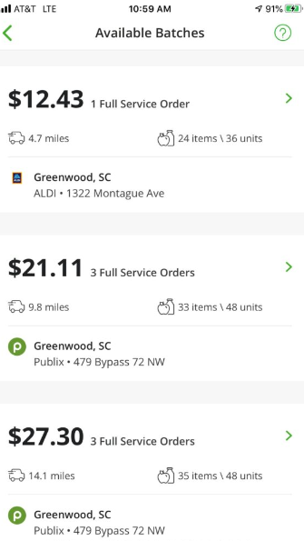
Fig: Order Requests

      - Order pick-up and delivery
        - Shopper will see the “heat area” on the map with the highest order frequency.
        - Shopper once view the order will reach the store’s location to pick-up the grocery using google map navigator.
        - Once the shopper reaches the store, he/she will update the status as “arrived at the store”.
        - Slide to start (button): The shopper will tap the start button as soon as he/she start the purchase.
        - Filling the order: As soon as the shopper is appropriately navigated inside the store, the app guides ahead in picking items as per the order list:
- On sliding the bar to begin shopping, the app will display the shopping list of current order.
- The item will be listed with name, image, quantity and description (location to find in store), price. There will be following options-
- Found item (button)
- Can’t find the item (button)
- Message customer (button)
- On clicking “found item” button, the shopper will have to scan the barcode of the item at the store.
- Done tab: As the app scans the barcode, this item will either be sent to the shopping list as a success or, in case of a wrong item, the app will suggest what it thinks the shopper has scanned, further guiding him to look for the right one.
- Not found: If the item in the shopping list is not found, the shopper can either look for the replacement item and can scan the bar-code to send it for customer review or if the customer/user has already added replacement while placing order which is available at store, then he/she can simply scan the bar-code to add it as a replacement.
- Review tab: The shopper will be able to view the status of substitutes added by the shopper in the review section. The user can either approve the replacement item or can request for refund. In-case of refund, the earning of shopper will get affected.
- As the user is done reviewing changes made by the shopper, the app indicates “All changes have been approved by the user”, with a number of other responses as per user approval.
- To-do tab: The to-do tab will display the items which are yet to be added in the cart by the shopper.
        - As soon as the order is approved by the user, the checkout process begins.

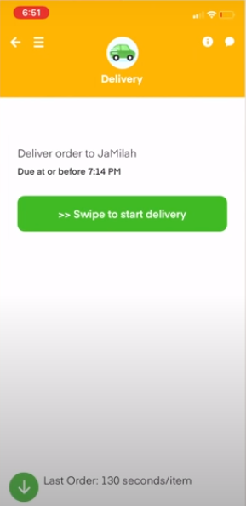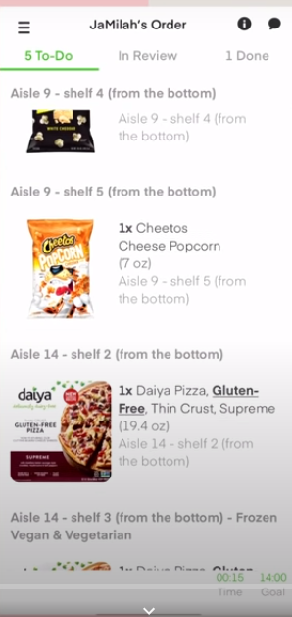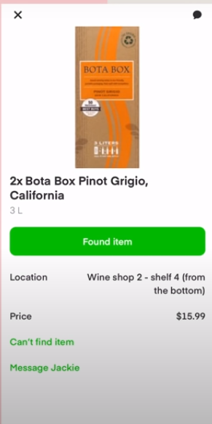
Fig: Filling Orders

      - Checkout
        - The app will issue a code with the shopper which he/she can present to the cashier at the store.
        - Swipe the card (optional): The platform will provide a debit MasterCard to the shopper that can be swiped for the order in a dedicated checkout lane and card machine.
        - Once the card is swiped, a total appears on the app screen, which when accepted deducts the amount from the shopper’s wallet and allows them to be on their way.
        - Receipt check: The ‘Complete the Receipt Check’ screen will request the shopper to enter the barcode details of the grocery receipt.
        - The shopper’s phone reads this barcode data and enters it into the shopper’s app.
        - This sends the shopper straight to the delivery screen where the receipt is used for reconciliation.
        - Start delivery (button):
        - On swiping over the “Swipe to start delivery” slider, the app creates a route on the shopper’s navigation app.
        - Following the directions, the shopper is able to deliver the order with ease.
        - Once the shopper is out to deliver the package to the user, the convenience is transported at their doorstep.
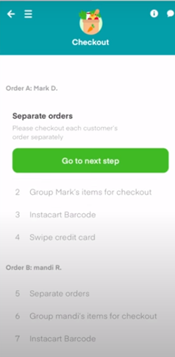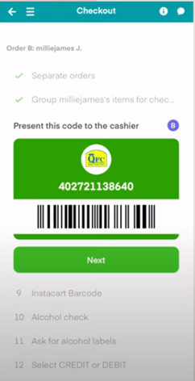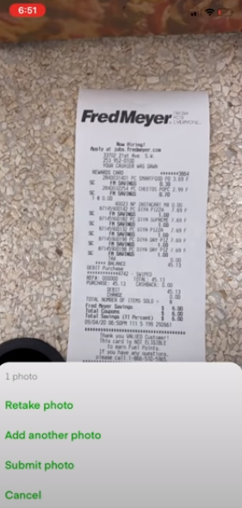
Fig: Checkout Screen

      - Chat & Call With Customer
        - The shopper will be able to chat with the customer while filling the order in case the items in the list are not available and checking for replacements.
        - The chat will be one-to one and text/image based.
        - The shopper will be able to call the customer.

      - Pick-up Orders
        - In case of pick-up orders the shopper will only purchase the items and will head to the parking area of the store to deliver the groceries to the customer/user.
        - The pick-up screen will display following elements of information-
- Order due time (let’s say 2pm)
- Order item number/unit
- Vehicle details
- ETA of the customer/user
        - The shopper can mark the order complete.

      - Take Survey
        - The app will collect the shopper’s satisfaction level from the survey asking “how was your last shift”
- Great
- Okay
- Bad
        - The admin will review the Shoppers’ data to assess the total speed of the shift, along with total orders shopped and items picked.
        - The shopper can use these stats to better the entire run for the shopping as well as the delivery.

      - My orders
        - Shopper will be able to view the list of all orders (completed/ongoing).
        - The order summary screen will display following elements of information-
- Day and date and start time
- Distance covered on map
- Estimate earning
- Distance from shopper’s location
- Order type
- Number of items
- Batch payment breakdown-
- Distance fee
- Batch incentive
- Customer tip
- Total amount
        - Shopper will be able to filter the order by status, date range and order id

      - My Earnings
        - The shopper will be able to view his/her earnings from this section on each batch/order.
        - There will be following information available on my earnings screen –
- Current wallet balance
- Cash-out balance: The amount which shopper can withdraw from the account. There will be fixed amount of money which shopper will be able to withdraw at a time.
- Total collected tip amount
- View transaction history
        - The shopper will get the commission amount on weekly basis from the system admin.
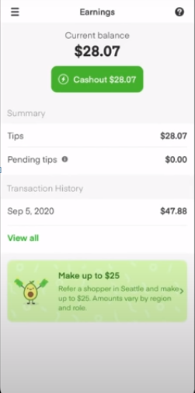
Fig: My Earnings

      - Account Settings
        - Shopper will set up their profile by submitting required fields such as –
- Picture
- First Name
- Last Name
- Email Address
- Contact number
- Upload required document:
- User identification document
- Driving license
        - Add bank details: Shopper will be able to add bank details to receive payment from system admin
        - Profile Details: Shopper will be able to edit and update their basic information.
        - My Vehicle: The shopper will be able to add his/her vehicle details such as vehicle name, type, color model etc.
        - My Earnings: Shopper will be able to view their payouts (based on defined commission and customer tips) on weekly, monthly and yearly basis.
        - Change Password – Shopper will be able to change the password.
        - Logout – Shopper can logout from the application.

      - Notifications
        - Shopper will receive notifications in the below scenarios i.e.
- When receive new order/batch request
- When they start and complete the order

    - Admin Panel

      - Log In:
        - Email id
        - Password
      - Forgot Password:
        - Enter the registered email id and get the reset password link on email.
        - Set password
      - Dashboard:
        - Admin will see the dashboard where the stats of daily sales, daily orders will be shown. This will provide an insight for daily or monthly activities done on the portal.
        - Admin will be able to see summarized stats on the dashboard such as-
- Total orders
- Total ongoing orders
- Total completed orders
- Total registered users
- Total Active users
- Total registered drivers
- Total online shoppers
- Total registered grocers/vendors
- Total revenue
        - Clicking on any of the above stats will redirect the admin to its related section.

      - Social Media Management
        - Admin will be able to view all the social media posts on the platform including the other activities.
        - Admin will be able to delete/ block/ unblock any posts/ comment as required.
        - Admin will be able to block user’s as well from making a post/ comment.

      - User Management
        - Admin will be able to view when the user joins the platform.
        - Admin can view the all the details of users including their personal details, orders and payment method.
        - Admin will be able to manage accounts handled by the users.
        - Admin can check the number of active users on the app.
        - The admin also holds the right to block the users from the platform.

      - Commission Management
        - The admin will define the commission of shoppers and vendors on percentage or value basis.
        - The admin will be able to edit/update the commission anytime.

      - Vendors management
        - Admin will add the vendors from this section and can send the credentials on their email address
        - Admin will be able to approve/reject the registration requests of the vendors.
        - Admin will be able to add/ remove and manage vendors on the platform.
        - Admin can view the passwords of all the vendors
        - Admin can define the commission for each vendor
        - Admin will be able to view all the details of each vendor including the orders, payments, built up commission and product catalogue etc.
        - Admin can block/unblock vendors.

      - Shopper management
        - Admin will view all registered shoppers on the platform with profile and other details such as-
- Shopper name
- Shopper email address
- Shopper phone number
- Shopper vehicle details
- Postal code
- Bank details
        - The admin will do the background check of the shoppers and accept/decline the requests accordingly.
        - Admin can block/unblock drivers from this section.
        - Admin will be able to view the list of orders assigned to any shoppers on date basis and see the details.
        - Admin will defile the commission for drivers based on value or percentage basis.

      - Membership Management
        - The admin will be able to view current membership plans on the app with details such as- plan name, description, features offered, price.
        - The admin will view list of subscribed users from here along with following details-
- Name of user
- Contact details
- Plan name
- Activation and expiration date of plan
- Total free delivery orders etc.
        - The admin will be able to edit/update membership plan prices from here.

      - Item category/sub-category management
        - Search/ list categories: Admin will search and list all categories at one click.
        - Activate/ de-activate categories: Admin will be able to activate/ deactivate the categories of products/services.
        - Edit /Update categories: Admin will be able to edit or update the categories through this option.
        - Add new category: Admin will add new categories he/ she want to add.
        - Category Form will have the following:
- Category Name
- Short Information
- Image
- Detail Information

      - Referrals Management
        - The admin will define the referrer and referee share for each referral by shopper.
        - The admin will be able to edit/update the referral amount anytime.

      - Location Management
        - The admin will be able to add new service areas i.e. cities
        - Admin will able to add certain service zones (areas by zip-code) in the city and also able to block them.
        - Admin will also be able to adjust the radius for booking.

      - Items Managements
        - Admin will view all the grocery items listed by the vendors/grocers
        - Admin will be able to view all the details related to items
        - Admin can edit the item details except the price.
        - Admin will be able to delete any item from the system.
        - Admin will able to filter the items according to vendors, category or sub/category.

      - Orders Management
        - Admin will be able to see all the incoming orders into the system with details such as-
- Store name
- Store’s location
- Customer (s) name
- Customer location
- Shopper name
- Shopper travel journey on map
- Number of orders
- Order type: Full service or pick-up only
- Total items\units
- Date and time or time slot
- Payment breakdown
- Shopper’s commission
- Vendor’s commission
- Order receipt
        - Admin will view the order status of each order/batch.

      - Transactions and pay-outs
        - Admin will be able to view transactions (for orders/batches) that has taken place on the system and view details
        - Admin will be able to view total pay-outs of shoppers and vendors.
        - Admin will be able to view total generated revenue by the system.

      - Notifications Management:
        - Admin will be able to manage all the notification
        - Admin will be able to send custom notification to the users, shoppers and vendors with attachments (picture/ file).

      - Settings:
        - Admin will be able to edit the profile.
        - Admin will be able to change the password.
        - Admin will be able to logout from the platform.

Implementation of AI in Online Grocery Application (Optional)

  - Customer Centric visual Search
Visual search and image recognition can be used to narrow, contextualize and ultimately improve search results for online shoppers. This enables customer-centric experience by focusing on visual elements of the search unlike traditional alphanumeric search engines that require specific information to reach the desired result
For example, is Pinterest’s recent update that allows users to select an item in any photograph online, and then request the system to show similar results using image recognition software.

  - AI for online grocery search
Nowadays the performance of any restaurant, cafe, or grocery store is dependent upon their ratings and reviews on the internet. Most of the time customers get to know about them through google map or search.
In these scenarios, the foodservice solution uses AI that offers to combine data from different grocery delivery programs to give users adequate information about the grocery store that might be of his/her interest and relevant to the location.
Not only this, Google maps has added a new enhancement that uses AI to spotlight the most popular items at grocery stores.

  - Route Optimization
In an on-demand grocery delivery system, it is very important to minimize delivery time and cost.
With the help of the locus route optimization engine, it takes into account various real-world factors such as weather, traffic, delays, and roadblocks and generates optimal delivery routes.
An optimal delivery assignment to the delivery agents can be backed by AI. It eliminates the manual task of decision making and provides flexibility in planning on-demand deliveries such as multi-hub drop-offs, reverse pickups, and many more.

  - Improve recommendations for customers
By implementing AI in the system, the system can smartly scan through a large amount of data (petabytes). This level of intelligence is essential in delivering a personalized shopping experience for the customer. The algorithm intakes a variety of inputs such as customer preferences, account information, contextual information, purchase history, and 3rd party data as well. This allows the retailers to send more personalized messages and recommendations for their customers.

For ex, the app might highlight gluten-free products for a gluten-free shopper or kid-friendly snacks for a parent. The app can also provide personal pricing and alert shoppers if an item on their shopping list are on sale.

  - Content Feed Personalization
Automation of the various routines is one of the many benefits of machine learning. A great example of implementing machine learning in grocery delivery system is personalization. This can adjust the entire appearance of e-commerce to meet a particular customer's requirement and preference.

The prime focus behind personalization with AI in the online grocery business is greater user engagement that causes better customer experience with more conversions rate. It takes note of customer's product purchase patterns, searches, product views, and interactions with ads etc. All this useful information is gathered and classified by various machine learning algorithms and matched with system's database to bring out relevant stuff.
This result in personalized product feed, related suggestions, special offers, and targeted ads.

  - Location Based Algorithm
The location based algorithm will automatically list the grocery items based on the user’s entered location.
  - Personal touch with chat bots
A chat bot is a computer program that stimulates conversation with humans over the internet to complete specific service(s). Chat bots for online grocery delivery platform are typically designed to-

- Complete buyers purchase by automating order processes
- Personalization: It collects data about customers and makes better food item suggestions and recommendations
- Provide valuable 24X7 customer support solution

  - Analysis and Analytics
Analysis by the system will provide valuable insights and further analyses in-depth detail about the visitors on the platform that will be useful to app owners to shape the campaign strategy of the business further.

KPI collected in the process:
- Number of visitors
- Ratio of new/returning visitors
- Session duration
- Average page speed
- Average time on post
- Click through

ML Action Points: To be Implemented*
Based on the collected data and analyses following will be actions taken by app and outputs available to the various user types.

  - For customers:
Based on the above analytics and user behavior, system will:
- Customer centric visual search: Visual search within the app for customers
- Grocery search: Identification of most popular items in the store and sharing with the customers.
- Route optimization: App will share the most optimal route on the map
- Improve recommendations for the customer: App will learn from user buying behavior and share relevant product data as required.
- Content feed personalization: Customer will receive content/ search and product recommendations based on the buying behavior
- Location based algorithm: Location based recommendations
- Personal touch with chat bots: Third party Chat bot API will be integrated
- Analysis and analytics: Collection of the data and auto analysis algorithms.

Send relevant notifications, email or SMS offering relevant grocery items and offers. The notifications can be at (all based on user behavior):
- Recommending grocery items based on past orders and searches
- Suggesting grocery items based on search preferences
- Item listing in feed
- Reminder for not logging in x days
- Content upload by admin

  - For Admin: The system will share analyzed data with the admin in organized form. The data will be filter able using the various filters as
- Most/ least active users
- Most visited properties
- Most enquired properties
- Locations with most user activity

  - Based on provided admin will be able to send out custom notification or content to the users.

Assumptions & Dependencies
  - All the copyright information like content, images, stock animations, stock videos text, etc. will be provided by the client.
  - The mobile application will be developed in portrait mode (mobile) only. Languages will be: English and Vietnamese/ Chinese
  - The proposal includes the development cost of application as per the features provided. It does
not include any costing related to hardware or domain hosting or any 3rd party API integration or
other costs which may or may not be required at a later stage and are not envisioned at this point of time. Please note that if we require any API integration for calling, SMS, photo sharing, messaging feature, and if it’s paid then the same needs to be borne by the client. We will let you know about this while we are in development mode.
Servers and domain names etc. will be provided by the client; however, the client will require our assistance in uploading the final product to the server. While development is going on the product will be tested on our test servers and once live it will shift to client servers.
Possible API/ third party services to be used:
Function | Service Name/ Provider | Quantity
Hosting | Amazon AWS/ Any | One
Payment processor | Paypal/ Stripe/ Any | One
Card API with POS | Marqeta | One
SMS | Twilio | One
Google Playstore | Google | One
Apple Store | Apple | One
Domain | Godaddy/ Any | One
Chat bot | - | One

  - Ninehertz will submit the app on Google Play Store and Apple Store for approval.

  - The virtual card/ physical card will be integrated with the shopper app via the API provided by the client.

  - API of one POS will be integrated with the system. In case, the API does not work, the vendor will upload and manage the product data manually only via provided web panel.

  - Designs flow will be provided by the client which will be used further for designing.

- Technology Stack

  - Android: - ( Front end )
Development framework (React Native)
Version Support: Android version 7 and up.

  - iOS: - ( Front end )
Development framework (React Native)
Minimum iOS Support: iOS 11
Maximum iOS Support: iOS 14

  - Website, Web panel and Backend:-
Node JS.

- SECURITY PRACTICES

- Query Parameterization:
Hacker’s user SQL injection to input the string and steal password data. To stop SQL injection, and prevent untrusted input from being interpreted as part of a SQL command, we follow Query Parameterization practices.

- Secure Password Storage:
To store password, we recommend and follow combining three major techniques. Use a one-way algorithm, use a salt, and use an algorithm that is purposely slow, in order to prevent GPU cracking rigs and similar resources from exposing passwords. The algorithms SCRYPT and PBKDF2 are the kind of algorithms we put in use.

- Contextual output encoding XSS defence:
Cross Site Scripting (XSS) or, JavaScript injection, can be used for session hijacking, site defacement, network scanning, undermining CSRF defences, site redirection/phishing, load of remotely hosted scripts, data theft and keystroke logging. Contextual output encoding/escaping is a crucial programming technique we use to stop XSS. This is performed on output, when we are building a user interface, at the last moment before untrusted data is dynamically added to HTML.

- Content Security:
We create a standardized framework to provide browser-based protection that will stop XSS, with less developer involvement. In order for content security policy to be effective, all JavaScript that’s embedded in HTML gets removed and deployed in a separate external JavaScript file. From this point, if a content security policy aware browser detects JavaScript embedded in a HTML document – for example if a hacker tries to insert it – the action is rejected. This really locks down the browser, preventing many forms of XSS attacks.

- Cross site request forgery:
Once a user has logged into a secure site, if they were then to open another tab and inadvertently launch a malicious site, the site in question could host a forged request that could take advantage of the fact that the user is already logged in. The malicious site could then submit fake requests that could carry out great harm – such as tricking the user into transferring money from a banking website. To prevent this type of attack, we deploy cryptographic tokens which requires users to re-authenticate to complete a transaction or event to prevent in-session hijacks.

- Multi factor authentication:
We use two-factor (2FA) or even multi-factor authentication (MFA) i.e. 2FA and MFA to verify a user’s identity. Many consumer websites and other online services now offer multi-factor authentication, such as Google, Apple, Facebook, Twitter, Blizzard and more.

- Forgotten password security design: Many sites allow for a user to request an existing, or even new, password be sent to a registered email address with little, if any, verification. A stronger process would be to validate identity with security questions- Send the user a randomly generated token via out-of-band method (i.e. SMS or token). Verify code in the same web session and enforce a lockout policy- Change the password.

- CODING PRACTICES

    - Increase Code Complexity and Use Obfuscation
    - Avoid Simple Logic
    - Test Third-Party libraries
    - Implement Anti-tamper Techniques
    - Securely Store Sensitive Data in RAM
    - Understand Secure Deletion of Data
    - Avoid Query String for Sensitive Data

