CUSTOMER CHURN PREDICTION USING MACHINE LEARNING

- IBM SkillsBuild Data Analytics with AI
- Academic Internship Program
- Submitted by: Akhila keshavareddy
- Project: Customer Churn Prediction
1.Abstract:
Customer churn prediction is an important application of data analytics and machine learning. This project develops a machine learning-based system to predict whether a bank customer is likely to leave the organization. The Churn_Modelling dataset containing 10,000 customer records was analyzed using Python. Data preprocessing, exploratory data analysis, visualization, feature encoding, model training, and evaluation were performed. Logistic Regression, Decision Tree, and Random Forest classification algorithms were implemented. The models were evaluated using Accuracy, Precision, Recall, F1 Score, and Confusion Matrix. A Random Forest model was also used for feature importance analysis and prediction of new customers.
2. Introduction:
Explain:
- What customer churn means
- Why customer retention is important
- How data analytics can identify churn patterns
- How machine learning can help predict potential churn
3.Problem statement:
To develop a machine learning system that analyzes customer information and predicts whether a customer is likely to churn, helping organizations understand customer behavior and support customer retention strategies.
4. Objectives:
- Analyze customer data.
- Perform data cleaning and preprocessing.
- Identify patterns associated with customer churn.
- Perform exploratory data analysis.
- Train multiple machine learning classification models.
- Evaluate model performance.
- Identify important customer features.
- Predict churn for a new customer.
5. Dataset Description:
- Dataset: Churn_Modelling.csv
- Number of records: 10,000
- Original number of columns: 14
- Target variable: Exited
6. Technologies Used:
- Python
- Pandas
- NumPy
- Matplotlib
- Seaborn
- Scikit-learn
- Jupyter Notebook
- IBM Bob
7. Methodology:
Data Collection
↓
Data Loading
↓
Data Cleaning
↓
Exploratory Data Analysis
↓
Categorical Encoding
↓
Train-Test Split
↓
Feature Scaling
↓
Model Training
↓
Model Evaluation
↓
Churn Prediction

- Exploratory Data Analysis:
  - Customer Churn Distribution
  - Geography vs Churn
  - Gender vs Churn
  - Age vs Churn
  - Credit Score vs Churn
  - Balance vs Churn
  - Tenure vs Churn
  - Number of Products vs Churn
  - Estimated Salary vs Churn

- Machine Learning Models:
- Logistic Regression
Used as a baseline classification algorithm.
- Decision Tree
Uses decision rules to classify customers.
- Random Forest
Combines multiple decision trees to improve classification performance.

10. Model Evaluation:
Model | Accuracy | Precision | Recall | F1 Score
Logistic Regression | 80.80% | 58.91% | 18.67% | 28.36%
Decision Tree | 85.60% | 78.74% | 40.05% | 53.09%
Random Forest | 86.45% | 78.33% | 46.19% | 58.11%
11. Feature Importance: 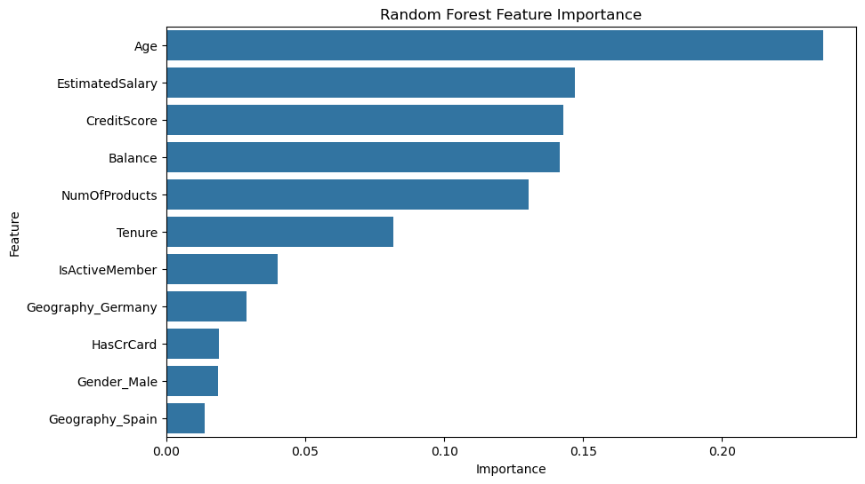
12. New Customer Prediction:
- Credit Score: 650
- Geography: France
- Gender: Female
- Age: 40
- Tenure: 5
- Balance: 50000
- Number of Products: 2
- Has Credit Card: Yes
- Active Member: Yes
- Estimated Salary: 60000
13. Business Insights:
## Business Insights

The customer churn analysis provides useful insights that can help businesses understand customer behavior and identify customers who may be at risk of leaving.

### Key Insights

1. Customer characteristics such as age, geography, credit score, account balance, number of products, and activity status can provide useful information for predicting churn.

2. The exploratory analysis helps identify differences between customers who stayed and customers who exited.

3. Machine learning models can be used to identify customers who may be likely to churn.

4. Feature importance from the Random Forest model helps identify the variables that contribute most to the prediction.

5. Customer churn prediction can help organizations take preventive actions before customers leave.

14. Recommendations:
Based on the analysis, organizations can consider the following actions:
  - Identify customers with a high predicted probability of churn.
  - Provide personalized offers or services to customers at risk of leaving.
  - Improve customer engagement through targeted communication.
  - Monitor inactive customers regularly.
  - Analyze customer behavior across different geographical regions.
  - Use machine learning predictions as a supporting tool for customer retention strategies.

15.Conclusion:

This project developed a machine learning-based customer churn prediction system using the Churn_Modelling dataset.

The project followed a complete data analytics workflow including data loading, data cleaning, exploratory data analysis, data preprocessing, model training, model evaluation, and customer prediction.

Three machine learning algorithms were implemented: Logistic Regression, Decision Tree, and Random Forest. Their performance was evaluated using Accuracy, Precision, Recall, and F1 Score.

The Random Forest model was also used to identify feature importance and predict whether a new customer is likely to stay or churn.

The project demonstrates how data analytics and machine learning can be used to support customer retention and business decision-making.

16. Future scope:
- The project can be further improved by:

  - Using additional customer behavioral data.
  - Performing hyperparameter tuning.
  - Testing additional machine learning algorithms.
  - Using cross-validation.
  - Developing an interactive dashboard.
  - Deploying the model as a web or cloud application.
  - Updating the model periodically with new customer data.

17. References:
- Kaggle – Churn Modelling Dataset
- Python Documentation
- Pandas Documentation
- Scikit-learn Documentation
- Matplotlib Documentation
- Seaborn Documentation
- IBM SkillsBuild

