Full inventory of Products : Total 20

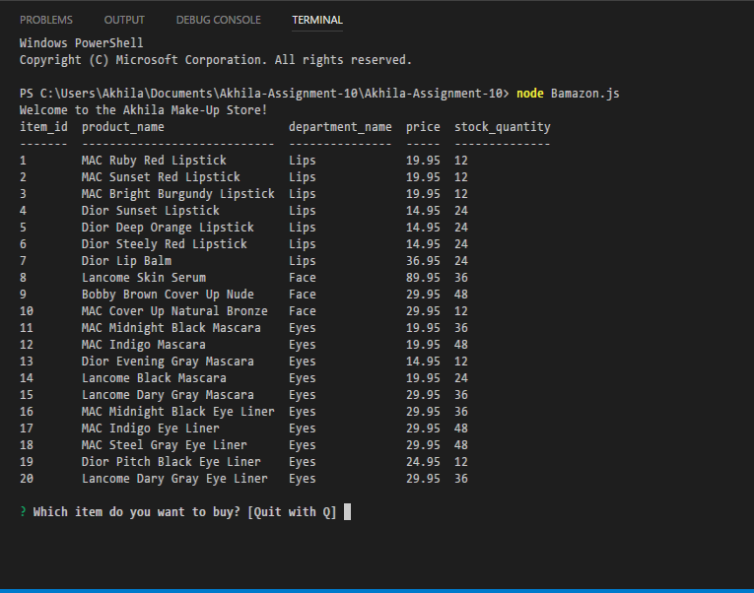

Identifying the item you’re buying using Item ID: Item # 3, Qty=1

Once this item was bought, the qty went down to 11.

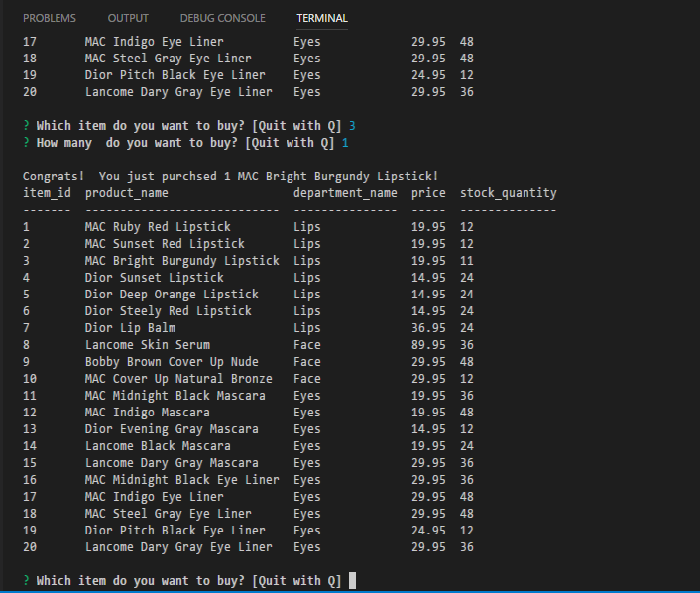

Buying too many quantities not enough in stock. Item #20

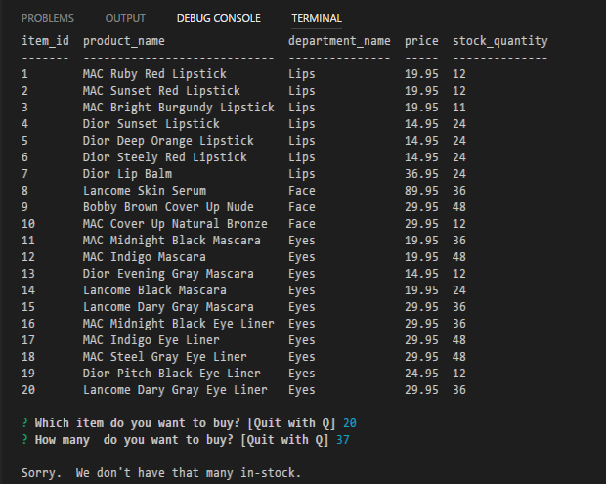

Trying to buy item that is not in the inventory

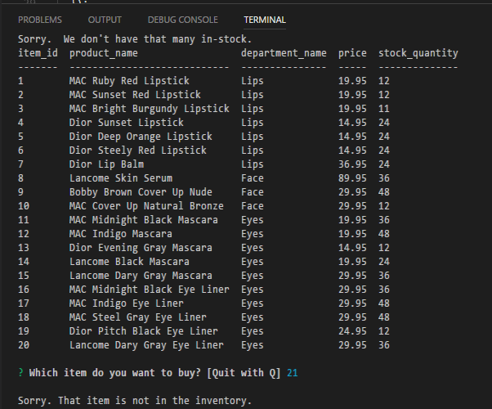

GOOD BYE:

