**Assignment 1**

**Advance machine learning**

**Step 1: Import Libraries**

For processing vectors, which we transmit as input in vector format, NumPy is a useful linear algebra library. We can plot our results using Matplotlib for visualization. Sklearn and train test split method is used to train our model.

**Step 2**

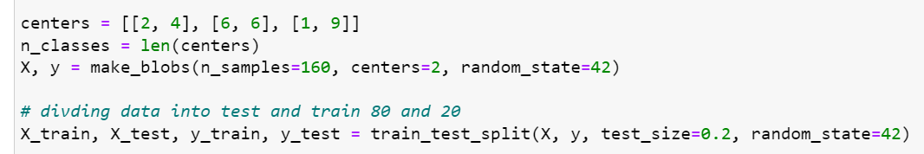

To process a set of sample data, make blobs was used, and the samples were divided by 80-20.

**Step3:**

The KNN model was used on the dataset. Initially, the K values ranging from 1 to 15 were taken to evaluate the results. If no K range is specified, the default value of 1 is used. The data was fitted using "knn.fit," which prepares the model for training.

With some parameters algorithm as auto and leaf size=40 and metric= Minkowski and weights=uniform and using 5 neighbors.

**Step 4:**

The predictions and target values for each k-value are predicted and plotted the results. The test accuracy for all k-values was 1 using the samples mentioned above. Additionally, we created a graph to visualize these results.

