Python3   
Ping

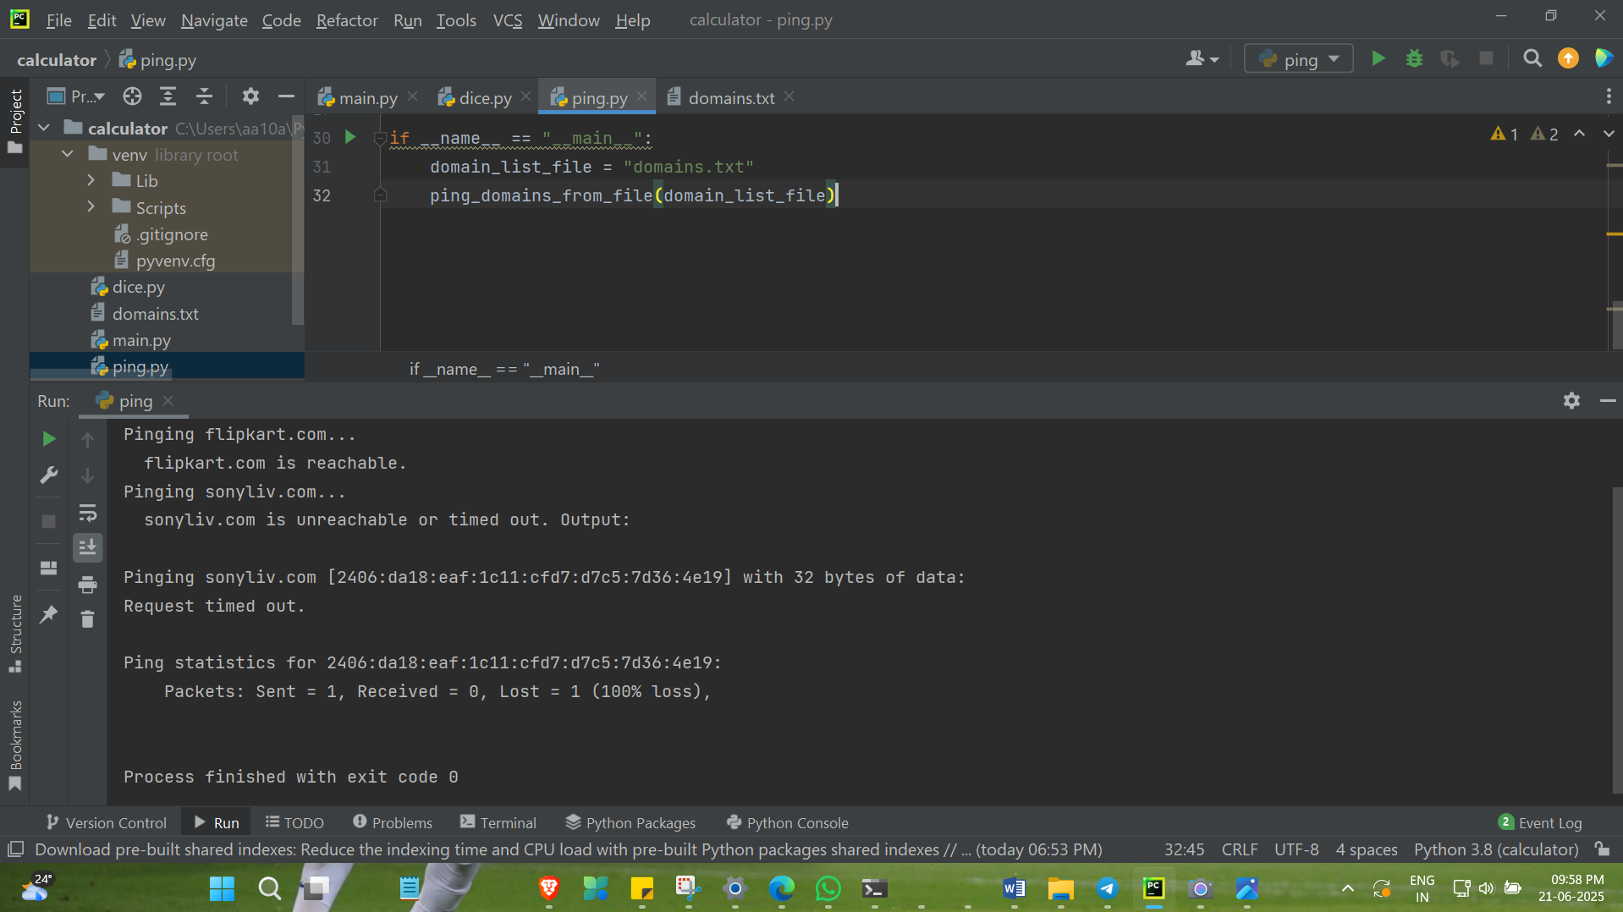

import subprocess  
  
def ping_domains_from_file(filepath):  
  
 try:  
 with open(filepath, 'r') as f:  
 domains = [line.strip() for line in f if line.strip()]  
 except FileNotFoundError:  
 print(f"Error: File '{filepath}' not found.")  
 return  
  
 for domain in domains:  
 print(f"Pinging {domain}...")  
 try:  
  
 if subprocess.os.name == 'nt':  
 command = ["ping", "-n", "1", domain]  
 else:  
 command = ["ping", "-c", "1", domain]  
  
 result = subprocess.run(command, capture_output=True, text=True, check=False)  
  
 if result.returncode == 0:  
 print(f" {domain} is reachable.")  
 else:  
 print(f" {domain} is unreachable or timed out. Output:\n{result.stdout}{result.stderr}")  
 except Exception as e:  
 print(f" Error pinging {domain}: {e}")  
  
if __name__ == "__main__":  
 domain_list_file = "domains.txt"  
 ping_domains_from_file(domain_list_file)