Python1  
calculator cli  
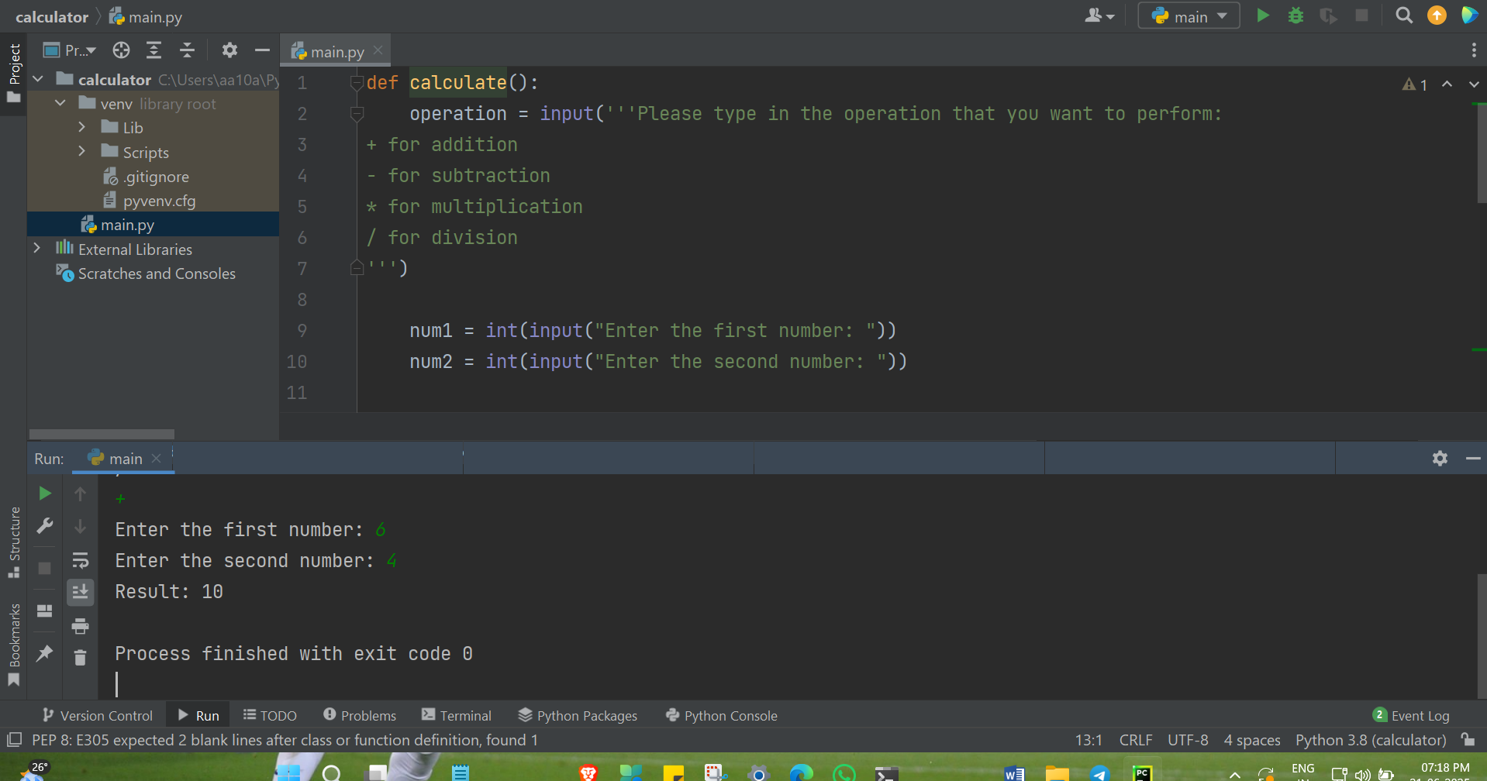

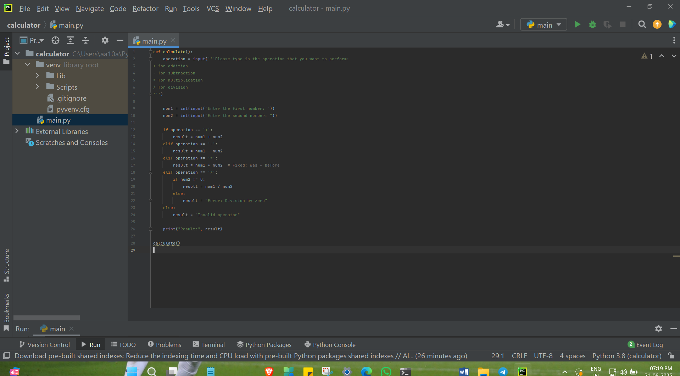

Code: def calculate():  
 operation = input('''Please type in the operation that you want to perform:   
+ for addition  
- for subtraction  
\* for multiplication  
/ for division  
''')  
  
 num1 = int(input("Enter the first number: "))  
 num2 = int(input("Enter the second number: "))  
  
 if operation == '+':  
 result = num1 + num2  
 elif operation == '-':  
 result = num1 - num2  
 elif operation == '\*':  
 result = num1 \* num2 # Fixed: was + before  
 elif operation == '/':  
 if num2 != 0:  
 result = num1 / num2  
 else:  
 result = "Error: Division by zero"  
 else:  
 result = "Invalid operator"  
  
 print("Result:", result)  
  
calculate()